







Clare Savage
Chair
Australian Energy Regulator (AER)
E: Clare.Savage@aer.gov.au
CC: RateOfReturn@aer.gov.au
AER reference: AER25010572
7th August 2026
Dear Clare
The undersigned Councils of Social Service, welcome the opportunity to make a submission to the AERs Draft Decision and Explanatory Statement on the Rate of Return Instrument (RORI) 2026.
This submission follows our Joint Submission Rate of Return Instrument (RORI) Review 2026.
The Rate of Return Instrument (RORI) specifies how the Australian Energy regulator (AER) will determine the allowed rate of return on capital invested in regulated electricity and gas networks, for the four-year period following RORI’s release.
The rate of return for capital investment, sets around 40 to 60% of network costs.
While we welcome AERs proposed changes to some aspects of the 2026 RORI, which could result in some small savings to consumers, the proposed changes are too incremental, rather than the material shift necessary given the significant impacts electricity prices are having on inflation, interest rates, cost of living, and energy hardship.
We support the submission and recommendations made by Energy Consumers Australia and point to the supporting evidence provided by consultants EMAS.
In support of ECA’s submission, we make the following key points and recommendations.
Inflated network prices are contributing to economic and social harm
- Network costs are a significant part of the electricity bill and driver of electricity price rises – network costs account for around 39% of residential retail costs. Residential network charges have increased by over 10% in many networks over the past two years, with costs forecast to continue to rise significantly over the coming years.
- Rising energy costs are contributing to inflation and interest rate rises – inflation data consistently shows rising electricity costs are adding to inflationary pressure in Australia, contributing to RBA interest rate rises with further impacts on the economy, cost of living pressures, and rising unemployment.
- Rising energy costs are contributing to energy unaffordability and energy hardship - Research by Energy Consumers Australia finds that despite bill relief, around two thirds of households say they are having some difficulty affording their energy bills, with one in five households estimated to be facing energy hardship.
Research by our organisations find that because of high electricity bills people are depriving themselves of energy, not heating homes in winter or cooling homes in summer, borrowing money to pay bills, and skipping meals and medicines to afford energy bills. These experiences are having a significant impact on people and communities’ health and wellbeing.
Recommendation: the AER’s decision making framework must consider the broader economic and household impacts of higher network costs.
The AER has a responsibility to put the interest of consumers ahead of the interests of corporates and shareholders
- AER's decisions on the rate of return substantially affects energy costs for consumers - The AER's decisions on the regulated rate of return accounted for around 48% of energy networks' total revenue allowances for 2025. Therefore, the AER's revenue decisions and the AER's decisions on the rate of return substantially affect energy costs, most acutely felt by consumers on low incomes.

- AER is required to make decisions in the interest of consumers, not a “balanced outcome” between consumers and networks - The AER must execute its legislative duties under the National Electricity Objective (NEO) which states that while revenue and pricing principles explicitly dictate that Network Service providers (NSPs) must have a reasonable opportunity to recover efficient costs, “pricing must ultimately promote the efficient use of, and investment in, infrastructure in the long-term interest of consumers”.

We are deeply concerned that the AER’s Explanatory Statement for its draft decision states that it had achieved a “balanced outcome” that “avoids outcomes that favour either service providers or consumers”. A “balanced outcome” between networks and consumers should not be the AER’s goal or a criterion within its decision-making framework. Its primary objective should be to act in the interests of consumers.

- Consumer groups are calling for substantial changes to the framework – the AER’s Explanatory Statement for its draft decision also stated that there is “Broad stakeholder confidence - stakeholders have generally accepted the RORI outcomes, with limited calls for changes to the framework.” This is a blatantly untrue assertion. In 2022, the AER’s Consumer Reference Group in response to the 2022 Draft decision argued that the RORI reflected upward bias toward network providers across many parameters rather than outcomes for consumers and called for reforms. In both the Energy Consumer Australia (ECA) submission and the joint COSS submission to the 2026 RORI Review, we clearly articulated our concerns with a number of the parameters within the RORI framework and have called for substantial changes.
Recommendation: the AER’s decision making framework must prioritise the interest of consumers and make substantial changes to the RORI to reduce network “allowed” and “actual” returns.
AER’s annual allowed returns are too high
In the lead up to the AER’s 2022 RORI decision, the AER’s Consumer Reference Group argued that the RORI reflected upward bias toward network providers across many parameters rather than outcomes for consumers. According to an independent review conducted for ECA, this resulted in the network prices being 6.4% or $941 million higher than necessary.
There are several reforms the AER can make to further reduce the annual allowed returns:
- Further reducing the equity beta estimate - While we welcome the AER’s proposed change to reduce equity beta, as per consumer group submissions, we do not believe the reduction from 6.0 to 5.5 goes far enough. The AER estimates this change will reduce total network regulated revenue by around $940 million, with an estimate bill savings for residential customers of $8 per annum. As ECA note in their submission “The AER’s estimate is biased by the inclusion of non-representative firms and the international data which the AER itself expresses caution with. The domestic data shows clearly that the equity beta estimates of majority-regulated Australian firms are generally below 0.4.” Based on the arguments noted in ECA‘s submission and evidence provided by the independent consultants EMAS, the equity beta estimate should be no higher than 0.5 (preferably below).
Recommendation: The AER should set the equity beta no higher than 0.5 and preferably below.
- Reduce the Market Risk Premium (MRP) – The AER proposes to reduce the MRP down from 6.2% to 6.1%, which we welcome, but again it does not go far enough. The AER estimates that change will deliver an aggregate reduction in regulated revenues of around $190 million and reduce the average residential customer bill by about $1.50 per annum.

We support ECA’s recommendation to adopt an MRP of no more than 6.0% and preferably less. The ECA in their submission notes “The AER’s draft decision of 6.1% is at the top of a reasonable range, with limited evidence to support this decision. This appears to contradict the AER’s approach of using a midpoint to estimate equity beta [for example]. By selecting 6.1%, the AER is heavily skewing its decision toward the upwardly biased arithmetic mean (6.3%), rather than anchoring near the true midpoint (5.65%) or the weighted average (6.0%).”
Recommendation: The AER should set the Market Risk Premium to no higher than 6.0% and preferably less.
Actual returns are too high
AER analyses repeatedly show that networks materially outperform the annual allowed regulated returns (see figure’s 1 and 2).
The independent analysis by EMAS argues that a material proportion of this outperformance is due to how inflation is treated in the rate of return instrument.
Figure 1 Aggregate Actual real return on equity compared to allowed real return on equity – electricity networks
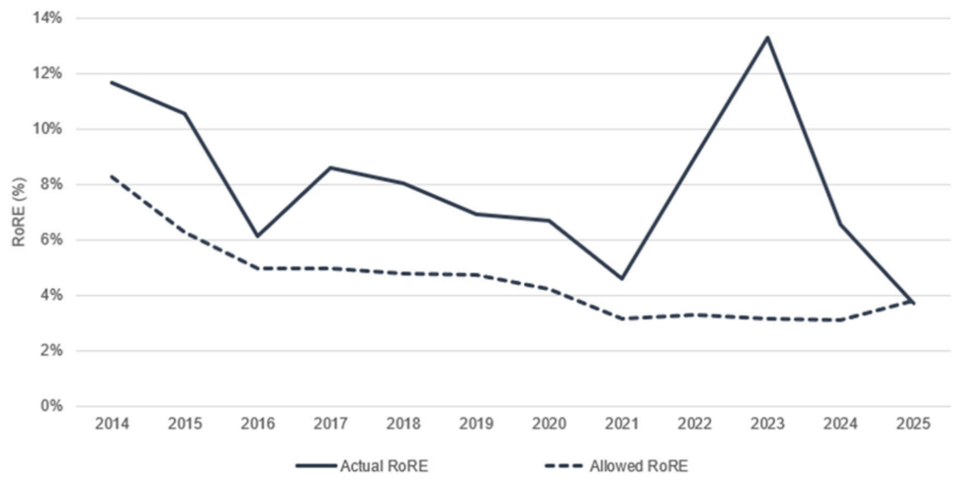
Figure 2 Individual Network level average annual allowed and actual rate of return on equity 2022-2025

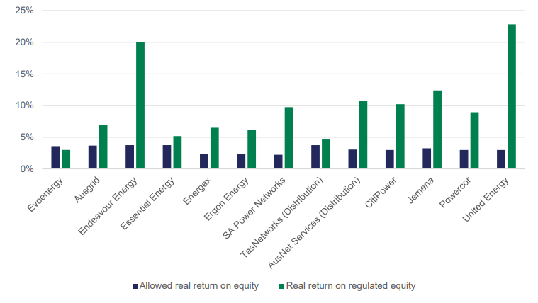
Source: ECA Analysis of AER Operational Performance Data
When inflation is higher than forecast, it increases a network's allowed return on capital, leading to windfall gains:
- By directly increasing the total value of their asset base, which boosts the return on capital calculated as a percentage of that base; and
- Through delayed revenue adjustment. If actual inflation outpaces this forecast, the network receives higher actual cash flow compensation and higher indexed RAB growth, resulting in actual returns on equity that exceed the initial allowed rates.
The AER has acknowledged the impact of inflation forecasts, which we welcome, but has said it is beyond the scope of the 2026 RoRI review and any change to the regulatory treatment of inflation must await a discretionary AER review.
However, independent consultants EMAS argues the AER can do two things within the scope of the RORI, to reduce how inflation is considered and avoid windfall gains:
- Amend clause 9 of the 2026 RORI to limit the impact of inflation forecasting differences of returns on equity – According the EMAS report, in clause 9 of the 2022 RoRI, the AER defines a 10-year Trailing Average Portfolio Return on Debt (TAPRD), which is then meant to be applied in the Post Tax Revenue Model (PTRM) to set forward revenue and price paths over a regulatory control period. However, in setting the allowed return on debt in annual pricing resets, the AER does not apply the RoRI TAPRD. Instead, it applies what it calls the ‘Inflation rate variation’ (IRV) to the return on debt, which it says reflects ‘prevailing economic conditions.’ This modifies the allowed return on debt relative to the outcome that would arise under the TAPRD framework alone.

EMAS recommends an amendment to clause 9 to “create an obligation and head of power [authority] for the AER to remove material gains or losses of the IRV to the TAPRD, to the extent required to ensure consistency, ensuring returns are commensurate with the regulatory and commercial risks, and a reasonable opportunity to recover at least the efficient costs the operator incurs.”

Addressing how inflation is treated in the current RORI process, rather than waiting for a separate review, is critical given predictions of rising inflation in Australia, further interest rate rises, increasing cost of living and rising energy hardship.
Recommendation: The AER should amend clause 9 of the RORI to create an obligation and authority for the AER to remove material gains or losses of the IRV to the TAPRD, to the extent required. This would increase consistency, ensure returns are commensurate with the regulatory and commercial risks, and provide a reasonable opportunity to recover at least the efficient costs the operator incurs.
- Retain “uniform” Trailing Average Portfolio Return on Debt (TAPRD) – The AER’s draft decision suggests it will retain a uniform TAPRD rather than shift to a weighted TARPD, which we support. Independent consultants EMAS note that a shift to a weighted TARPD would lead to an increase in prices for consumers.
Recommendation: The AER should retain uniform Trailing Average Portfolio Return on Debt (TAPRD).
We urge the AER to make further changes to their final determination for RORI 2026 to maximise savings to consumers and reduce broader economic and social impacts of increasing network prices.
If you have any questions please contact, Kellie Caught, Program Director Climate and Energy, ACOSS at kellie@acoss.org.au


Yours sincerely

Kellie Caught
Program Director, Climate and Energy
ACOSS
on behalf of ACOSS, ACTCOSS, NCOSS, QCOSS, TASCOSS, SACOSS, VCOSS

ECA (2026) 2026 Draft Rate of Return Instrument, Submission to Australian Energy Regulator https://energyconsumersaustralia.com.au/sites/default/files/2026-07/submission-doc-aer-rori-draft-26.pdf
EMAS (2026) Report for Energy Consumers Australia’s Submission to the AER’s Draft decision on the 2026 Rate of return Instrument Review https://energyconsumersaustralia.com.au/sites/default/files/2026-07/web-doc-emas-response-aer-2026-rori-draft-decision.pdf
https://energyconsumersaustralia.com.au/news/one-highest-impact-decisions-home-energy-bills-about-made-heres-why-matters
Consumer Price Index, Australia | Australian Bureau of Statistics
Energy Consumers Australia, Consumer Energy Report Card survey, December 2025.
Energy Consumers Australia, Understanding and measuring energy hardship in Australia, July 2025.
See for example ACOSS (2026) Heat in Homes Survey 2026 https://www.acoss.org.au/wp-content/uploads/2026/03/Heat-in-Homes-Digital-1.0.pdf
AER Consumer Reference Group, Response to the AER’s Draft Rate of Return Instrument, September 2022
ECA (2026) 2026 Draft Rate of Return Instrument, Submission to Australian Energy Regulator https://energyconsumersaustralia.com.au/sites/default/files/2026-07/submission-doc-aer-rori-draft-26.pdf
The equity beta is a measure of systemic risk relative to the market and contributes to the overall assessment of risk to equity. A higher equity beta implies higher systematic risk, which in turn requires a higher expected rate of return for investors to compensate them for that increased risk
ECA (2026) 2026 Draft Rate of Return Instrument, Submission to Australian Energy Regulator https://energyconsumersaustralia.com.au/sites/default/files/2026-07/submission-doc-aer-rori-draft-26.pdf
The Market Risk Premium (MRP) is the extra return investors expect from a risky market portfolio compared to a safe, risk-free asset.
ECA (2026) 2026 Draft Rate of return Instrument, Submission to Australian Energy Regulator https://energyconsumersaustralia.com.au/sites/default/files/2026-07/submission-doc-aer-rori-draft-26.pdf
AER, 2024 Electricity and Gas Network Performance Report, September 2024.
EMAS (2026) Report for Energy Consumers Australia’s Submission to the AER’s Draft decision on the 2026 Rate of return Instrument Review https://energyconsumersaustralia.com.au/sites/default/files/2026-07/web-doc-emas-response-aer-2026-rori-draft-decision.pdf
ECA (2026) 2026 Draft Rate of return Instrument, Submission to Australian Energy Regulator https://energyconsumersaustralia.com.au/sites/default/files/2026-07/submission-doc-aer-rori-draft-26.pdf
Network revenue models use nominal rates of return combined with an AER inflation forecast.
EMAS (2026) Report for Energy Consumers Australia’s Submission to the AER’s Draft decision on the 2026 Rate of return Instrument Review https://energyconsumersaustralia.com.au/sites/default/files/2026-07/web-doc-emas-response-aer-2026-rori-draft-decision.pdf
EMAS (2026) Report for Energy Consumers Australia’s Submission to the AER’s Draft decision on the 2026 Rate of return Instrument Review https://energyconsumersaustralia.com.au/sites/default/files/2026-07/web-doc-emas-response-aer-2026-rori-draft-decision.pdf
Applies a fixed, equal fraction to each of the past 10 years
Adjusts annual historical weights to reflect changes or expansions in the underlying debt portfolio (such as growth in a regulated asset base.
According to the AER, a weighted Trailing Average Portfolio Return on Debt can increase costs to consumers by lagging behind falling market rates, overcompensating utilities during capital expansions, and shifting heavier financing allowances onto current rate-payers when large infrastructure investments occur

