# Incorporating an emissions reduction objective into the national energy objectives consultation paper

15 February 2023

About ACOSS

The Australian Council of Social Service (ACOSS) is a national voice in support of people affected by poverty, disadvantage and inequality and the peak body for the community services and civil society sector.

ACOSS consists of a network of approximately 4000 organisations and individuals across Australia in metro, regional and remote areas.

Our vision is an end to poverty in all its forms; economies that are fair, sustainable and resilient; and communities that are just, peaceful and inclusive.

## Discussion

ACOSS welcomes the opportunity to make a submission to the consultation paper on incorporating an emissions reduction objective into the national energy objectives consultation paper.

We welcome the collective leadership of Energy Ministers on emissions reduction inclusion in energy law and support the proposal to introduce an emissions reduction objective in the NEO. ACOSS has been a strong advocate for the inclusion of such an objective and we agree it will send a clear signal to the wider industry, market participants, investors and the public of the need to achieve a decarbonised, modern and reliable grid.

### Incorporate social equity and demand side objectives into the National Energy Objectives (NEO)

The inclusion of a decarbonisation objective will not on its own address the challenges around increasing energy systems costs, rising energy bills, reliability and resilience, and growing inequity.  We and a broad set of stakeholders across a range of sectors believe social equity and demand side objectives must also be included in the current proposed amendments to the NEO.

We attach at the end of this submission a joint statement from a broad coalition of 37 community, business, environment, and research sector organisations who are calling on energy Ministers to incorporate social equity and demand side objectives, in addition to emissions reduction objectives, into the National Energy Objectives (NEO).

The AER has noted that Australia’s energy market is growing ever-more complex and impenetrable for many in our society.[1] With the rapid pace of energy transition, people experiencing financial and social disadvantage, particularly First Nations communities, are at risk of being left behind and energy poverty and inequality increasing. Changes to the energy market design, rules and regulations; growth in new technology, products and services; shifts in global and local energy market conditions; and the unequal distribution of energy market costs, have already created wide-ranging and severe social equity impacts, with the potential to get worse.

There are 3 million people, including 761,000 children, living below the poverty line. They are already going without heating or cooling, having fewer showers, cooking less, and going without food and medicines to afford their energy bills. Single parents and their children, Aboriginal and Torres’s Strait Islander people, people over 65 who rent, and people with a disability are overrepresented in this group.

People on low income spend four times more of their income on energy compared to people on higher incomes.[2] Research shows that people experiencing financial disadvantage are not accessing new energy technologies that can help them reduce their energy bills at the same rate as people on high incomes. The rates are worse if you don’t own your own home.

Unfortunately, more and more costs of the energy transition are being loaded on energy bills, which is resulting in people experiencing financial disadvantage paying disproportionately more of the costs of the transition.

For example, there is research that finds subsidy schemes for small-scale solar panels recovered through electricity bills are inequitable and regressive, such as feed-in tariffs[3] and the Small-Scale Renewable Energy Scheme (SRES),[4] which provide direct financial benefits to solar households.

Network costs make up two-fifths of the electricity bill (more in some network areas) and at present are recovered via consumption tariffs through a combination of fixed and usage charges.

Households able to substantially reduce their usage, like solar owners, contribute less to network costs, which leads to other households paying a greater share of all network costs (under non-cost reflective tariffs and network revenue caps).

Further a shift to cost-reflective tariffs could address some inequities but some consumers will be worse off. Greater attention from market bodies is needed to identify and mitigate negative impacts. Research by Victorian Energy Policy Centre found that households in the lowest socio-economic areas do not respond to differences in peak and off-peak prices.[5] A study by ANU found that vulnerable households were the least well equipped to understand and respond to the different pricing structures, and often had the least flexibility in terms of shifting their electricity use to different periods, and ultimately paid higher prices for their electricity under time-of-use tariffs.[6]

Many of these issues are not being appropriately addressed because equity is not an objective in the NEO.

We believe with clear equity and demand side objectives, market design, rules and regulations can make a positive contribution to social equity, by:

* Distributing costs, benefits and risks transparently and fairly to allow for equitable outcomes regardless of people’s ability to engage with the energy system.
* Incentivising energy market participants to innovate in ways that bring benefits to all consumers.
* Providing appropriate protections to support people to access affordable, efficiently priced basic energy supply regardless of how much or little they interact with energy services.

Equally a shift in the objectives to focus on the ‘cost of energy bills’ or ‘energy affordability’ would place greater emphasis and investment into energy performance and demand management both in front of the meter (energy system) and behind the meter (the house or business).

### More efficient, effective and in the interest of consumers to make a suite of changes now

As noted in the joint statement, given the time and resources required to amend energy laws as well as to socialise and implement changes, it would be more efficient and effective to make a suite of interrelated changes now. This will also ensure that the broader benefits to consumers, society and the economy are realised sooner.

In the consultation paper, Ministers acknowledged these as important matters for future consideration. At a minimum, it is our shared view that all Australian governments should commit in principle to making these changes and outline at the next Energy Ministers meeting their next steps and timeline on these important system reforms.

### Response to emission reduction proposal

Unfortunately, due to short-term frame for consultation over the holiday period coinciding with multiple submissions due, we were unable to consult with members on the detail of the proposed changes to incorporate emission reductions in the NEO.

In principle we agree that the proposed change to ‘consumers of energy’, instead of ‘consumers of electricity’ and ‘consumers of gas’, is helpful.

In principle we would also support the proposal for market bodies to develop guidelines regarding how they interpret the revised national energy objectives. These guidelines should be developed in consultation with stakeholders and ensure they are consistent between market bodies.

We think more consideration should be given to the economic efficiency frame and how emission reductions targets are incorporated and would welcome further opportunity to provide feedback on these if given the opportunity to consult with members.

#### Contact

Kellie Caught

Program Director – Climate and Energy

kellie@acoss.org.au

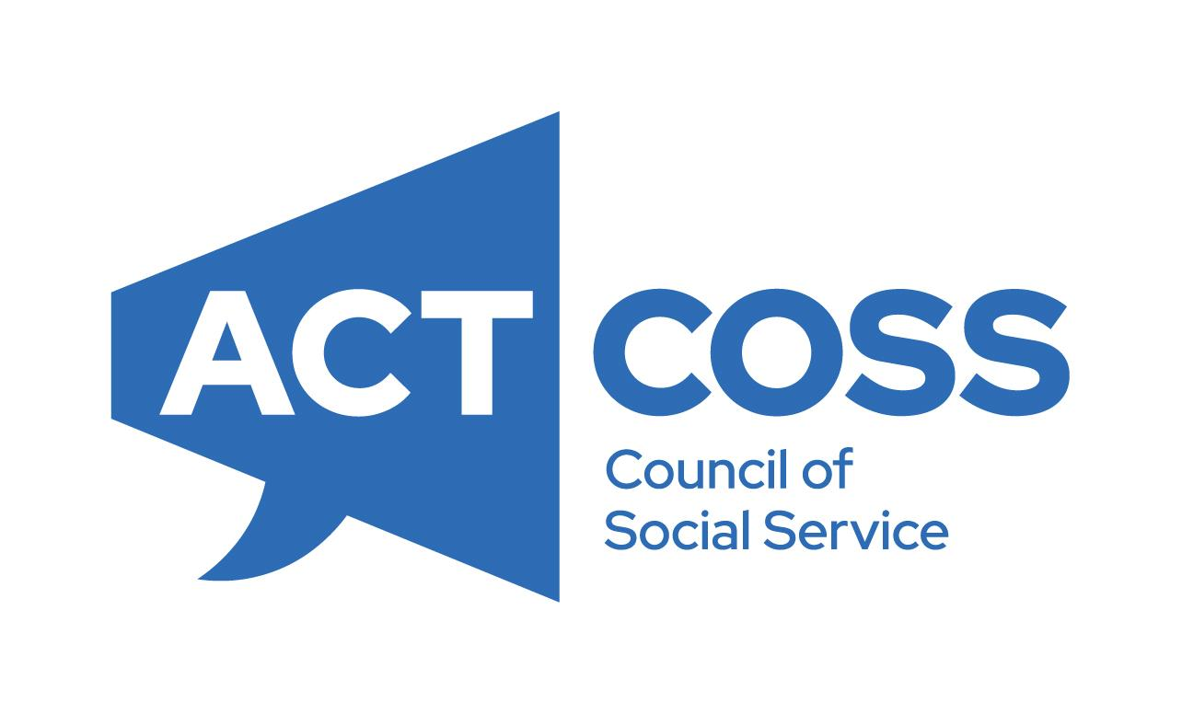**Built-in not bolted-on:   
Statement of support to include social equity and demand side objectives in amendments to the National Energy Objectives**

We are a broad coalition of community, business, environment, and research sector organisations who are calling on energy Ministers to incorporate social equity and demand side objectives, in addition to emissions reduction objectives, into the National Energy Objectives (NEO).

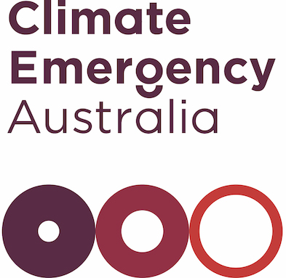Energy is an essential service. It plays a critical role in the health and well-being of people, and powers the economy. However, the energy system is rapidly and profoundly changing and the laws that govern our energy system have not changed to meet the new challenges. If we get the settings and systems right, our future energy system won’t just be clean, it will also be cheaper and fairer for everyone. If we get the settings and systems wrong, the transition will be unnecessarily costly, inequitable, unreliable, and slow.

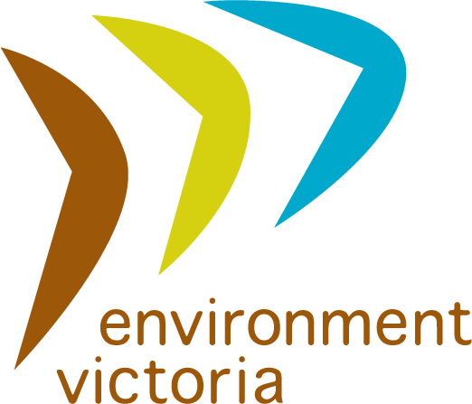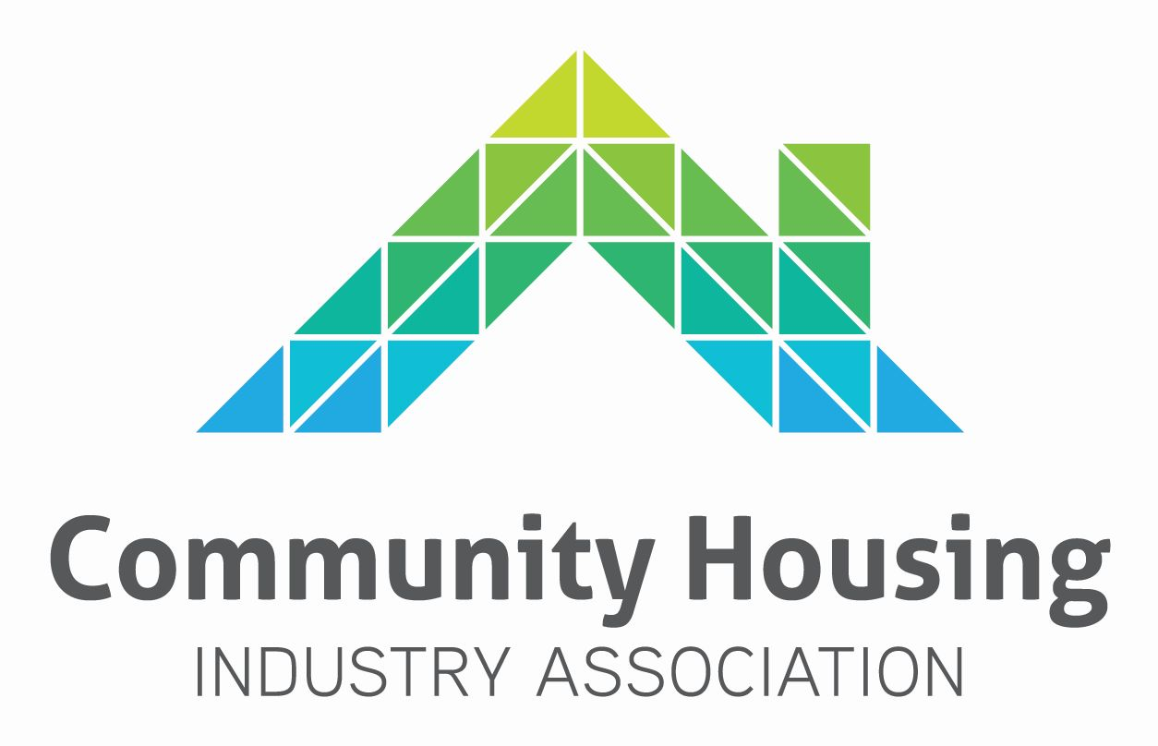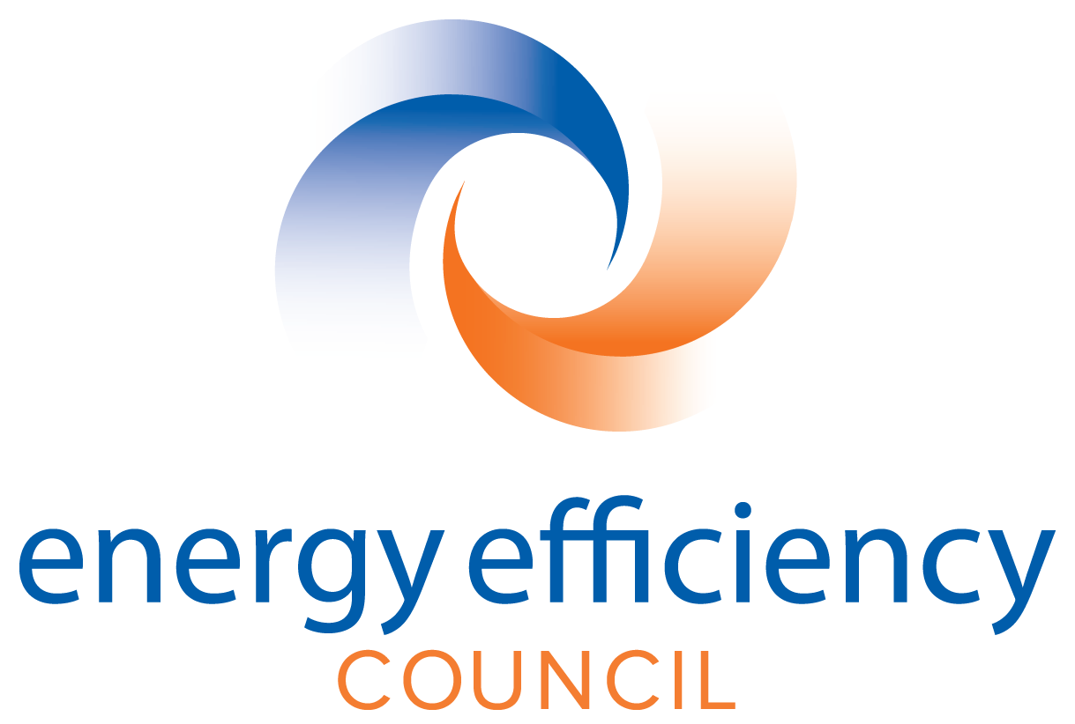Our organisations welcome the collective leadership of Energy Ministers on emissions reduction inclusion in energy law and support the proposal to introduce an emissions reduction objective in the NEO. We agree it will send a clear signal to the wider industry, market participants, investors and the public of the need to achieve a decarbonised, modern and reliable grid.

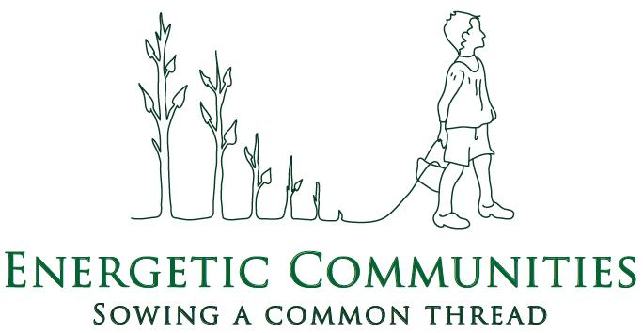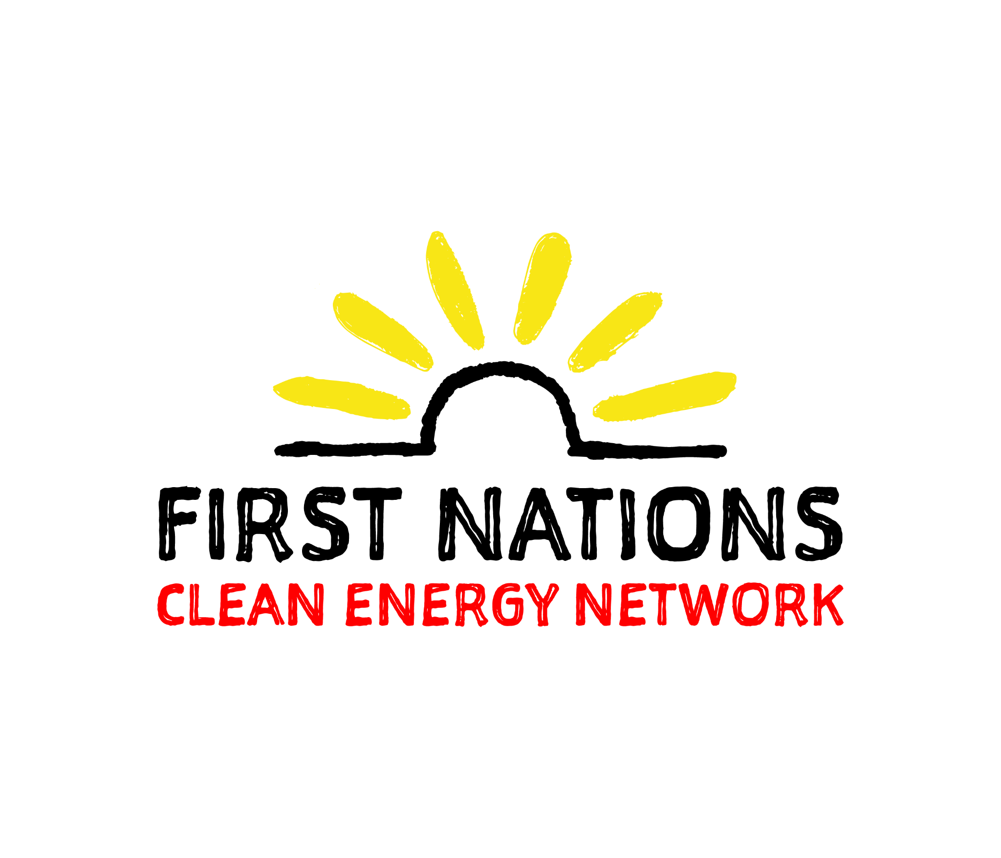However, the inclusion of a decarbonisation objective will not on its own address the challenges around increasing energy systems costs, rising energy bills, reliability and resilience, and growing inequity. As outlined below, we believe social equity and demand side objectives must also be included in the current proposed amendments to the NEO.

*Social equity objective will reduce energy poverty and inequality*

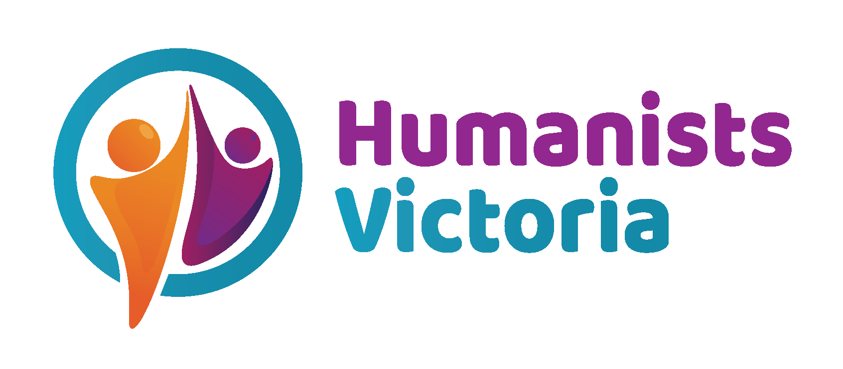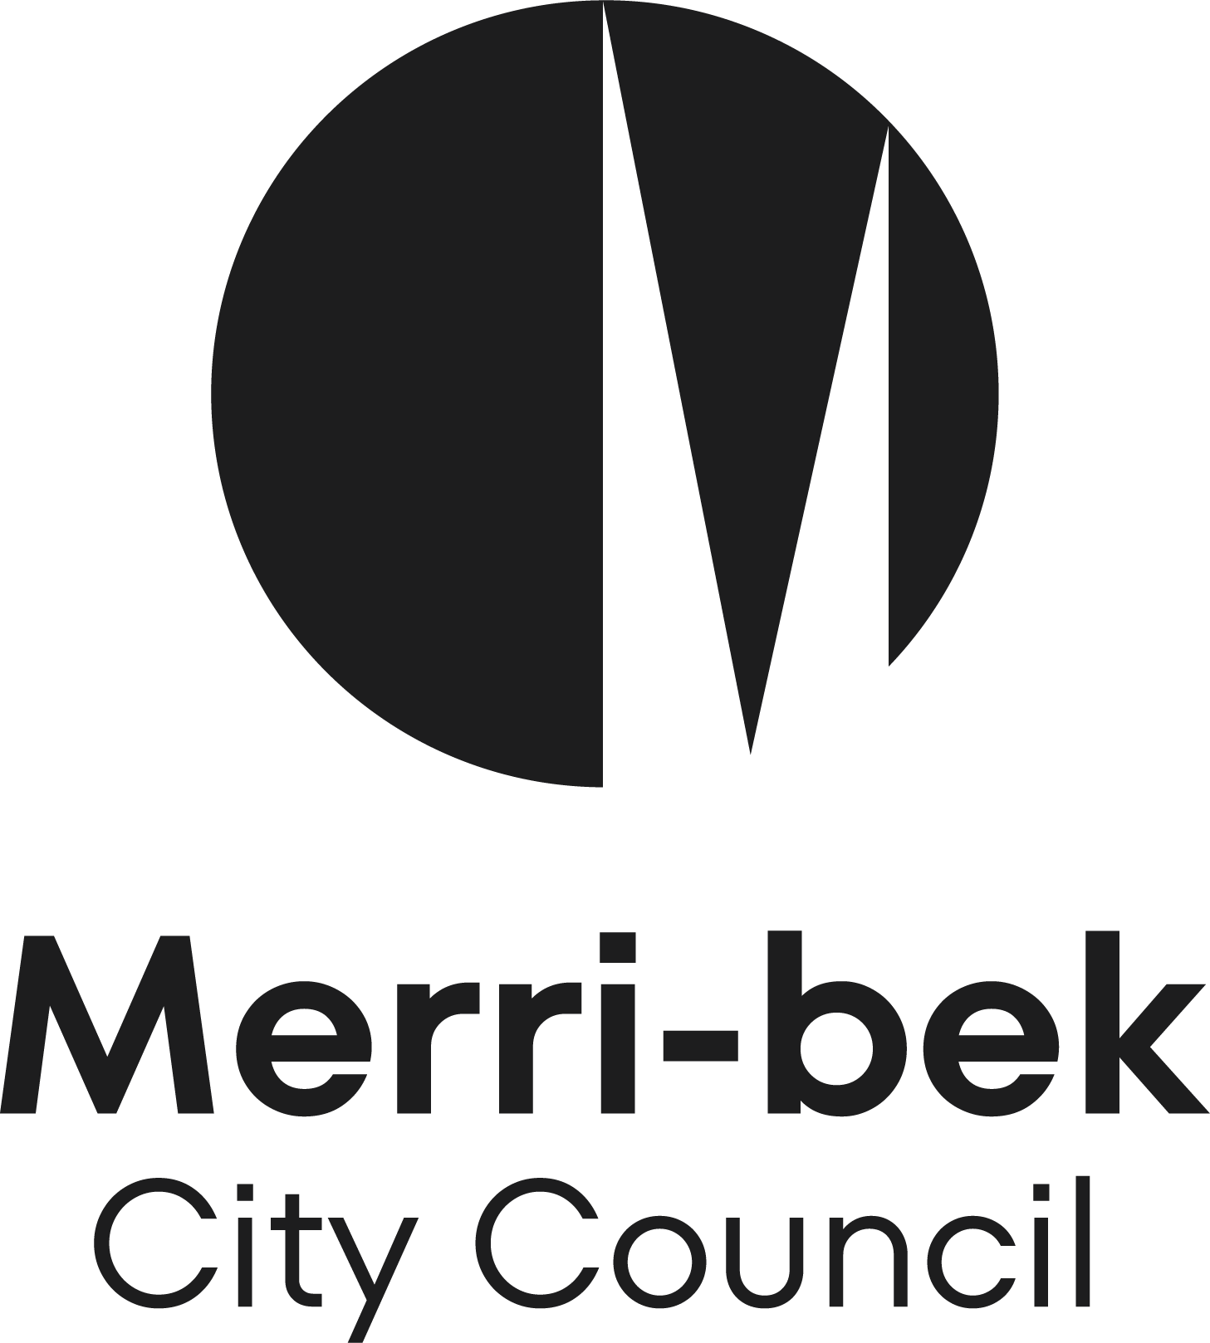With the rapid pace of energy transition, people experiencing financial and social disadvantage, particularly First Nations communities, are at risk of being left behind and energy poverty and inequality increasing. Changes to the energy market design, rules and regulations; growth in new technology, products and services; shifts in global and local energy market conditions; and the unequal distribution of energy market costs, have already created wide-ranging and severe social equity impacts, with the potential to get worse. People experiencing financial disadvantage pay disproportionally more for the energy transition and many are missing out on some of the benefits.

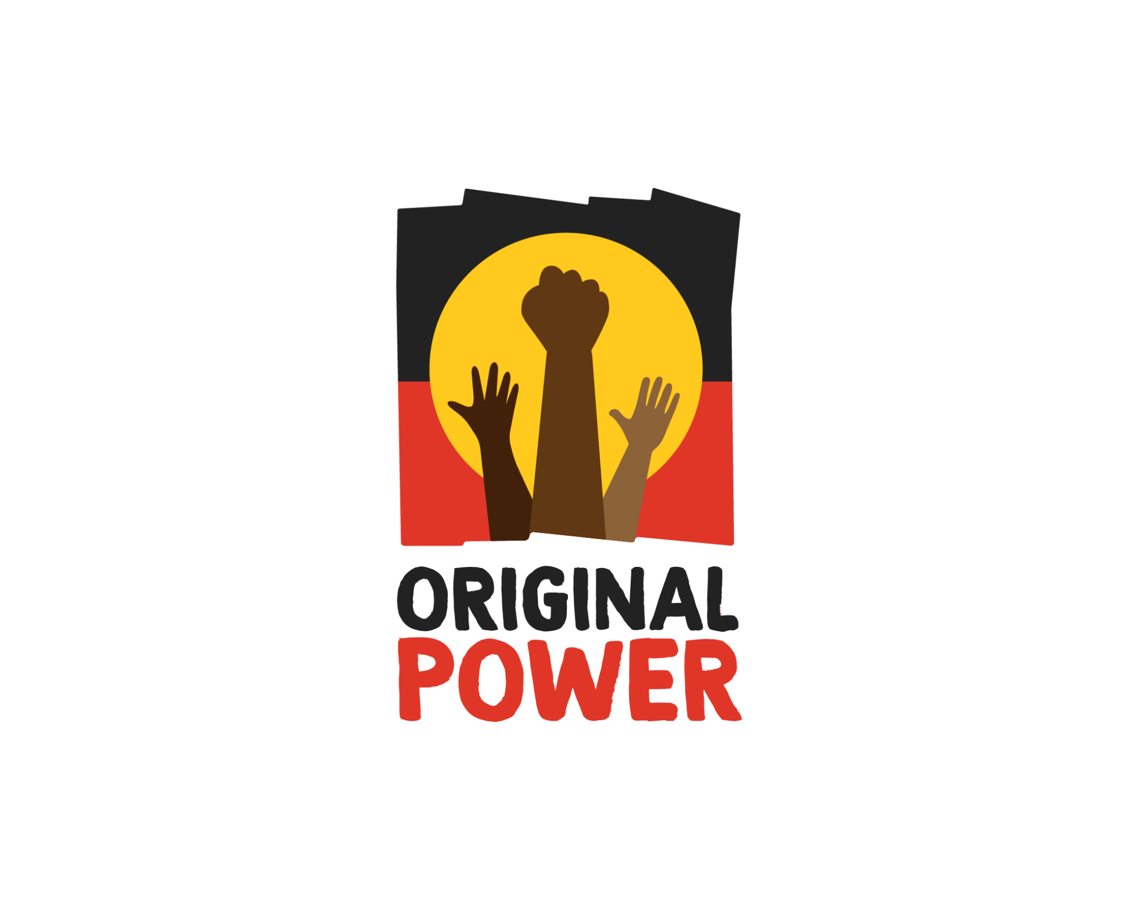The current framing of the NEO does not give regard to the social or distributional impacts of energy policy or regulatory decisions, especially for low-income and disadvantaged households that go beyond just ‘price’. We believe with clear objectives, market design, rules and regulations can make a positive contribution to social equity, by:

* 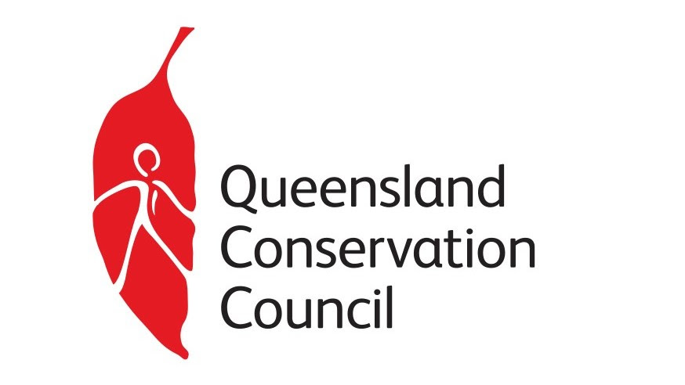Distributing costs, benefits, and risks transparently and fairly to allow for equitable outcomes regardless of people’s ability to engage with the energy system
* Incentivising energy market participants to innovate in ways that bring benefits to all consumers
* Providing appropriate protections to support people to access affordable, efficiently priced basic energy supply regardless of how much or little they interact with energy services.

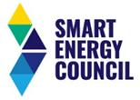Given the essential nature of energy supply, it is important that market bodies and market participants place social and distributional impacts at the center of energy policy and regulatory decisions. Incorporating an explicit reference to social equity in the NEO would ensure this fundamental consideration is part of decision-making.

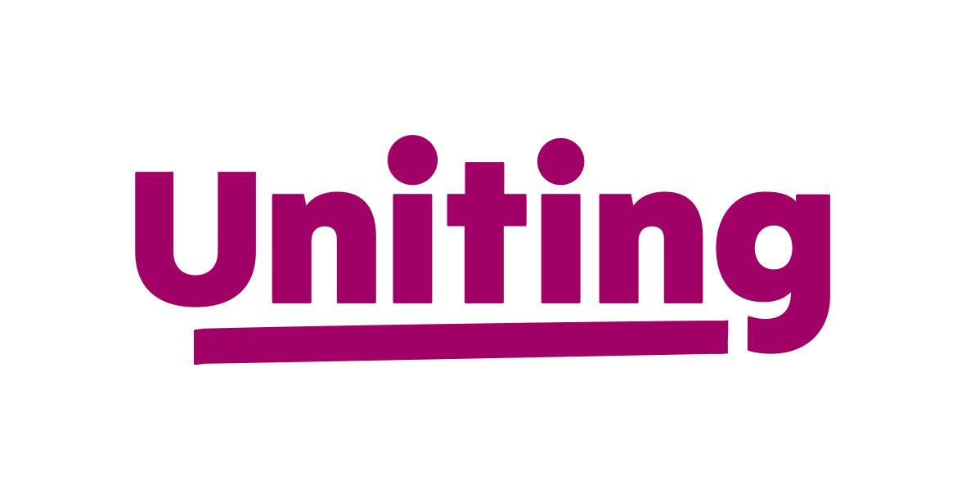*Reduce energy bills and improve energy affordability by improving energy performance*

The NEO needs to focus on reducing total energy bills and making energy affordable for all Australian households and businesses. The NEO’s current focus on ‘price’ fails to encourage improvements in energy performance and efficiency that can slash energy bills, even as the prices charged for energy go up.

Energy efficiency, electrification and energy management can have a direct and immediate impact on reducing emissions and energy bills, reducing the exposure of consumers to energy price shocks. Study after study has noted energy efficiency techniques as some of the cheapest abatement available and it remains a substantially untapped resource in Australia.

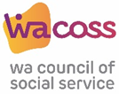Including a focus on the ‘cost of energy bills’ or ‘energy affordability’ in the objectives would place greater emphasis and investment into energy performance and demand management both in front of the meter (energy system) and behind the meter (the house or business).

*More efficient, effective and in the interest of consumers to make a suite of changes now*

Given the time and resources required to amend energy laws as well as to socialise and implement changes, it would be more efficient and effective to make a suite of interrelated changes now. This will also ensure that the broader benefits to consumers, society and the economy are realised sooner.

In the consultation paper, Ministers acknowledged these as important matters for future consideration. At a minimum, it is our shared view that all Australian governments should commit in principle to making these changes and outline at the next Energy Ministers meeting their next steps and timeline on these important system reforms.

1. <https://www.aer.gov.au/news-release/aer-starts-a-journey-towards-energy-equity>
2. ACOSS and BSL (2018) [Energy Stressed in Australia](https://www.acoss.org.au/wp-content/uploads/2018/10/Energy-Stressed-in-Australia.pdf)
3. Nelson, T., Simshauser, P. and Nelson, J. (2012) [Queensland Solar Feed-in-Tariffs and the Merit order Effect: Economic Benefit, or Regressive Taxation and Wealth Transfers?](https://www.sciencedirect.com/science/article/pii/S0313592612500305)
4. Best, R., Chareunsy, A. and Li, H. (2021) [Equity and effectiveness of Australian small-scale solar schemes](https://researchers.mq.edu.au/en/publications/equity-and-effectiveness-of-australian-small-scale-solar-schemes)
5. <https://vuir.vu.edu.au/40599/1/200612%20TOU%20tariff%20paper.pdf>
6. https://reneweconomy.com.au/time-of-use-electricity-tariffs-could-hit-vulnerable-households-with-high-costs-15074/