**ACOSS Submission to National Energy Performance Strategy Consultation**

7th of February 2023

About ACOSS

The Australian Council of Social Service (ACOSS) is a national voice in support of people affected by poverty, disadvantage and inequality and the peak body for the community services and welfare sector.

ACOSS consists of a network of approximately 4000 organisations and individuals across Australia in metropolitan, regional and remote areas.

Our vision is an end to poverty in all its forms; economies that are fair, sustainable, and resilient; and communities that are just, peaceful, and inclusive.

Submission supported by

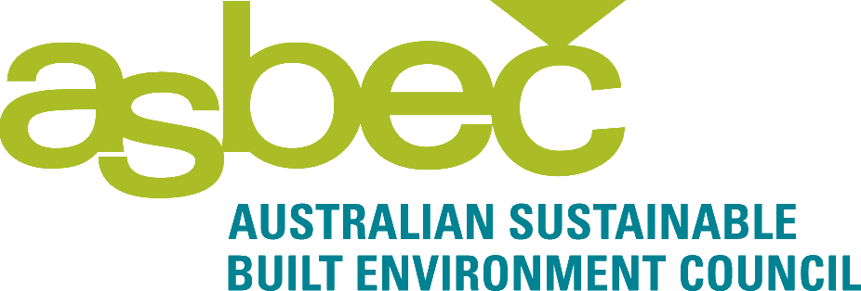

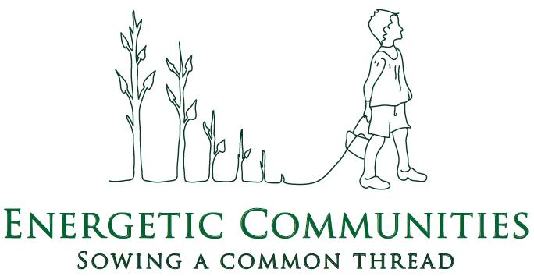



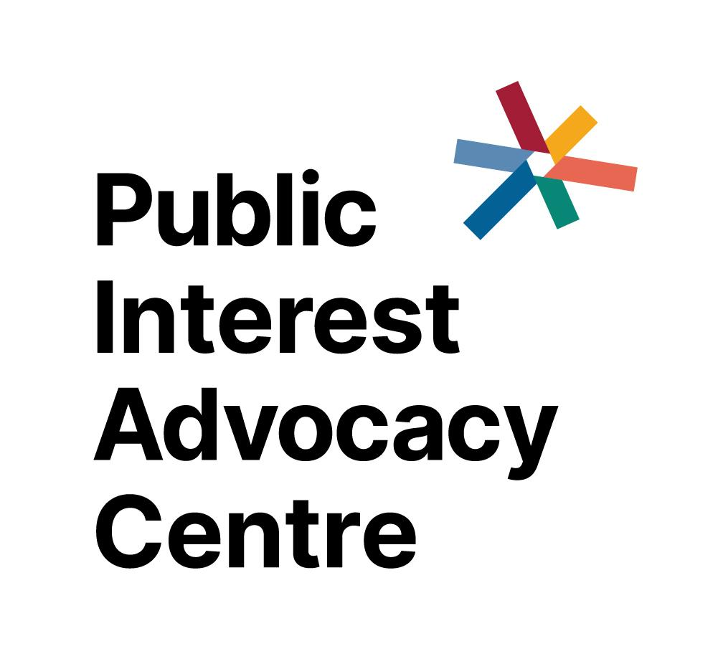



# 

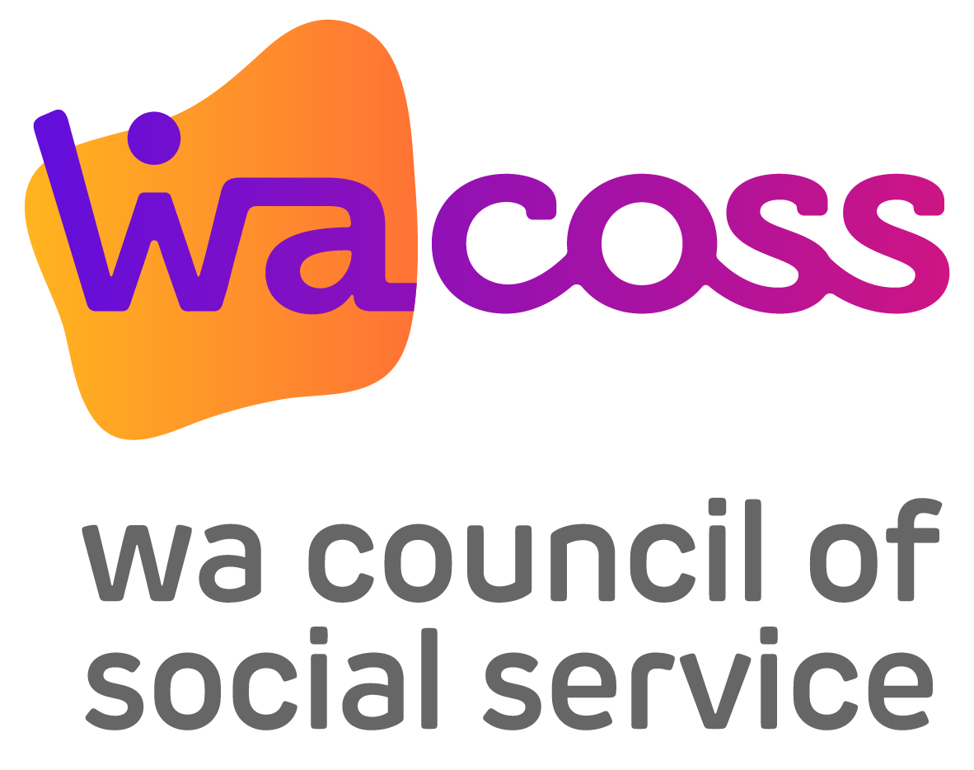

# Introduction

We welcome the Federal Government's commitment to developing a national energy performance strategy (NEPS) and this opportunity to provide initial input into its development.

As energy bills mount in the wake of surging global energy prices, and the climate change crisis worsens, the case for improving energy performance has never been stronger.

People experiencing financial disadvantage are particularly impacted. Too many of our most vulnerable live in dangerously cold or hot homes, unable to afford energy and access the benefits being created from electrification, energy efficiency, renewable energy, and demand management.

A well-designed, fair, and inclusive national energy performance strategy has the potential to achieve a range of positive outcomes for the economy, people, and planet. It could:

* Reduce energy bills and prevent energy hardship
* Reduce poverty and inequality
* Create homes and workplaces that are healthy, comfortable, and climate-safe, improving health and well-being for current and future climates
* Slash emissions at least cost and accelerate the transition to a net zero economy, keeping open a pathway to limiting global warming to 1.5º C
* Improve energy reliability and security
* Support faster uptake of electric vehicles
* Reduce costs of the energy system
* Improve the productivity and competitiveness of business and the economy
* Support employment growth in urban, regional, and remote areas

We welcome many of the energy performance initiatives currently underway in jurisdictions, from the Greenhouse and Energy Minimum Standards (GEMS), raising minimum energy efficiency requirements under the Nationwide House Energy Rating Scheme (NatHERS) star ratings system, expanding the National Australian Built Environment Rating System (NABERS), and developing a national framework for mandatory energy efficiency rental standards.

However more can and should be done. According to the 2022 International Energy Efficiency Scorecard, Australia is ranked 18 out of the top 25 energy consuming countries, on energy efficiency performance and policies energy.[1] Previous national energy performance targets lacked ambition and we are not on track to achieve the targets. The targets have lacked the governance frameworks, policies, and investments to achieve effective and beneficial outcomes.

We agree with the [NEPS consultation paper](https://storage.googleapis.com/files-au-climate/climate-au/p/prj22e6a0bce56ceb8293a73/public_assets/neps-consultation-paper.pdf), that **a new national energy performance strategy is needed** andwill help to prioritise, coordinate and harmonise government, industry and household efforts to improve energy performance across the economy.

Australia's focus on developing frameworks and incentives on the energy supply side - at the expense of energy demand and performance - means we are exposed to unpredictable energy market transition.

Energy efficiency, electrification, and energy management (alongside onsite renewables) can have a direct and immediate impact on reducing emissions and energy bills, with a positive return on investment in many cases. Study after study has noted energy efficiency techniques as some of the cheapest abatement available and it remains a substantially untapped resource in Australia.

There is now an opportunity to accelerate demand management, energy efficiency and electrification measures. This will require strong governance frameworks, clear objectives, principles, and targets to promote demand-side market participation, improve the energy performance of residential and commercial buildings, transport, industries and overcome market failures.

Residential buildings hold the key to the transformation to a zero-emissions energy system to a great extent, as the energy demand generated by homes disproportionately impacts the energy systems overall peak demand in the energy system. Improving the energy performance of residential buildings is also where significant gains can be made to improve the health and wellbeing of people and reduce poverty and inequality.

Australia’s residential building sector accounts for around 24% of electricity consumption and is responsible for around 12% of national greenhouse gas emissions.[2] In addition to setting more ambitious standards for new energy builds, there is also an urgent need to commence the long-term task of fixing Australia’s existing residential stock.

Around 8 million dwellings were constructed prior to the introduction of any residential energy efficiency standards.[3] The average energy efficiency rating of existing homes in Australia is only 1.7 stars compared to new homes average 6.1 stars.[4] Many of these 8 million homes will require substantial rehabilitation to make them zero-emissions, healthy and climate-safe.

As a result of poor efficiency, many existing homes are expensive to power and make it difficult to maintain a healthy home.

Many homes in Australia are making people sick because they are too hot in summer and too cold in winter and are costly to keep at healthy and comfortable temperatures year-round.[5] Every year, the deaths of 10,000 people in Australia are attributable to cold[6] and heatwaves are responsible for more deaths than all other extreme weather events combined,[7] with an estimated 36,000 deaths associated with the heat between 2006 and 2017.[8] Lack of access to energy efficient homes is considered a primary factor.

Health and extreme weather-related deaths are likely to only increase as scientists predict an increase in frequency and intensity of extreme weather events including heat waves.

A recent report by Asthma Australia that surveyed 5,041 people found that three in ten people with asthma reported their symptoms are worse after spending time in their homes, triggered by gas cooktops, mould or dampness and pests. In their report they note that cooking with gas is estimated to be responsible for up to 12% of the childhood asthma burden in Australia which is comparable to the risk of tobacco smoke exposure in the home.[9] Asthma Australia recommends increasing thermal efficiency and transitioning away from gas to healthy and efficient heating and cooking including reverse cycle air conditioning, induction cooktops and efficient rangehoods.[10]

Research in Australia and New Zealand have shown that energy efficient homes lead to fewer visits to health professionals and hospitals, and self-reporting of improved health outcomes, less days away from school and work, and less social isolation.[11] A recent research study by Sustainability Victoria demonstrated savings in healthcare bills of $887 per person per year for a modest one-off energy efficiency retrofit of $3,000.[12]

With recent energy price rises and more predicted over the next couple of years,[13] it will become even harder for people to afford to keep their homes and themselves healthy. This is particularly true for people on low incomes who already spend four times more of their income on energy bills,[14] after they have deprived themselves of energy and other essential services. The ACOSS report, *How JobSeeker and other income support payments are falling behind the cost of living*, released in September 2022 found that more than half (57%) of respondents surveyed are shortening or taking fewer showers because of increased energy costs, 70% are cutting their use of heating, 46% of respondents are going to bed early to keep warm, 28% currently have energy bill debt and a further 22% expect to go into debt when they receive their next bill.[15] We know that people will go without food, health care and other essentials to afford their energy bills.

There is extensive research showing that significant bill savings can be made with improving the energy efficiency of homes,[16] electrifying,[17] and investing in onsite renewable energy.[18]

We also know what the solutions are.

The 2023 report, *Renovation Pathways*, by ClimateWorks finds an overreliance on market forces will not generate the levels of action needed across the building stock and that regulation and other policy interventions will be necessary.[19]

Interventions should include putting in place appropriate national residential building rating tools, mandatory requirements to disclose the energy performance of homes when selling and renting and mandating energy efficiency standards in rental properties. The current speed at which these frameworks are being developed is too slow.

One area that is critical and will require special attention and prioritisation, is improving the energy performance of low-income homes, including social (public and community housing) and private rental housing, Aboriginal and Torres Strait Islander housing and low-income homeowner housing.

Governments will have a crucial role in ensuring the homes of our most vulnerable people are upgraded as a matter of priority.

As we have observed from international best practice, energy performance objectives, economy-wide and sector targets, supported by practical sector-based programs to improve energy efficiency in homes, businesses, and industry, will help us reduce emissions faster and cheaper.

Making energy performance someone’s job, i.e., strong governance frameworks and bodies to coordinate, monitor and promote energy performance, has led to success in international jurisdictions.

There are also a range of important enablers that will be crucial to achieving energy performance, including tools and regulations as mentioned above, as well as quality controls and appropriate workforce to improve residential stock. As these will take time to develop, efforts to implement them should be accelerated. This includes training and accreditation to ensure that residential rehabilitation can be carried out by a reliable and skilled workforce.

Government investment in improving the energy performance of homes of people on low incomes, would assist in establishing the frameworks, tools, skills, workforce, and supply chains that will underpin multi-decade efforts to upgrade our broader housing stock.

Finally, we support the development of a ‘national’ strategy to prioritise, coordinate and harmonise government, industry, and household efforts to improve energy performance across the economy. There is much the federal government can lead on as well as use levers to accelerate and increase ambition and outcomes of state and territory government initiatives and/or remits. A national strategy should not prevent states and territories going further faster; it should harness their ambition and facilitate greater ambition from those State and Territories who may be lagging behind.

This submission will focus on three of the five strategic focus areas outlined in the consultation paper, namely governance and targets, residential, and supply chains. We defer to colleagues at Energy Efficiency Council, the Property Council and AIG for further recommendations around commercial and industrial areas.

# Summary recommendations

Objectives, Governance and Targets

**Recommendation 1:**  In consultation with stakeholders, develop objectives for the overall National Energy Performance strategy and specific sector outcomes. The objectives should include outcomes to achieve improved energy performance; reduce emissions in line with limiting global warming to 1.5 degrees C; improve energy security; improve people’s health, wellbeing, and resilience to climate change impacts; and reduce poverty and inequality*.*

**Recommendation 2:** Select a range of economy-wide energy performance targets that reflects objectives, with short and long-term goals consistent with limiting warming to 1.5 degrees C. Require the targets to be reviewed every five years and communicated in Australia's Nationally Determined Contributions (NDCs).

**Recommendation 3:** Set sector energy performance targets that reflect the objectives, with dates, to contribute to achieving the objectives, including sectoral targets for:

* 1. Residential
  2. Low-income residential
  3. Commercial
  4. Industrial
  5. Agriculture
  6. Energy Intensive Industry
  7. Transport

**Recommendation 4:** Set well-designed and resourced standards, policies, and programs, to achieve the sector objectives and targets (see some specific recommendations further below).

**Recommendation 5:** Progress against the National Energy Performance Strategy be included in the Minister’s annual climate change statement to Parliament, and the advice provided by the Climate Change Authority to the Minister in advance of the statement.

**Recommendation 6:** To determine the national economy-wide and sectoral targets, the federal Government should first undertake modelling to identify energy performance opportunities in Australia, consistent with meeting or exceeding the goal to limiting warming below 1.5 degrees C and other stated objectives (see Recommendation 1) and then consult with stakeholders to inform the final targets*.*

**Recommendation 7:** The Commonwealth, state and territory governments establish a national energy performance body.[20] The body would link policy areas together that are responsible for energy, buildings, housing, industry, and transport; and make energy demand as integral to energy system policy and market settings as energy supply.

**Recommendation 8:** All federal departments and agencies embed energy performance objectives, goals/targets, and policies into their work**.**

**Recommendation 9:** The Commonwealth, state, and territory governments reform national energy laws such as the National Energy Objectives and network Regulatory Investment Tests. To promote, facilitate and value electrification, energy efficiency, demand management and social equity.

**Recommendation 10:** Commonwealth, state and territory governments require that the Integrated System Plan gives **greater weighting** to electrification, energy efficiency and demand management opportunities in future plans. This activity could be supported by resourcing the development of an annual Energy Performance Statement of Opportunities.

**Recommendation 11:** The Commonwealth, state and territory governments embed consumer (including low-income consumer) and energy performance experts, within governance structures.

**Recommendation 12:** Expand and resource the role of consumer and community advocates in energy performance planning, governance, and delivery, to ensure outcomes are consumer focused.

Residential existing homes

**Recommendation 13:** Set a date to achieve zero energy (and carbon) ready existing buildings. Including a long-term goal and end date, with incremental stages. The date should be consistent with limiting global warming to 1.5 degrees C.[21]

**Recommendation 14:** Urgently finalise and implement a national residential building energy performance rating system for existing homes.

**Recommendation 15:** Introduce mandatory disclosure of energy performance for all buildings when they are sold and leased, by 2025.

**Recommendation 16:** Mandate minimum energy efficiency performance standards for rental properties, by 2025 (see also recommendations 32, 33, 34, and 36 for more detail).

**Recommendation 17:** Provide information and equitable incentives for homeowners to upgrade their homes, with targeted support for upgrades to people on low incomes (see also recommendation 31).

**Recommendation 18:** Prioritise investment to improve the energy performance of social and affordable housing (see recommendations 35, 39, 40, and 41 for more details).

**Recommendation 19:** Put in place a strategy, with dates, to phase out gas and support electrification in existing homes with targeted support for people on low-incomes and policies for rental properties, to ensure a fair and inclusive transition.

**Recommendation 20:** NEPS take a leadership role to review, improve, and expand to all jurisdictions Energy Efficiency Obligation Schemes.

**Recommendation 21:** The Federal Government commission modelling to measure the benefits of achieving zero energy carbon-ready existing homes and costs of delaying action. This should not delay ongoing work on implementation.

**Recommendation 22:** Eliminate inefficient appliances sold in Australia by tightening requirements and expanding eligible appliances via the Greenhouse and Energy Minimum Standards (GEMS).

**Recommendation 23:** The Federal Government commission a comprehensive baseline study of residential energy performance to build a critical mass of energy performance ratings and create a high-quality data set on residential energy performance. This should not delay ongoing work on implementation.

Residential new homes

**Recommendation 24:** The NEPS facilitates implementation of the new 7-star NatHERS rating and energy budget in all jurisdictions by the end of 2023.

**Recommendation 25:** The NEPS facilitates jurisdictions building all new social housing at 7.5 plus star rating and renewable-powered, including through providing access to additional funding if needed**.**

**Recommendation 26:** The NEPS facilitates the next increase in new build standards to achieve zero carbon homes (best practice thermal efficiency, all-electric, powered by renewable) by 2025.

**Recommendations 27:** The NEPS works with jurisdictions to stop gas connections to new builds.

**Recommendation 28:** The NEPS includes program to provide people with user-friendly information and tools to understand energy performance ratings, and the potential long-term benefits of energy efficiency, in order to encourage take-up beyond the minimum performance standard.

**Recommendation 29:** The NEPS works with jurisdictions and industry to ensure effective compliance with minimum standards through skills training and incentives, and improved mechanisms for dispute resolution and redress.

**Recommendation 30:** Provide a well-resourced regulator with adequate tools and powers to address non-compliance.

Low-income homeowners

**Recommendation 31:** The Federal Government funds or incentivises access to funds to support low-income homeowners to access energy efficiency audits and upgrades, electrify and install solar PV. This could be done in partnership with energy companies, local councils or administered through a third-party provider.

Low income social and private renters

**Recommendation 32:** Mandate minimum energy efficiency performance standards for rental properties, as part of broader standards for what constitutes healthy and habitable rental housing, with the aim to legislate ‘modelled performance’ standards by 2025 in all jurisdictions, providing 3-4 years for full compliance.

**Recommendation 33:** The mandated energy efficiency performance standards are aligned with the [Community Sector Blueprint](https://www.healthyhomes.org.au/news/community-sector-blueprint) for energy efficiency rental standards.[22]

**Recommendation 34:** To support implementation of mandatory energy efficiency performance standards in rental properties, consider the use of incentives, ensuring that any incentives are targeted and equitable and used to encourage compliance and greater ambition. Where incentives are used, they should be conditional on limiting rent increases. Noting financial support will be needed for community housing providers.

**Recommendation 35:** Prioritise funding to social and affordable housing (public and community housing) to bring every dwelling to at least 5 stars equivalent[23] (modelled performance, with electrification and where possible powered by renewables) before 2030.[24] Governments need to budget for upgrades or replacement (where it's not cost effective to upgrade) of stock through additional funding to ensure there is not a reduction in present or future stock.

**Recommendation 36:** Build the foundation for national rental home upgrades. While minimum mandatory rental standards are likely to be the most effective policy intervention to improve the energy performance of rental homes, the following items under this measure would build knowledge and evidence to assist implementation of such standards and include:

* A national baseline study of the energy performance of rental homes
* Pilot methods to build engagement with landlords
* Run a trial and evaluation of different technical interventions to improve energy performance in a range of rental properties across the country
* With states and territories, provide funding for co-development of feature-based minimum rental standards, with a long-term goal of implementing performance-based rental standards
* Provide seed funding for the Clean Energy Finance Corporation (CEFC) to develop a finance program to support landlords to implement upgrades to comply with minimum rental standards.

Apartments

**Recommendation 37:** Work with jurisdictional governments to investigate whether reform of relevant strata laws and/or new governance options is required to improve energy efficiency and performance in existing apartments. This may include, for example, limiting or prohibiting the ability of strata schemes to prevent or restrict upgrades or retrofits in individual strata lots that may be required to meet new mandated energy efficiency standards.

**Recommendation 38:** Where the dwelling is a sole occupancy unit in an apartment building, ratings (e.g., NatHERS) should complement the NABERS base building rating (where applicable).

Regional, Remote and First Nations

**Recommendation 39:** Federal and state/territory governments prioritise energy performance retrofits of Aboriginal and Torres Strait Islander social housing and provide joint funding to electrify, improve the energy efficiency (to at least 5 stars), and install solar PV to Aboriginal and Torres Strait Islander public and community housing, before 2030. Governments need to budget for upgrades or replacement (where it's not cost effective to upgrade) of stock through additional funding, to ensure there is not a reduction in present or future stock (see also recommendation 35).

**Recommendation 40**: Federal and state/territory governments provide access to reverse cycle air conditioning Aboriginal and Torres Strait Islander social housing in areas with extreme heat or cold.

**Recommendation 41:** Federal and state/territory governments fund educational programs for Aboriginal and Torres Strait Islander social housing tenants to support retrofits. The programs should be delivered in linguistically and culturally appropriate ways and in partnership with community leaders.

Supply chains and workforce

**Recommendation 42:** The NEPS prioritise retrofits to low-income housing, to assist in establishing the frameworks, skills and supply chains that will underpin a multi-decade effort to upgrade our housing stock.

# Discussion

## Targets

|  |
| --- |
| Questions for consultation   * Would an energy efficiency target or targets be suitable for Australia? * What is the most appropriate methodology for designing and implementing a target that effectively drives demand-side action towards Australia’s overall net zero target? * How should progress towards an energy efficiency target be measured? |

### Energy performance targets are necessary to achieve outcomes

We believe an energy efficiency target, supported by practical programs to improve energy efficiency in homes, businesses, and industry, will help us reduce emissions faster and more cheaply.

Energy efficiency targets would provide a useful framework to:

* achieve a range of objectives
* allow monitoring and evaluation against performance indicators,
* make it clear actions need to be taken by a certain date,
* drive strategic policy decisions,
* encourage investment in energy efficiency.

A target would both place downward pressure on the total amount of energy used, as well as reducing the energy intensity of the economy.

Energy efficiency targets should aim to increase the improvement in energy productivity, accelerate emissions reductions and meet other objectives.

### Setting energy performance targets

In 2015, COAG Energy Ministers developed a National Energy Productivity Plan (NEPP) with an overall goal to deliver a 40 per cent improvement in Australia’s energy productivity by 2030.[25] Although Australia’s economic energy intensity has been decreasing, overall energy consumption has almost doubled since 1981 with energy intensity decreasing at a relatively steady rate, averaging a decline of around 2 per cent per annum over the past decade (see figure 1). Based on progress over the last decade, Australia would achieve the NEPP goal by around 2034. There has been little focus or tracking of the NEPP.

Figure 1: Australia’s energy intensity and consumption – base year of FY1981[26]

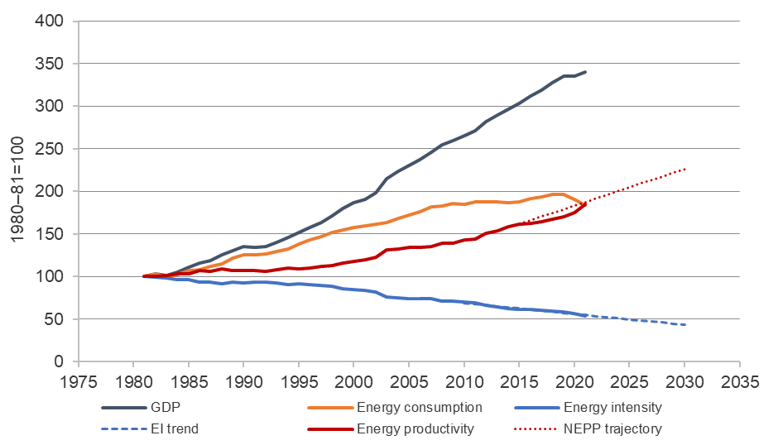

We have observed other countries have had success when they have an overall target or goal, with dates, sectoral targets, standards, and sector-based programs, to achieve the goal.[27]

We recommend energy efficiency targets should encompass all of the following:

* A range of national and sectoral targets
* Clearly defined objectives for the target
* Dates and time frames to achieve the target
* Clear and relevant indicators to measure progress towards the target
* Well-designed and appropriately resourced programs or policies to achieve the target.
* An accountable entity responsible for achievement of the target (or coordination of achievement of the target).

### Creating objectives is critical to setting targets and achieving outcomes

Many international jurisdictions set objectives as part of their energy performance plans, including national and sectoral objectives.[28] A number of international jurisdictions include objectives beyond just energy performance.

Including a range of objectives provides an opportunity to achieve multiple government goals including emissions reductions; energy security; improving health, wellbeing, and climate-resilience; and reducing poverty and inequality.

Further, expressing the objectives of the NEPS in terms beyond improvements to energy performance could help build momentum for widespread take up of energy performance measures and bring the importance of energy performance into the living room of every Australian.

Common examples of energy efficiency objectives include:

* Reducing energy consumption compared to business as usual
* Reducing energy consumption by an absolute amount
* Reducing economic energy intensity

Energy consumption objectives and targets (energy savings to an actual or assumed baseline) are easy to measure, understand and communicate. However, Energy consumption targets can interact poorly with unexpected economic growth that increases the overall usage of energy.

Energy Intensity (energy used over GDP) or productivity targets GDP over energy used) on the other hand accommodate economic growth or contraction. They are also easy to measure and calculate and are widely used by other economies enabling benchmarking. The disadvantage is intensity targets do not require an overall reduction in energy use making them less useful for the purpose of energy conservation.

Given the challenges of these common energy efficiency objectives other international jurisdiction have chosen to include a range of other objectives, including:

* Decouple economic activity or growth
* Improve energy security
* Reducing poverty and inequality

Other objectives the federal government could also consider, include:

* Improve health, wellbeing, and climate resilience
* Reduce the amount of non-renewable primary energy use
* Reduce energy consumption in buildings
* Electrify all homes
* Prioritise improving the energy performance of low-income housing

### Sectoral targets beneficial

As indicated, we think there are also benefits in setting sectoral objectives and targets, in addition to an economy wide objectives and targets. Sectoral objectives and targets have a number of benefits:

* Ensure all sectors are contribution to the overall goal
* Be tailored to the circumstances of a particular sector
* Be integrated with deep, long-term planning for sectoral decarbonisation pathways
* They can help achieve a number of objectives in addition to improving energy performance and emissions reductions. For example, the government might set a more ambitious target to improve the energy performance of low-income homes which would assist in reducing poverty and inequality.
* Complements Australia’s existing suite of climate and energy policies, which seek to address climate change through a toolkit of different policies, appropriate to different sectors

In addition to residential buildings, commercial buildings, and industrial energy performance, we believe there is an opportunity to include other sectors such as transport (like they do in California [29] and New Zealand[30]) agriculture and services.

### Metrics and indicators

Metrics and indicators will depend on the objectives and targets chosen. As indicated above, we recommend using a range of relevant indicators to measure progress against the target, including relevant economy-wide metrics, as well as relevant sectoral metrics.

### Ensure targets are consistent with emissions reduction goals and progress tracked

We note Australia’s reduction in energy intensity goals are half of what the International Energy Agency is advocating for, with calls for energy intensity improvements in countries of at least 4 per cent per annum to help achieve global climate goals.[31]

It is important that objectives and targets are in line with what’s needed to achieve emissions reductions goals and contribute to limiting global warming to 1.5 degrees C. This should include setting long-term and short-term targets, linked to National Determined Contributions (NDCs), and reviewed and updated regularly.

### Setting dates and time frames necessary

We note that setting targets without dates is problematic. For example, the Trajectory for Low Energy Buildings[32] sets a trajectory or goal of achieving ‘zero energy (and carbon) ready buildings’ but has no date as to when this will be done by. Without a timeline, we believe progress to develop and implement policies has been slow.

### Further consultation is needed to set target ambition

In terms of the ambition of the target, Global bodies like the International Energy Agency and International Renewable Energy Agency see energy efficiency and electrification alone achieving more than 40% of emissions reductions by 2050. As noted, early IEA has previously advocated for energy intensity improvements around 4 percent to help achieve global emissions reduction goals. Modelling by ClimateWorks Centre points to a 16% reduction in total energy use by 2030 in a 1.5ºC pathway – which can only be achieved through energy efficiency.

A modelling and consultation exercise to identify energy performance opportunities in Australia, consistent with meeting or exceeding the goal to limiting warming below 1.5 degrees and other stated objectives, would greatly assist in setting target ambition.

At this stage we don’t propose any particular targets, and believe further consultation occurs based on the discussion above and recommendations below.

As will be discussed below, a governance framework with a dedicated body or agency will also be important to help drive, measure, monitor and make recommendations to adjust existing and/or implement new programs to meet the targets.

**Recommendation 1: In consultation with stakeholders, develop objectives for the overall National Energy Performance strategy and specific sector outcomes. The objectives should include outcomes to achieve improved energy performance; reduce emissions in line with limiting global warming to 1.5 degrees C; improve energy security; improve people’s health, wellbeing, and resilience to climate change impacts; and reduce poverty and inequality.**

**Recommendation 2: Select a range of economy-wide energy performance targets that reflects objectives, with short and long-term goals consistent with limiting warming to 1.5 degrees C. Require the targets to be reviewed every five years and communicated in Australia's Nationally Determined Contributions (NDCs).**

**Recommendation 3: Select a range of sector energy performance targets, with dates, to contribute to achieving the objective, including sectoral targets for:**

* 1. **Residential**
  2. **Low-income residential**
  3. **Commercial**
  4. **Industrial**
  5. **Agriculture**
  6. **Energy Intensive Industry**
  7. **Transport**

**Recommendation 4: Set well-designed and resourced standards, policies, and programs, to achieve the sector objectives and targets (see some specific recommendations further below).**

**Recommendation 5: Progress against the National Energy Performance Strategy be included in the Minister’s annual climate change statement to Parliament, and the advice provided by the Climate Change Authority to the Minister in advance of the statement.**

**Recommendation 6: To determine the national economy-wide and sectoral targets, the federal Government should first undertake modelling to identify energy performance opportunities in Australia, consistent with meeting or exceeding the goal to limiting warming below 1.5 degrees C and other stated objectives (see recommendation 1) and then consult with stakeholders to inform the final targets.**

## Governance

|  |
| --- |
| Questions for consultation   * How can demand considerations be better integrated into Australian energy governance and what are the priorities for change? * What new or modified coordination mechanisms or institutional responsibilities would be appropriate to better drive energy performance action in the future? |

### Governance barriers to effective energy performance outcomes

Despite the significant role and substantial benefits improved energy performance can contribute to achieving rapid emissions reductions, energy security, energy system cost reduction, business competitiveness, improve health and wellbeing and reduce poverty and inequality, a range of barriers has thwarted its contribution in Australia.

Demand-side measures are frequently the subject of market failures such as split incentives, information imbalances, externalities, and substantial market power imbalances.

Focus on developing objectives, frameworks, institutions, and incentives focused on the supply side means there has not been the attention needed to fully realise energy performance benefits.

Internationally, jurisdictions have recognised the need to have a strong governance frameworks and bodies to promote energy performance and overcome market failures, including New Zealand[33], California,[34] Ireland[35] and New York[36].

ACOSS has been working with the Energy Efficiency Council (EEC), the Property Council (PC) and the Australian Industry Group (AIG) to identify barriers to improving energy performance. We have identified six key issues in energy market governance that need reform to enable the uptake of demand-side measures:

1. There is no energy performance ‘authority or body’ to develop, implement and monitor energy performance measures on equal footing with supply-side interests.
2. National energy laws do not encourage, promote, or adequately value energy performance and demand-side activities.
3. Energy market governance and planning lacks systems, resources, information, and processes to evaluate the optimal mix of demand-side and supply side measures.
4. Consumers and energy performance experts are not adequately represented in energy market design, regulation, and operation.
5. There is a lack of systemic, coordinated capacity to develop and implement energy efficiency and demand-side policies.
6. Weak planning and coordination for energy network and market development means that demand-side opportunities and policies are insufficiently developed and prosecuted.

### Make energy performance and demand side someone’s job

Currently, responsibility for energy performance is distributed across a wide range of portfolios, ministers, jurisdictions, and businesses. There is no-one responsible to drive, measure, monitor and make recommendations to adjust existing and/or implement new programs to meet the targets.

As noted in footnotes 12, 13, and 14, a number of international jurisdictions have dedicated authorities and commissioners whose responsibilities are to drive, measure and support implementation of energy performance measures across a number of sectors.

We join the calls of others for the NEPS to establish a dedicated energy performance body to be responsible for driving improvements to energy performance and meeting objectives and targets. Such a body would have a range of functions, and provide a central point for developing, coordinating, and supporting implementation of energy performance policies across sectors**,** including energy, buildings, industry, and transport. The exact functions and form of such a body would need to be crafted in consultation with stakeholders, other governments, and industry. Lessons can be drawn from international jurisdictions that have dedicated authorities.

The body could utilise existing government structures and could sit within a government department, like for example the [National Emergency Management Agency](https://nema.gov.au/#/map) (NEMA) sits within the Department of Home Affairs.

An energy performance body could for example:

* Be responsible to Commonwealth, state, and territory jurisdictions, in the same way as current energy market bodies.
* Have functions to plan, analyse, develop, and prosecute improvements to energy performance strategies, policies, and programs.
* Provide a national point of coordination for energy performance activities.
* Be a one stop shop for people, business, and other stakeholders to access information, engage, and find support.
* Work with investors, business, and other relevant stakeholders to provide appropriate incentives and foster conditions to accelerate uptake of policies to achieve targets.
* Provide clear inputs to energy system planning processes on opportunities to manage energy demand to optimise system costs, security, and reliability.
* Where possible, exercise responsibility for national functions relating to energy performance (such as making minimum energy performance standards).

**Recommendation 7: The Commonwealth, state and territory governments establish a national energy performance body, to link policy areas together that are responsible for energy, buildings, industry, and transport, and make energy demand as integral to energy system policy and market settings as energy supply.**

**Recommendation 8: All federal departments embed energy performance objectives, goals/targets, and policies into their work.**

### Reform national energy law to promote, facilitate and value electrification, energy efficiency and demand management

National energy laws and frameworks focus almost exclusively on the regulation of the supply of energy, which has meant energy performance has largely fallen by the wayside.

For example, the National Energy Objectives require energy market bodies to make decisions prioritising efficient investment in energy markets with respect to the price, security, and reliability of energy supply.[37] As we focus on transitioning to zero emissions energy, energy performance will be critical, yet there is no reference to energy performance in the objective. The focus on price of energy supply further exacerbates the problem, as the focus is on unit cost of energy to a consumer rather than total cost of energy bills (which incorporates total cost of energy service and the energy performance of what’s consuming the energy). A focus on overall *cost or affordability of energy bills* would facilitate greater emphasis and investment into energy performance and demand management within the energy ecosystem, including energy system efficiency and end use efficiency (at the consumers end).

Consideration should also be given to incorporating energy performance and demand management into transmission and network objectives and regulatory investment tests, which could result in greater investment in energy performance of end use (consumer end) and demand side activities.

**Recommendation 9: The Commonwealth, state, and territory governments reform national energy laws such as the National Energy Objectives and network regulatory investment tests. To promote, facilitate and value electrification, energy efficiency, demand management and social equity.**

### Better integrate demand-side opportunities into energy system planning

The Integrated Systems Plan (ISP)[38] developed by the Australian Energy Market Operator (AEMO) treats energy demand as an exogenous input, rather than a factor that can be influenced and varied to ensure optimal investment in the energy system, and therefore optimal reliability and affordability.

The ISP should be required to give greater weighting to electrification, energy efficiency and demand management in future plans. As suggested by the Energy Efficiency Council in their submission to the NEPS consultation, an annual Energy Performance Statement of Opportunities[39] could be developed to inform the ISPs work.

**Recommendation 10: Commonwealth, state and territory governments require that the Integrated System Plan gives greater weighting to electrification, energy efficiency and demand management opportunities into future plans. This activity could be supported by resourcing the development of an annual Energy Performance Statement of Opportunities.**

### Expand and resource the role of consumer advocates and energy performance experts in governance, strategic planning, and policy development

Consumers and other energy users are represented by a number of different groups in the national energy markets. However, the voices representing consumers – particularly small and low-income consumers – are limited in scope and poorly resourced compared to the voices representing the supply side of the energy market. Although it is not the intention, existing market frameworks and governance largely ignore consumer participation. While all three market bodies have mechanisms for consumer consultation, only *one* director of the AER, AEMO or AEMC has any expertise involving consumer issues. The balance of energy market body corporate leaders are former energy industry executives, business executives, public service executives or lawyers. While these leaders provide valuable expertise, there is a clear gap in systemically driving the activities of these bodies towards the evolving interests of consumers, who are likely to benefit most from expanding demand-side measures in energy markets.

**Recommendation 11: The Commonwealth, state and territory governments embed consumer (including low-income consumer) and energy performance experts, within governance structures.**

**Recommendation 12: Expand and resource the role of consumer and community advocates in energy performance planning, governance, and delivery, to ensure outcomes are consumer focused.**

## Residential

### General

|  |
| --- |
| Questions for consultation   * What are the key opportunities to improve the energy performance of new and existing residential buildings? * What opportunities are there to improve or streamline existing policies aimed at empowering consumers to undertake energy performance improvements in their homes? * What are key financial and non-financial barriers to the uptake of energy performance improvement opportunities? How can these barriers be overcome? * How can demand management and electrification support lowering energy bills and emissions? * How does poor energy performance impact disadvantaged communities? |

All Australian governments have committed to implementing a national plan that aims to achieve zero energy and carbon-ready residential buildings, to contribute to emission reduction goals.

In addition to achieving the above goal, Governments are also seeking to develop policies that achieve the following:

* lower household energy bills
* contribute to household energy security and reliability
* improve people’s health and well-being
* build greater climate resilience of homes, for example to heatwaves
* contribute to Closing the Gap in First Nations Communities
* reduce wastage for the wider economy
* assist in lowering peak demand

Improving the energy efficiency, electrifying, and powering homes with renewable energy, will contribute significantly to achieving the above goals. We also see improving the energy efficiency of homes is a crucial part of ensuring an equitable transition to zero emissions.

### Existing homes

There are significant challenges to achieving the above goals and outcomes. There are more than 9.7 million existing homes in Australia. Around 8 million dwellings were constructed prior to the introduction of any residential energy efficiency standards, and many of these will require substantial rehabilitation to make them comfortable, efficient and climate-safe. Many of these homes have poor energy performance. It is estimated that existing homes in Australia average a 1.7-star rating compared to 6.1 stars for new homes.

As a result of poor efficiency, the majority of existing homes are expensive to power and make it difficult to maintain a healthy environment. In fact, many homes in Australia are making people sick because they are too hot in summer and too cold in winter and are costly to keep at healthy and comfortable temperatures year-round.[40] Every year, the deaths of 10,000 Australians are attributable to cold[41] and heatwaves are responsible for more deaths than all other extreme weather events combined,[42] with an estimated 36,000 deaths associated with the heat between 2006 and 2017.[43] Lack of access to energy-efficient homes is considered a primary factor.[44]

These homes are wasting energy to operate, contributing to increased individual and governmental health costs and unaffordable energy bills. These impacts are being amplified because of the energy crisis which will see higher energy prices over the medium term.

Existing Energy Efficiency Obligation Schemes have historically been most successful in driving investment in least-cost low-impact energy efficiency measures and have had low take-up amongst people on low incomes. We, therefore, do not see Obligation schemes as a primary policy instrument to achieve the Trajectory’s objectives, but rather a complementary measure, unless improvements are made to better target low-income households and more impactful energy efficiency measures. We do support further analysis of how energy efficiency obligation schemes could support the core policy mechanisms such as mandatory standards and disclosures.

There is work underway via the Trajectory for Low Energy buildings,[45] which is developing policies to deliver cost-effective energy efficiency improvements to homes under the following 12 workstreams:

Enabling mechanisms that provide the foundations for improvements and underpin other policies. These are:

* Practical guidance for consumers
* Supply chain development
* Energy ratings and tools

Targeted building policies overcome specific market barriers that occur at the different stages of a building’s life. These are:

* Energy efficiency requirements for new buildings and renovations
* Energy efficiency disclosure
* Minimum rental requirements
* Improving HVAC performance
* Improving energy efficiency in government operations

Supporting measures assist with cost-effective transition and complement the targeted building policies. These are:

* Apartments and strata titled buildings
* Financial incentives
* Vulnerable households
* Greenhouse and Energy Minimum Standards (GEMS)
* Data collection and analysis
* Other targeted initiatives

However, we are concerned this process is slow with very few commitments to implement substantial reform. The NEPS along with appropriate resourcing, can help accelerate the work of the Trajectory

Barriers include:

* No timeline has been set to achieve the Trajectory goal of zero energy (and carbon) ready buildings
* Not seen as a priority by all jurisdictions
* Not whole of governments support. Work is being driven within the energy portfolio and there is not enough cross-government buy in and support across building Ministers, Consumer Affairs Ministers, Social Service Ministers, and Treasury
* Lack of Incentives and levers
* Lack of resources to undertake the work
* Opposition by some vested interests in building sector and landlords/real estate agents
* Lack of willingness to provide financial incentives or support

The delay in progressing the Trajectory for existing buildings means we have failed to realise the benefits in emissions reductions, energy savings and economic value, in addition to reducing the impact on people facing phenomenally high energy prices and more extreme weather. For example, modelling done for the Trajectory process in 2019 argued:

If all policies were implemented in 2022 in all jurisdictions, they could deliver a net present value (NPV) of $5 billion, reduce greenhouse gas emissions by 52.7 MtCO2-e and save 429.3 PJ of energy by 2050.

However, if all policies were implemented three years later in 2025, they could only deliver a net present value of $3.4 billion and reduce greenhouse gas emissions by 40.3 MtCO2-e and 329.7 PJ of energy saved by 2050.

The Coalition for Healthy and Affordable Homes has produced a number of statements[46] and submission to the Trajectory process,[47] calling for a range of recommendations. The recommendations below build on these previous recommendations.

**Recommendation 13: Set a date to achieve zero energy (and carbon) ready existing buildings. Including a long-term goal and end date, with incremental stages. The date should be consistent with limiting global warming to 1.5 degrees C.[48]**

**Recommendation 14: Urgently finalise and implement a national residential building energy performance rating system for existing homes.**

**Recommendation 15: Introduce mandatory disclosure of energy performance for all buildings when they are sold and leased, by 2025.[49]**

**Recommendation 16: Mandate minimum energy efficiency performance standards for rental properties (see recommendations 32, 33, 34, and 36 for more detail).**

**Recommendation 17: Provide information and equitable incentives for homeowners to upgrade their homes, with targeted support for upgrades to people on low incomes or experiencing disadvantage (see also recommendation 31).**

**Recommendation 18: Prioritised and targeted financial support to improve the energy performance of social and affordable housing (see recommendations 35, 39, 40 and 41 for more details).**

**Recommendation 19: Put in place a strategy, with dates, to phase out gas and support electrification in existing homes with targeted support for people on low-incomes and policies for rental properties, to ensure a fair and inclusive transition.**

**Recommendation 20: NEPS take a leadership role to review, improve, and expand to all jurisdictions Energy Efficiency Obligation Schemes.**

**Recommendation 21: The Federal Government commission modelling to measure the benefits of achieving zero energy carbon-ready existing homes and costs of delaying action. This should not delay ongoing work on implementation.**

**Recommendation 22: Eliminate inefficient appliances sold in Australia by tightening requirements and expanding eligible appliances via the Greenhouse and Energy Minimum Standards (GEMS).[50]**

**Recommendation 23: The federal Government commission a comprehensive baseline study of residential energy performance to build a critical mass of energy performance ratings and create a high-quality data set on residential energy performance. This should not delay ongoing work on implementation.**

### New Buildings

We welcomed the recent Building Ministers' decision to increase the National Construction Code (NCC) requirement to build new homes from 6 to 7 stars. Lifting home energy ratings from 6 to 7 stars reduces heating and cooling costs by 25%; add in solar and all-electric appliances and households can reduce energy bills by as much as 75%.[51]

We also know that better energy standards will tackle energy poverty and inequality. Raising standards means everyone living in new homes, including renters and social housing residents, benefit from lower bills and better health outcomes, not just people who choose to build beyond NCC requirements.

The next step should be to build all new homes to zero carbon-ready standards, which includes best practice thermal efficiency, all-electric and powered by renewables, by 2025. Continuing with an incremental approach to increasing new building standards, means homeowners would need to retrofit relatively recent stock a few times to meet the end goal by a later date.

This will require no new gas connections, the provision of user-friendly information for homeowners and trades, and ensuring compliance with standards.

Further work should also be undertaken to include energy performance techniques not currently included in NatHERS such as passive build designs and foliage, and requirements to make homes climate-safe.

**Recommendation 24: NEPS facilitates implementation of the new 7-star NatHERS rating and energy budget in all jurisdictions by the end of 2023.**

**Recommendation 25: NEPS facilitates jurisdictions building all new social housing at 7.5 plus star rating and renewable-powered, including through providing access to additional funding if needed.**

**Recommendation 26: NEPS facilitates the next increase in new build standards to achieve zero carbon homes (best practice thermal efficiency, all-electric, powered by renewable) by 2025.**

**Recommendations 27: NEPS works with jurisdictions to end gas connections to new residential buildings.**

**Recommendation 28: NEPS includes program to provide people with user-friendly information and tools to understand energy performance ratings, and the potential long-term benefits of energy efficiency, to encourage take-up beyond the minimum performance standard.**

**Recommendation 29: NEPS works with jurisdiction and industry to ensure effective compliance with minimum standards through skills training and incentives, and improved mechanisms for dispute resolution and redress.**

**Recommendation 30: Provide a well-resourced regulator with adequate tools and powers to address non-compliance.**

### Low-income

|  |
| --- |
| Questions for consultation   * What are the opportunities to improve the energy performance of residential buildings for low-income households? * What are the financial and non-financial barriers to uptake of energy efficiency upgrades for low-income households, and what can be done to overcome them? * What actions should be prioritised to assist low-income households to improve energy efficiency in their homes? * What delivery mechanisms would be most effective to provide targeted support? |

### People on low incomes have the most to gain from improving energy performance

As outlined above, people on low incomes are more likely to live in inefficient homes and pay disproportionately more for their energy and the energy transition. We know there are multiple benefits for improving the energy performance of homes of people on low incomes, including:

* **Lower energy bills:**Modelling by ANU found that for a one-off capital investment in energy efficiency measures or rooftop solar of $2,000 for apartments and $5,000 for houses, the average annual energy bill savings ranged from $289 for apartments to $1,139 a year for houses. An Australian study of improved energy efficiency in social housing found bill savings of $1,050 a year.[52] St George Community Housing retrofitted 1400 Community Housing places across NSW, saving tenants an average of $570 each year
* **Improved health and wellbeing:** Research in Australia and New Zealand have shown that energy efficient homes lead to fewer visits to health professionals and hospitals, and self-reporting of improved health outcomes, less days away from school and work, and less social isolation.[53] [54] An Australian study found thebiggest benefit from improved thermal comfort was during extreme weather conditions such as heatwaves.[55]
* **Reduce poverty and improve social equity:** Energy bill savings, improved health outcomes, fewer days away from school and work, resulting from improved energy performance of low-income homes directly contribute to reducing poverty and improving social equity outcomes.
* **Economic stimulus**: Analysis by Deloitte Access Economics found that explicit targeting energy efficiency upgrades of Australia’s most financially disadvantaged households is projected to deliver a 17% higher economic impact than an equivalent program delivered across a broader base.[56] It notes these positive impacts are sustained as improved energy efficiency effectively delivers ongoing productivity improvements for the Australian economy.

The remainder of this section will focus on low-income **homeowners**, as sections 3.3 and 3.4 will focus on people on low-income in social and private rentals and Indigenous and Torres Strait Islander Housing, respectively.

### Low-income homeowners

There are 1.1 million low-income households, including many older people with health risks that own their own home but do not have the disposable income to improve their home’s energy performance.

While there have been some successful solar retrofit programs run by local councils for people on low income who own their own homes, these programs have not been successfully replicated for energy efficiency. Reasons include:

* Greater coordination and quality control is needed to undertake energy efficiency retrofits, as multiple producers and trades would be required
* There are no subsidies for energy efficiency measures like there currently are for solar.
* There is less certainty around the business case and a payback period for councils to be confident they will recoup costs through rates in a reasonable time frame.
* There is less certainty around the business case and payback for homeowners to feel it is worth their while to co-invest/payback via rates.

Some banks currently provide low interest or home equity loans to support energy efficiency upgrades, but anecdotal evidence suggests similar barriers prevent wide take-up amongst low-income homeowners.

Jurisdictions, potentially in partnership (this could be with energy companies or impact investors)

* Fully fund a program to be managed by third party to implement energy efficiency audits, upgrades and/or solar PV installations to low-income homeowners.
* Provide subsidies for energy efficiency measures

The National Low Income Energy Performance Program (NLEPP) developed and supported by a range of stakeholders provides a guide as to how a low-income homeowner retrofit program could be rolled out.[57]

**Recommendation 31: The Federal Government funds or incentivises access to funds, to support low-income homeowners access to energy efficiency audits and upgrades, electrify and install solar PV. This could be done in partnership with energy companies, local councils or administered through a third-party provider**.

### Renters

|  |
| --- |
| Questions for consultation   * What are the key opportunities to improve the energy performance of residential buildings for renters? * What options are available to overcome the split incentive for renters and landlords? * What options are available to support public and community housing tenants? * How can the energy performance of rental homes be made more transparent to prospective tenants? * How can governments and private sector support renters to improve energy performance? |

Improving the energy efficiency of private, public and community rental properties is critical to achieving reducing emissions above and improved outcomes for renters, as well as reducing poverty and inequality.

Currently, 1 in 3 households is renting. More people are renting for over 10 years. There are more renting households with children, and the number of renters aged over 55 continues to increase. People on low incomes are more likely to be renters (40%), as are Indigenous Australian adults (68%) and Indigenous Australians living in remote and very remote areas (89%).[58] Low-income households are more likely to live in the most inefficient houses and spend a greater proportion of their income on utility bills compared to owner-occupiers.

Australia's social housing (public and community housing) is often old, less efficient, and more costly to run which impacts the economic and health and social wellbeing for those who can least afford it.[59] According to PowerHousing Australia’s, 2022 Australian Affordable Housing Report, Australia will need to look to replace ageing social housing stock and create additional social and affordable housing outcomes.[60]

### Mandatory Energy Efficiency Standards for rental properties are critical

Renters are rarely able to influence the energy efficiency of the homes they live in. Currently, they have little or no reliable information regarding the performance of their property. They have no security of tenure and limited rights to make changes to improve the thermal and energy performance of the rental house. Renters must live with the health and economic consequences and face the threat of eviction or punitive rent rises if they raise issues with the property. People on low incomes have fewer choices and are living in housing that is the least efficient and often unfit to support their health and wellbeing.

Landlords have no price signal, incentive, or requirement to raise the standard of their properties. Current tax rebates for replacing appliances require ‘like for like replacement’. There is overwhelming evidence that market forces are not capable of encouraging landlords to improve rental properties’ efficiency. Even when landlords have been offered free energy efficiency upgrades, many have declined.

The best way to address this market failure and improve the efficiency of rental properties is to require properties to meet mandatory minimum energy efficiency standards.

We acknowledge there is a process underway to develop a national framework to implement mandatory energy efficiency strategies, however we are concerned this is progressing too slowly. Besides Victoria and The Australian Capital Territory, no other State or Territory has committed to implement mandatory energy efficiency standards. This work needs to be accelerated and commitments made by State and Territory Government to implement mandatory energy efficiency standards.

To support the development of the national framework, we refer to the *Community Sector Blueprint: A National Framework for Minimum Energy Efficiency Rental Requirements*,[61] developed by diverse expertise of members and supporters across issues relating to energy efficiency and rental standards and endorsed by more than 8 organisations. It outlines key characteristics that should be present in the National Framework for Minimum Energy Efficiency Rental Requirements being produced by federal, state and territory governments, due to be released in early 2023.

We would like to emphasise that improving the energy efficiency of rental properties should be communicated as a responsibility of the owner as part of their wider responsibility as a service provider to provide a safe, healthy, efficient, and decent home. In this context, minimum energy efficiency standards are simply an updated determination of what is an acceptable standard of housing to ensure the increasing proportion of people renting - and often for life - have a home that can sustainably and affordably support their health and wellbeing.

Recommendation 32: **Mandate minimum energy efficiency performance standard for rental properties, as part of broader standards for what constitutes healthy and habitable rental housing, with the aim to legislate ‘modelled performance’ standards by 2025 in all jurisdictions, providing 3-4 years for full compliance.**

**Recommendation 33: The mandated energy efficiency performance standards are aligned with the** [**Community Sector Blueprint**](https://www.healthyhomes.org.au/news/community-sector-blueprint) **for energy efficiency rental standards[62]**

### Provide financial support to improve energy performance of social and private rental

The federal Government could help drive development and implementation of mandatory energy efficiency standards in rental properties through providing financial incentives. This will be particularly important for public and community housing, where financial support will be needed for community housing providers to implement the standards.

As noted in the Community Sector Blueprint for rental standards,[63] property investors already receive generous tax concessions and incentives as part of owning a rental property, and therefore additional incentives should be carefully considered.

However, the federal governments could introduce incentives (or leverage existing schemes) to support more ambitious standards and encourage compliance. Such incentives should be targeted and equitable and not disproportionately benefit higher income earners.

Options for financial incentives or supports include:

* A flat rebate or subsidy (such as [Victoria’s subsidy for landlords who install reverse cycle air conditioners](https://www.heatingupgrades.vic.gov.au/upgrades-rental-properties)). Such a subsidy could decrease over time, incentivising early movers, or landlords that go further faster and avoid a boom in demand in the lead-up to an enforcement deadline.
* Subsidised finance (such as [ACT’s sustainable household loan scheme](https://www.climatechoices.act.gov.au/policy-programs/sustainable-household-scheme)). This could be a reduced-interest or no-interest loan. It could also include rates-based financing that ties repayments to the property address, and could, in practice, allow a landlord to shift their compliance cost to a future owner who would also benefit from the investment.
* Free or subsidised energy assessments and certification. Governments could subsidise the cost of energy assessments and certification. This would reduce compliance costs and encourage lessors to establish a connection with an expert who knows their property and can advise on suitable retrofits.

We would argue however, that Government funds should be prioritised towards improving the energy performance of **low-income social and private rental** properties. As noted earlier some of the most vulnerable people live in social and private rental properties, including people with disabilities, the elderly, Aboriginal and Torres Strait Islander people, single parents, and their children.

The energy efficiency of Australian homes is so poor that millions of people on low-income, especially those that rent, are getting sick or dying because they can’t afford energy bills and are unable to install retrofits to keep their homes warm in winter or cool in summer.

We are advocating for an initial target of bringing every public and community housing dwelling to at least 5 stars (modelled performance, with electrification) by 2030 (see additional requirements for Aboriginal and Torres Strait Islander social housing section 3.5 below). This would make a significant reduction in the energy bills and improve the health and wellbeing of tenants, while contributing to emissions reductions, energy security, and reducing poverty and inequality.

The National Low Income Energy Performance Program (NLEPP) developed and supported by a range of stakeholders provides a guide as to how this can be done.[64]

This targeted government funded activity can be used to establish the frameworks, tools, skills, and supply chains that will underpin multi-decade efforts to upgrade our broader housing stock.

**Recommendation 34: To support implementation of mandatory energy efficiency performance standards, consider the use of incentives, ensuring that any incentives are targeted and equitable and used to encourage compliance and greater ambition. Where incentives are used, they should be conditional on limiting rent increases. Noting financial support will be needed for community housing providers.**

**Recommendation 35: Prioritise funding to social and affordable housing (public and community housing) to bring every dwelling to at least 5 stars equivalent (modelled performance, with electrification and where possible power by renewables) before 2030. Governments need to budget for upgrades or replacement (where it's not cost effective to upgrade) of stock, through additional funding to ensure there is not a reduction in present or future stock.**

**Recommendation 36: Build the foundation for national rental home upgrades. While minimum mandatory rental standards are likely to be the most effective policy intervention to improve energy performance in rental homes, the following items under this measure would build knowledge and evidence ahead of implementation of such standards and include:**

* **A national baseline study of the energy performance of rental homes**
* **Pilot methods to build engagement with landlords**
* **Run a trial and evaluation of different technical interventions to improve energy performance in a range of rental properties across the country**
* **With states and territories, provide funding for co-development of feature-based minimum rental standards, with a long-term goal of implementing performance-based rental standards**
* **Provide seed funding for the Clean Energy Finance Corporation (CEFC) to develop a finance program to support landlords to implement upgrades to comply with minimum rental standards.**

### Apartments

|  |
| --- |
| Questions for consultation   * How can governments support better energy performance in apartments and similar dwellings |

A significant number of people across Australia live in housing within a strata scheme, largely in apartments and flats. As noted in the discussion paper, many residents will have limited opportunities or capacity to change energy providers or opt for renewable infrastructure or otherwise reduce energy use. This is particularly true for renters in strata schemes, as they are generally not able to participate in discussion or strata decision making through Owners’ Corporations.

Greater consideration by federal and jurisdictional governments in relation to the specific supports needed for those living in strata scheme to help overcome barriers to take up opportunities to improve energy performance, and/or otherwise meet energy efficiency performance standards. The energy performance ratings system adopted for individual residential apartments or other strata properties (for the individual lots or units within the strata scheme) will need to complement and work alongside the NABERS base building rating that generally applies for all common property.

In addition, across jurisdictions it may be necessary to consider how relevant strata laws regarding strata management can facilitate and support improving energy performance of a scheme and remove barriers to this. As an example, Queensland strata law prohibits by-laws that unreasonably prevent installation of solar panels (and other sustainability infrastructure) solely to preserve the external appearance of a building. NSW is considering implementing similar provisions within NSW strata laws but broadening this to include a wider range of sustainability infrastructure. Prohibiting the ability of strata schemes to unreasonably prevent or restrict upgrades or retrofits in individual strata lots may also be required to ensure lots of owners are able to meet new mandated energy efficiency standards for existing residential buildings once these are implemented.

**Recommendation 37: Work with jurisdictional governments to investigate whether reform of relevant strata laws and/or new governance options is required to improve energy efficiency and performance in existing apartments. This may include, for example, limiting or prohibiting the ability of strata schemes to prevent or restrict upgrades or retrofits in individual strata lots that may be required to meet new mandated energy efficiency standards.**

**Recommendation 38: Where the dwelling is a sole occupancy unit in an apartment building, ratings (e.g., NatHERS) should complement the NABERS base building rating (where applicable).**

### Regional, Remote and First Nations Peoples

|  |
| --- |
| Questions for consultation   * How are communities in different geographic locations impacted by poor energy performance and what needs to be done to ensure access to improvements? * What are the key opportunities to ensure the benefits of improved energy performance are available to First Nations Australians, and Australians located in remote communities? |

The Australian Institute of Health and Welfare (AIHW) notes that a safe, secure home with working facilities is a key support for the good health and wellbeing of Aboriginal and Torres Strait Islander people. It can influence life expectancy, young child mortality, disability, chronic disease, and family and community violence (SCRGSP 2020).

More than 68% of Indigenous Australian adults are renters, with 34% living in social housing and 34% private renters or renting from another type of landlord. The statistics change considerably when looking at Indigenous Australians living in remote and very remote areas, with 89% renting, including 71% living in social housing.[65]

Figure 3 Tenure type, Indigenous Australians, by remoteness area 2018-2019

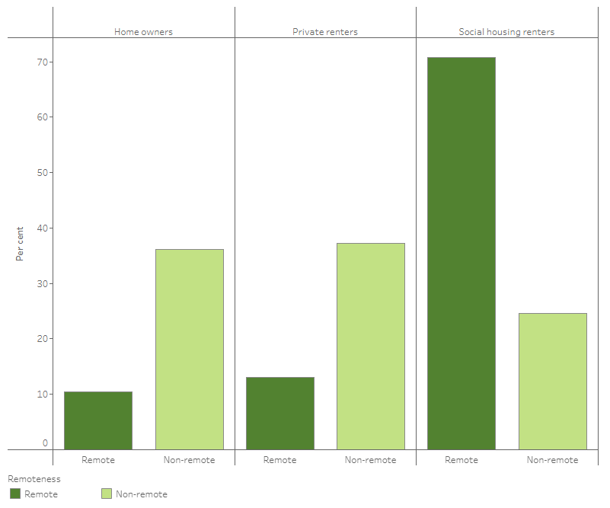

Remote areas are more likely to experience extremes in temperatures and as climate change continues to accelerate more days over 50 degrees are predicted to increase. In some regions in northern Australia high heats above 35 are relentless for months. For example, Daily temperatures reach 35 degrees in Kununurra for more than half the year.

Temperatures at or above 35 degrees are dangerous to human health and wellbeing, especially when combined with humid conditions.

A report by the Kimberley Community Legal Services *Stuck in the Heat: lived experience of public housing tenants in the Kimberley,[66]* states that“Living in the Kimberley region means extreme heat and humidity are part of life. For six months of the year the heat is enduring, it does not cool down at night and there is very little respite. Air-conditioned workplaces and housing provide much needed relief from the sweltering temperature and humidity. For those without access to air-conditioned houses, however, the temperature can make life unbearable.” Tenants in the Kimberley described their homes as ‘heat box’, ‘sweat box’, ‘oven’, ‘incinerator’ or ‘tin box’. The report notes that the effects of extreme heat in adequate housing impacts not only the health of tenants but their social, mental, and financial well-being.

There is little to no data on the energy efficiency levels of Indigenous housing. According to the Australian Institute of Health and Welfare (AIHW), 20% of indigenous households were living in dwellings that did not meet acceptable standards (1 basic facility undeniable and 2 major structural problems), 33% were living in dwellings with at least 1 structural problem and 18% were living in overcrowded dwellings.[67] Thermal comfort was the lowest rated amenity in Aboriginal Households across Australia.[68]

As noted earlier, vulnerable groups such as the elderly, and those with chronic health issues, living in poorly maintained houses will amplify their vulnerability to heat.[69] According to the National Aboriginal and Torres Strait Islander Health Plan 2013-2023, Aboriginal and Torres Strait Islander people experience higher levels of preventable diseases and chronic illness in part due to overcrowded and run-down housing.[70] The *Stuck in the Heat* report, found that a third of public housing tenants we surveyed who had children said their children have been unwell 10 or more times in the past year due to the heat.[71]

Further, many Indigenous communities rely on metering cards to access electricity and can go days or weeks without electricity because they cannot afford a new metering card, which makes people more reliant on thermal efficiency of housing to stay cool.

Anecdotally it is reported that much remote housing lacks adequate insulation, heating and cooling, and access to rooftop solar.

The report *Stuck in the Heat,* described the ways tenants tried to keep themselves and their homes cool, including:

* hosing down the roof, veranda and under the house,
* hosing down concrete outside the house,
* getting their children to play outside under a hose or sprinkler,
* putting foil on the windows,
* using sheets and other material as curtains,
* going to the TAB or the supermarket to stay cool,
* wiping themselves down with a cool cloth,
* lying down inside with the fan,
* avoiding walking outside from 7am to 5pm,
* seeking respite at aged care facilities,
* going to a family member’s house who has better air conditioning,
* sleeping outside because it is cooler than inside

The report *Stuck in the Heat, also notes* that overcrowding can also make managing the heat difficult - the more people there are in a house, the harder it is to cool it down effectively.[72] Homelessness rates in the Kimberley are nine times the WA Average, and over 60 percent of those who are homeless in the Kimberley and the Pilbara are staying in severely overcrowded dwellings.[73] Anecdotal evidence suggests similar issues in other remote communities.

**Recommendation 39: Federal and state/territory governments prioritise energy performance retrofits of Aboriginal and Torres Strait Islander social housing and provide joint funding to electrify, improve the energy efficiency (to at least 5 stars), and install solar PV to Aboriginal and Torres Strait Islander public and community housing, before 2030. Governments need to budget for upgrades or replacement (where it's not cost effective to upgrade) of stock through additional funding, to ensure there is not a reduction in present or future stock (see also recommendation 35).**

**Recommendation 40: Federal and state/territory governments provide access to reverse cycle air conditioning Aboriginal and Torres Strait Islander social housing in areas with extreme heat or cold.**

**Recommendation 41: Federal and state/territory governments fund educational programs for Aboriginal and Torres Strait Islander social housing tenants to support retrofits.**

The programs should be delivered in linguistically and culturally appropriate ways and in partnership with community leaders

## Supply chains and workforce

|  |
| --- |
| Questions for consultation   * What support is needed for Australian manufacturing or other supply focused businesses to improve energy performance? * What are the most critical supply issues hindering energy efficiency action? * What is needed in the finance sector to help accelerate the uptake of energy performance investments? |

An appropriate workforce to implement residential upgrades will be critical and will take time to develop, especially in new skills areas such as energy efficiency audits and trades where skill shortages are already occurring such as electrical and plumbing. Workforce shortage is still more acute in regional and remote areas.

There are opportunities to provide training, accreditation, and business opportunities to long-term unemployed and people in regional and remote communities, including First Nations people.

Efforts to understand what is needed should begin sooner rather than later. This includes training and accreditation to ensure that residential rehabilitation can be carried out by a reliable skilled workforce.

Prioritising retrofits to low-income housing, can be used to establish the frameworks, skills and supply chains that will underpin multi-decade effort to upgrade our housing stock.

**Recommendation 42: The NEPS prioritise retrofits to low-income housing, to assist in establishing the frameworks, skills and supply chains that will underpin multi-decade effort to upgrade our housing stock.**

# Acknowledgements

This submission was prepared in consultation with the Community Coalition for Healthy and Affordable Homes (a network of more than 50 organisations across social, housing, energy efficiency, building and property, consumer, research, business, and union sectors), the ACOSS Climate and Energy Policy Network, the Energy Efficiency Council, the Property Council, and the Australian Industry Group.

# Contact

Kellie Caught

Program Director - Climate and Energy, ACOSS

E: kellie@acoss.org.au M: 0406383277

1. <https://www.aceee.org/sites/default/files/pdfs/i2201.pdf>
2. <https://www.energy.gov.au/government-priorities/buildings/residential-buildings>
3. <https://www.powerhousingaustralia.com.au/wp-content/uploads/2021/11/PHA-eScan-2021-FINAL.pdf>
4. COAG Energy Council (2019) Report for Achieving Low Energy Existing Homes <https://energyministers.gov.au/sites/prod.energycouncil/files/publications/documents/Trajectory%20Addendum%20%20Report%20for%20Achieving%20Low%20Energy%20Existing%20Homes_1.pdf>
5. DELWP (2022) Research Report on Energy Efficiency in Rental Properties. https://www.energy.vic.gov.au/__data/assets/pdf_file/0021/451335/NGR-1708010-DELWP-Energy-Efficiency_Full-Fin alReport.pdf
6. Gasparrini, Antonio, Yuming Guo, Masahiro Hashizume, Eric Lavigne, Antonella Zanobetti, Joel Schwartz, Aurelio Tobias, et al. “Mortality Risk Attributable to High and Low Ambient Temperature: A Multicountry Observational Study.” The Lancet 386, no. 9991 (2015): 369–75.<http://dx.doi.org/10.1016/S0140-6736(14)62114-0>
7. L Coates et al., ‘Exploring 167 years of vulnerability: an examination of extreme heat events in Australia 1844–2010’, in Environmental Science & Policy, vol. 42, 2014, 33–44
8. <https://iceds.anu.edu.au/research/research-stories/we-know-heat-kills-accurately-measuring-these-deaths-will-helpus-assess>
9. Knibbs, Woldeyohannes, Marks, Cowie. 2018. Damp housing, gas stoves and the burden of childhood asthma

   in Australia. MJA.208(7):299–302.
10. <https://asthma.org.au/wp-content/uploads/2022/11/AA2022_Housing-Survey-Report_full_v4.pdf>
11. Moore, T; Nicholls, L; Strengers, Y; Maller, C; and Horne, R (2017) Benefits and challenges of energy efficient social housing. Energy Procedia 121 (2017) 300-307 AND <http://www.healthyhousing.org.nz/research/past-research/housing-insulation-and-health-study/>
12. <https://www.sustainability.vic.gov.au/research-data-and-insights/research/research-reports/the-victorian-healthy-homes-program-research-findings>
13. The 2022 Federal Budget projected electricity prices will increase 56% and gas prices 44% over next two years (https://www.abc.net.au/news/2022-10-26/federal-budget-anthony-albanese-electricty-prices-intervention/100441256). The energy market intervention announced on the 9th of December 2022, will reduce the size of the increase but not eliminate it. See https://www.pm.gov.au/media/energy-price-relief-plan for details of projected impact on energy price rises.
14. https://www.acoss.org.au/wp-content/uploads/2018/10/Energy-Stressed-in-Australia.pdf
15. <https://www.acoss.org.au/wp-content/uploads/2022/09/ACOSS-cost-of-living-report_web_v02.pdf>
16. <https://www.acoss.org.au/wp-content/uploads/2019/02/FINAL-Report-Affordable-clean-energy-for-people-on-low-incomes_web.pdf> AND Moore, T; Nicholls, L; Strengers, Y; Maller, C; and Horne, R (2017) Benefits and challenges of energy efficient social housing. Energy Procedia 121 (2017) 300-307.
17. <https://www.climatecouncil.org.au/resources/switch-and-save-how-gas-is-costing-households/> AND <https://www.rewiringaustralia.org/why-to-electrify> AND <https://renew.org.au/research/all-electric-solar-homes-save-thousands-over-gas-report/>
18. <https://www.sunspot.org.au/> AND <https://www.acoss.org.au/wp-content/uploads/2019/02/FINAL-Report-Affordable-clean-energy-for-people-on-low-incomes_web.pdf>
19. <https://www.climateworkscentre.org/project/renovation-pathways/>
20. The body could utilise existing government structures and could sit within a Government department, like for example the [National Emergency Management Agency](https://nema.gov.au/#/map) (NEMA) sits within the Department of Home Affairs.
21. Noting that modelling by the Climate Targets panel found that Australia would need to achieve net zero by 2035 to do our fair share to limit global warming to 1.5 degrees C. <https://www.climatecollege.unimelb.edu.au/files/site1/docs/%5Bmi7%3Ami7uid%5D/ClimateTargetsPanelReport.pdf>
22. <https://www.healthyhomes.org.au/news/community-sector-blueprint>
23. Noting the Whole of Home Performance rating will be a score out of 100. <https://www.nathers.gov.au/sites/default/files/2022-09/Changes%20to%20the%202022%20certificate%20%26%20non-accredited%20report.pdf>
24. Excluding housing that will need replacement.
25. <https://energyconsumersaustralia.com.au/wp-content/uploads/National-Energy-Productivity-Plan-Release.pdf>
26. <https://www.energy.gov.au/data/australian-energy-intensity-and-energy-productivity>
27. ACEEE (2022) International Energy Efficiency Score Card <https://www.aceee.org/sites/default/files/pdfs/i2201.pdf>
28. Insert examples of France, New York, NZ.
29. <https://www.eeca.govt.nz/>
30. <https://www.energy.ca.gov/about/divisions-and-offices/efficiency-division>
31. IEA 2022, [*Ministers from around the world agree to speed up energy efficiency progress to help tackle global energy crisis*](https://www.iea.org/news/ministers-from-around-the-world-agree-to-speed-up-energy-efficiency-progress-to-help-tackle-global-energy-crisis)
32. <https://www.energy.gov.au/government-priorities/energy-ministers/energy-ministers-publications/trajectory-low-energy-buildings>
33. New Zealand has established an Energy Efficiency and Conservation Authority. It was established as a Crown entity under the Energy Efficiency and Conservation Act 2000 to encourage, promote and support energy efficiency, energy conservation and the use of renewable sources of energy. See <https://www.eeca.govt.nz/>
34. California has established an Energy Commission, which includes a dedicated Commissioner and division to focus specifically on energy efficiency. See <https://www.energy.ca.gov/about/divisions-and-offices/efficiency-division>
35. The Sustainable Energy Authority of Ireland, was established as a governmental agency with the functions of promoting and assisting ‘environmentally and economically sustainable production, supply and use of energy’, energy efficiency and renewable energy, minimising the environmental impact of energy production and supply, promoting and assisting related R&D, to advise the Minister and energy users.
36. The New York State Energy Research and Development Authority, known as NYSERDA, promotes energy efficiency and the use of renewable energy sources. NYSERDA works with stakeholders throughout New York including residents, business owners, developers, community leaders, local government officials, university researchers, utility representatives, investors, and entrepreneurs. See <https://www.nyserda.ny.gov/About>
37. <https://www.aemc.gov.au/regulation/neo#:~:text=The%20National%20Energy%20Retail%20Objective%20as%20stated%20in%20the%20National,security%20of%20supply%20of%20energy.%E2%80%9D>
38. The ISP is a whole-of-system plan that provides an integrated roadmap for the efficient development of the National Electricity Market (NEM) over the next 20 years and beyond. <https://aemo.com.au/en/energy-systems/major-publications/integrated-system-plan-isp>
39. In the same manner as the electricity and gas statements of opportunity.
40. DELWP, "Research Report on Energy Efficiency in Rental Properties". <https://www.infrastructurevictoria.com.au/wp-content/uploads/2022/03/Infrastructure-Victoria-submission-Inquiry-into-Renewable-Energy-in-Victoria.pdf>
41. Gasparrini, Antonio, Yuming Guo, Masahiro Hashizume, Eric Lavigne, Antonella Zanobetti, Joel Schwartz, Aurelio Tobias, et al. “Mortality Risk Attributable to High and Low Ambient Temperature: A Multicountry Observational Study.” The Lancet 386, no. 9991 (2015): 369–75. <http://dx.doi.org/10.1016/S0140-6736(14)62114-0>
42. L Coates et al., ‘Exploring 167 years of vulnerability: an examination of extreme heat events in Australia 1844–2010’, in Environmental Science & Policy, vol. 42, 2014, 33–44
43. <https://iceds.anu.edu.au/research/research-stories/we-know-heat-kills-accurately-measuring-these-deaths-will-help-us-assess>
44. Bouchama, Abderrezak, Mohammed Dehbi, Gamal Mohamed, Franziska Matthies, Mohamed Shoukri, and Bettina Menne. “Prognostic Factors in Heat Wave – Related Deaths.” Archives of Internal Medicine 167, no. 20 (2012): 2170–76.
45. <https://www.energy.gov.au/government-priorities/buildings/trajectory-low-energy-buildings>
46. Community Joint statement (2019) All Australians Deserve a healthy and affordable home: community organisations call for a national strategy for low energy homes. <https://renew.org.au/wp-content/uploads/2019/07/Community-Joint-Statement-for-Healthy-Affordable-Homes.pdf>
47. <https://www.acoss.org.au/wp-content/uploads/2019/11/Joint-submission-to-NEPP-Trajectory-for-low-Energy-Existing-Houses-September-Consultation-Final.pdf> AND <https://www.acoss.org.au/wp-content/uploads/2019/09/Joint-Submission-to-NEPP-Trajectory-for-Low-Energy-Existing-Homes-Consultation-Paper.pdf>
48. Noting that modelling by the Climate Targets panel found that Australia would need to achieve net zero by 2035 to do our fair share to limit global warming to 1.5 degrees C. <https://www.climatecollege.unimelb.edu.au/files/site1/docs/%5Bmi7%3Ami7uid%5D/ClimateTargetsPanelReport.pdf>
49. See ASBEC briefing note on why mandatory disclosure is important <https://www.asbec.asn.au/wordpress/wp-content/uploads/2023/01/National-Disclosure-of-Energy-Performance_ASBEC-Policy-Paper-FINAL.pdf>
50. According to the Energy Efficiency Council theGEMS program (and international equivalents) has been shown time and time again to reduce costs for consumers, while providing benefits in reducing energy system demands and reducing emissions.
51. <https://renew.org.au/advocacy/climate-resilient-homes/households-better-off-lowering-energy-bills-with-the-2022-national-construction-code/>
52. Moore, T; Nicholls, L; Strengers, Y; Maller, C; and Horne, R (2017) Benefits and challenges of energy efficient social housing. Energy Procedia 121 (2017) 300-307.
53. Ibid.
54. <http://www.healthyhousing.org.nz/research/past-research/housing-insulation-and-health-study/>
55. Moore, T; Nicholls, L; Strengers, Y; Maller, C; and Horne, R (2017) Benefits and challenges of energy efficient social housing. Energy Procedia 121 (2017) 300-307
56. Deloitte Access Economics (2021) The economic impacts of the National Low-income Energy Productivity Program
57. <https://www.acoss.org.au/wp-content/uploads/2021/08/Brief-Proposal-and-implementaion-plan-for-National-Low-income-Energy-Productivity-Program-September-2021.pdf>
58. <https://www.aihw.gov.au/reports/australias-welfare/indigenous-housing>
59. <https://www.powerhousingaustralia.com.au/wp-content/uploads/2021/11/PHA-eScan-2021-FINAL.pdf>
60. ibd.
61. <https://www.healthyhomes.org.au/news/community-sector-blueprint>
62. Ibid.
63. <https://www.google.com/url?q=https://www.healthyhomes.org.au/news/community-sector-blueprint&sa=D&source=docs&ust=1674547057143467&usg=AOvVaw2UHJW6fH4EL_YcqJueAIPW>
64. <https://www.acoss.org.au/wp-content/uploads/2021/08/Brief-Proposal-and-implementaion-plan-for-National-Low-income-Energy-Productivity-Program-September-2021.pdf>
65. <https://www.aihw.gov.au/reports/australias-welfare/indigenous-housing>
66. Kimberley Community Legal Services (2022) *Stuck in the Heat: lived experience of public housing tenants in the Kimberley,* <https://static1.squarespace.com/static/56aae0e04d088e4dfa68396f/t/6385f2f85f679917d0fb7b2e/1669722882386/Stuck+in+the+Heat+2022.pdf>
67. Australian Institute of Health and Welfare (2021) Indigenous Housing <https://www.aihw.gov.au/reports/australias-welfare/indigenous-housing>
68. Australian Institute of Health and Welfare (2019) Aboriginal and Torres Strait Islander people: a focus report on housing and homelessness <https://www.aihw.gov.au/reports/housing-assistance/indigenous-people-focus-housing-homelessness/contents/summary>
69. Lander et al., (2019) ‘Extreme Heat Driven by the Climate Emergency: Impacts on the Health and Wellbeing of Public Housing Tenants in Mildura’ (Report prepared by Mallee Family Care and the University of Sydney) 4
70. Australian Government (2013) ‘National Aboriginal and Torres Strait Islander Health Plan 2013-2023.
71. Kimberley Community Legal Services (2022) *Stuck in the Heat: lived experience of public housing tenants in the Kimberley,* <https://static1.squarespace.com/static/56aae0e04d088e4dfa68396f/t/6385f2f85f679917d0fb7b2e/1669722882386/Stuck+in+the+Heat+2022.pdf>
72. Kimberley Community Legal Services (2022) *Stuck in the Heat: lived experience of public housing tenants in the Kimberley,* <https://static1.squarespace.com/static/56aae0e04d088e4dfa68396f/t/6385f2f85f679917d0fb7b2e/1669722882386/Stuck+in+the+Heat+2022.pdf>
73. Ibd, pg 8.