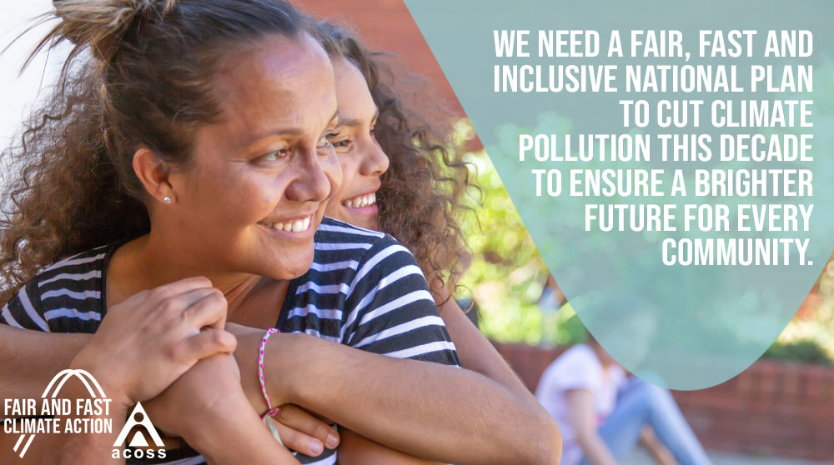

**Fair, fast and inclusive climate change action and thriving climate-resilient communities**

**Federal Election 2022**

We call on all parties and candidates to support fair, fast and inclusive action on climate change and to build greater resilience to the climate change impacts already locked in.

Climate change not only threatens our environment, it also threatens people’s homes, livelihoods, health, quality of life, employment and increases risks and burdens for future generations.

People experiencing financial or social disadvantage are impacted by climate change first, worst, and longest because they have access to fewer resources to cope, adapt and recover.

It is already exposing them to greater levels of harm and disadvantage and is posing a particular threat to First Nations communities and to the future of our young people.

People who experience poverty and disadvantage are also worse off if the transition to a clean economy is poorly managed and inequitable. This is because they always pay disproportionately more of their incomes on essential services and have less choice and control to reduce costs.

A fair, fast and inclusive plan to address climate change along with a plan to build community-led climate-resilient communities, has the ability to improve the lives of people facing disadvantage, from the cities to the outback. It creates opportunities to reduce poverty and inequality and support self-determination through more affordable, healthier and reliable energy, housing and transport, and the creation of new clean jobs.

Despite being one of the wealthiest developed nations, Australia is currently not on track to do our fair share to achieve the international goal of limiting global temperature increases to well below 2 degrees Celsius and pursue a limit of 1.5 degrees. Further, the reliance on markets, fossil fuel subsidies, and poorly designed incentives has meant the transition to date has been slow, wasteful, and inequitable.

Delaying action will heighten the risks of more dangerous climate change. Failure to cut emissions this decade and to build climate resilience will cost the economy and society more and make poverty and inequality in Australia worse.

Through a well-planned transition that is fast, fair and inclusive, putting people experiencing disadvantage, impacted workers, young people and communities first, we can create a safer, more prosperous, sustainable and fairer society and economy.

We call on the next federal parliament to take the following steps as a high priority.

## **Undertake fair, fast and inclusive action on climate change**

**Establish an independent Climate Change Framework that is fair and inclusive**

* Establish a national framework, via a Climate Change Act, to guide fast, fair and inclusive action on climate change mitigation and build resilience. The Act should be guided by principles of inclusiveness, participation, equity and sustainability. It should acknowledge the duty of care to protect children from climate change and require consultation with impacted groups including vulnerable and marginalised communities, First Nations peoples, people with disabilities, people experiencing poverty, elderly people, children and women.
* Establish an independent Climate Change Advisory body (with expertise and experience regarding social and financial disadvantage) that is empowered and resourced to advise governments and the community on policies, measures and the pace at which they’re implemented.

**Rapidly reduce emissions this decade**

* The science says Australia needs to cut emissions to 75% (from 2005 levels) by 2030 to do its fair share to limit global warming. At the very least Australia should match commitments from our key allies to halve our emissions by 2030, and reach net zero emissions by 2035.
* Prioritise the energy sector for faster, earlier emissions reductions.

**Ensure cost recovery and incentives are fair and equitable**

* Ensure climate change transition subsidies, incentives and cost-recovery measures are progressive, equitable and targeted to support those with the least. For example, exempt people on low incomes from contributing to the costs of the small-scale renewable energy scheme (SRES) or shift it from energy bills and onto the government budget.

**Target policies and measures that provide benefits to people experiencing financial and social disadvantage, including:**

* Energy efficient low-income homes - The federal Government jointly invests to [improve energy efficiency and install rooftop solar for 1.8 million low-income homes](https://www.acoss.org.au/wp-content/uploads/2021/08/Brief-Proposal-and-implementaion-plan-for-National-Low-income-Energy-Productivity-Program-September-2021.pdf) (public and community housing, low-income homeowners and low-income rental properties) which would cut power bills, improve health outcomes, improve resilience to climate change, create more than 23,800 local jobs and add $4.9 billion to GDP.
* Empowered First Nations Communities - In consultation with First Nations communities, including the [First Nations Clean Energy Network](https://www.firstnationscleanenergy.org.au/the_network_s_federal_election_ask), put in place policies and measures to enable First Nations communities to engage, own and profit share in large scale renewable energy projects on country, carbon offset projects on country, and more efficient and energy productive homes and communities.
* Clean, affordable and accessible transport - Develop a national strategy, including supporting state and territory government to transition to clean, affordable and accessible transport in cities, urban and regional areas. This should include, providing access to EVs targeted for low-income communities through additional financial incentives for people on low incomes and ensuring charging stations are built in lower socio-economic areas; and support for electrification of public transport infrastructure.
* Access to energy storage - Ensure incentives for household and community batteries incorporate equity principles in design. Including providing additional financial incentives to assist people on low incomes access them and ensure community-scale batteries are built-in lower socio-economic areas.

**Commit to a planned phase-out of coal and gas and support affected workers and communities with the transition to net-zero emissions**

* Create a framework for a planned and orderly closure of coal and gas infrastructure, including a moratorium on new coal mines, consistent with the goals of limiting warming to 1.5 degrees.
* Establish and fund an Energy Transition Authority, with community representation, to support affected workers and communities with the transition to net-zero emissions. The Energy Transition Authority should support worker retraining, redeployment and support in consultation with workers, unions and companies. The Energy Transition Authority would also work with local government and communities on plans to transform and diversify their economies to create jobs and provide pathways to employment for those disadvantaged in the labour market.

**Clean job creation plan (as part of a broader jobs creation plan to achieve full employment)**

* Create employment opportunities that reduce emissions and build climate resilience. The opportunities should prioritise groups who are long-term unemployed, at risk of long-term unemployment and increase participation of women. Opportunities include job creation through energy efficiency and rooftop solar for low-income homes; renewable energy and carbon offsets; public and active transport construction; ecosystem restoration; disaster recovery support services; urban green spaces; community-scale energy storage in lower-income areas.
* Prioritise community-based employment of First Nations people by supporting the creation of clean energy, carbon offset and resilience projects owned and run by First Nations communities.
* Ensure clean job creation meets the needs of local communities, including by targeting jobs for groups who are long-term unemployed, through [local employment and skills development partnerships](https://www.acoss.org.au/wp-content/uploads/2020/08/200812-Local-employment-and-skills-development-partnerships-FINAL-2.pdf)**.**
* Sustainable jobs for fossil fuel-dependent communities (see above)

**Agency to focus on delivering clean, affordable, dependable energy for all**

* Create a joint federal and State/Territory Agency to monitor and recommend reforms to reduce energy hardship, improve energy affordability and ensure people experiencing social and financial disadvantage benefit from the energy transition.

## **Build thriving climate-resilient communities**

* Undertake a national review of affordable, accessible and quality insurance, having regard to worsening climate change impacts and the need to provide specific support for people experiencing financial disadvantage.
* Support and resource the development of local Community Resilience Hubs that are community-led, to assist the community in planning, response, recovery and resilience-building to better meet the challenges of the climate change impacts already locked in.
* Prioritise funding to support Aboriginal and Torres Strait Islander peoples and communities to participate in whole-of-community response to building climate resilience and to better prepare for, respond and recover from natural disasters that build on traditional and local knowledge support.
* Support communities develop local climate change adaptation and resilience plans, by providing easy access to data such as climate impacts modelling, geospatial, infrastructure, and socio-economic, at the local level.
* Provide resources to community, health and education sector organisations to adapt to climate change, be better prepared for emergencies and disasters, improve the resilience of their clients, and ensure continuity of care for vulnerable people during and after climate disaster events.
* Invest in improving the energy efficiency and resilience of low-income homes (see above) and in public infrastructure to support climate resilience.
* See also ACOSS Disaster Response, Recovery, Resilience proposals [here](https://www.acoss.org.au/wp-content/uploads/2022/03/220317-ACOSS-Disaster-Response-Recovery-and-Resilience-Plan-Final-Public.pdf).

## **Provide adequate incomes and housing to manage the transition and climate change impacts**

* Lift income support to improve the capacity of people on low incomes to manage the transition and deal with climate change impacts, including increasing Jobseeker, Youth Allowances and other income support payments to at least $70 a day, index payments to wages as well as CPI, and increasing Commonwealth Rent Assistance by 50% (see [here](https://www.acoss.org.au/election-2022/election-social-security-net/) for more).
* Implement policies to create a better fairer housing system - including building at least 25,000 new social and affordable housing dwellings per year, a new affordable rental investment incentive scheme and mandatory energy efficiency rental standards - that improves access to secure, affordable and efficient housing to manage the transition and deal with climate change effects (see [here](https://www.acoss.org.au/election-2022/election-social-housing/) for more).

## **Contribute a fair share to international finance to support developing countries**

* Immediately increase Australia’s current climate finance to $3 billion over 2020-2025 and scale up Australia’s contributions to global climate finance to provide a fair share by 2030.

## **End fossil fuel subsidies & redistribute to fund fair, fast, inclusive transition and build more climate-resilient communities**

* End the more than $11.6 billion dollars of annual subsidies for fossil fuel production and use, that contribute to increasing emissions. Start with the removal of the more than $8 billion annually in fuel tax credits for off-road vehicle use. And end the additional billions in government funding for gas and coal projects and fossil carbon capture and storage (CCS) projects. Redistribute the funding to deliver fair, fast and inclusive action on climate change and build climate-resilient communities.

## Contact

Kellie Caught

Program Director - Climate and Energy, ACOSS