A new post-lockdown health hazard: Sudden reintroduction of unrealistic job search requirements and penalties
Summary
Any sudden reinstatement of excessive job search requirements and payment suspensions for people on unemployment payments after lockdowns end in Sydney, Melbourne and elsewhere - would put people’s health at risk and cause widespread hardship and distress. It would further damage the mental health of people already struggling to survive on inadequate income support and could increase the spread of COVID-related illness.
ACOSS understands that the Federal Government is advising people on unemployment payments and jobactive providers that ‘mutual obligations’ – requirements to search for jobs attend face-to-face meetings with jobactive providers and participate in training courses and Work for the Dole – will be restored in Sydney from 13 October, Melbourne from 28 October and the Australian Capital Territory on 19 October.
These requirements were suspended during the long lockdowns in those cities and other parts of the country including Shepparton and the south coast of NSW, to protect people from COVID. This also recognised that during lockdowns, fewer jobs are available and it is impractical and risky for people to attend face to face meetings.
This briefing explains ‘mutual obligations’ and the penalties attached to them. It reveals that when they were restored after last year’s lockdowns, over 750,000 payment suspensions were imposed in just three months from January to April 2021.
We recommend that the Federal Government take the sensible course (in line with the approach last year):
- A gradual, phased reintroduction only of mutual obligations and face-to-face employment services, no sooner than one month after ‘Phase C’ of the easing of COVID restrictions begins;
- Work with organisations representing people directly affected, employment service providers and health experts to develop a roadmap for employment services and mutual obligations after lockdowns, that takes into account local and regional conditions, including labour markets and public health requirements as well as individual circumstances;
- Remove harsh elements of the income support compliance system; and
- Increase unemployment and related payments so that people can maintain their health and secure their housing while searching for employment.
See further below for specific recommendations.

Sudden reintroduction of mutual obligations would be hazardous
Any sudden reintroduction of mutual obligations puts people at risk.
COVID could spread to more people with vulnerabilities since many people on unemployment payments have a disability or chronic illness, live with family members who do, or have been unable to obtain vaccinations.
As we indicated in our recent open letter to National Cabinet, we are deeply concerned that only one third of First Nations people have had this opportunity and vaccination rates among people with disability and people in low-income areas generally are well below the national average.
Yet people could be required to attend face-to-face meetings with employment services or take up jobs involving regular public contact, and compulsory activities like Work for the Dole require people to work together in groups.
Issues about disclosure of sensitive health information to employment service providers have also not been resolved.
People who do not meet mutual obligation rules are subject to sudden suspension of their payments and other penalties, leading to widespread anxiety and financial hardship. This comes at a time when people on the lowest incomes are already anxious or depressed from prolonged lockdowns, and fearful of COVID.
As highlighted in an Australian Institute of Health and Welfare report, people on low incomes have been dying at four times the rate of the community as a whole.
Many people in locked-down areas face the imminent prospect of losing COVID Disaster Payments and dropping down to the $45 Jobseeker payments.
Over 750,000 payment suspensions were imposed in just three months after previous lockdowns eased
ACOSS analysis shows that these ‘mutual obligation’ requirements had already led to an unconscionable number of payment suspensions in the period from 1 January to mid-April 2021 when the latest data was published. Over that period, 751,000 payment suspensions were imposed on people receiving unemployment payments in the jobactive system, or around 200,000 per month.
If this trend is repeated as lockdowns are eased across the half the country, we estimate that there could easily be another 500,000 payment suspensions between now and Christmas
These figures point to the dangers of reintroducing the excessive 20 job application targets per month because 60% of the suspensions occurred when people were unable to meet them, even though at that time the requirement was only 15 per month.
Our analysis shows that these payment suspensions are harmful – they expose people who are already suffering from poverty and anxiety while searching for employment.
At a recent ACOSS forum we asked participants to tell us what it felt like to have to do high levels of ongoing job searching. The word cloud that was produced with participant at the forum shows the high level of distress that people have been experiencing in jobactive employment services

Figure 1 – Word cloud from ACOSS Mutual Obligation forum
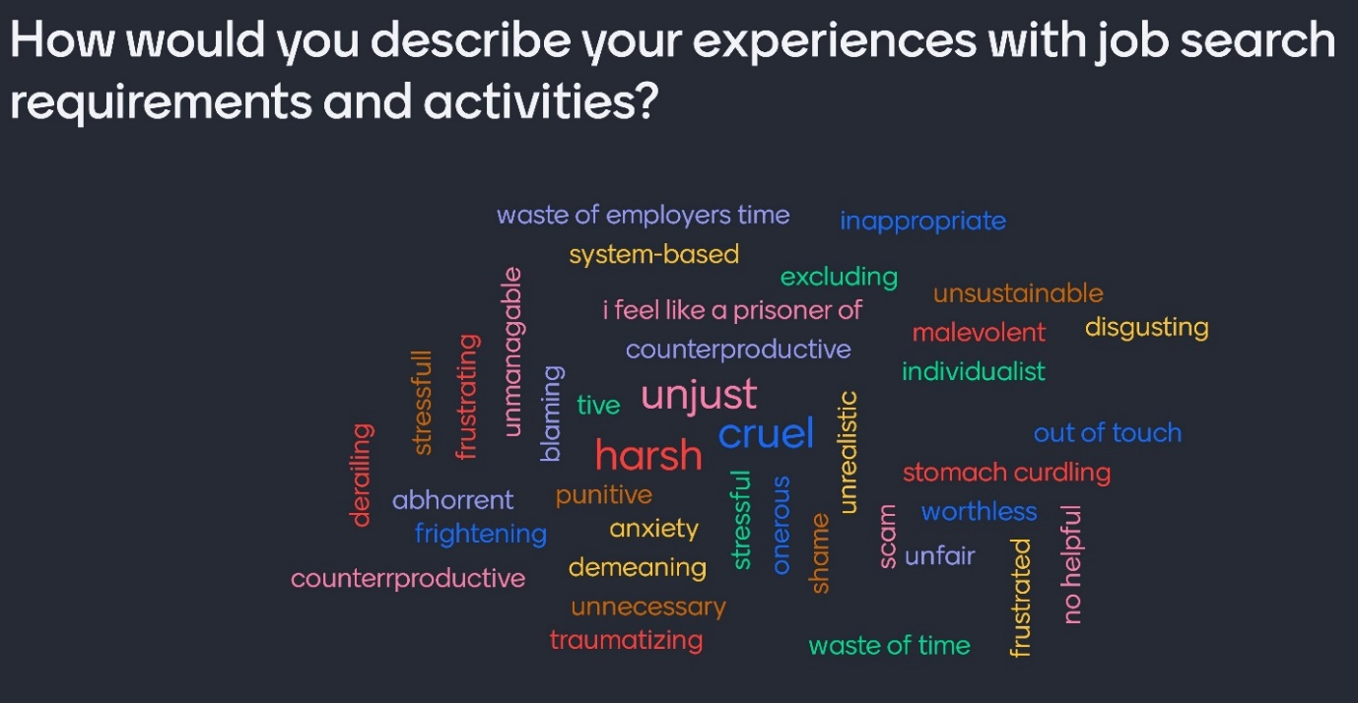
Participants in the forum made comments like these about job search requirement.
20 a month requirement is unreasonable for anyone
Not enough jobs to apply for
The number of Job searches should be based on the applicant’s employment history
They tell us there are plenty of jobs would like to know where they are because I keep getting knocked back - I am also 53 so ageism is huge
Excessive job search requirements waste time and effort and impose burdens on employers
People on unemployment payments want to find employment: in the absence of job search requirements during lockdowns many still applied for jobs and sought help from employment services.
Employment service providers should be able to concentrate on their main job – to help connect people needing paid employment to employers – rather than devote most of their time to policing unrealistic benefit requirements and managing pointless activities such as Work for the Dole.
It will take time for employment to recover from lockdowns and border closures, and for people to regain confidence to attend face to face meetings and interviews and apply for jobs in workplaces where they will be in regular contact with large numbers of people.
The default requirement to apply for 20 jobs a month also imposes a burden on employers, who are flooded with applications from people who are not actually well-matched to the job.
Policy recommendations
The critical first step is to develop a plan – similar to the ‘roadmaps’ announced by State governments – for a gradual, cautious reintroduction of mutual obligations. There should be no ‘snap back’ to the 20 jobs a month rule and large-scale payment suspensions the instant lockdowns are eased.
Recommendation 1
Any reintroduction of mutual obligations and compulsory face to face services should be deferred until at least one month after ‘Phase C’ of the easing of COVID restrictions commences.
This should be clearly communicated to all parties in a timely way.
More broadly, ACOSS believes that this lifting of restrictions should only occur once safe vaccination rates have been achieved amongst high-risk groups including people on low incomes.
Recommendation 2:
- The government should work with organisations representing people directly affected, employment service providers and health and other experts to develop a roadmap for employment services and mutual obligations after lockdowns.
- As was done last year, when the default job search requirement was gradually increased to 4, then 10 applications per month and face to face meetings with employment services were encouraged but voluntary, this should be done gradually, taking account of local labour market conditions and health concerns
- Scheduled six-monthly and annual activities in the locked-down areas should be deferred.
The second step is to reform the system of mutual obligations and penalties. Job search requirements are unrealistic, many of the compulsory activities waste time, energy and resources as they don’t improve people’s employment prospects, and widespread and abrupt payment suspensions cause anxiety and financial hardship.
The system has not been publicly reviewed for over a decade despite the urgent need for reform in this area.
Recommendation 3:
- A public review of activity requirements, and the compliance and penalty system for unemployment payments, should be held in advance of the introduction of the new employment services system in July 2022
- In the interim, default job search requirements should be reduced, reductions in requirements for people with barriers to employment such as parents and people with disability and older workers should be fully legislated, and automation of payment suspensions should be removed.

We reiterate here some of our key recommendations to improve income support and the employment prospects of people who are most disadvantaged in the labour market, as we recover from the pandemic and recession.
Recommendation 4
- Permanently increase JobSeeker and other working-age payments to at least the OECD-recognised measure of poverty ($67 a day for single people);
- Increase Commonwealth Rent Assistance by 50% to ensure people with low incomes can better afford their rent;
- Introduce eviction moratoriums where people are at risk of homelessness, and invest in social housing infrastructure as part of a plan to meet the 500,000 shortfall in affordable housing for people on the lowest incomes.
- Introduce a flexible jobs and training guarantee for people unemployed for 12 months or more.

Conclusion
ACOSS believes unrealistic mutual obligation requirements and harsh compliance measures are counterproductive and harmful for people searching for paid work. We urge the Federal Government to prevent hundreds of thousands of people every month from experiencing payment suspensions by ensuring that any restoration of activity requirements after lockdowns is gradual, and by reviewing and reforming the system.
In the first instance, the restoration of activity requirements including face to face meetings should not commence until at least one month after lockdowns are substantially lifted in each affected region (in phase ‘C’ of the national plan for easing of lockdowns).

Background
What are mutual obligation requirements?
These are a set of requirements for people receiving unemployment payments (including Jobseeker payment and Youth Allowance) that are included in person’s Job Plan as discussed with their employment service provider. They may include:
- accepting a job if offered;
- attending job interviews;
- applying for a set number of jobs each month;
- attending appointments with an employment service provider;
- attending activities or training, including Work for the Dole.
The default job search requirement is 20 job applications per month, which people must report regularly on the job search app or to their employment service provider.
Participation in ‘activities’ such as training or unpaid Work for the Dole is required for up to three months at regular intervals.
How does the compliance and penalty system work?
The system of payment suspensions and penalties is called the Targeted Compliance Framework (TCF), which commenced in 2018.
When people on income support do not meet the mutual obligation requirements in their job plans, their payments are suspended and can be cancelled.
‘Demerit Points’ accrue when the person is assessed by the provider to not have ‘reasonable excuse’ for not meeting a requirement that triggers a payment suspension. If more than four demerit points accrue within six months, penalties of up to four weeks without income support may be imposed.
Before these penalties are imposed, there is review interview called a Capability Interview in which the person’s capacity to meet requirements is assessed and they are given an opportunity to explain why they did not meet the requirement. This interview is held with either by a job services provider, the digital services contact centre or Services Australia. A further review interview is held with Services Australia before payment penalties are applied.
How are payment suspensions applied?
When a person does meet a requirement on time, they receive a message (usually by SMS) informing them of this and asking them to contact their provider or the digital service contact centre. If they do not do so and then meet the requirement, their payment is suspended.
In theory, the person is given the opportunity to speak to their provider or the digital contact centre (usually by phone) to explain their circumstances and agree to meet the requirement before a suspension is imposed. A two-day delay in payment suspensions was introduced in December 2020 to enable people to contact their provider or digital contact centre to resolve issues before a suspension is imposed. If the person does not ‘re-engage’ within that time, the suspension is automatically imposed and they are notified of this (usually by SMS).
A payment suspension may not result in an actual loss of payment. If the person engages with their provider or the digital services contact centre before their payment is due and meets the requirement, the suspension may be lifted. In most cases this occurs before the payment falls due.
Suspended payments are fully back-paid when these ‘reconnection requirements’ are met (for example, by attending a missed appointment with a provider or completing the required number of job searches). Payments are cancelled automatically when people do not meet a reconnection requirement within 28 days.
Over 750,000 payment suspensions were imposed when lockdowns were eased earlier this year
Payment suspensions are triggered when people who are on income support payments are considered not to have met a requirement in their job plan. In less than 4 months between January and mid-April 2021, 750,847 payment suspensions were imposed on people receiving unemployment payments. One in five people on the JobsSeeker and Youth Allowance payments had their payment suspended As Figure 2 shows 60 percent of the payment suspensions were for people who had not met job application targets in the previous month.
Figure 2 – Payment suspensions jobactive January-Mid April 2021
Suspension Category | Jan-21 | Feb-21 | Mar-21 | Mid Apr-21
Provider Appointment | 60,226 | 60,510 | 74,952 | 100,311
Job Plan | 4,770 | 3,869 | 3,646 | 7,694
Job Search | 132,134 | 94,781 | 117,223 | 70,426
Points Based Period | 178 | 173 | 226 | 156
Total | 201,454 | 163,537 | 200,902 | 184,954
It is likely that even more payment suspensions will occur after lockdowns are lifted and mutual obligation requirements resume. That is because the data in in Figure 2 is for the period January 2021-mid April 2021. At that point in time, most people had 15 job searches to complete per month as part of their Mutual Obligations. The default number of job searches required increased to 20 in July 2021, in line with government policy before the pandemic.
People classified as ‘’vulnerable’’ are more likely to have their payments cancelled.
The payment suspension data is also of concern because it shows that payment suspensions disproportionately affect people who have been flagged by Services Australia as ‘vulnerable’. For example, figure 3 shows that although people experiencing homelessness represent only 9 percent of the jobactive caseload, they received over 14 percent of the payment suspensions. They also received demerit points (under the Targeted Compliance Framework) at a rate of 21 per cent.
Figure 3 – Payment suspensions in jobactive by demographic
DESE breakdown of jobactive participants by identified ‘vulnerability’ | Number | % of all jobactive participants | Overall suspensions | 4th demerit points |  | % of 4th demerit points
TOTAL | 852,847 |  |  |  | 1172
INDIGENOUS | 76,430 | 9% | 18% |  | 289 | 25%
DISABILITY | 140,717 | 17% | 20% |  | 275 | 23%
HOMELESSNESS | 72,884 | 9% | 14% |  | 250 | 21%
Culturally and Linguistically Diverse | 188,800 | 22% | 17% |  | np
EX-OFFENDERS | 84,748 | 10% | 19% |  | 355 | 30%
Source: Source: Response to Employment portfolio question number: SQ21-000851 2021-22 Budget estimates, May 2021.
The data available show that payment suspensions and payment cancellations disproportionately affect people who have been flagged by Services Australia as ‘vulnerable’.
The data on cancellations has previously been subjected to questions in the Senate where the Department of Education Skills and Employment’s officials indicated they were unable to provide the reasons for payment cancellations. When asked for more information on their knowledge of what has been happening to those people identified as ‘vulnerable’ they noted the disproportionate impact of the cancellations and suspensions on these groups.
Payment suspensions cause anxiety and hardship
The excessive number of payment suspensions shows that unrealistic job search targets are harming people looking for paid work in the middle of the pandemic. In many cases, people have not met a requirement for reasons beyond their control such as provider error, a poor internet connection, a disability or caring responsibilities, or a lack of sufficient jobs in their locality.
Threat of payment suspensions causes a great deal of needless anxiety, and many payments are delayed. In many cases the person is not at fault (for example their employment service provider did not properly notify of them of a rescheduled meeting).
At a recent ACOSS forum on mutual obligation, participants produced the word cloud in Figure 4 to show how payment suspensions affected them.

Figure 4: Word cloud from ACOSS Mutual obligation forum
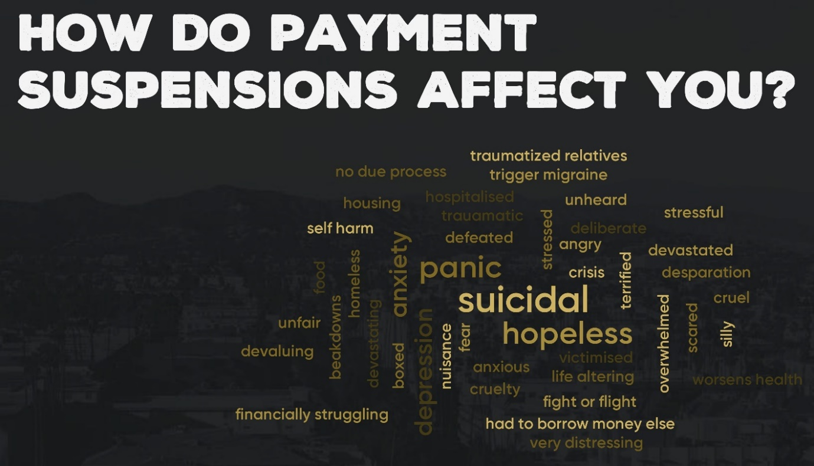

Activity requirements are unreasonable and unrealistic
People receiving income support while they are searching for employment are required to sign a job plan and given requirements to undertake activities the Government considers are appropriate to helping them get a job. These are generally activities like attending appointments with a provider, attending Work for the Dole or training, and meeting a monthly target for job applications.
These job search requirements are problematic because the target number of applications, which is usually 20 per month, is unrealistically high for most people on income support payments.
This default requirement can be reduced by employment service providers where the person has caring responsibilities or a disability or lives in an area where there are few job vacancies. However, this discretion is not exercised in a consistent way. All too often, the default requirement to apply for 20 jobs applies.
Job search requirements were eased in the pandemic last year, but the default requirement to apply for 20 jobs a month has now been restored.
In recognition that it was not realistic to make people apply for jobs under lockdown conditions, these requirements were suspended during lockdowns. From September 2020, as lockdowns were eased, the government gradually reintroduced job search requirements to 4 a month, then 10 a month.
This year, the required number has increased again, to 15 and then 20 applications per month.
Job search requirements were tightened in March 2021
The government announced in March 2021 tighter job search rules, to enforce an existing rule that people must search for jobs at a variety of skill levels using a variety of methods. This new rule is very difficult to enforce fairly and consistently, and it increases the time people can devote to searching for the relevant number of jobs. At the least, the default requirement of 20 applications should have been reduced when this rule was introduced.
In addition, it announced that:
• Employment service providers will be audited regularly to ensure they check compliance with job search requirements
• A ‘dob-in’ line would be established for employers to report when they believe a person has not met the job search requirements.

Payment suspensions last an average of 4.3 days, but can go for longer, and after 28 days result in outright payment cancellations.
Source: Response to Employment portfolio question number: SQ21-000851 Senate 2021-22 Budget estimates, May 2021.
Social Security (Administration) (Job Search Efforts) Determination 2018 https://www.legislation.gov.au/Series/F2018L00776

