Submission on the Review of the Regulatory Framework for Metering Services

Australian Energy Market Commission

8 March 2021

Contents

[About signatories 2](#_Toc65606304)

[Summary 3](#_Toc65606305)

[Discussion 5](#_Toc65606306)

[Smart metering can facilitate better consumer outcomes 5](#_Toc65606307)

[Purpose of the smart metering review 7](#_Toc65606308)

[Expectations of the 2015 smart metering reforms have not been met 8](#_Toc65606309)

[Barriers to smart metering uptake and full realisation of benefits 12](#_Toc65606310)

[Current rules are complex, ad hoc and inequitable 12](#_Toc65606311)

[Smart metering not considered essential infrastructure 12](#_Toc65606312)

[Lack of appropriate consumer information, tools and data 13](#_Toc65606313)

[Consumers not getting access to full range of services 13](#_Toc65606314)

[Poor utilisation of data undermines benefits 14](#_Toc65606315)

[Remote disconnection for non-payment is detrimental 14](#_Toc65606316)

[Smart metering should enhance consumer choice of tariffs options, not force people on tariffs where they may be worse off. 14](#_Toc65606317)

[Recommendations 16](#_Toc65606318)

[Clearly define objectives and principles to guide reform 16](#_Toc65606319)

[Treat smart metering as an essential infrastructure, accessible to all 17](#_Toc65606320)

[Increase minimum service standards 18](#_Toc65606321)

[Restrict Remote Disconnection for debt management 18](#_Toc65606322)

[Improve Access to Data 18](#_Toc65606323)

[Ensure adequate consumer protection 18](#_Toc65606324)

[Provide better consumer information and education to maximise benefits 19](#_Toc65606325)

[Ensure consumers are not worse off under Tariff reform policy 19](#_Toc65606326)

[Appendix - Advantages and disadvantages of different models of Smart meter rollout 21](#_Toc65606329)

# About signatories

The signatories to this submission include national and state organisations that represent the voice of residential consumers, including people affected by poverty, disadvantage and inequity. Collectively we are part of a network of approximately 4000 organisations and individuals across Australia in metro, regional and remote areas.

Our broad vision is an end to poverty in all its forms; economies that are fair, sustainable and resilient; and communities that are just, peaceful and inclusive.

This includes reducing economy wide greenhouse gas emissions to net zero emissions before 2050 and a zero emissions electricity sector earlier. Based on the available evidence, delaying action now will require faster, more expensive and more disruptive change in the future, while heightening risks of more dangerous climate change. The transition to zero emissions must be equitable, just and inclusive.

We view energy as essential infrastructure. It is critical to the health, wellbeing, economic participation and social inclusion of all people in Australia. We believe everyone has the right to access clean, affordable, dependable energy.

Our vision for the energy system is for an inclusive, sustainable, zero carbon energy system that actively improves outcomes for people, the community and the environment.

Decorative Logo in Heading


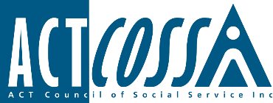

# cid:a89dd07e-11b7-413d-9387-93eb0005c944@ausprd01.prod.outlook.comC:\Users\kellie\AppData\Local\Microsoft\Windows\INetCache\Content.Outlook\6WPKUP8E\Uniting purple logo on white background for digital (RGB jpeg).jpgC:\Users\kellie\AppData\Local\Microsoft\Windows\INetCache\Content.Word\TasCOSS blue transp logo.jpgC:\Users\kellie\AppData\Local\Microsoft\Windows\INetCache\Content.Outlook\6WPKUP8E\master_logo_red_notag (2) (002).jpgC:\Users\kellie\AppData\Local\Microsoft\Windows\INetCache\Content.Outlook\6WPKUP8E\RENEW_RGB_Logo_w_Strapline.jpgSummary

Smart meters or metering are digital electricity meters or devices that can communicate energy information to the consumer, network operators and retailers/aggregators. Smart metering can have multiple benefits for networks, retailers and consumers, when implemented well and with appropriate consumer protections and support, smart metering can deliver a more efficient and effective energy system and reduce the costs of essential energy to all consumers.

Smart metering will become essential infrastructure, to enable consumers to access new services, markets and pricing and to facilitate more effective and efficient management of the electricity grid. It will therefore be critical that all consumers including people with low income or experiencing disadvantage can access smart metering to ensure they are not left behind in the energy transition.

The 2015 changes to metering rules – transferring smart metering roles and responsibilities away from networks service providers to retailers and metering coordinators – has created a series of complex relationships with multiple stakeholders that separate responsibility from incentives, benefits and costs.

The changes have not met expectations. Reforms were expected to lead to an extensive smart meter uptake and provide a range of consumer benefits, including access to better information, new products and services, and better retail and network services.

Instead Australia is lagging behind OECD countries in penetration of smart metering. The framework has become complicated, with dysfunctional relationships between participants and no clear objectives, and has led to metering specifications that are inadequate and not efficiently and effectively realising the key potential benefits that metering technology can enable for all consumers.

In addition, there are a number of reforms that need to be made in parallel to deal with potential downsides to installation of smart metering, especially for people on low incomes or experiencing disadvantage, in particular:

* Reforms are needed with respect to the implementation of time-of-use and demand tariffs, where consumers are being ‘opted’ in or ‘defaulted to’ these tariffs where a smart meter is present, despite some consumers being worse off.
* Reforms are needed to rules regarding remote disconnection for non-payment, which is resulting in further pressures on finances, health and wellbeing of people already experiencing hardship.

Recommendations

The submission makes 21 recommendations, which are outlined in full below, including:

* Clearly define objectives and principles to guide reform
* Treat smart metering as essential infrastructure, accessible to all
* Increase minimum service standards
* Restrict remote disconnection for debt management
* Improve access to data
* Ensure adequate consumer protection
* Provide better consumer information and education to maximise benefits
* Ensure vulnerable consumers are not worse off under tariff reform policy

# Discussion

We welcome the opportunity to make a submission on the Review of the Regulatory Framework for Metering Services.

The primary focus of this submission will be consideration of how to improve the efficiency, effectiveness and social equity of smart metering regulation to realise benefits for all consumers, including people on low-income or experiencing disadvantage. It will also briefly consider interrelated issues that impact on consumer confidence of smart metering including tariff reform, disconnection, and data privacy.

## Smart metering can facilitate better consumer outcomes

Smart meters or metering are electronic devices used in the home, business or on networks that digitally record energy information such as energy consumption, voltage levels, current and power factor. They communicate the information to the consumer, network operators and retailers/aggregators to optimise network use and, with appropriate software and communications, can assist consumers to reduce energy costs and improve the efficiency of their use.

As shown in Figure 1, smart metering can have multiple benefits for networks, retailers and consumers, that together can deliver a more efficient and effective energy system and reduce the costs of essential energy to all consumers. Which will particularly benefit people on low incomes who pay disproportionately more of their income on energy bills.[[1]](#footnote-1)

For example, the information to networks can enable them to better manage the energy system and identify faults more efficiently and effectively, thereby reducing costs.

The information to retailers enables better billing services, efficient service delivery (i.e remote connections), innovative pricing and delivery of new services or products.

The information to consumers can help them better understand and manage energy costs and consumption. Advanced smart metering technologies also enable consumers that have the technology to access a range of beneficial behind the meter (aka in the home) services like reading the consumption of and managing smart appliances, demand response, electric vehicle charge and discharge, and solar PV.

Smart metering will play a major and increasingly important role in the future grid as identified by the Energy Security Board in their Post-2025 Market Design Review, especially for participation in the two-sided market and further DER integration.[[2]](#footnote-2)

As such, smart metering will become an essential infrastructure for all consumers, to enable access to new services, markets and pricing and to facilitate more effective and efficient management of the grid. It will therefore be critical that all consumers including people with low income or experiencing disadvantage can access smart metering to ensure they are not left behind in the energy transition.

We are concerned the current regulatory model is failing to ensure no-one is left behind. Specifically, people on low incomes and experiencing disadvantage, especially those who rent, will be some of the last groups of consumers to access smart metering and/or not realise all the benefits. This would exacerbate existing disadvantages and result in people already vulnerable to energy stress being further left behind in the energy transition.

**Figure 1 Potential benefits of smart metering\***

|  |  |  |  |  |
| --- | --- | --- | --- | --- |
| **Consumer Benefits** |  | **Network Benefits** |  | **Retailer Benefits** |
| * Access to new energy:   + Services & products, such as demand management & virtual power plants (VPP)   + Pricing options * Contribution to improved energy literacy & control over energy costs:   + Access to accurate and frequent information about energy use through smart meter data   + Apps that provide user friendly data like charts   + Apps that provide projected costs. * Elimination of estimations of bills to improve bill accuracy & more frequent billing to manage budgets & reduce bill shock * Manage smart appliances * Ability to change retailer more quickly * Maximise the value of solar & battery systems though measurement of solar exports * Faster restoration & reduced blackouts due to smart meter grid management * Improved safety & cost reduction through identification of faults or problems. |  | * Dynamic voltage control to help manage network peaks * Enable effective management of DER, such as solar, by data to improve visibility of low voltage network & enable operating envelopes, granular control and export management. * Coordinate smart charge infrastructure * Avoid infrastructure investment through imported asset performance, insights & targeted maintenance, * Better outage management & restoration via real-time data * Improved safety due to neural integrity monitoring |  | * Minimises manual meter reading costs * Real-time data improves demand forecasting & consumer insights * Should improve customer experience & reduce pain points and complaints through access to data and timely bill management * Enables development and delivery of new services & products, including VPPs & DER schemes |

\* Note some of the potential benefits are interdependent and/or contingent on other factors, for example, access to new pricing or tariff structure is only beneficial if the new tariff itself benefits the consumer.

## Purpose of the smart metering review

In 2015, the *Expanding competition in metering and related services rule (Competition in metering)* made extensive changes to the metering rules, transferring smart metering roles and responsibilities away from networks service providers to retailers and metering coordinators.

The rather complex rules require multiple participants, with different roles and responsibilities (see figure 2). The rules allow any party that meets certain registration requirements to provide metering services. The retailer is the first port of call and is responsible for arranging the metering services for its small customers by engaging the metering coordinator. The Metering Coordinator will appoint: a Metering Provider (MP) for metering installation and maintenance. a Metering Data Provider (MDP) for meter data activities. Distribution networks will need to enter into a commercial arrangement with retailers and/or metering coordinators to access metering services.

**Figure 2 Key roles and responsibilities of smart metering rollout in the NEM (except Victoria)[[3]](#footnote-3)**

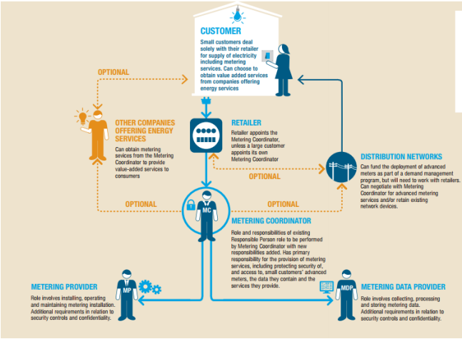

When a new connection is made, or when the customer’s existing meter is due for replacement (lifetime of existing meters can be 50 years[[4]](#footnote-4)), since 1st December 2017 the new meter must be ‘smart’ (an advanced meter with minimum specified capabilities), with the retailer and consumer not given any choice, i.e. a mandated rollout. Additionally, where a meter is faulty, or where a customer has installed solar PV and the meter is required to measure both imports and exports, a retailer will be obliged to install a smart meter.

In addition to mandatory installation in the case of replacements or new connections, the rules take a ‘market-led approach’:

* Retailers can choose which customers will be offered a smart meter, with the consumer free to accept or decline the offer; or
* customers can request the installation of a smart meter; however, if the customer’s existing meter remains fit for purpose and is working accurately the retailer is under no obligation to fulfil the customer’s request.

According to the AEMC consultation paper, the *Competition in metering* reforms were expected to lead to an extensive smart meter uptake and provide a range of consumer benefits, including access to better information, cost reflective pricing, new products and services, and better retail and network services.[[5]](#footnote-5)

The Commission has, therefore, self-initiated this review to determine whether the reforms introduced under the *Competition in metering* rule change have (a) met expectations and (b) whether changes are required to improve the efficiency and effectiveness of the regulatory framework for metering services. The review will also determine whether the regulatory framework for metering services supports the implementation of other electricity sector reforms where metering services will play a role.

## Expectations of the 2015 smart metering reforms have not been met

With the exception of Victoria, which took a more equitable route and undertook a mandatory statewide rollout, rollout in other National Energy Market (NEM) states and territories has been slow and cumbersome.

Outside of Victoria, Australia has one of the lowest levels of smart meter adoption in the OECD of only 15%[[6]](#footnote-6)-17.4%[[7]](#footnote-7), compared to Italy, Finland, China and Sweden above 90%, and New Zealand on 73% (see figure 3). While NSW has installed the largest number of smart meters (see figure 4) and Tasmania has the highest penetration, the vast majority of consumers remain on old electricity meters, with data read only four times a year.

**Figure 3. Advanced metering penetration by Country**[[8]](#footnote-8)

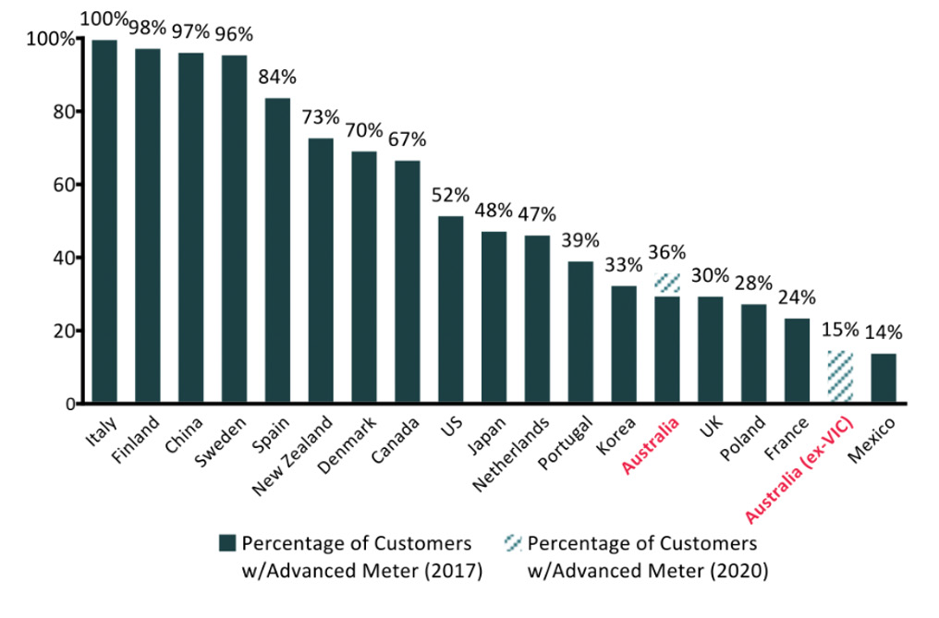

**Figure 4. Total Number of smart meters by jurisdiction[[9]](#footnote-9)**

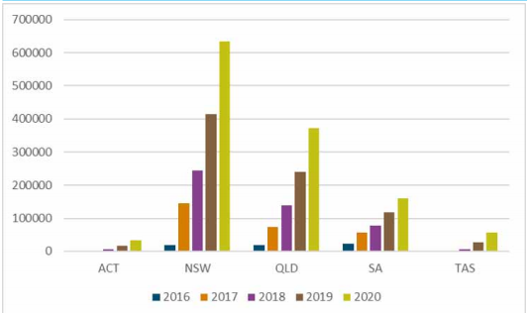

According to Intellihub, since the *Competition in metering* rules took effect in December 2017, around 5% of meters are being replaced with smart metering each year, mainly for new houses or for customers who need them to install solar PV.[[10]](#footnote-10)

Intellihub calculate it would be close to 2050 before a full deployment of smart meters is achieved in Australia at the current rate of deployment. In comparison, other countries completed or plan to complete smart meter deployments in five to seven years (see figure 5).[[11]](#footnote-11)

**Figure 5. EU Smart-metering deployment timelines[[12]](#footnote-12)**

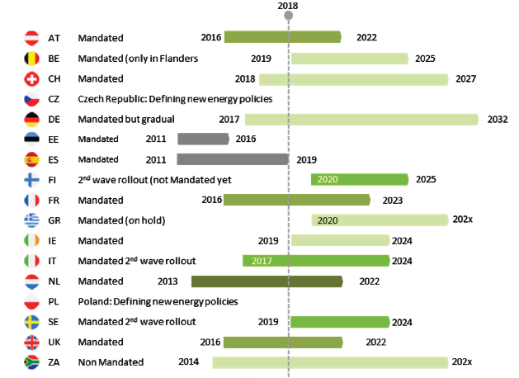

As shown in figure 6, the majority of smart meter uptake has been a result of customer request primarily for the installation of solar, new connection, and meter repair/replacement. Only 14.5% has been retailer led. It’s unknown how many people on low-income have received smart metering.

**Figure 6. Reasons for smart meter update, 2019-2020[[13]](#footnote-13)**

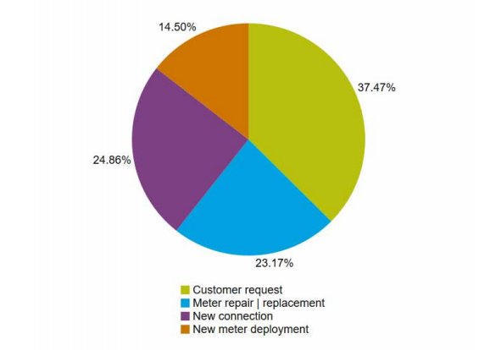

We agree with the stakeholders’ views expressed in the AEMC consultation paper (4.2.1) that the smart metering and smart metering data is being underutilised and the various benefits outlined in figure 1 are not being realised. As noted above we are particularly concerned the current model does not facilitate an equitable roll out of smart meters and people on low incomes and experiencing disadvantage, especially those who rent, will be some of the last groups of consumers to access smart metering and/or not realise all the benefits.

It has been argued that many of the benefits of smart metering require market saturation to be realised;[[14]](#footnote-14) access to a beneficial range of services; consumer education and support, and more functional data access arrangements.

In addition, the report *Smart-er Metering Policy: Getting the framework right for a consumer-focused smart meter rollout*[[15]](#footnote-15) out of the University of Melbourne raises concern that under previous metering rules, household meter pricing was regulated. However, under current rules the price is unregulated in most of the NEM. This raises concerns about the impact of the reforms on consumer electricity prices and impact on equity.

Smart metering has also been the subject of numerous complaints to ombudsman schemes over recent years, resulting in incorrect billing or health and safety concerns.[[16]](#footnote-16)

## Barriers to smart metering uptake and full realisation of benefits

While there are significant benefits and opportunities arising from well implemented smart metering for the energy system and ultimately all consumers, there are a range of issues that are and will continue to act as a barrier to smart metering rollout, especially for people on low-income or experiencing disadvantage.

It is therefore critical that the regulatory framework is built upon an adequate and up-to-date understanding of the barriers faced by consumers in realising the benefits of smart metering and that it includes measures that address these barriers. The regulatory framework should aim to ensure that smart metering does not result in greater complexity and increased burden being placed on energy consumers in order for them to access affordable energy.

### Current rules are complex, ad hoc and inequitable

There are no incentives, guidelines or timeframes provided to facilitate a faster, more cost-effective and more equitable uptake of smart meters. Under current rules, smart metering rollout might not be complete until 2050[[17]](#footnote-17) or longer.[[18]](#footnote-18)

Having multiple parties involved in installation of a smart meter increases the cost of installation and maintenance.

The costs of each installation are relatively high due to the ad hoc geographic nature of new customer connections and meters requiring replacement, versus a planned large-scale rollout.[[19]](#footnote-19)

### Smart metering not considered essential infrastructure

The current regulatory framework does not consider smart metering as essential infrastructure, despite:

* the clear benefits to the energy system and consumers, and
* their necessity to participate in new proposed markets (two-sided market) and access new services (demand management, managing smart appliances, solar PV, virtual power plant) or new pricing reforms (time-of-use tariffs or demand tariffs)

### Lack of appropriate consumer information, tools, data and support

There is a lack of information and education for consumers about smart meters, the benefits, service options, and how to optimise benefits.

For example, there is low awareness amongst consumers that they can request a copy of their consumption data used to calculate their electricity bill. According to the report *Smart-er Metering Policy*[[20]](#footnote-20), the process for requesting consumption data is cumbersome.

The report also notes that the data is often not presented in a simple consumer-friendly format, and there are limited tools provided to assist consumers to help understand and interpret their data. Ensuring there is simple user friendly information and tools is important, particularly for people with low energy literacy, language or other barriers.

There is no simple way for consumers to authorise third party access to their billing data to provide advice on options.

With the exception of the Victorian Government’s SwitchOn Tariff comparison website, there is no user-friendly independent platform that enables customers to plug in their smart metering data to compare tariffs and services.

### Consumers not getting access to full range of services

The *Smart-er Metering Policy* report found that retailers are not offering the full range of smart meter enabled services to their customers.[[21]](#footnote-21)

While the AEMC sets a minimum of six service specifications (see 2.5.3 of consultation paper), these minimum services mainly benefit retailers:[[22]](#footnote-22)

Assessment shows that there are limited benefits across all consumers from the minimum services. The analysis shows the minimum six services provide predominantly retailer benefits and will assist in reducing their operational costs. There is no guarantee of consumer benefits and none of the services support distributor benefits which could indirectly translate into consumer benefits and/or societal benefits.

The minimum service specifications do not include access to behind the meter services and emerging markets. The Victorian mandated rollout required access to at least 20 service specifications.

The report argues that only scheduled meter read has the potential to provide ongoing benefits to all households in the shape of more accurate and frequent billing, but that access to these and other benefits is not currently guaranteed.

### Poor utilisation of data undermines benefits

As noted above, there are still significant barriers to customers or third parties accessing the metering data and that data being utilised to better understand energy use, compare offers, or identify value added services.

Due to insufficient minimum specifications of metering, and dysfunctional relationships created by the framework, there is no certainty that networks can access the data they require to provide better services, or that it will be provided cost-effectively even if they can access the data. Without access to data, network benefits are not realised or households could end up with two meters, one belonging to their retailer and one belonging to their network.

### Remote disconnection for non-payment is detrimental

The *Smart-er Metering Policy* report notes that one of the 6 services, remote de-energisation (disconnections), can disadvantage consumers, in particular people experiencing energy hardship where disconnections can be made remotely without making contact or visiting the resident.

Consumers should not be disadvantaged by smart metering reform. Remote disconnection for the purpose of debt management is problematic and should be addressed.

### Smart metering should enhance consumer choice of tariffs options, not force vulnerable people on tariffs where they may be worse off.

In most network areas, time-of–use or demand tariffs, are being introduced. While time-of-use tariffs can reduce network costs because they better reflect the costs when the network is being utilised, for some people it can be hard to shift their energy use to avoid higher prices or take advantage of lower prices, and can end up paying more for energy.

For example, a study from the United States identified equity concerns for vulnerable consumer groups in the transition to time-of-use tariffs (TOU):

We found that assignment to TOU disproportionately increases bills for households with elderly and disabled occupants, and predicts worse health outcomes for households with disabled and ethnic minority occupants than those for non-vulnerable counterparts. These results suggest that vulnerable groups should be considered separately in demand-side response rate design, and future pilots should seek to determine which designs most effectively avoid exacerbating existing energy injustices or creating new ones.

Similar concerns have been raised in the Australian context and was highlighted in the 2020 DEIP Access and Pricing Outcomes Report, where it recommended:

AEMC initiates a review (in collaboration with consumer groups, networks, retailers and the AER), of the impact of consumption tariff reform on customers, in particular vulnerable consumers, within the next 12 months. This would identify additional actions needed to be undertaken by retailers, improve consumer protections and support improving choice and control via complementary measures.[[23]](#footnote-23)

This is an issue for smart metering reform because in some networks and/or jurisdictions, consumers are being “opted-in” or “defaulted” to tariffs, like time-of-use tariffs, upon installation of a smart meter.

For example, in South Australia, the South Australian Government introduced its ‘Regulatory Changes for Smarter Homes’ policy, which includes a requirement for retailers to Mandatorily assign customers currently on smart meters to a time of use (ToU) tariff. Implementation of this requirement has been delayed due to COVID-19, but will come into effect on 1 July 2021. During 2020-21, any new meter connections or upgrades (e.g. new builds, renovations, solar installed post 1 July 2020) have been placed on a ToU tariff as a default, with some provision for customers to opt out. From 1 July 2021, customers with smart meters will have no option to opt-out with the ToU tariffs applied by default.

Whereas in Victoria, the rules introduced by the Victorian Government, state that retailers have to include a flat retail tariff as a standing offer; get explicit informed consent before putting a residential customer on a flexible or cost -reflective retail tariff; and give small customers (defined as residential and small business) the right to opt-out of a cost-reflective retail tariff.

In the Australian Capital Territory, there is no Government policy with respect to implementation of tariff reform, but some retailers are defaulting customers to demand tariffs. The network provider Evoenergy, is automatically allocating consumers to network demand tariffs if they have a smart meter. Electricity retailers can choose whether they apply Evoenergy’s network demand tariffs to their customers through their retail tariffs. Until recently, ActewAGL customers with a smart meter were automatically placed on a retail demand tariff and had an option to switch to a time-of-use tariff; they were not able to access flat rate tariffs. ActewAGL changed its tariff assignment policy from 1 July 2020, and customers with smart meters are now automatically placed on time-of-use tariffs and can opt to move to a retail demand tariff. Other ACT electricity retailers – Origin Energy and Energy Australia – offer flat rate retail tariffs to smart meter customers despite having an underlying network demand tariff.

Where implementation of time of use tariffs are up to retailers, retailers may not yet have determined or publicised their policy regarding network time-of-use or demand tariffs and whether those will be passed through.

Retailers may not adequately explain potential new default tariff styles that can flow from the presence of a smart meter, or what options a consumer has with respect to the take-up of new tariffs.

As a result, consumers are reportedly avoiding installation of smart metering because they do not want to go on a new tariffs such as time-of-use.

It’s critical that vulnerable consumers are not disadvantaged from smart metering, smart metering should enhance consumer choice of tariffs options, not force vulnerable people on tariffs where they may be worse off.

# Recommendations

The following recommendations provide direction of further reforms we believe are necessary to maximise smart metering benefits for all consumers. Further consideration would be needed as to how new reforms would be implemented.

## Clearly define objectives and principles to guide reform

In the report *Smart-er Metering Policy* by the University of Melbourne, the authors outlined the advantages and disadvantages of different approaches (mandatory, voluntary and hybrid) to smart meter roll out (see appendix A). To determine which approach is appropriate, it is important to have clear objectives and principles to guide the approach to ensure the desired consumer benefits and outcomes are achieved.

We believe the following problem statement, objective and principles should be considered.

Proposed problem statement - Smart metering rollout

The framework for metering has created a series of complex relationships with multiple stakeholders that separate responsibility from incentives, benefits and costs. The framework is complicated, with no clear objectives, and has led to metering specifications that are inadequate and metering arrangements that are not efficiently and effectively realising the key potential benefits that metering technology can enable for all consumers.

Proposed objectives - Smart metering rollout

To roll out appropriately capable smart metering to consumers in a timely, cost-effective and equitable way, and to ensure metering contributes to an efficient energy system capable of maximising the benefits for all consumers.

Proposed Principles - Smart metering rollout

* Consumers should benefit from smart meters and not be disadvantaged.
* Smart metering should be considered essential infrastructure for all consumers, to facilitate access to clean, affordable and dependable energy for all.
* Metering responsibilities should be simplified to improve efficiencies, easy for consumers and reduce risks.
* Responsibility for metering should be delegated to entities with most capability for managing cost and risk efficiently, and most direct incentive to undertake rollout quickly, efficiently and for the benefit of the system.
* There should be clear and transparent responsibility for who the meter belongs to, who is responsible for maintenance and replacement.
* Costs to individual consumers of installing smart meters should not be a barrier and should be minimised. It should be covered by network/retailer efficiency gains and other benefits.
* Improve consumer decision-making by providing appropriate consumer information and education on smart metering, rights and capabilities, smart metering services and managing energy needs. Ensuring options and tools are clear, transparent, learnable, in plain language and accessible.
* Minimum service and compliance provisions are documented and transparent.
* Installation and ongoing use of meters should be done in a way to prevent health and safety risks.
* Adequate protections are in place, including the inclusion of smart metering complaints in energy ombudsman schemes.
* Data framework developed that:
  + Enables access to smart metering data by market participants at marginal costs;
  + Gives consumers the right to have control over their own data, at no cost; and
  + Enables appropriate and necessary use of data for energy services.
* Protections are in place to reduce data security risk and report transparently.
* Supports energy transition and decarbonisation of the electricity grid.
* Regular reviews should be undertaken to monitor and report on benefits.

These principles should be considered as part of the assessment framework.

Recommendation 1:AEMC to develop problem statement, objectives and principles in consultation with consumers and stakeholders.

## Treat smart metering as an essential infrastructure, accessible to all

Recommendation 2:There should be a universal scaled roll out of smart metering. A timeline should be set for smart metering to be rolled out to improve social equity and receive the full range of smart metering benefits, by 2030, preferably sooner.

Recommendation 3:Consideration should be given to transferring smart metering installation and maintenance back to Distribution Network Service Providers as part of delivering essential infrastructure; reducing complexity, dysfunction and inefficiency; and generating maximum individual consumer and social benefits. If so, the metering costs and regulated asset base implications will need to be a part of Network regulatory proposals and associated AER review, over an appropriate appreciation period.

## Increase minimum service standards

Recommendation 4: AEMC should increase the minimum service specifications to include services that will benefit consumers and enable participation in new markets. Additional functions should be added at no costs (see also recommendation 5 on disconnections).

## Restrict Remote Disconnection for debt management

Recommendation 5:Remote disconnection for the purpose of debt management is problematic and should be addressed. Retailers should be required to have demonstrated they have carried out all prior obligations and undertaken a site visit before remote disconnection can occur.

## Improve Access to Data

Recommendation 6: Consumers should be given access to their data at no cost.

Recommendation 7: Enable access to smart meter services for consumers’ authorised representatives (third parties) in a way that upholds privacy protections and reinforces consumer access and control of data.

Recommendation 8: Party responsible for metering data should provide universal access to market participants at marginal costs.

## Ensure adequate consumer protection

Recommendation 9:Smart metering complaints and handling be included in energy ombudsman schemes.

Recommendation 10:Consumer protections should be enhanced and the lessons learnt from Victoria smart metering roll-out, including wrongful disconnections, be incorporated.

Recommendation 11:National Energy Customer Framework (NECF) and Australian Consumer Law are regularly reviewed and modified to support customers in the purchase of new energy products and services.

Recommendation 12: Complementary measures are developed to provide access to affordable, clean dependable energy, for those that can’t access smart metering and/or participate in the energy market.

## Provide better consumer information, education and supports to maximise benefits

In addition to a timely universal scaled roll out of smart metering, better coordination and better data access arrangements, there is a need for better consumer information and education to help consumers get the most out of their smart metering.

Recommendation 13:Requirement that there is consistent and simple communications around smart meters for all households, notifying them of their entitlements and rights, including data access.

Recommendation 14**:** Require Retailers or aggregators to provideappropriate information, tools (such as apps), education and supports to consumers to:

* increase their awareness about the services available as a result of smart metering and how to use them;
* better understand, interpret and utilise their data to maximise the ability to lower their electricity costs; and
* realise the benefits of smart metering regardless of their data and/or digital capacity.

Recommendation 15:Governments provide targeted communications, education, and support for vulnerable consumers to ensure they can reap the benefits from smart metering.

Recommendation 16: The Australian Government’s Energy Made Easy tariff comparison website be reviewed and upgraded to include the ability to compare time-of-use and fixed tariffs; providing annual costs information and add support for solar credits.

Recommendation 17: Develop a process for the simple user-friendly provision of smart meter data to consumers.

Recommendation 18: Consumers to be able to grant third parties access to the data in a way that protects consumer privacy rights.

## Ensure vulnerable consumers are not worse off under Tariff reform policy

Recommendation 19: Complementary tariff policy be developed to ensure there are tariff options for consumers, and consumers are not forced on to tariffs that could leave them worse off.

Recommendation 20: Jurisdictions invest in communications campaigns to educate and support consumers with tariff reform.

Recommendation 21:AEMC initiates a review (in collaboration with consumer groups, networks, retailers and the AER), of the impact of consumption tariff reform on customers, in particular vulnerable consumers, within the next 12 months. This would identify additional actions needed to be undertaken by retailers, improve consumer protections and support improving choice and control via complementary measures.[[24]](#footnote-24)

#### Acknowledgements

This submission was prepared in consultation with the ACOSS Climate and Energy Policy Network and members of the National Energy Consumer Roundtable. In addition to the signatories, we’d like to acknowledge the contributions of PIAC and YFS Ltd (Logan).

#### Contact

Kellie Caught, Senior Adviser Climate and Energy, ACOSS

E: [kellie@acoss.org.au](mailto:kellie@acoss.org.au) M: 0406383277

# Appendix - Advantages and disadvantages of different models of Smart meter rollout

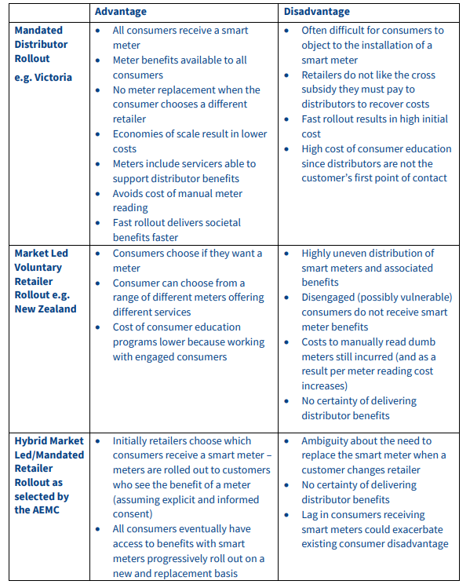

Source: Chandrashekeran, S, Dufty G and Gill M (2018) [Smart-er Metering Policy: Getting the framework right for a consumer-focused smart meter rollout](https://geography.unimelb.edu.au/__data/assets/pdf_file/0007/2685643/Smart-er-meter-policy-230218.pdf)

1. ACOSS and BSL (2019) [Energy Stressed in Australia.](https://www.acoss.org.au/wp-content/uploads/2018/10/Energy-Stressed-in-Australia.pdf) [↑](#footnote-ref-1)
2. Energy Security Board (2020) [Post 2025 Market Design Consultation Paper](http://www.coagenergycouncil.gov.au/sites/prod.energycouncil/files/publications/documents/P2025%20Market%20Design%20Consultation%20paper.Final_.pdf). September 2020. [↑](#footnote-ref-2)
3. Chandrashekeran, S, Dufty G and Gill M (2018) [Smart-er Metering Policy: Getting the framework right for a consumer-focused smart meter rollout](https://geography.unimelb.edu.au/__data/assets/pdf_file/0007/2685643/Smart-er-meter-policy-230218.pdf). [↑](#footnote-ref-3)
4. Ibid. [↑](#footnote-ref-4)
5. AEMC (2020) [Consultation Paper: Metering Services Review](https://www.aemc.gov.au/sites/default/files/2020-12/EMO0040%20Review%20of%20the%20regulatory%20framework%20for%20metering%20services-%20Consult%20paper%20FINAL%20v2.pdf). Page 2 [↑](#footnote-ref-5)
6. Intellihub (2020) Intellihub group submission to technology investment roadmap discussion paper. [↑](#footnote-ref-6)
7. AEMC (2020) [Consultation Paper: Metering Services Review](https://www.aemc.gov.au/sites/default/files/2020-12/EMO0040%20Review%20of%20the%20regulatory%20framework%20for%20metering%20services-%20Consult%20paper%20FINAL%20v2.pdf). [↑](#footnote-ref-7)
8. Intellihub (2020) Intellihub group submission to technology investment roadmap discussion paper. [↑](#footnote-ref-8)
9. AEMC (2020) [Consultation Paper: Metering Services Review](https://www.aemc.gov.au/sites/default/files/2020-12/EMO0040%20Review%20of%20the%20regulatory%20framework%20for%20metering%20services-%20Consult%20paper%20FINAL%20v2.pdf). [↑](#footnote-ref-9)
10. Intellihub (2020) Intellihub group submission to technology investment roadmap discussion paper. [↑](#footnote-ref-10)
11. Ibid. [↑](#footnote-ref-11)
12. Ibid. [↑](#footnote-ref-12)
13. AEMC (2020) [Consultation Paper: Metering Services](https://www.aemc.gov.au/sites/default/files/2020-12/EMO0040%20Review%20of%20the%20regulatory%20framework%20for%20metering%20services-%20Consult%20paper%20FINAL%20v2.pdf). [↑](#footnote-ref-13)
14. DelosDelta (2018) [The Smart Metering Revolution: How Australia Fell Behind, and How We can Get Back on Track](https://www.delosdelta.com/wp-content/uploads/2018/10/The-Smart-Meter-Revolution-Delos-Delta-Report-FINAL-Oct-2018.pdf). [↑](#footnote-ref-14)
15. Chandrashekeran, S, Dufty G and Gill M (2018) [Smart-er Metering Policy: Getting the framework right for a consumer-focused smart meter rollout.](https://geography.unimelb.edu.au/__data/assets/pdf_file/0007/2685643/Smart-er-meter-policy-230218.pdf) [↑](#footnote-ref-15)
16. <https://www.abc.net.au/news/2019-10-16/energy-company-apologises-for-issuing-incorrect-bills/11606754> [↑](#footnote-ref-16)
17. Intellihub (2020) Intellihub group submission to technology investment roadmap discussion paper [↑](#footnote-ref-17)
18. Chandrashekeran, S, Dufty G and Gill M (2018) [Smart-er Metering Policy: Getting the framework right for a consumer-focused smart meter rollout](https://geography.unimelb.edu.au/__data/assets/pdf_file/0007/2685643/Smart-er-meter-policy-230218.pdf). [↑](#footnote-ref-18)
19. DelosDelta (2018) [The Smart Metering Revolution: How Australia Fell Behind, and How We can Get Back on Track](https://www.delosdelta.com/wp-content/uploads/2018/10/The-Smart-Meter-Revolution-Delos-Delta-Report-FINAL-Oct-2018.pdf). [↑](#footnote-ref-19)
20. Chandrashekeran, S, Dufty G and Gill M (2018) [Smart-er Metering Policy: Getting the framework right for a consumer-focused smart meter rollout](https://geography.unimelb.edu.au/__data/assets/pdf_file/0007/2685643/Smart-er-meter-policy-230218.pdf). [↑](#footnote-ref-20)
21. Ibid. [↑](#footnote-ref-21)
22. Ibid. [↑](#footnote-ref-22)
23. [DEIP Access & Pricing Reform Package: Outcomes report, June 2020](https://arena.gov.au/assets/2020/07/deip-access-pricing-reform-package-outcomes.pdf). [↑](#footnote-ref-23)
24. As per finding 9 and accompanying next steps in [DEIP Access & Pricing Reform Package: Outcomes report, June 2020](https://arena.gov.au/assets/2020/07/deip-access-pricing-reform-package-outcomes.pdf). [↑](#footnote-ref-24)