ACOSS Health of the NEM 2020:

Health of the NEM- Current and emerging affordability issues for people on low incomes

December 2020

The Australian Council of Social Service (ACOSS) is a national voice in support of people affected by poverty, disadvantage and inequality and the peak body for the community services and civil society sector.
ACOSS consists of a network of approximately 4000 organisations and individuals across Australia in metro, regional and remote areas.
Our vision is an end to poverty in all its forms; economies that are fair, sustainable and resilient; and communities that are just, peaceful and inclusive.

Locked Bag 4777
Strawberry Hills, NSW 2012
Australia
Email: info@acoss.org.au
Website: www.acoss.org.au
© 2020 ACOSS

This report was drafted for ACOSS by The Energy Project Pty Ltd

www.energyproject.com.au

The report was managed and finalised by Kellie Caught, Senior Adviser (Climate and Energy), ACOSS
ACOSS would like to acknowledge members of the ACOSS Climate and Energy Network and the National Consumer Roundtable on Energy for their input in finalising the report and recommendations.

Contents
Executive Summary 3
Recommendations 4
Health of the NEM rating 4
Dedicated process to reduce vulnerability to energy 4
Policies and measures 4
1. Background 8
1.1 ESB assessment criteria 8
1.2 Price trends vs affordability trends 9
1.3 Understanding vulnerability 10
1.4 Policy framework to support low-income and disadvantaged households 12
2. COVID-19 Impacts 13
2.1 Statement of the issue 13
2.2 Message to the ESB 13
2.3 Energy bill affordability 13
2.4 Energy debt 16
2.5 Energy market responses 18
2.6 Jurisdictional assistance 19
3. Issues raised in 2019 ACOSS Health of the NEM brief 21
3.1 Difficulties accessing information 21
3.2 Inadequate energy concessions frameworks 21
3.3 Inadequate hardship policies 21
3.4 Inadequate consumer protections 22
3.5 Inability to access energy efficiency measures and distributed energy resources 22
4. Post-2025 energy market design 22
4.1 Inadequate consumer protections 22
4.2 Message to the ESB 23
4.3 Background 23
5. Emerging issue: Embedded Networks 23
5.1 Statement of the issue 23
5.2 Message to the ESB 24
5.3 Background 24
5.4 Current issues 25
5.5 Regulatory framework declared not fit for purpose in 2017 29
6. Emerging Issue: Gas transition 29
6.1 Statement of the issue 29
6.2 Message to the ESB 29
6.3 Background 30
6.4 Current issues 31

Executive Summary
Each year the Energy Security Board (ESB) reports on the Health of the National Energy Market (NEM), including on current and emerging affordability issues. The report is an annual assessment of how well the east coast electricity and gas markets are functioning and where improvement is required. It includes rating the health of the objective ‘affordable energy and satisfied consumers’ against current status and future outlook.
ACOSS has developed this brief to ensure the energy issues facing people on low incomes and experiencing disadvantage are recognised, assessed and have appropriate solutions implemented. This is important because access to affordable, clean, and reliable energy is essential - it is critical to the health, wellbeing, economic participation and social inclusion of people. This is the second year ACOSS has provided a brief.
In assessing the Health of the NEM in 2020, the impacts of the COVID-19 pandemic cannot be ignored. While average wholesale prices and default residential electricity prices have fallen in 2020, the COVID-19 impacts of increased residential consumption, lower employment and lower incomes have and will over the coming 12 months combine to reduce affordability and exacerbate vulnerability for a large number of households.
The September 2020 ABS Household Impacts of COVID-19 Survey found over 20% of households with children reported that their finances had worsened. The October survey found that of the 12% of Australians who had accessed their superannuation, 58% said they were doing so to pay household bills, followed by 49% purchasing household supplies, including groceries.
The Australian Energy Regulator (AER) and Victorian Essential Services Commission (ESC) have been publishing weekly data with worrying trends. Following a moratorium on disconnections for non-payment at the start of the pandemic, both regulators are expressing concern over the levels of energy debt being accrued. While multiple retailers have seen a significant increase in the rate of people meeting hardship payment plans that were in place prior to COVID-19, most likely due to the Coronavirus Supplement that initially doubled the rate of JobSeeker, overall debt is growing and likely to continue to grow when the Coronavirus Supplement is cut further. The ESC is also reporting similar concerns around hardship and debt for water customers.
In addition to the issues being created because of COVID-19, many of the issues raised in the 2019 ACOSS Health of the NEM report stubbornly remain, such as difficulties accessing information, inadequate energy concession frameworks, inadequate and inconsistent hardship policies, inadequate consumer protections, and an inability for people on low incomes to access energy efficiency measures and distributed energy resources.
Further, two new issues are emerging in the NEM that need to be addressed:
- The rise of Embedded Networks (ENs) - privately owned and managed electricity networks that often supply all premises within a specific area or building - as the ‘model of choice’ for developers of new medium and high-density housing is limiting choice for consumers and exposing gaps in the consumer protection framework.
- The transition away from fossil gas to electricity or to hydrogen will have costs to consumers. However, there is no accurate information on what the costs will be, no plan for a transition or understanding of who pays. The longer we delay a clearly articulated plan or transition, the greater the increase in risks and costs will be for people less able to transition.
Energy is an essential service. For people, it is critical to health, social, and economic outcomes. What’s clear is that energy debt, deprivation and disconnection remains persistent, with 2020 shining a light on the failures of the system to protect people experiencing vulnerability. What’s more, failure to address issues relating to the energy transition such as access to energy measures and technologies that can reduce energy bills, and a lack of planning around the gas transition, means people on low incomes or experiencing disadvantage are at risk of being left behind and facing worsening energy poverty.
Given the range of current persistent and emerging issues impacting on energy affordability, especially for people on low incomes or experiencing disadvantage, we recommend the following.

Recommendations

Health of the NEM rating
Recommendation 1: The ESB maintain its rating of the current status of affordability and vulnerable customers as Critical.
Recommendation 2: The ESB revise the outlook for affordability from Moderate to Moderate-Critical.
Recommendation 3: The ESB revise the outlook for vulnerable customers from Moderate-Critical to Critical.

Dedicated process to reduce vulnerability to energy
Recommendation 4: National Federation Reform Council should establish a permanent committee to annually review and progress reforms to reduce energy vulnerability.
Recommendation 5: The ESB establish another work stream in its post-2025 market design work to identify market and non-market solutions to deal with the limitations of rules and regulations post-2025 market design, to ensure no one is left behind in the transition.

Policies and measures

Outcome 1: Stable and efficient pricing
Recommendation 6: The Federal Government should shift the Small-Scale Renewable Energy Target (SRET) off consumer bills and onto the Federal Government budget. The scheme should be transitioned to be better targeted to people on low incomes to access energy efficiency measures and DER technology like rooftop solar, including public, Aboriginal and Community housing and low-income owner occupiers (see for example recommendation 18).
Recommendation 7: The NEM state and territory governments should shift any remaining solar feed-in-tariffs off electricity bills and on to State and Territory budgets.
Recommendation 8: AEMC initiate a review (In collaboration with consumer groups, networks, retailers and the AER), of the impact of consumption tariff reform on customers, in particular vulnerable consumers within the next 12 months. This would identify additional actions needed to be undertaken by retailers, improve consumer protections and support improving choice and control via complementary measures.
Recommendation 9: Implement a plan to incentivise emissions reductions in the NEM. We note the electricity sector can and should reduce its emissions faster than other sectors.
Recommendation 10: The National Federation Reform Council to undertake a review of the role of fossil and hydrogen gas in providing clean affordable energy for residential consumers, including costs of maintaining two networks or one network, and what plans and measures need to be put in place for the changing role - particularly for people who are least able to transition.
Recommendation 11: Introduce policies to improve price stability and affordability of gas for domestic electricity generation, manufacturing, and homes that are consistent with rapid and equitable transition away from fossil gas.
Recommendation 12: The AER and/or the Australian Energy Market Commission (AEMC) undertake a fit-for-purpose review of the National Gas Objective, gas law and rules to see how these might need to be changed in the context of NEM state and territory governments reaching net-zero emission targets.
Recommendation 13: Network approaches to managing stranded asset risk for the gas network (e.g. applications of accelerated depreciation to new and existing assets) should be the subject of a wider AER consultation process that considers the energy system as a whole and ensures that people on low income with limited choices do not pay excessively for any stranded assets.

Outcome 2: Informed and enabled consumers
Recommendation 14: The National Federation Reform Council progress ACCC recommendation 38 that the Federal Government and the relevant state or territory governments should fund a grant scheme for consumer and community organisations to provide targeted support to assist vulnerable consumers to improve energy literacy.
Recommendations 15: The AER require retailers to regularly notify their customers if they would be better off on another one of their offers.

Outcome 3: Energy consumed efficiently and productively
Recommendation 16: Building on the work of the Trajectory for Low Energy Building – Existing Homes, state and territory governments commit to implement the measures being developed to increase energy efficiency of existing homes, specifically:
- Introduce mandatory disclosure of home energy performance at point of sale;
- Introduce mandatory energy efficiency standards for rental properties.
Recommendation 17: The Federal Government and state and territory governments implement the proposal for a National Low-income Energy Productivity Program (NLEPP) which would install energy efficiency and solar energy efficiency measures, and solar systems, in the homes of people on low incomes (targeted at public housing, community housing, low-income homeowners, energy inefficient rental homes) and provide a low-income appliance replacement offer.
Recommendation 18: NEM state and territory governments review their home energy assistance schemes or equivalent to improve access, uptake, and ability to better meet the needs of those most vulnerable.
Recommendation 19: The Federal Government and state and territory governments partner to establish a Clean Energy for Aboriginal and Torres Strait Islander Communities Fund to invest in large scale and rooftop solar energy, battery storage and building energy efficiency improvements for regional and remote Aboriginal and Torres Strait Islander communities.
Recommendation 20: Enable residential households to access the demand response mechanism.
Recommendation 21: The Federal Government and state and territory governments provide support for low-income and other at-risk households in the transition to no fossil gas or renewable gas.

Outcome 4: Robust consumer protections
Recommendation 22: The moratorium on disconnections continues until at least June 2021. Upon recommencement of disconnections, retailers should be required to have demonstrated they have carried out all prior obligations before requesting permission to issue a disconnection notice that is delivered by a pre-visit.
Recommendation 23: The AER undertake a review of the new hardship guidelines by May 2021, with a view to further strengthening early access and improving uptake of retailer hardship policies, along the lines of the Victorian Payment Difficulty Framework.
Recommendation 24: NEM states and territory governments agree to implement the AEMC Embedded Network Reforms. With the reforms being retrofitted as far as possible to legacy embedded networks.
Recommendation 25: Specifically regulate new energy technology consumer protections or incorporate these into expansions of current regulation for traditional energy supply. This should include:
- Banning unsolicited sales for new energy technology products and services;
- Extending the Energy Ombudsman’s jurisdictions to include the retail sale of new energy products and services;
- Establishing a default fund to provide compensation to those entitled but unable to access it due to the insolvency of a new energy technology retail business;
- The national consumer credit laws should be amended so that all buy now, pay later finance arrangements fall within their ambit.
Recommendation 26: Develop and implement better metrics to measure energy affordability. There is a need to better measure energy affordability and to do so more frequently. ACOSS recommends using a range of primary and secondary indicators (like the EU does) to measure energy stress. Having a range of measures will capture different circumstances and behaviours including the deprivation of energy, and they will enable the development of more targeted and fit-for-purpose policy solutions. The metrics should be accessible to everyone at no cost.
Useful metrics include:
- Low-Income High-Cost (LIHC)
- Inability to keep home warm/cool
- Arrears on bills
- Hidden Energy poverty (HEP)
- Share of expenditure (2M)

Outcome 5: All households have the capacity to pay
Recommendation 27: The Federal Government provide additional short-term (up to 12 months) financial support (in recognition of additional hardship bought on by COVID-19), via an emergency payment allowance to customers in hardship arrangements. The mechanism for delivery of the financial support should be developed in consultation with consumer groups, states and territories, to ensure it is well targeted to those in need, complementary to State and Territory schemes, transparent and benefits the customer. As this will also relieve debt on the books of retailers, retailers must implement a range of measures including putting customers on a payment plan, no disconnections, making the best offer going forward, and providing energy efficiency advice. This payment does not negate the need to implement recommendation 28.
Recommendation 28: The Federal Government permanently increase the rate of JobSeeker, Youth Allowance and related payments by $185-$275 per week. The payments should be indexed to wages, a representative basket of goods, or the CPI (whichever is higher) to ensure they maintain pace with community living standards.
Recommendation 29: The National Federation Reform Council progress ACCC recommendation 37 to improve energy concession schemes across the NEM to ensure that, to the extent possible, there is a uniform, national, best practice approach to electricity concessions.

Background

ESB assessment criteria
Each year, the ESB assess the health of the NEM in terms of progress achieved and the future outlook for 6 objectives. The first objective ‘Affordable energy and satisfied customers’ aims to capture the plight of low-income and other vulnerable consumers. Progress is then assessed against 4 criteria:
- Energy is increasingly affordable for all consumers, supported by consumer protections and access to dispute resolution;
- Consumers are empowered to manage their demand and can access distributed energy and energy efficiency solutions;
- Consumers are able to and can easily identify and secure the best deal for their circumstances;
- Vulnerable consumers are on suitable pricing plans, receiving concessions when needed, and can benefit from distributed energy and energy efficiency schemes.
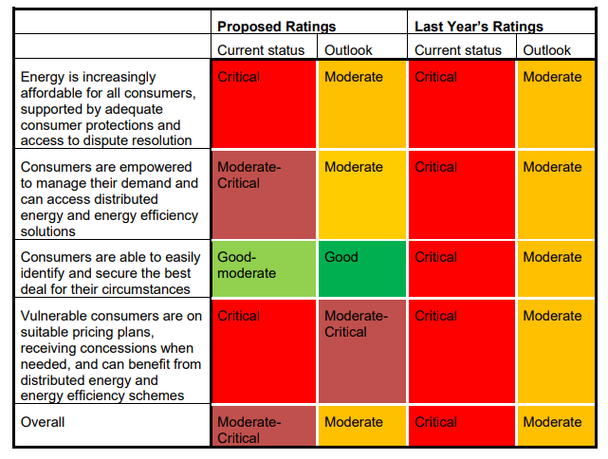
The ESB’s 2019 health assessment is summarised in Figure 1.

Figure 1: ESB health assessment summary.
This report will include a recommendation on how ESB should rate this objective for 2020.

Price trends vs affordability trends
The ABS CPI data includes an index for electricity prices, gas and other household fuels (mainly firewood). The latest data, for September 2020, illustrated recent trends of modest falls in electricity prices compared to general inflation. The national figures for the last 20 years are shown in Figure 2, illustrating the profound divergence of energy prices from general inflation from around 2007-8 and the recent moderation.
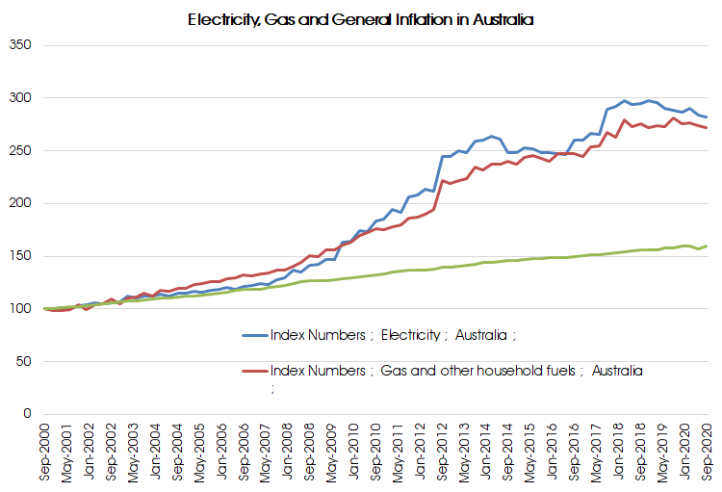
Figure 2: Electricity, Gas and All Groups Price Indices, Sep 2000 = 100. Source: ABS, Sep 2020.

However, averages hide a lot of detail and this is certainly the case with energy prices. Unfortunately, moderating prices do not automatically translate to increased affordability for a significant number of households.
The AER’s State of the Energy Market 2020 report highlights the significant proportion of Household Disposable Income spent on electricity by low-income households in each jurisdiction.
According to the AER, affordability can be stated as:
A customer’s ability to pay their energy bills. Affordability is impacted by their energy consumption, energy contract and associated prices, household income and other essential living expenses.
While there is no universally accepted measure of affordability, it is generally accepted that it relates to both the cost incurred and capacity to pay. The methodology for the annual assessment of affordability by the AER uses Household Disposable Income estimates as a proxy for capacity to pay. Poverty analysis by ACOSS however used Household Disposable Income after housing costs as reflecting capacity to pay. Combined, a lack of housing affordability and energy affordability can make a household particularly vulnerable.
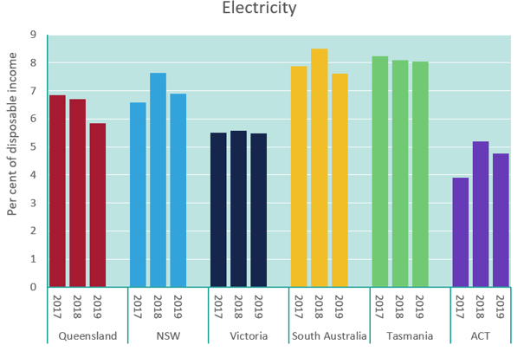
Figure 3: Energy bill burden on low-income households.

Understanding vulnerability
It is important to understand the elevated status that energy bills have in the complex dynamics of personal and household finances.
Energy is an essential service. For people, it is critical to health, social, and economic outcomes. Importantly, it is a service that people must continue to use regardless of their ability to afford it. It is therefore vital that reforms put the needs of people at the centre- especially those most at risk of being unable to afford access.
Energy is particularly fraught for the millions of people living below the poverty line or experiencing disadvantage. People on low incomes pay disproportionately more of their income on energy (on average 6.4%, up from 5.4% a decade ago- after energy concessions are taken into account) compared to households in the highest income quintile (on average 1.5% of income, up from 1.4% a decade ago). People on low incomes often live in inefficient homes that are expensive to heat and cool, and do not have the means or control to improve the efficiency, especially if they rent.
Energy affordability is not just determined by incomes and the price of energy- it is also about the level of consumption (which is influenced by house size, building fabric, appliance efficiency, family size, health conditions etc.), capacity to pay after paying for other essentials and, increasingly, ability to access energy saving measures and technologies.
Those with the least control and access to resources suffer the most from high energy bills. Some people deprive themselves of energy and go without heating, cooling, hot water, and cooking to the detriment of their health, in order to afford their energy bills. Other people cope by forgoing other essentials like food, medicine and dental or do not send their kids on school excursions- just to pay the energy bills.
The Consumer Policy Research Centre (CPRC) recently completed a report for the AER on current regulatory approaches to vulnerability in Australia. We encourage the ESB to take on board some of the key messages from this important piece of work, summarised below.

Understanding Energy Vulnerability

Australian consumers’ circumstances
- 1 in 5 callers to the National Debt Helpline with energy issues were experiencing mental health issues
- 44% of Australians have low literacy levels
- 2 in 3 Australians experience some level of financial stress
- 1 in 5 Australians have a disability
- 1 in 5 Australians speak a language other than English at home
- 30% of Australians have savings less than 1 month’s income or none at all, placing them only a few payments away from financial difficulty

Key messages
- Anyone can become vulnerable as a consumer
Vulnerable circumstances can include illness, job loss, financial shocks, the death of a loved one and natural disasters. These can be transient or long-term. Risks of consumer vulnerability will also change over time, as a result of regulatory, business, technological and social changes, and new understandings of consumer needs.
- Vulnerability can arise from personal circumstances or market features, or both
Market features, including complexity and poor product and service design, deliberate exploitation of people’s behavioural biases, information asymmetry and targeted exploitation of particular communities can cause vulnerability.
- People’s lived experience of markets matters
Market problems are best addressed when consumers’ actual experience of markets in the context of their lives, and their inclusion in —or exclusion from—essential services are understood.
- Vulnerability can be tackled at multiple stages of the customer journey
From product, service and market design, to specific measures for customers facing payment problems and other difficult circumstances, such as family violence.
- Data has an important role to play in vulnerability strategies
Data can be used to help identify areas of pressing need, prioritise regulators’ vulnerability work, and identify customers at risk of, or experiencing, vulnerability. It can also be to develop innovative interventions and engagement with vulnerable consumers, and in improved product and service design.

Policy framework to support low-income and disadvantaged households
In 2017 ACOSS, The Brotherhood of St Laurence and The Climate Institute, published the report, Empowering disadvantaged households to access affordable, clean energy, which outlined a policy framework to support low-income and disadvantaged households to transition to clean energy. The framework is based around 5 policy objectives:
- Deliver cheap, clean energy
- Inform and enable consumers to engage in the electricity market
- Improve household efficiency and productivity
- Provide stronger consumer protection
- Improve capacity to pay bills
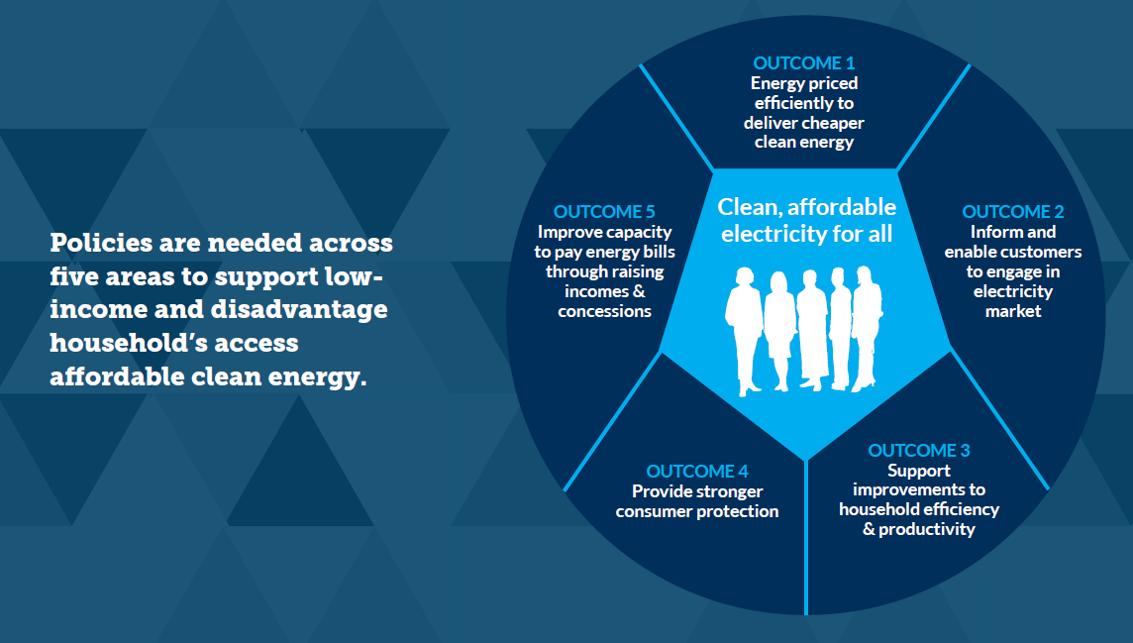
ACOSS and its members are of the view that the ESB is critically placed to advance these policy outcomes and that the annual Health of the NEM Reports are essential to communicating them to decision makers.

COVID-19 Impacts

Statement of the issue
The impacts of the COVID-19 pandemic on employment imply a large, new cohort of households are struggling with energy affordability and debt. Coordinated industry and regulator responses remain a critical need.

Message to the ESB
- COVID-19 has highlighted weaknesses in the structure of the retail market, its ability to provide an essential service, and protect and support access to that service for people experiencing financial difficulty.
- The moratorium on disconnections continues until at least June 2021. Upon recommencement of disconnections, retailers should be required to have demonstrated they have carried out all prior obligations before requesting permission to issue a disconnection notice that is delivered by a pre-visit.
- Temporary relief is needed to deal with the rise in energy debt, however longer-term reform is needed especially with respect to hardship framework and energy concessions.

Energy bill affordability
While average wholesale prices and default residential electricity prices have fallen in 2020, the COVID-19 impacts of increased residential consumption, lower employment and lower incomes have and will over the coming 12 months combine to reduce affordability and exacerbate vulnerability for a large number of households.
The following section presents a range of indicators of the impact COVID-19 has had on both costs incurred and capacity to pay.
The employment impacts of COVID-19 may represent the most profound change to our understanding of who is vulnerable to energy affordability. In 2019 SACOSS released a report looking at people in paid work on low incomes (referred to as ‘waged poor’) that adds further depth to our understanding of people struggling with energy affordability and at risk of falling through the gaps of existing supports.
ABS Labour Force Statistics highlight the COVID-19 triggered spikes in unemployment and underemployment in Figure 4.
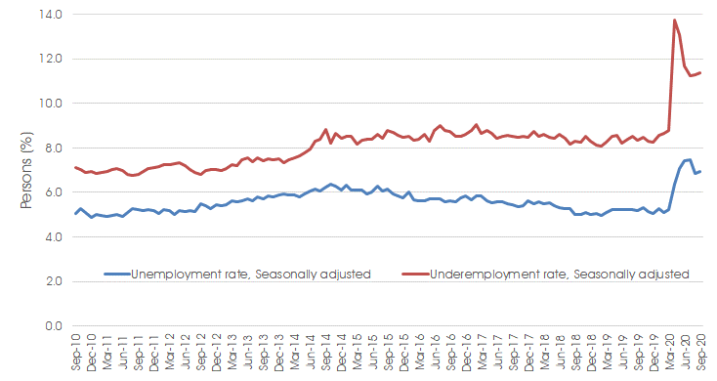
Figure 4: Seasonally adjusted unemployment and underemployment rates in Australia.

The Australian Bureau of Statistics Household Impacts of COVID-19 Survey is a monthly, longitudinal survey that is providing insights into the prevalence and nature of impacts from COVID-19 on households in Australia. In September, over 20% of households with children reported that their household finances had worsened. The October survey reported that due to COVID-19:
- 1 in 7 (14%) people living in a home owned with a mortgage had their mortgage repayment deferred or reduced (includes mortgages on a current dwelling or an investment property);
- 1 in 13 people (8%) living in a rented home had their rent payment for the dwelling deferred or reduced; and
- 1 in 20 Australians (5%) had a bill or rate payment deferred or reduced.
Energy Consumers Australia conducted research in 2020 to understand consumer attitudes and concerns in the context of the pandemic. The key findings in the Shock to the System report included:
- Around half of people (49%) say they have more concern about their ability to pay household bills since the COVID-19 pandemic started, with the number rising to 71% for those who have lost work during the crisis;
- Electricity bills were the top cost of living issue for consumers, with 73% rating electricity one of their top 3 concerns, ahead of groceries (56%) and housing costs (50%);
- 67% of energy decision makers expect an increase in their electricity bill this year; and
- 20% of energy decision makers say they have already requested financial assistance to pay their electricity bill. Of these, half (10%) received help which was useful, and half (10%) did not receive help that was useful.
The ACCC published new data in September 2020 as part of its market monitoring program (following from the 2017-18 Retail Electricity Pricing Inquiry) that also references the findings of the CPRC. & The September 2020 Supplementary Report stated:
The COVID-19 pandemic has significantly affected electricity customers. Overall, demand across the National Electricity Market (NEM) was down just 2 per cent in Q2 2020 compared to Q2 2019 with increased residential consumption largely offsetting the decrease in business consumption. In Victoria, for example, households consumed between 10 and 30 per cent more electricity between April and May this year compared with last year. This is due to the combination of colder weather this year and the COVID-19 restrictions keeping people at home. Victorian Small and Medium-sized enterprises (SME) consumed between 10 and 20 per cent less during the same period.
Many customers are experiencing reduced incomes. Data from the AER suggests more customers are falling a month behind in bill payments while others are further increasing existing debts. Organisations such as the AEMC have noted the likelihood that more customers will face difficulty paying their energy bills in the months ahead. There are indications that more consumers are shopping around for better deals with a CPRC survey in July finding that 10 per cent of respondents had switched energy plans or providers compared to 4 per cent in the CPRC’s June survey.
A number of recommendations from the ACCC’s 2017-18 Inquiry have been implemented, including the introduction of regulated Default Market Offers to replace high-priced standing offers. However, other recommendations remain unresolved, including:
- ACCC recommendation 24 - The small-scale renewable energy scheme should be wound down and abolished by 2021;
- ACCC recommendation 25 - Shift remaining feed-in-tariffs onto government budgets;
- ACCC recommendation 37 - Improve energy concession schemes across the NEM; and
- ACCC recommendation 38 - In addition to existing funding, the Australian Government and the relevant state or territory government should fund (to a value of $5 per household in each NEM region, or $43 million NEM-wide, per annum) a grant scheme for consumer and community organisations to provide targeted support to assist vulnerable consumers to improve energy literacy.
The ESB is encouraged to reflect on these.
QCOSS also published an important research report in September 2020: COVID-19 and Consumer Energy Vulnerability in Queensland – Consumer Impacts, Behaviours, Responses and Recovery Priorities. This report includes an assessment of changing energy usage and consumer behaviours and the current response by government, regulatory bodies and industry in the Queensland context.

Energy debt
The story of energy debt during the pandemic is only beginning to be understood. There have been reports from retailers seeing repayment of pre-COVID debt by some customers, which is most likely a result of the Coronavirus Supplement that doubled the JobSeeker Payment (previously known as ‘Newstart’ at the onset of COVID-19. It shows how providing adequate income support is critical to ensuring people can afford the basic. However, the Federal Government has already cut the Coronavirus Supplement, and another cut is slated for 31 December 2020. Despite some initial improvement in pre-COVID debt, overall debt levels are growing.
QCOSS research indicates that debt is being accrued by some households for the first time, consistent with the impacts seen on employment (QCOSS page 4):
In monitoring consumer payments, multiple retailers have seen a significant increase in the rate of people meeting hardship payment plans that were in place prior to COVID-19. This change in rate suggests that some consumers are now in a better position to meet their payment obligations and as such are meeting them.
It is reasonable to assume this, in some significant part, is attributable to increased Federal Government income supports such as JobSeeker Coronavirus Supplement.
Of those newly seeking retailer support, anecdotal perspectives from retailers point to first-time support seekers including many who were just ‘getting by’ prior to COVID-19 and are now experiencing reduced incomes that have tipped them into financial difficulty.
The ABS Household Impacts of COVID-19 Monthly Survey suggest another potential source of funds for repaying energy debt is superannuation. The October 2020 survey included questions around early access to superannuation (1 in 8 or 12% of Australians with superannuation reported they had applied for early access to their superannuation) and asked respondents to select all uses and planned uses of the money (see resulting work cloud in figure 5). Paying household bills (58%) was the most commonly reported use or planned use, followed by purchasing household supplies, including groceries (49%).
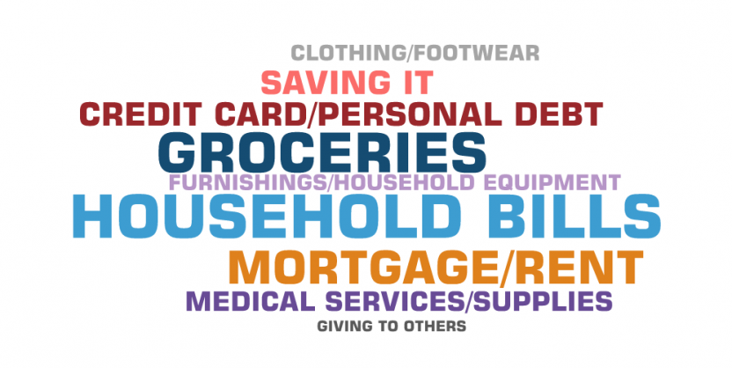

Figure 5: Wordcloud of responses from Persons aged 18 years and over, uses of money from early access to superannuation.
The AER and Victorian ESC publish weekly data in an effort to understand the evolving impacts of the pandemic. Following a moratorium on disconnections for non-payment at the start of the pandemic, both regulators are expressing concern over the levels of energy debt being accrued. The ESC is also reporting similar concerns around hardship and debt for water customers.
The AER reports that from early August disconnections for failure to pay have recommenced. The AER expects these disconnections to align with the current (third) Statement of Expectations:
Before 31 March 2021 (and potentially beyond), do not disconnect – other than at their request … any residential customer who may be in financial stress who:
  - is in contact with you in relation to their debt; or
  - is accessing any retailer support.
The AER statistics published in October 2020 showed consumer debt is rising, with the average 90-day debt increasing from $960 in March 2020 to over $1100 by the end of September 2020. Total debt for households on hardship programs grew by more than $9 million to almost $114 million, with the average amount of debt growing by 17 per cent to $1,390.
Kate Symons, Chair of the ESC recently stated at a meeting with heads of power companies that the latest data shows more signs of energy stress are emerging:
Average debt for residential customers who can’t pay for their ongoing usage has increased to $1,588, 13 per cent higher than in April.
The October 2020 ACCC Report also stated (p11):
It is likely that the AER and ESCV debt figures do not reflect the full economic impact of COVID-19. There is typically a lag in debt figures as they only accumulate once a customer has been billed for previous consumption and then failed to pay by the required date. Larger debts may be seen in coming months, especially once winter bills fall due. Many customers will also have used the enhanced government support payments introduced early in the COVID-19 pandemic to assist with energy bills. Such support may be less in coming months.
Energy is not the only debt for many households. Water and telecommunications businesses have also been expected to offer flexible payment options for households in financial distress. In Victoria, for example, the number of metropolitan customers on water hardships programs continues to steadily increase. At the end of September:
- 18,195 customers were accessing a water business hardship program
- The application rate for the Utility Relief Grant peaked at 848 mid-September
- 152,991 customers were on a payment plan
ACOSS is very concerned about growing levels of debt and consumers' ability to pay on top of other financial pressures.

Energy market responses

Australian Energy Regulator
In response to the expected impacts of COVID-19 the AER published several versions of a Statement of Expectations of energy businesses from March to November 2020. These expectations focused on supporting energy customers via the following:
- Flexible payment plan and hardship arrangements;
- No disconnections for non-payment;
- Deferment of credit referrals;
- Fee waivers;
- Prioritisation of life support customers;
- Clear and up-to-date communication with customers; and
- Minimal supply interruptions.
The November update extends these expectations to exempt sellers, on-selling electricity within embedded networks.

Energy Services Commission Victoria
The ESC made changes to the Energy Retail Code mandating specific support to energy customers through the coronavirus pandemic 2020. This includes an ongoing requirement to assist customers in completing Utility Relief Grant applications and temporary tariff checks on all customers receiving tailored assistance due to financial difficulty (October 2020 – April 2021). The Commission is also developing a strategy to address customer vulnerability across their regulatory functions.

Australian Energy Market Commission
Upon request by the AER, the Australian Energy Market Commission (AEMC) amended the National Electricity Law to allow some retailers to defer the payment of network charges to distribution network service providers for customers impacted by COVID-19 for a period of 6 months.

Joint market bodies
Following extensive stakeholder consultation feedback, the AER, AEMC and Australian Energy Market Operator released advice on their collective work program, including a regulatory implementation map. The purpose of this framework is to ease regulatory pressure on the energy sector during the COVID-19 crisis while also protecting key reforms underway for energy consumers.

The Energy Charter
The Energy Charter was officially launched on 31 January 2019.
CEO signatories of the Energy Charter agree to publicly disclose how they are delivering against the Energy Charter Principles annually through public disclosures. The Independent Accountability Panel reviews these annual disclosures, interviews the CEOs and engages with key stakeholders to produce an annual Independent Accountability Panel Report (IAP) focused on encouraging continuous improvement.
The top 3 initiatives in 2020 reported by the signatories were:
- Stakeholders said it is hard to get an overall picture of the level of customer service that the industry provides. In response TEC has committed that each signatory will disclose their customer satisfaction scores.
- Sponsored over 10 #BetterTogether initiatives that focus on specific issues to drive real change for customers (as recommended by the Independent Accountability Panel). Initiatives included improving electricity and gas connections, getting concessions to the right people and improving energy literacy for culturally and linguistically diverse communities.
- Supporting customers impacted by COVID-19 by uniting with one voice and letting customers and communities know ‘We’ve got you’ in a national awareness campaign translated across 10 languages, together with customer resources for COVID-19, including for students.

Jurisdictional assistance

Queensland
The Queensland Government provided $500 million for energy bill relief with a $200 household utility assistance payment provided via retailers directly to bills for all residential electricity account holders, implemented April 2020 onward.
In July 2020, The Queensland Government announced it would bring forward the next pre-committed $50 electricity asset ownership dividend, which will be automatically credited and appear on residential customers’ bills between September and November 2020.
Updated Energy Efficiency Information with ways to save on household energy bills during COVID-19. Provided a $200 Utility relief payment to assist with electricity and water costs for residential customers, including embedded network customers, automatically applied to electricity bills.

New South Wales
Increased access to Energy Accounts Payment Assistance (EAPA) $50 vouchers.

Victoria
In August 2020, the Victorian Government announced a $3.7 million support package, to support for Victorians who need help with energy bills. This included an Energy Assistance and Brokerage Program delivered online or via the phone to help people get the best value energy deal, run by a consortium which includes the Brotherhood of St Laurence, the Australian Energy Foundation and Uniting Vic.
In the November 2020 Budget, the Victorian Government announced:
- $83.2m in 2020-21 (total $131.6m/2yrs) to provide for a one-off $250 Power Saving Bonus for Victorian households that have at least one JobSeeker, youth allowance recipient or pensioner
- $163.7m in 2020-21 ($447.7m/4yrs) for energy efficiency upgrades in 250,000 low–income households and over 35,000 social housing properties.

Tasmania
The State Government has capped price increases for 12 months on electricity bills.
Aurora Energy established a COVID-19 Customer Support Program and a $5m Customer Support Fund to help residential and small business customers. This allows Aurora to allocate more resourcing to people experiencing hardship through bill relief, waiving fees and charges, freezing debt, payment plans and more.

South Australia
Once-off $500 boost to the 2020/21 Cost of Living Concession for households that receive the Centrelink JobSeeker Payment.

Australian Capital Territory
Households already receiving the annual $700 Utilities Concession received an additional $200 rebate through their electricity bill in June or July 2020. These households will continue to receive the annual $700 Utilities Concession and additional $200 rebate in 2020-21.
The Utilities Concession has been extended to eligible asylum seekers for 2020-21. Asylum seekers with a valid ACT Services Access Card can apply by 30 June 2021 for a $900 rebate on their electricity bills for 2020-21. This includes the annual $700 Utilities Concession and additional one-off $200 rebate.
The ACT Government will contribute up to $250,000 to a new fund to assist households severely impacted by COVID-19 through the Utilities Hardship Fund. The operation of the fund has been determined in consultation with electricity retailers, who have been asked to make a co-contribution in order to access the fund.
The ACT Government will freeze the Utilities Network Facilities Tax (UNFT) at its current level for the next year. This is intended to enable utility providers to pass on savings to customers and support improved hardship measures for ACT customers.

Issues raised in 2019 ACOSS Health of the NEM brief
The issues raised in the last ACOSS Health of the NEM brief remain. These are summarised below.

Difficulties accessing information
Increasingly, energy users are required to engage actively to manage their home energy usage and navigate the market if they want to lower their energy bills. While there is some evidence that some at-risk households do engage actively in the energy market to find the best deals, other people face limits and barriers (eg. lack of capital, language and literacy barriers, confusion and lack of transparency and increased market and system complexity). These limits and barriers increase people’s vulnerability to high energy costs.
As noted above the ACCC recommendation 38 - the Australian Government and the relevant state or territory government should fund a grant scheme for consumer and community organisations to provide targeted support to assist vulnerable consumers to improve energy literacy, has not been progressed.

Inadequate energy concessions frameworks
ACOSS members cited inadequate and poorly targeted energy concessions as a key issue that needs urgent attention to improve the affordability of energy bills for people on low incomes. Low-income households spend on average 6.4% of their income on energy bills, with over a quarter spending more than 8.8%, these figures are after energy concessions are taken into account.
The ACCC found that roughly 14% of people who are eligible for an energy concession do not receive one. There is also considerable variation between states, which add to higher administrative costs, inequity between household types, and inequity between states.
As noted above the ACCC recommendation 37 - Improve energy concession schemes across the NEM, has not been progressed.

Inadequate hardship policies
The number for people in hardship and experiencing disconnections pre-COVID was too high, although recent changes in Victoria and nationally to hardship guidelines could have a positive effect.
The AER released a new Customer Hardship Policy Guideline (Hardship Guideline) for retailers in April 2019. While most ACOSS members see the new Hardship Policy Guidelines as an improvement on the previous regime, there has been no material in payment plan usage or hardship support, no discernable decrease in disconnections and no material decrease in debt indicators. ACOSS members believe the Hardship Guideline has significant gaps, remains inadequate and is not up to the standards set by the Victorian Payment Difficulty Framework.
Analysis of the Victorian Payment Difficulty Framework by CALC in their 2019 Energy Assistance Report, suggests it is contributing to a significant drop in disconnections and providing better support to people struggling with energy debt. However, the report also identified that non-compliance with the Payment Difficulty Framework is an ongoing issue, with retailers arranging unfair payment plans and support despite regulatory requirements.

Inadequate consumer protections
ACOSS members noted the need for fairer energy contracts and discounts. Concerns were also raised around inadequate protections with respect to emerging products and services. Organisations like VCOSS, CALC and Council of the Ageing Australia have outlined a range of policies to provide fairer contracts and discounts for Victorians, which could be applied to other NEM jurisdictions.

Inability to access energy efficiency measures and distributed energy resources
Increasingly, ACOSS members are viewing the poor energy performance of existing homes as a major cause of unaffordable bills for many people on low incomes, especially as energy costs continue to rise and extreme weather, like heatwaves, fuelled by the climate crisis, increase.
People on low incomes, especially renters are more likely to be living in energy inefficient homes and have inefficient appliances, yet cannot afford to invest in energy efficiency measures- and if they rent they have no ability to do so.
While there are over 2 million homes that already host rooftop solar and 80,000 with batteries, reducing their energy bills by an average of $400 per annum, there are millions of people who are currently locked out of DER. This particularly affects people on low incomes who already pay significantly more of their incomes on energy bills and contribute disproportionately to DER subsidies and system costs, but either cannot afford or do not have access to energy solutions.

4. Post-2025 energy market design

Inadequate consumer protections
The ESB has been tasked by the Energy Council (formerly COAG Energy Council) to advise on a long-term, fit-for-purpose market design for the NEM.
Much of the post-2025 market design has focused on the technical and market challenges, which we agree are necessary to the transition. However, this focus has been at the expense of a focus on designing a market that works better for people, and ensuring that no-one is left behind in the transition.

Message to the ESB
- Energy debt, deprivation and disconnection has been a feature of the NEM since it began and is not being addressed as part of the post-2025 energy market design.
- There are significant barriers to access distributed energy resources and participate in emerging energy markets, for people experiencing social or financial disadvantage.
- The ESB should establish another work stream to identify market and non-market solutions to deal with the limitations of rules and regulations post-2025 market design, to ensure no one is left behind in the transition.

Background
Australia’s electricity system is undergoing transformational change driven by the need to decarbonise, technology changes and consumer preferences. It is transitioning from a highly centralised, fossil fuel dominated system, to an increasingly decentralised and decarbonised future.
The ESB notes that the changes occurring mean that the current set of systems, tools, market arrangements and regulatory frameworks is no longer entirely fit for purpose and able to meet the changing needs of the system and customers.
Indeed, the structure of the energy market and its cost impact on consumers can either be a significant contributor to household vulnerability, or help alleviate it. Energy debt, deprivation and disconnection has been a feature of the NEM since it began- yet this remains a relatively ‘fringe’ issue for policymakers. 2020 has continued to show that our current energy market structure increases household vulnerability.
The post-2025 market review could be an opportunity to create an energy system that helps alleviate household vulnerability, however none of the ESBs 7 future market design work streams (listed below) are designed to specifically do this:
- Resource Adequacy Mechanisms;
- Ageing thermal generation strategy;
- Essential system services;
- Scheduling and ahead mechanisms;
- Two-sided markets;
- Valuing demand flexibility and integrating DER; and
- Transmission access and the coordination of generation and transmission investment.
In the ACOSS submission to the post-2025 review, we recommended that the ESB establish another work stream to identify market and non-market solutions to deal with the limitations of rules and regulations post-2025 market design, to ensure no one is left behind in the transition.

5. Emerging issue: Embedded Networks

Statement of the issue
Embedded Networks (ENs) - privately owned and managed electricity networks that often supply all premises within a specific area or building - are increasingly the model of choice for new housing developments. The regulatory frameworks for ENs have been declared ‘no longer fit for purpose’ but reforms have stalled. People in ENs are more exposed to less choice, higher energy prices, poor customer service and only a second class of consumer protections.

Message to the ESB
- The number of people receiving their electricity supply from these private energy networks is unknown but rising. Better data collection would help identify issues and inform policy.
- ENs are the ‘model of choice’ for new medium and high-density housing.
- EN customers are vulnerable to high prices, poor customer service and do not receive the same levels of consumer protection.
- The AEMC concluded that existing arrangements are not fit for purpose, but their proposed new framework released in 2019 has stalled and needs to be resurrected. These reforms need to be retrofitted as far as possible to legacy ENs.

Background
ENs are private electricity networks serving multiple premises and located within, and connected to, a distribution system through a parent connection point in the NEM. Common examples of ENs include shopping centres, retirement villages, caravan parks, apartment blocks and office buildings.
The supply and sale of electricity within ENs are heavily regulated activities that must be conducted under either licence/authorisation or an exemption from such licence. ENs located with the NEM are mostly governed by supply and sale conditions administered by the AER. There are some jurisdictional exceptions to this:
- Victoria: EN supply activities are governed by 2 regulatory frameworks, the National Exemption Framework administered by the AER and a jurisdictional framework administered by the ESC. On-selling activities are only governed by the ESC’s retail exemption framework.
- Tasmania: Only the AER’s Network Exemption Framework applies to ENs in this location.
The majority of ENs within the NEM are electricity, however some are gas. Gas ENs are governed by jurisdictional supply regulations and the AER’s retail on-selling conditions. Gas ENs are not permitted in Victoria.

Current issues

Growth in ENs
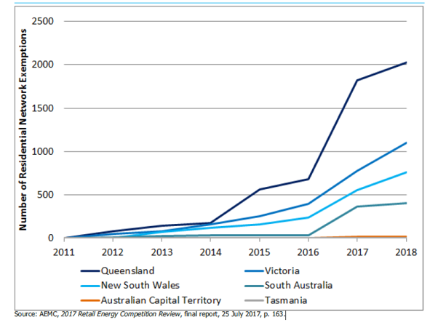
The number of residential ENs operating in Australia has increased significantly since 2011. Data from the AEMC demonstrates a sharp increase in the number of residential exemption registrations in 2016 that has continued to 2018 (excluding the ACT), see Figure 6 below. This data represent EN exemptions that are registered only, therefore the number of actual EN’s will are likely to be significantly higher as EN’s with less than 10 customers are categorised as ‘deemed’ and do not need to register an exemption.
Figure 6: Jurisdictional residential network exemption registrations (cumulative).
The number of residents living in ENs is much more difficult to determine. All grid connected customers have a unique National Metering Identifier (NMI) that provides ‘visibility’ in the market. EN customers who buy their electricity from an exempt on-seller do not have individual NMI’s, rather they are ‘hidden’ behind the gate/parent meter that services the EN, has its own NMI and is connected directly to the grid.
Data from the ESC provides indicative numbers of residential EN customers in Victoria (see figure 7). Similarly, to the AER Data, the ESC data relies on the information provided to the Commission for registered exemptions only. The majority of EN customers in Victoria are residential customers with almost 64% of these customers living in multi-unit dwellings such as apartments or rooming houses.
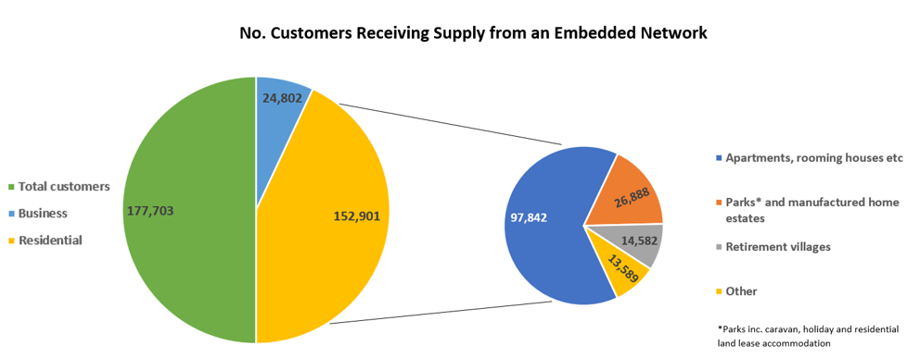
Other states such as Queensland have found it very difficult to quantify the number of residents living in EN accommodation. Recent estimates place the figure anywhere between 60,000 – 187,000 residents.
Figure 7: Victorian customers receiving supply from an embedded network.

Housing density creates the opportunity
The AEMC has stated that the residential apartment market is the primary driver of the growth in ENs. Over the past 25 years, Australia has witnessed a 78% increase in the number of occupied apartments, flats and units. While growth in this market has slowed since 2018 and is expected to decrease even further with the effects of COVID-19, the Housing Institute of Australia forecasts around 42,100 multi-unit developments will start in 2020/21.
Around 26,000 Victorian EN residents live in accommodation such as caravan parks and manufactured home estates, with both types of accommodation considered a ‘vital aspect of affordable housing from both the supply and demand side.’
ENs have become a popular option for medium and high-density residential developers as they can provide ‘infrastructure cost savings, end-to-end project management through the construction phase, and low-cost utility solutions to purchasers.’ As the AEMC noted during their EN framework review:
In recent years new types of businesses have emerged that fund and supply the metering and other electrical infrastructure in apartment complexes. In return, these businesses may receive lengthy contracts to provide power to the whole building and effectively become a monopoly retailer to occupants. Many such businesses also provide other bundled services, including hot water, chilled water for air-conditioning, gas for cooking and telecommunications.
This combination of new medium/high-density housing developments and developer incentives for installing ENs means that more energy consumers will be receiving and buying their electricity via an embedded network.
These arrangements have resulted in some apartment residents receiving higher than expected energy bills and unexplained changes to tariffs while being completely unaware of the EN installation. Exercising their retailer of choice right is difficult if not impossible due to metering complications. The scale of such events has led to a commitment from the Victorian Government to ban ENs in new-build apartment blocks unless the building uses renewable energy micro grids to deliver low-cost renewable energy to residents.

Access to concessions and regulated price
Residential customers who are on-sold electricity via an EN are usually still able to claim energy concessions under the usual eligibility conditions. All states excluding Queensland allow residents to claim the energy concession directly from the State Government. In Queensland, the EN operator needs to make bulk claims for concessions from the retailer supplying the ‘parent meter’ for the network. However, anecdotal evidence indicates that this is not common practice, and many otherwise eligible households are missing out.
However, those in ENs with exempt sellers may not be able to get rebates or emergency support payments, such as in NSW. People in some specific EN set-ups i.e. non-strata apartments such as community housing may not be able to access them.
While on-market or on-grid customers in New South Wales, South Australia and south east Queensland have their prices capped at the default market offer (DMO) prices, the DMO does not apply in embedded networks meaning there are no restrictions on energy rates. However, the Victorian default offer (VDO) applies to most business in embedded networks.

Authorised or exempt?
The business model for on-selling electricity is changing. Traditionally, the owner/operator of an EN supplies and on-sells electricity to residents or engages a third party to manage the on-selling on their behalf. In recent times on-selling within ENs has become a commercial opportunity for authorised energy retailers who operate under a full retail authorisation license rather than a license exemption- or pick the framework that best suits the business model.
Under the AER and ESC licensing and exemption frameworks, the prices that exempt on-sellers can charge for the supply and sale of energy are capped. On-sellers cannot charge customers more than the local area retailers’ standing offer price or the Victorian Default Offer for supply and consumption tariffs and all other energy-related fees and charges.
An authorised retailer is also not constrained by the same pricing conditions or pricing thresholds contained in some jurisdictional housing legislation. The Energy and Water Ombudsman NSW (EWON) received 32 complaints in 2019-20 from EN residents living in 5 separate residential parks. Residents had been purchasing their electricity from the park operator until the operator engaged an energy retailer. This change was made without resident consent and resulted in significant increases to resident bills, including prohibited fees and charges.

No real choice
While the National and Victorian EN frameworks mandate EN customers must be able to choose their own retailer, in reality this is very difficult to do. It means residents must find an energy-only contract with another retailer but continue to pay the network portion of their electricity to the EN owner. The appetite of energy retailers to offer individual customers an energy-only contract is very low. The transfer and billing processes are cumbersome. These can result in customers paying duplicate network charges, require changes to customer metering and authorised retailers having no obligation to offer energy-only contracts.

Access to dispute resolution has only just begun
In the past two years EN residents in New South Wales, Victoria and South Australia have been able to contact the Energy and Water Ombudsman (EWO) schemes for free advice, information and dispute resolution. Changes to the jurisdictional laws mandate membership to EWO schemes for EN on-sellers. This is a significant shift in customer protections for EN residents and reflects the same level of service provided to residents connected directly to the NEM.
The EWOs report annually on the number of EN members, complaints received and the nature of these complaints. For 2019-20, the combined EWO schemes in NSW, Victoria and South Australia reported:
- 592 energy embedded network members;
- A combined total of 786 complaints related to energy ENs; and
- A high proportion of these complaints (67%) were related to billing (i.e. high bills, billing errors, tariffs, fees and charges and unexplained changes to tariffs).
These figures along with the EN issues previously discussed demonstrate the following:
- Consumer protections are vital to ensuring EN residents receive services comparable to those connected directly to the grid;
- EN residents are being financially penalised by some EN arrangements;
- The current EN frameworks (e.g. rules and EN conditions) do not provide adequate protection for EN residents; and
- The combination of all these elements presents a very concerning outlook for vulnerable residents living with EN arrangements.
However, we note there seems to be a barrier to the AER monitoring compliance with exemption conditions in existing ENs. These powers need to be strengthened.

Regulatory framework declared not fit for purpose in 2017
On 28 November 2017 the AEMC published a final report on its review of regulatory arrangements for ENs. The final report found that the current regulatory arrangements for ENs are no longer fit for purpose, given the growth in the number of ENs and businesses providing services in this sector. The Commission made final recommendations that would provide EN customers with appropriate levels of access to retail competition and consumer protections.
In 2019, the AEMC completed a review of the EN exemptions framework operating within the NEM. The Commission found the lack of information on the volume of EN customers was ‘a significant drawback of the current exemptions system.’
The AEMC published a final report that proposed a package of law and rule changes to update the regulatory frameworks for ENs. Once implemented, the proposed framework aims to provide better protections and access to more competitive retail offers for consumers in ENs.
We note however, the proposed reforms do not apply to legacy ENs where many of the most vulnerable residents reside (such as residential parks and retirement villages). Consideration should be given to retrofitting the proposed reforms as far as possible.
Implementation of the AEMCs proposed framework has stalled. The AEMC published their final report in June 2019. The next steps required a redraft of electricity and energy retail laws and the subsequent passing of legislation by the South Australian Parliament. No date or timeframes for this work to be completed have been provided.
As the financial impacts of COVID-19 continue to intensify for vulnerable households, the resurrection of the AEMC’s proposed EN framework is timely and critical for those living within EN accommodation.

6. Emerging Issue: Gas transition

Statement of the issue
The future of reticulated gas and the risks to vulnerable customers from an inevitable transition to no or renewable gas under a regulatory framework that may no longer be fit for purpose.

Message to the ESB
- Increasing supply and extending the life of fossil gas is incompatible with a zero carbon economy.
- Affordability of fossil gas is an ongoing issue. The Liquified Natural Gas export industry uses 80% of the natural gas produced in Australia. Affordability has been materially impacted as a result.
- Maintaining two networks is likely to be inefficient and increase fixed costs for residential gas consumers.
- The transition away from fossil gas to electricity or to hydrogen will have costs to consumers. There is no accurate information on what the costs will be, no plan for a transition and no understanding of who pays. The longer we delay a clearly articulated plan or transition, the greater the increase in risks and costs- with the people least likely to be able to deal with it those who will pay the most.
- There are significant barriers to consumers making informed and timely choices on their energy source preferences.
- ACOSS recommends a number of action (see recommendations) including:
  - That the National Federation Reform Council undertake a review of the role of fossil and hydrogen gas in providing clean affordable energy for residential consumers, including costs of maintaining 2 networks or one network, and what plans and measures need to be put in place for the changing role- particularly for people who are least able to transition.
  - Federal, State and Territory Government provide support for low-income and other at-risk households in the transition to no or renewable gas.

Background
According to Energy Networks Australia, Natural Gas is reticulated to over 5 million homes and businesses and this is growing by around 100,000 connections per annum. A further 2 million households and businesses, most in regional areas, rely on Liquified Petroleum Gas for water and home heating, cooking and a variety of commercial and industrial applications.
Australian Energy Statistics for 2018-19 illustrate the role of reticulated natural gas in Australia’s energy mix. Natural gas accounted for 26% of energy consumption in 2018-19 but Figure 8 of the 2020 Update shows that the vast majority (over 80%) of gas production is for the Liquified Natural Gas export industry.
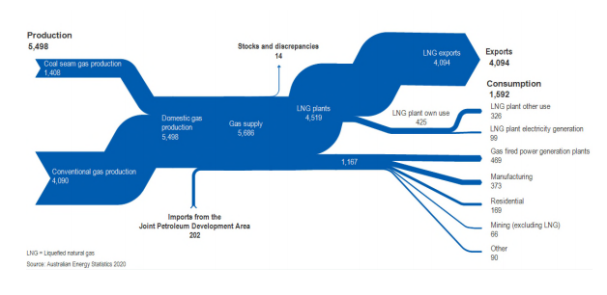Figure 8: Australian natural gas flows, petajoules, 2018-19
Gas used by households for heating, cooking and hot water represents 3% of the 5,498 PJ of gas produced, but 14% of the non-export consumption.
However, fossil gas is not compatible with a shift to zero emissions energy. For electricity generation, gas is, on average, less emissions-intensive than coal. However, the methane within fossil gas is a powerful greenhouses gas with a 100-year global warming potential 25 times that of CO₂. Measured over a 20-year period, methane is 84 times more potent as a greenhouse gas than CO₂.
There is an inevitable transition away from fossil gas to no or renewable gas (in the form of hydrogen), however there is no plan for the transition.

Current issues

Existential threats
The role of reticulated gas for households is being challenged by high prices and increased concern over the contribution this fossil fuel makes to overall greenhouse gas emissions and, consequentially, climate change.
The Grattan Institute’s November 2020 report Flame out: the future of natural gas, paints a bleak outlook for natural gas in Australia:
Far from fuelling the recovery from the COVID recession, natural gas will inevitably decline as an energy source for industry and homes in Australia, according to a new Grattan Institute report.
Flame out: the future of natural gas shows that a combination of economics and environmental imperatives imperil the industry.
These concerns are playing out in both politics and policy. The ACT has legislated to achieve net zero greenhouse emissions by 2045 and, following the recent election, has re-committed to phase out fossil-fuel-gas in the ACT by 2045 at the latest and set a goal of no new gas mains infrastructure to new developments by 2023. ACT gas distributor Evoenergy submitted its proposed 2021-26 Access Arrangement to the AER in June 2020 and has reflected this jurisdictional policy. Evoenergy’s consumer engagement has included a Citizen’s Jury process that tackled the question:
The ACT Government has legislated for net zero greenhouse gas emission by 2045. Evoenergy is committed to transform the gas network to meeting this target. As part of this transition, what are our consumers expectations of the service provided to them?
The Jury responded with comprehensive recommendations for Evoenergy and the ACT Government that acknowledged the complexity of the issues. A key theme though was the implications for customers in the transition from the current use of fossil gas to renewable or no gas (electrification).
At the same time, South Australian gas distributor Australian Gas Networks (AGN) submitted its proposed 2021-26 Access Arrangement to the AER. The AGN proposal includes a key theme of decarbonising the gas distribution network and poses a fundamental question:
The actual future of gas networks will be determined by a combination of government policy, technology developments and the cumulative decisions of millions of customers. The future presents network businesses and the AER with a challenge – how do we manage this uncertainty while promoting the efficient investment and operation of natural gas services in the long-term interests of customers?
The Australian and International Standard for Risk Management defines risk as the ‘effect of uncertainty on objectives.’ This uncertainty over the future of reticulated gas can be considered as a risk to the objective of energy affordability.
This risk is not just based on the cost of gas or the cost of gas networks if they become under-utilised in the future- the key risk to householders comes in the form of the cost of fixed home appliances such as heating, cooktops and water heaters. A particularly vulnerable group is renters where the choice to use gas is determined not by themselves but their landlord.

Transition to an all-electric future?
A majority of homes in Australia are duel fuel, having a connection to both the gas and electricity grids. Many households rely on gas for cooking, heating water and space heating.
Technology is being developed to produce renewable hydrogen, by splitting water into hydrogen and oxygen. Renewable hydrogen could be liquified and exported, and can be used as a replacement for gas in industrial, manufacturing and buildings. The Federal Government and state and territory governments are investing in developing a renewable hydrogen industry in Australia.
However renewable hydrogen is not a direct like for like with natural gas and requires modifications to transport and replacement of appliances. In other words, there will be a cost to consumers of transitioning to renewable hydrogen.
Given the potential for low-carbon grid delivered electricity, and the higher efficiency afforded by electric appliances, there has been a growing debate about the merits of shifting to all-electric homes with electricity for heating, cooling and cooking within the home.
The benefits of shifting to all-electric homes include:
- No longer paying for 2 network costs
- Potentially more energy efficient and cheaper
  - Electric appliances are more efficient than gas appliances, such as reverse cycle air-conditioning and hot water heat pumps
  - Maintaining and utilising one network should create efficiencies and reduce costs
  - Considerable effort via market and policy reform is being applied to improve the efficiency of the NEM
- Participate in new services and markets- these are being developed to reward households for managing their electric appliances, such as turning down or off air-conditioning during peak demand events.
Renew released a study of the costs or savings when switching to electricity from gas for heating, hot water and cooking. The study found that in every location in Australia for new homes, the best choice is to go all-electric and install solar PV. The worst return is in Melbourne, but even there you will be almost $10,000 in front after 10 years.
Similarly it was also cost effective to replace the home's last gas appliance with electricity (when it is due for replacement) in all circumstances and locations. Even in places where the running costs of gas are lower than for electric appliances, abolishing the fixed charge of the gas connection outweighs this.
However, the upfront costs of converting an existing dual fuel household where gas appliances are in good working order, to all-electric can be substantial.
Some of the challenges of transitioning from fossil gas to all-electric or renewable hydrogen for vulnerable households include:
- Costs of replacing appliances
- Costs of disconnecting from gas
- Lack of consumer education
- Lack of choice if in social or private rental property
- Lack of transition plan away from fossil gas, will increase risks and costs, vulnerable households will pay the most
- Stranded assets increase cost to gas consumers
ACT Council of Social Service CEO, Dr Emma Campbell, echoed fears that Canberrans on low incomes could be forgotten in the ACT transition to all-electric homes:
People on low incomes face a double disadvantage because they can't afford the upfront costs to buy new appliances or they may live in rental properties where they're reliant on landlords for electric upgrades.
We're very supportive of a transition to zero net greenhouse gas emissions by 2045 or earlier but it's really important that the transition is just, fair and does not leave people on low incomes … stranded on a gas network with higher bills compared to the rest of the Canberra community.
Most of the focus of policy makers has been on the transition of the electricity network. Transition away from fossil gas to electricity or to hydrogen will have costs to consumers, there is no accurate information on what the costs will be, no plan for a transition or understanding of who pays. The longer we delay a clearly articulated plan or transition, the greater the increase in risks and costs for people less able to transition.

The 2017, 2018 and 2019 Health of the NEM Reports are available here
Noting the ACT Government has committed to phase out fossil-fuel-gas by 2045 at the latest and set a goal of no new gas mains infrastructure to new developments by 2023.
ACOSS (2019): Health of the NEM – Current and emerging energy affordability issues for people on low incomes.
Ibid.
Ibid.
Ibid.
Ibid.
Ibid.
Ibid.
Ibid.
See for example Consumer Action Law Centre (2019): Sunny Side Up: Strengthening the consumer protection regime for solar panels in Victoria.
ACOSS op. cit.
Ibid.
Ibid (with update).
Ibid.
AER (2020) Statement of Energy Market 2020, pg 26.
AER (2020): State of the Energy Market Report. Note: Based on average household consumption data for each state. Energy costs based on the median of generally available single-rate offers (inclusive of discounts) at June each year. The data account for available concessions and rebates. Income data are equivalised disposable income (adjusted lowest income quintile) as reported by the ABS in 2015–16 and 2017–18, adjusted for other years using the consumer price index.
ACOSS and BSL (2018): Energy Stressed in Australia.
CPRC (2020): Exploring regulatory approaches to consumer vulnerability.
ACOSS and BSL (2017): Empowering disadvantaged households to access affordable, clean energy.
AEMO (2020) Quarterly Energy Dynamics Q3 2020.
SACOSS (2019): Working to make ends meet: low-income workers and energy bill stress.
ABS (2020): Household impacts of COVID-19 survey.
Energy Consumers Australia (2020): COVID-19 research.
ACCC (2020): Electricity market monitoring 2018-25.
ACCC (2018): Retail electricity pricing inquiry 2017-2018.
AER (2020b): Weekly retail market dashboards – COVID-19.
AEMC (2020): Final report: 2020 Retail energy competition review.
CPRC (2020): Consumers and COVID-19: from crisis to recovery, monthly insights report, p9.
QCOSS (2020): Feeling the heat: QCOSS research finds energy bills hit hard.
Ibid.
ABS, op. cit.
AER (2020b): op. cit.
AER (2020c): Statement of Expectations of energy businesses: Protecting customers and the energy market during COVID-19.
AER (2020d): AER extends COVID-19 energy consumer protections.
ESC (2020): Regulator urges energy companies to keep eye on vulnerable consumers.
AER (2020c): op. cit.
ESC (2020): Regulating with consumer vulnerability in mind.
AEMC (2020): Deferral of network charges.
AER (2020): Joint market body prioritisation framework - COVID-19.
The Energy Charter (2018): About the Energy Charter.
The Energy Charter (2020): Disclosure Report.
Queensland Government (2020): COVID-19 financial support for individuals.
NSW Government (2020): COVID-19 financial support for individuals and households.
Premier of Victoria (2020) New help for Victorians with their energy bills.
VCOSS (2020) Affording the basics: 2020 Victorian Budget Analysis.
Tasmanian Government (2020): Unprecedented new Social and Economic Support Package released.
Aurora Energy (2020): COVID-19 customer support program.
https://www.covid-19.sa.gov.au/latest-news/$7.8-m-boost-to-help-with-cost-of-living Government of South Australia (2020): Media release ‘$7.8m boost to help with cost of living’, 22 April 2020.
ActewAGL (2020): ACT Government COVID-19 rebates; ACT Government (2020): COVID-19 Families and households.
ACOSS op. cit.
Consumer Action Law Centre (2019): Energy Assistance Report: Tracking how Victoria’s changing energy policies are impacting households across the state.
VCOSS (2019): Fairer energy contracts and discounts for all Victorians.
AER (2018): Network service provider registration exemption guideline; Retail exempt selling guideline.
AEMC (2015): Embedded Networks: rule change.
AEMC (2019): Updating the regulatory frameworks for Embedded Networks, p19.
AEMO (2014): Embedded Networks – Detailed market design.
ESC (2020): Embedded electricity network data and customer numbers.
Department of Natural Resources, Mines and Energy (2019): Review of Queensland energy legislation, Part 2: Options paper, Queensland Government.
AEMC (2019): Updating the regulatory frameworks for Embedded Networks, p17.
ABS (2017): Census of Population and Housing: Reflecting Australia - Stories from the Census, 2016: Apartment Living.
HIA (2020): Housing Forecasts.
Caravan Industry Association of Australia (2020): Caravan parks and MHEs: A vital aspect of affordable housing.
Butler, L (2019): Busting the biggest myths around embedded networks.
AEMC (2019): op. cit., p1..
EWOV (2019): Annual Report 2018-19, p48.
DEWLP (2019): It’s your right to pay what’s fair.
Department of Human Services (2020): Jurisdictional energy concessions, Government of South Australia; ACT Revenue Officer (2020): Utilities concession; Department of Health and Human Services (2020): Concessions & benefits; Energy NSW (2020): Rebates and discounts.
Energy Australia, Help and Support: Default Market Offer
ESC, Embedded network tariffs including caravan parks
AER (2018b): op. cit., p37; DEWLP (2019): General Exemption Order, p8.
EWON (2020): Annual Report 2019/2020.
AEMC (2019): op. cit., Section 6: Network Billing.
EWON (2019): Living in an embedded network.
AEMC (2017): Review of regulatory arrangements for embedded networks.
AEMC (2019): op. cit., Summary.
HILDA (2020): Who’s hit hardest by the COVID-19 economic shutdown?
Energy Networks Australia (2020): Gas Vision 2050: Our plan for a decarbonised gas network.
DIER (2020): Australian energy statistics.
Ibid
UNECE (2020): Methane management: The challenge.
Grattan Institute (2020): Flame out: The future of natural gas.
AER (2020f): Evoenergy - Access arrangement 2021-26.
AER (2020g): Evoenergy – Appendix 1.2 - Citizens’ jury recommendations report.
AER (2020h): Australian Gas Networks (SA) – Access arrangement 2021-26
ibid. p. 32.
International Organisation for Standardisation (2018): Risk management – Guidelines.
Renew Australia (2018a): All-electric solar homes save thousands over gas
Renew Australia (2018b): Gas versus electricity: Your hip pocket guide; Renew Australia (2018a): op. cit.
Ibid.

