#### cid:B7A97C67-1204-4380-9FE1-31677570FC31Decorative Logo in Heading 9 November 2020

# C:\Users\kellie\AppData\Local\Microsoft\Windows\INetCache\Content.Outlook\6WPKUP8E\MA-MasterLogo-POS-CMYK-FA.pngC:\Users\kellie\AppData\Local\Microsoft\Windows\INetCache\Content.Outlook\6WPKUP8E\ALA_logo-Stacked.jpgCommunity sector urges parliament to progress the Climate Change (National Framework for Adaptation and Mitigation) Bill 2020

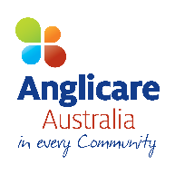Members of the Australian Community Sector are calling on all members of the Commonwealth Parliament to consider the Climate Change (National Framework for Adaptation and Mitigation) Bill 2020and to allow a parliamentary inquiry with public hearings, so the community, business and people can have their say.

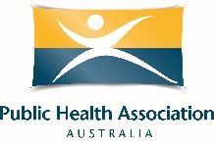Climate change and a slow, poorly managed transition to net zero emissions are a major threat to achieving our vision to end poverty in all its forms; create economies that are fair, sustainable and resilient; and build communities that are just, peaceful and inclusive.

Climate change is causing immediate and accelerated damage, including through more severe and frequent heat waves, bushfires, droughts, floods and sea level rise. It is not only damaging our environment, it is damaging people’s homes, livelihoods, health, quality of life, employment, and cost of living, and is increasing risks and burdens for future generations.

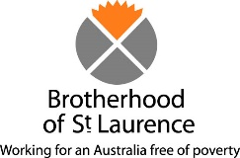People on low incomes are usually hit first, hardest and longest by climate change impacts and often lack choice and control to prepare, respond and recover. Climate change impacts not only entrench poverty but can drive people into poverty. Recovery can take years.

Analysis by Deloitte Access Economics finds a lack of climate action over the *next 50 y*ears will cost our economy $3.4 trillion and 880,000 jobs. Their earlier research found the social costs of more severe weather events is equal to and probably greater than economic costs. The longer we delay and avoid emissions reductions the greater the costs.

Taking action would deliver profound economic, social and environmental benefits, including saving lives and creating jobs. Deloitte has found that if action is taken in line with a target of net zero emissions by 2050, 250,000 jobs will be created and $680 billion added to the economy. We can reduce the severity of impacts but will still need to deal with the climate impacts already locked in.

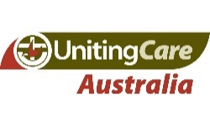We need a plan to provide confidence that as a nation we will reduce emissions, support people and communities with the transition, and build resilience, in a timely manner.  The Climate Change (National Framework for Adaptation and Mitigation) Bill 2020 proposedby Independent MP Zali Steggall offers a way forward. It is non-partisan and will complement and accelerate actions already taken by Federal, State and Territory Governments.

We urge all MPs to support a parliamentary inquiry into the Bill to enable people and communities to inform the final form of the Bill, and for parties to work together on agreeing and adopting legislation*.*