Cashless debit cards & income management: a briefing note on the evidence

October 2020

## Snapshot of evaluations and their findings

# 

|  |  |  |  |
| --- | --- | --- | --- |
| **Evaluation** | **SPRC/ANU (income management) (2014 & 2019)** | **Orima evaluation of Ceduna and East Kimberley trials (cashless debit card) (2017)** | **Adelaide University baseline report of Goldfields trial (cashless debit card) (2019)** |
| **Number of people affected** | 25,000 | 2,000 | 3,000 |
| **Alcohol consumption/**  **spending on alcohol** | Continued downward trend in alcohol consumption/sales data, which had been declining since 2005 before income management (and IM made no change to this downward trend).  2014 report stated there is some evidence of a decline in moderate alcohol problems, but serious alcohol problems had increased. The 2019 update shows there has been an increase in risky drinking among Aboriginal and Torres Strait Islander People. | Perceived reduction among people who self-reported using alcohol, with 96 people across the two trial sites saying they drank less frequently after the card was introduced (out of 231 who said they drank alcohol). This figure should be treated with caution as the same dataset reported a larger number of people drinking six drinks or more in one sitting than the number of people who reported drinking alcohol at all.  No alcohol sales data recorded. | No systemic qualitative or quantitative data recorded. Some comment from participants and non-participants in the trial area about their perceptions of alcohol use.  No alcohol sales data recorded. |
| **Illicit drug consumption** | Some evidence of decline in moderate drug use, but a possible worsening of serious drug use. | 30 out of 62 people who said that they had ever used an illicit drug said they hadn’t used one since the trial began. | No systemic qualitative or quantitative data collected. |
|  | Slight reduction in moderate gambling issues, but increase in severe gambling issues. | 52 people of 109 across the two trial sites reported gambling less since the cashless debit card.  Orima reported a drop in gambling in Ceduna in the year since CDC was implemented. However, ANAO identified that these data covered a population 60% of whom were not in the trial area. Orima also acknowledged that there has been a downward decline in Ceduna poker machine revenue since 2011/12.  Note that there are no poker machines in the East Kimberley so no poker machine data was available. Orima asked people about playing cards and gambling at home to assess the effect of cashless debit on gambling in the EK. | No systemic qualitative or quantitative data collected. |
| **Child wellbeing** | No gain or a worsening of outcomes for child wellbeing:   * Increase in low birth weights * Relative worsening of infant mortality for Aboriginal children in the NT * Increase rate of injury deaths for Aboriginal children aged 0-14 years   Increase in reports and substantiations of child abuse. | No specific recording of perceived impact on children’s wellbeing.  74% of people said that cashless debit had either had no change (42%) or had made their lives worse (32%). | No systematic data recorded. |
| **School attendance** | Evidence of a negative effect following introduction of income management. No positive ongoing effect. | No change to school attendance rates. | Not recorded. |
| **Employment** | Not recorded | Not recorded | Not recorded |
| **Spending on fresh food/groceries** | No change in spending on food, and data show that BasicsCard spending on fruit and vegetables is very low and less than non-basic card spending on fruit and vegetables. | No sales data presented. Some anecdotal comment that people are buying more groceries. | No systematic recording of impact on food. |
| **Alcohol-related emergency department presentations** | Marked increase in alcohol-related emergency department presentations, especially among Aboriginal population. | Not recorded for East Kimberley; recorded a drop of 6 presentations (from 128) compared with the same period before the trial in Ceduna. | Not recorded. |
| **Criminal justice** | Increase in imprisonment and assault | No imprisonment rate recorded  No decrease in assault, with increase in crimes, including domestic violence in Kununurra. | No imprisonment or crime rate recorded. |
|  |  |  |  |



## Income Management and cashless debit card

There are currently over 35,000 people subjected to income quarantining - either income management or cashless debit - around Australia.[1] The vast majority of people under income quarantining receive a working-age payment such as Newstart, Parenting Payment or the Disability Support Pension.

At least an estimated $1.5 billion has been spent on income quarantining in Australia.[2]

Income management has been in effect since 2007 when it was first used in largely Aboriginal communities in the Northern Territory. Cashless debit cards, which operate in the same way as income management in that they cannot be used to purchase banned goods, were introduced in trials in 2016. More than 80% of people subjected to cashless debit in these initial sites are Aboriginal.

Under income quarantining, people cannot purchase alcohol, gambling or withdraw cash from their restricted income component. Under income management, pornography is also a banned good.

Some form of income quarantining exists in selected communities in all states and territories except the ACT and Tasmania.

**Income quarantining in Australia**

|  |  |  |  |
| --- | --- | --- | --- |
| Where | Income management/CDC | Who it applies to | % restricted |
| Northern Territory | Income Management | Variety of payments & age cohorts (25,000 ppl) | 50% - 70% |
| East Kimberley, WA | Cashless Debit | Working age people receiving income support | 80% |
| Ceduna, SA | Cashless Debit | Working age people receiving income support | 80% |
| Goldfields, WA | Cashless Debit | Working age people receiving income support | 80% |
| Hinkler electorate, QLD | Cashless Debit | People under 35 receiving Newstart, Parenting Payment, Youth Allowance (Other) | 80% |
| Place-based income management (Playford SA, Logan, QLD, Shepparton, VIC, Bankstown, NSW, Rockhampton, QLD | Income Management | Variety of payments / age cohorts. | 50%-70% |
| Cape York | Income Management | Last resort option for people on income support | 50%-70% |

It has been reported that the big four banks and two major supermarkets have been working on addressing technical issues to allow a national rollout of the card. The Minister for Families and Social Services has described the card as a possible ‘mainstream financial literacy tool’.[3] There is no evidence that cashless debit assists with financial literacy (and as outlined below, this kind of approach has been found to do the reverse). The government’s description of cashless debit as a financial literacy tool is also big step away from the original purpose of income management, which was to:

* stem the flow of cash that is expended on substance abuse and gambling, and
* ensure funds that are provided for the welfare of children are actually expended in this way.[4]

In light of the mooted expansion of income quarantining, this briefing note reviews some of the evaluations of cashless debit and income management and their effectiveness in meeting their objectives.

There is no conclusive proof that quarantining income works to achieve stated social or behavioural objectives

It is broadly accepted that there is no reliable evidence that quarantining income support payments on its own addresses addiction, helps children, or results in long-term positive change. Dr Rob Bray, one of the authors of the evaluation of income management in the Northern Territory, has reviewed a number of evaluations of income quarantining, and concluded that “although questions about perceptions of change are frequently, although not universally, answered in the positive, these findings are not supported in studies using objective, and repeated, measures of outcomes and change.[5] In other words, the positive effects identified by some evaluations are opinion-based, and not supported by relevant data measuring health and wellbeing outcomes related to the policy’s objectives.

Dr Bray also raised concerns about income quarantining continuing despite evidence suggesting this policy has failed. He found that “the level of commitment to the program, within elements of government and the bureaucracy, has resulted in a process of rejection of evaluation findings when contrary to their belief in the program.”[6]

In the cashless debit and income management debates, we have consistently seen adverse findings rejected by decision makers. Instead, positive anecdotal and non-objective data is relied upon to justify continuing and expanding income quarantining.

The Orima evaluation of cashless debit

The first evaluation of cashless debit was conducted by Orima Research. Orima evaluated cashless debit in the first two trial sites, Ceduna, South Australia and Kununurra, Western Australia.

The Orima evaluation is the primary report used by government to justify expansion of cashless debit. The government generally cites the following statistics from the Orima report as evidence of the policy’s success:

* “of participants who reported that they do drink alcohol, 41 per cent of participants reported drinking alcohol less frequently, while 37 per cent of participants reported binge drinking less frequently.
* of participants who reported they do gamble, 48 per cent of participants reported gambling less.
* of participants who reported using illegal drugs before the program commenced, 48 per cent reported using illegal drugs less often.” [7]

These findings were gathered from interviews with people subjected to cashless debit. However, Orima did not collect any baseline data, commencing their research months after the beginning of cashless debit in the trial sites (with the second wave interviews happening more than 12 months after the policy started). Some research participants were asked to recall patterns of behaviour, including how many alcoholic beverages they drank in a week, from more than 12 months earlier. The ANU’s Janet Hunt critiqued this approach, arguing that interviewing people about past behaviour leads to recall bias, where people fail to correctly remember how they acted.[8]

Orima also relied on people telling the truth about their consumption habits, including consumption of illicit substances, which has been shown to be a flawed approach to conducting this kind of research as people may not want to self-incriminate.[9]

The Orima report has been widely criticised as unreliable. Australian National University academics Professor Matthew Gray and Dr Rob Bray described the evaluation as ‘deeply flawed’, arguing it had ‘excessive reliance upon self‐reported change rather than the use of objective measures’.[10] The Australian National Audit Office also criticised the evaluation, stating it was “difficult to conclude whether there had been a reduction in social harm” as the government’s “approach to monitoring and evaluation was inadequate”.[11]

The issues with the Orima evaluation have been widely acknowledged by experts. However, it continues to be used to justify continuation of cashless debit and its expansion.

Problems with the latest cashless debit evaluation

The latest evaluation of cashless debit commissioned by the government is the first report on the Goldfields trial, *Cashless Debit Card Baseline Data Collection in the Goldfields Region: Qualitative Findings* by the University of Adelaide. Despite the government stating that baseline data would be collected for the Goldfields trial site, researchers began their research after the trial started.[12] [13] As with the Orima report, it is not possible to collect adequate baseline data after a trial has commenced, especially when the report replies exclusively on qualitative research.

The Goldfields report collates the views of 66 non participants and 64 CDC participants about life before and after the card. Once again, this evaluation repeats the mistakes of the Orima evaluation, where people are asked to recall previous patterns of behaviour or perceived behaviours in their community. This fails to provide an objective account of what is happening in the lives of individuals affected and their community.[14]

The report does not include any quantitative data, which would provide an objective assessment of conditions in the trial site.[15] It also fails to include basic information that would be expected in a baseline report, including the number of trial participants broken down by payment type.

The ANAO urged the government to focus on capturing baseline data and ‘documenting expected outcomes’ in future evaluations of cashless debit.[16] Without collation of baseline data, specific targets cannot be developed (and consequently met). It is unacceptable that government has failed to address these evaluation shortcomings when it had the opportunity to do so in the Goldfields trial.

The 2012 and 2014 evaluations of Income Management in the Northern Territory

The most comprehensive evaluations of income management were conducted by researchers at the Social Policy Research Centre at UNSW, Sydney and the Australian National University.[17] These reports analysed both quantitative and qualitative data, and incorporated control groups and longitudinal data to measure outcomes. These are considered to be the most robust evaluations of income quarantining.

The latest evaluation, dated September 2014, or seven years after income management first commenced, ‘could not find any substantive evidence of the program having significant changes relative to its key policy objectives, including changing people’s behaviours.”[18] The report found no evidence of improved financial wellbeing, changes in spending patterns (including food and alcohol sales), nor was there any evident change in community wellbeing, including outcomes for children.[19] The evaluation concluded that rather than build capacity and independence, income management had made ‘people more dependent on welfare’.[20]

Dr Bray has recently updated research on core outcomes for communities under income management in the NT. He shows that child wellbeing outcomes have declined, including poorer school attendance, lower birth weights and higher incidence of abuse since income management was introduced.

The updated research shows that there has been a marked decline in alcohol consumption, but this reflects a broader decline trend before income management commenced – graph below from their submission.[21]

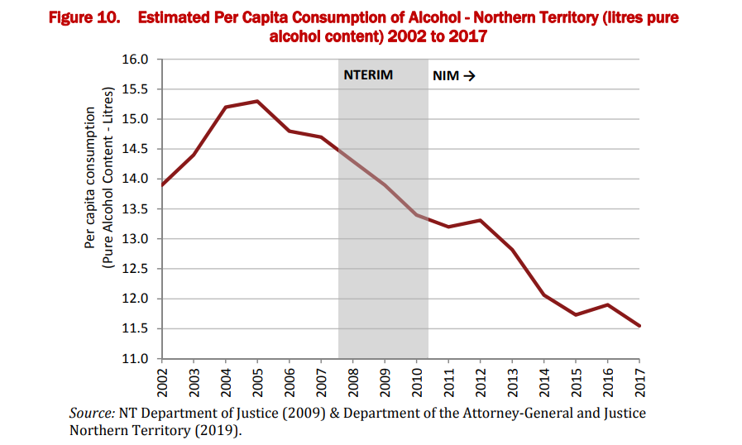

Dr Bray cites several examples that point to other alcohol measures, including limiting the amount of alcohol that may be purchased, that are more likely than income management to have contributed to this decline. He also notes that there has been no decline in risky alcohol consumption among Aboriginal People in the NT, and there has been an increase in presentations at emergency departments for alcohol consumption since 2005.[22]

Below is a graph of reported cases of alcohol intoxication in the East Kimberley before and after the implementation of cashless debit, which also shows an upward trend.[23]

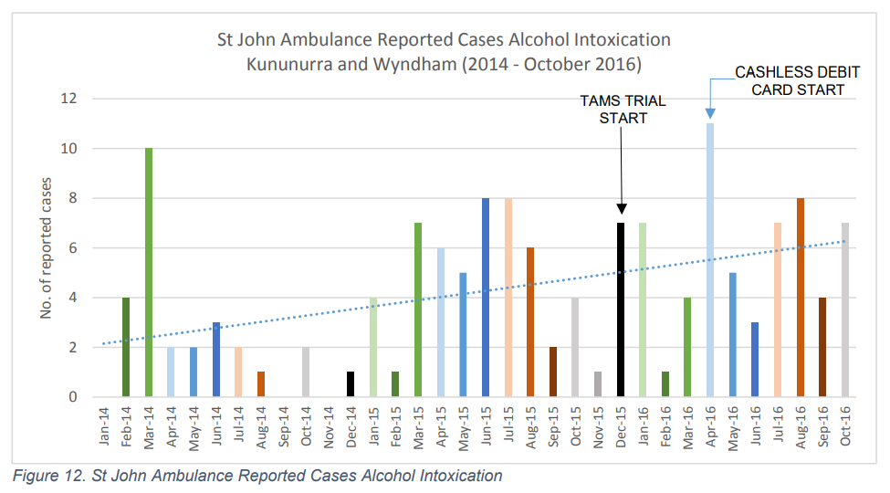

The government has largely ignored the findings of the UNSW and ANU evaluations in its commentary on income quarantining. This is a concern, given they provide the most comprehensive account of the operation of income management and its effect on communities.

No evidence to support a blanket approach

As shown earlier, addiction has ostensibly been the reason for quarantining income support payments. However, across the evaluations, it is clear that the vast majority of people subjected to income quarantining do not have an addiction to alcohol, drugs or gambling.

For example, if we are to accept the findings of the Orima evaluation, as the government has done, the first report shows that very few people subjected to the card in Ceduna and Kununurra report regular or ‘problem’ use of alcohol, drugs or gambling. For example:

* 80% of respondents said they never gambled.[24]
* 97% said they had never gambled or gambled more than what they could afford to lose.[25]
* 90% said they had never used an illicit drug.[26]
* Only 18% said they drank alcohol more than once per week, with around 81% saying they either never drank or drank less frequently than more than once per week.[27]

The Cape York trial, where income management is only used as an option of last resort, similarly found that few people were deemed to need an income management approach. Findings from its evaluation show that only 7.7% of people receiving income support payments were income managed.[28]

The 2014 NT Evaluation stated that there was no evidence that the groups singled out under the compulsory income management measure were the groups that presented the highest risk of engaging in target behaviours.[29]

The low proportion of people reporting problem use of banned goods shows that blanket application of this policy is unjustified. While there is some evidence that income quarantining may be a useful tool for individuals with addiction as part of a broad range of supports, the same cannot be said about blanket application. As Professor Gray and Dr Bray argue, “the evidence is clear that when they [income quarantining] are applied to broad populations based on some generic criteria they are an ineffective and costly policy with negative consequences.” [30]

These findings demonstrate that continuing and expanding mandatory income management and cashless debit are not supported by evidence. At best, such policies fail to deliver systemic change despite their significant cost. At worst, they do harm in communities, not least by stigmatising and discriminating against large groups of people for being on a low income.

Voluntary approaches are effective

Of all the research on income quarantining, there is evidence that a voluntary model is effective. The 2014 UNSW evaluation of the Voluntary Income Management in the Anangu Pitjantjatjara Yankunytjatjara (APY) Lands found that voluntary IM had a positive impact stating: “overall the introduction of income management into the APY Lands appears to be positively viewed by the community. There are indications that it may have already made a modest contribution to addressing some of the challenges in these communities”.[31]

The Australian Government agrees, acknowledging in its evidence to the United Nations Committee on Economic Social and Cultural Rights that voluntary income management is more effective than compulsory income management, saying that it delivers more positive results.[32]

ACOSS supports voluntary income quarantining. The evidence to date suggests that such an approach can be a useful tool for people to manage their affairs. Importantly, voluntary income quarantining places responsibility for managing income with the individual; not government as is the case with mandatory models. This is also important in terms of people’s financial literacy. The 2014 NT evaluation showed mandatory income management actually reduced people’s sense of responsibility for money management because Centrelink was heavily involved in paying bills, et cetera.[33]

By removing people’s ability to control their income, governments have inadvertently reduced people’s capacity to manage their income. Surely after the expenditure of more than $1 billion dollars on a failed policy, now is the time to accept that there is no evidence for continuing this paternalistic policy that restricts basic human rights.

1. Department of Social Services (2019) ‘CASHLESS DEBIT CARD (CDC) AND INCOME MANAGEMENT SUMMARY’ [PDF 138KB](https://www.aph.gov.au/-/media/Estimates/ca/supp1920/AddInfo_2.pdf?la=en&hash=8AD4CE91FC5F8B0D2916EA9F76E2B90DA64AE204)
2. Australian National Audit Office (2013) Administration of New Income Management in the Northern Territory, p.17 & Australian Treasury budget papers (no 2) 2013/14 -2019/20).
3. Crowe, David (2020) ‘'Financial literacy tool': Bid to take cashless welfare card national’ <https://www.smh.com.au/politics/federal/financial-literacy-tool-bid-to-take-cashless-welfare-card-national-20200131-p53wfm.html> 1 February
4. Explanatory Memorandum, Social Security and Other Legislation (Welfare Payment Reform) Bill 2007, p. 5.
5. Bray, R. J. (2016) ‘Seven years of evaluating income management – what have we learnt? Placing the findings of the New Income Management in the Northern Territory evaluation in context’, *Australian Journal of Social Issues* Vol.51 No.4, p. 464
6. Ibid.
7. DSS (2019) <https://www.dss.gov.au/families-and-children-programs-services-welfare-quarantining-cashless-debit-card/cashless-debit-card-evaluation>
8. Hunt, J. (2017) ‘The Cashless Debit Card evaluation: does it really prove success?’ <https://caepr.cass.anu.edu.au/sites/default/files/docs/CAEPR_Topical_Issue_2_2017_0.pdf>
9. Hunt, Ibid.
10. Professor Gray, M., Dr Bray, R. (2019) ‘Senate Standing Committee on Community Affairs Legislation Committee Inquiry into the Income Management to Cashless Debit Card Transition Bill, Submission’ <https://www.aph.gov.au/DocumentStore.ashx?id=66f25a45-583d-4b4e-99de-41f28e5c2800&subId=671157> p. 2
11. Australian National Audit Office (2018) The Implementation and Performance of the Cashless Debit Card Trial’ 17 July <https://www.anao.gov.au/work/performance-audit/implementation-and-performance-cashless-debit-card-trial>
12. Minister for Social Services Dan Tehan (2018) ‘Second Reading Speech: Social Services Legislation Amendment (Cashless Debit Card Trial Expansion) Bill 2018’ <https://parlinfo.aph.gov.au/parlInfo/download/media/pressrel/5996009/upload_binary/5996009.pdf;fileType=application%2Fpdf#search=%22media/pressrel/5996009%22>
13. DSS (2018) <https://www.dss.gov.au/families-and-children-programs-services-welfare-quarantining-cashless-debit-card/cashless-debit-card-evaluation>
14. Hunt, J. (2017) ‘The Cashless Debit Card evaluation: does it really prove success?’ <https://caepr.cass.anu.edu.au/sites/default/files/docs/CAEPR_Topical_Issue_2_2017_0.pdf>
15. DSS (2018) ‘Cashless Debit Card Baseline Data Collection in the Goldfields Region: Qualitative Findings’ <https://www.dss.gov.au/families-and-children-programs-services-welfare-quarantining-cashless-debit-card-cashless-debit-card-evaluation/cashless-debit-card-baseline-data-collection-in-the-goldfields-region-qualitative-findings>
16. Australian National Audit Office (2018) The Implementation and Performance of the Cashless Debit Card Trial’ 17 July <https://www.anao.gov.au/work/performance-audit/implementation-and-performance-cashless-debit-card-trial>
17. Evaluation of New Income Management in the Northern Territory <https://www.dss.gov.au/families-and-children/programs-services/welfare-conditionality/income-management/income-management-evaluations/evaluation-of-new-income-management-in-the-northern-territory>
18. SPRC (2014) ‘Evaluation of New Income Management in the Northern Territory’

    <https://www.dss.gov.au/sites/default/files/documents/12_2014/evaluation_of_new_income_management_in_the_northern_territory_full_repor.pdf> P.xxi
19. Ibid.
20. Ibid. p.xxii
21. Professor Gray, M., Dr Bray, R. (2019) ‘Senate Standing Committee on Community Affairs Legislation Committee Inquiry into the Income Management to Cashless Debit Card Transition Bill, Submission’ <https://www.aph.gov.au/DocumentStore.ashx?id=66f25a45-583d-4b4e-99de-41f28e5c2800&subId=671157> p.27
22. Ibid.
23. Codeswitch (2016) ‘Takeaway Alcohol Management System (TAMS): A review into the effectiveness of the trial system’, January – September 2016 <https://www.swek.wa.gov.au/Profiles/swek/Assets/ClientData/Document-Centre/2016_Final_Report_TAMS_Review.pdf> p.34
24. DSS (2017) <https://www.dss.gov.au/sites/default/files/documents/03_2017/final_cdct_evaluation_-_wave_1_interim_evaluation_report_9_february_2017.pdf> p.A41
25. Ibid., p.A43
26. Ibid., p.A33
27. Ibid., A32
28. DSS (2018) ‘Strategic review of Cape York Income Management FINAL REPORT’ <https://www.dss.gov.au/sites/default/files/documents/12_2018/final-report-strategic-review-cape-york-income-management.pdf> p.2
29. SPRC (2014) ‘Evaluation of New Income Management in the Northern Territory’

    <https://www.dss.gov.au/sites/default/files/documents/12_2014/evaluation_of_new_income_management_in_the_northern_territory_full_repor.pdf> P.295
30. Professor Gray & Dr Bray, Ibid., p. 3
31. Katz, I., & Bates, S. (2014). Voluntary Income Management in the Anangu Pitjantjatjara Yankunytjatjara (APY) Lands (SPRC Report 23/2014). Sydney: Social Policy Research Centre, UNSW Australia, p.2
32. The Australian Government (2018) ‘Concluding observations on the fifth periodic report of Australia: Information received from Australia on follow-up to the concluding observations’ Committee on Economic, Social and Cultural Rights 21 December, <https://tbinternet.ohchr.org/_layouts/treatybodyexternal/Download.aspx?symbolno=E%2fC.12%2fAUS%2fCO%2f5%2fAdd.1&Lang=en> p.3
33. Bray, J. R., Gray, M., Hand, K., & Katz, I. (2014). Evaluating New Income Management in the Northern Territory: Final Evaluation Report (SPRC Report 25/2014). Sydney: Social Policy Research Centre, UNSW Australia, p.319