A glimmer of hope

**Submission to Senate Economics Committee inquiry into Economic Recovery Package (JobMaker Hiring Credit) Amendment Bill 2020**

22 October 2020

About ACOSS

The Australian Council of Social Service (ACOSS) is a national voice in support of people affected by poverty, disadvantage and inequality and the peak body for the community services and civil society sector. ACOSS consists of a network of approximately 4000 organisations and individuals across Australia in metro, regional and remote areas. Our vision is an end to poverty in all its forms; economies that are fair, sustainable and resilient; and communities that are just, peaceful and inclusive.

Summary

ACOSS welcomes the Jobmaker wage subsidy as a means to grow employment as the economy recovers and, more importantly, to provide opportunities for people who would otherwise miss out, especially the one million or more people of all ages facing long-term unemployment next year.

ACOSS is concerned that the consultation period prior to voting on this important legislation is inadequate. It is important that stakeholders, especially people directly affected, have adequate opportunity to appear before a Committee Hearing and to provide input on the proposed Regulations.

ACOSS recommends that the Bill be passed subject to amendments to ensure the scheme and its outcomes are transparent, and a commitment from the government to adjust it as follows:

* Target wage subsidies to duration of unemployment (after 6 months for young people and 12 months for others) to prevent entrenchment of long-term unemployment;
* Double the subsidy in Jobmaker and existing wage subsidy schemes for positions offering at least 30 hours paid work a week;
* Introduce a scheme to subsidise 100% of the minimum wage for each person unemployed long-term who is employed for 6-12 months by community organisations in new additional positions on projects of community benefit;
* Give all people receiving Jobseeker or Youth Allowance long-term every opportunity to join the scheme;
* Involve labour market intermediaries such as employment services, Group Training Organisations, adult and community education providers and TAFEs in the scheme – including through the [Local Jobs Program](https://www.employment.gov.au/local-jobs-program) - to improve the match between employers and people seeking employment and to offer training and other support as required;
* Introduce administratively feasible checks and balances to maintain the scheme’s integrity, including that existing employees are not displaced, the positions on offer are ongoing, and people are properly paid;
* Exercise a duty of care for people recruited to the scheme by taking steps to guard against occupational health and safety and COVID-related risks.

Recommendation 1

**The Bill should be passed, subject to a clarifying statement from the Treasurer that, in making payments authorised by this legislation, the Government intends to:**

**(1) give priority under the Jobmaker scheme and existing wage subsidy programs to the employment of individuals who are at risk of prolonged unemployment, not confined to people under 35 years of age;**

**(2) facilitate a good match between prospective employees and employers, and access to appropriate training and support where required;**

**(3) ensure that workplaces are safe for prospective employees and relevant workplace standards are observed;**

**(4) ensure that the positions are ongoing ones extending beyond the duration of the subsidy and that displacement of existing employees is avoided;**

**(5) publish monthly data detailing the number and profile of employers and employees participating in the scheme (including their gender, age, Aboriginal or Torres Strait Islander status, and duration of unemployment), the extent to which positions and payrolls increase, and the employment status (fulltime part-time and casual) and duration of employment of those in subsidised jobs;**

**(6) formally evaluate the impact of the scheme on employment with different industries, occupations, and working hours; and on the employment prospects of different groups of unemployed people, and publish at least preliminary results before the end of 2021 and final results before the end of 2023.**

# Discussion

### JobSeeker and Jobkeeper have protected existing jobs, Jobmaker should help create new ones

#### Jobkeeper should be retained as long as needed and Jobseeker and related payments should be permanently increased

The purpose of the Jobkeeper Payment is to protect jobs at risk in the pandemic. It has performed this role admirably and should be retained until no longer needed – that is, until the pandemic and lockdowns no longer threaten people’s employment. JobSeeker

ACOSS advocates retention of the higher $750pw rate of Jobkeeper Payment for employment of 20 hours a week or more, to protect fulltime jobs that would otherwise be at risk and sustain consumer spending and employment growth across the economy. [1]

We support the introduction of the lower $375pw rate for positions of less than 20 hours a week to remedy the distortion in favour of such shorter-hours jobs in the original Jobkeeper scheme.

The doubling of the JobSeeker payment was also a vital measure both to protect people hit by unemployment from poverty and to also protect existing jobs, supporting well-targetted consumer demand in the economy.[2] We strongly advocate an urgent, permanent increase in Jobseeker and related payments for people of working age affected by unemployment, to a level that allows people to meet the essential costs of living. This is the most effective way to continue to protect people from and support growth in employment at the same time. ACOSS has developed and briefed the Federal Government on our detailed proposals.[3]

#### As the pandemic eases, Jobkeeper should gradually be replaced by the Jobmaker subsidy

ACOSS advocates the cautious and gradual replacement of Jobkeeper Payments by alternative economic and stimulus measures as the impact of the pandemic on the labour market eases. This should help speed the recovery in employment by facilitating adjustments from industries and occupations with declining job opportunities to those with better prospects of growth.

Along with investment in jobs-rich public infrastructure such as social housing and energy efficiency measures, expansion of vital care services, and a substantial increase in Jobseeker payments, there is a vital role for wage subsidies to promote employment over the coming year, when the risk of another upsurge in unemployment is greatest.[4]

#### The Jobmaker subsidy is likely to create additional jobs

Experience with wage subsidies indicates that they can boost employment, especially when the economy is recovering from recession. The reason for this is that subsidies bring forward hiring decisions by employers who are considering either restoring or expanding their organisation.

Wage subsidies for participants in the Job Services Australia program in 2010-12 were estimated in an official evaluation to increase the number of jobs in organisations receiving the subsidy by 11%.[5]

If this is replicated nationally, and there are 450,000 subsidised jobs as predicted in the Budget papers, then as a conservative estimate approximately 45,000 jobs would be created at an average cost of $80,000 per job. This compares very favourably with the Budget’s estimates for jobs generated by other policies, and is one-fifth the average cost ($475,000) of each job created over the next two years by the personal income tax cuts (Figure 1).

**Figure 1: Bang for the buck – The cost of each job created by different policies**

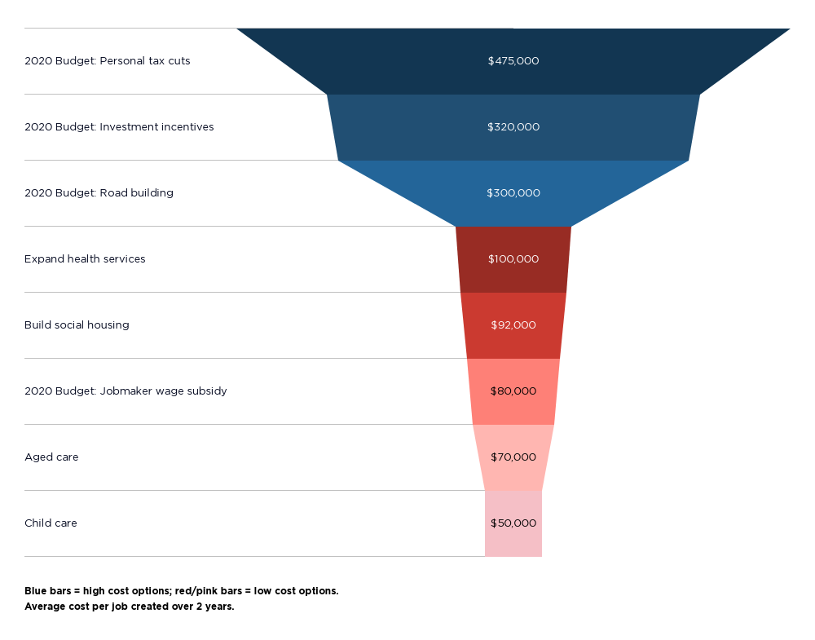

|  |
| --- |
| Note: Average cost (rounded) for each additional job created within the next two years.  Sources: 2020 Budget papers; Grudnoff M (2020), Tax cuts or spending: What is the most effective stimulus? Australia Institute; SGC Economics (2020), Economic impacts of social housing investment; Australia Institute (2020), Deloitte Access Economics (2018), Analysis of the impact of raising benefit rates; Department of Employment (2016), The effectiveness of wage subsidies in Job Services Australia. |

### Jobmaker should focus on improving the employment prospects of people of all ages unemployed long-term

While Jobmaker will generate additional jobs at the margin, its most important function is to encourage employers to hire people they may not otherwise consider.

As announced, the scheme gives priority to employment of people up to 35 years, with a higher subsidy for young people up to 25 years.

This is based on the disproportionate impact of the COVID recession on young people. The number of people on Jobseeker and Youth Allowance (‘unemployment payments’) under 25 years grew by 160% from September 2019 to June 2020, compared with 110% for those 25 years and over.

However, it is clear that people of all ages have been impacted. The *absolute* increase in the number of people on unemployment payments was greater among those over 25 years (706,000) than younger people (177,000). (Figure 2)

**Figure 2: People receiving Jobseker Payment and Youth Allowance – September 2019 and June 2020**

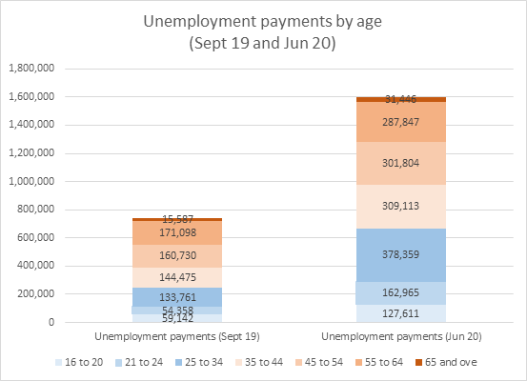

Among people on unemployment payments in August 2020, there were 696,000 people under 35 (43% of the total) and 929,000 over 35 (57% of the total).

A fairer and more cost-effective way to target employment assistance is to give priority to people who are unemployed or at serious risk of it. The Attachment shows that the number of people on unemployment payments for over a year (670,000) is almost twice the level (348,000) reached after the last recession in the early 1990s. We expect this to reach *over one million people next year*. More than half of this group is likely to be over 35 years of age.[6]

#### Well-designed wage subsidies make a difference for people at risk of prolonged unemployment

Evaluations of wage subsidy schemes for people unemployed long-term indicate that they can improve their employment prospects by 10-20 percentage points.[7] The wage subsidies in Job Services Australia were estimated to improve the chances of employment 12 months after the subsidy ended by an average of 14 percentage points.[8] If this result can be replicated at scale over a number of years, it would greatly reduce long-term unemployment and the scheme may well ‘pay for itself’ through future savings in unemployment payments and tax revenues. The social and economic benefits would be profound.

Wage subsidies work for two main reasons. First many subsidised employees are retained by the same employer after the subsidy expires. In those cases, the employer has been given an opportunity to trial an employee they might not otherwise consider, and finds they are suitable for the job. Second, a period of paid employment improves a person’s chances of being hired by another employer due to the work experience, skills and confidence that accrue during the placement.

#### The Jobmaker wage subsidy should prioritise people unemployed long-term regardless of age

We propose that the Jobmaker wage subsidies be targeted to:

* young people under 25 years who are unemployed for six months or more; and
* others who have been unemployed for 12 months or more.

Earlier access for people under 25 years recognises the more rapid deterioration in the skills and confidence of young people with limited paid work experience once they become unemployed.

Contrary to stereotypes, people unemployed long-term are a diverse group who are unemployed for many different reasons ranging from illness or disability or the interruption of careers by caring responsibilities, to the misfortune of entering or re-entering the paid workforce during a recession.[9] Many will be retained in employment if given the opportunity through a wage subsidy.

#### A less desirable alternative is to restrict Jobmaker to young people unemployed for six months or more, and expand existing wage subsidy schemes

Another option is to rapidly expand the existing wage subsidy schemes for other age groups. Five wage subsidy schemes are currently administered by the Department of Education, Skills and Employment or DESE (Table 1).

**Table 1: Wage subsidies administered by DESE and numbers assisted in 2018 and 2019**

|  |  |  |  |  |
| --- | --- | --- | --- | --- |
| **Program** | **Target group** | **Subsidy** | **Places in Jan–Aug 2018** | **Places in Jan-Aug 2019** |
| Restart | 50 years of age and over, unemployed >6 months | Up to $10,000 for 6 months ($385pw) | 7,268 | 3,596 |
| Long Term Unemployed or Indigenous | Any age, unemployed >12 months | Up to $6,500 for 6 months ($250pw) Up to $10,000 for 6 months($385pw) (Indigenous only) | 12,501 | 5,739 |
| Parents | Any age, unemployed >6 months | Up to $6,500 for 6 months ($250pw) | 3,361 | 1,831 |
| Young people | 15 to 24 years of age, unemployed >6 months | Up to $6,500 for 6 months ($250pw) | 5,180 | 2,174 |
| Total |  |  | 28,310 | 13,340 |

Sources: DESE (2020), jobactive wage subsidies fact sheet; Senate Education and Employment Committee Supplementary Budget Estimates 2019 – 2020, Department of Employment, Skills, Small and Family Business response to question No. EMSQ19-001430.

Note: Does not include the Youth Jobs Path wage subsidy.

As table 1 shows, the number of places in existing schemes is likely to be dwarfed by the anticipated 450,000 Jobmaker wage subsidy places.

Two of the main reasons for the small size of these schemes are:

* The capping of wage subsidies up to January 2019, even though demand for them was rising from January 2017 after they were redesigned to attract more employers;
* The removal of separate funding streams for wage subsidies (except for Youth Jobs Path) from January 2019, leaving employment service providers to pay for them through credits held in their Employment Fund (where more spending on wage subsidies may reduce the funds available to spend on other assistance such as vocational training).

As one provider warned in a Senate hearing after the latter decision was made:

*‘Recent moves to remove the quarantining of the wage subsidy pool have the potential effect of being negative for jobseekers, employers and providers in terms of being able to avail the maximum amount of funds for the purpose of supporting job placements through a wage subsidy process. This is very evident and critical when we consider the needs of Indigenous jobseekers. We are very concerned that removing the quarantined access to the pool for Indigenous wage subsidies and reverting this to providers needing to access their employment funds will have a detrimental impact on the success of many Indigenous jobseekers.’ [10]*

Expanding existing wage subsidies to a similar scale to Jobmaker would be challenging. At the least, it would require the government to introduce a distinct uncapped funding stream for the DESE wage subsidies and to promote it vigorously alongside the Jobmaker subsidy – including on relevant websites. A significantly larger subsidy than Jobmaker is likely to be needed.

Recommendation 2:

**In the regulations establishing the scheme, the Government should give priority of access to wage subsidies to people under 25 years old who are unemployed for at least six months and people aged 25 years or more who are unemployed for at least 12 months by either:  
  
(1) targeting the Jobmaker wage subsidies to these two groups rather than all people on unemployment payments up to 35 years old; or**

**(2) targeting the Jobmaker wage subsidies to recipients of unemployment payments up to 35 years who are unemployed for at least six months, and:**

* **expanding the existing wage subsidy schemes for people unemployed long-term, Aboriginal and Torres Strait Islander people, parents on income support and older people unemployed long-term by financing them through an uncapped subsidy pool outside the jobactive Employment Fund,**
* **promoting these existing subsidies widely, including on webpages where applications for Jobmaker subsidies are processed.**

### Jobmaker and existing wage subsidies should be doubled for people employed for 30 hours or more

To encourage employers to consider unemployed applicants that may not otherwise employ, wage subsidies are typically pitched at around half the minimum wage.

The flat $200pw subsidy is approximately half the minimum wage for people employed at the scheme’s minimum threshold of 20 hours a week. However, this is only one quarter of the minimum fulltime wage. This is unlikely to be sufficient to encourage employers to employ people on that basis.

In its present form, the scheme is therefore likely to distort hiring decisions in favour of short-hours jobs. This would accelerate the trend over the last decade towards part-time employment in entry-level positions, especially in service industries such as retail and hospitality. Most of these jobs are offered on a casual basis.

Since the lockdowns commenced, the recovery in fulltime jobs has been relatively weak (Figure 3).

**Figure 3: Part-time employment has recovered more strongly than fulltime employment**

Source: ABS Labour force data and Jericho G, Australia's post-Covid jobs snapback is all about part-time work, The Guardian 20 October 2020.

While short part-time casual jobs can lead to more secure fulltime roles, they do not provide a liveable income for people who are unemployed, and leave many still reliant on income support to make ends meet.

To avoid distorting the labour market in this way, we propose that the subsidies in Jobmaker and existing wage subsidy schemes be doubled for positions averaging 30 hours a week or more. Given that the scheme already requires information on average hours worked to enforce the minimum threshold of 20 hours a week, this should be feasible without imposing excessive administrative burdens on employers or the ATO.

Recommendation 3:

**(1) To remove disincentives for employers to employ fulltime employees under the scheme, in the regulations establishing it the government should double the subsidy for positions of 30 hours a week or more to $400 per week regardless of age.**

**(2) Wage subsidies in the existing schemes should also be doubled for positions of 30 hours a week or more.**

### A wage subsidy set at 100% of the minimum wage should be offered to community organisations employing people unemployed long-term

Wage subsidies for people who are unemployed typically last for 6-12 months and take two main forms:

* Partial or marginal wage subsidies which cover part of the wage (usually around half), and
* Full wage subsidies that meet the entire cost of employment.

*Partial* wage subsidies are more effective for people with less extensive barriers to employment (for example, those unemployed for six months to two years) , since the employer must commit to pay around half the wage for an introductory period, and having done so they are more likely to keep the person on.

*Full* wage subsidies are more effective in generating additional employment, especially in communities where paid work is scarce such as remote Aboriginal and Torres Strait Islander communities. Further, a full wage subsidy is likely to be needed to provide paid work experience in regular jobs for people with steeper barriers to employment (for example, where they have been unemployed for more than two years or have a chronic illness).

To enhance community benefit and avoid distorting markets for products and services, full wage subsidies are generally offered to community organisations that commit to creating additional temporary jobs that fulfil a social or environmental purpose (for example, community transport services or environmental regeneration after bushfires).

One example of a full wage subsidy scheme is the recently announced [Kickstart wage subsidy scheme](https://www.gov.uk/government/collections/kickstart-scheme#guidance-about-the-kickstart-scheme) in the United Kingdom, which offers 100% subsidied employment for six months for young people unemployed long-term. This is similar to the successful Future Jobs Fund program implemented in the UK in response to the Global Financial Crisis.[11]

We propose that a full wage subsidy scheme be established for people unemployed for 12 months or more, with priority to those facing additional labour market disadvantage. This would offer six to 12 months paid employment in community organisations on projects of benefit to the community, on the proviso that the jobs must be additional to any planned expansion of employment by the organisation.

Recommendation 4:

**A subsidy of 100% of the minimum wage should also be available to community organisations that provide paid work experience at the relevant minimum rates of pay for six to 12 months for people unemployed for more than 12 months, where the organisation can demonstrate that:  
(1) any subsidised positions are additional jobs that would not exist without the subsidy;  
(2) the positions are likely to make a positive contribution to community wellbeing and the employment prospects of the employee.**

### The Jobmaker wage subsidy should be widely promoted and accessible to people who are unemployed long-term

Along with Jobkeeper, the Jobmaker scheme is a welcome and timely innovation in response to the pandemic recession.

As with Jobkeeper, it is a hyrbrid scheme – in this case a wage subsidy for people who are unemployed run through the ATO as an adjunct to the Pay as You Go income tax system. As with the collection of Child Support through the income tax system, the Jobmaker scheme has potential to meet social objectives in a cost effective way, and it is scalable. The main advantages of using the tax system to administer wage subsidies are ready access to employers and simpler adminstration through the Single Touch Payroll system.

We understand the government proposes that the ATO administer the scheme in ‘light touch’ fashion, keeping administrative costs to a minimum, as with the Jobkeeper subsidy with which employers are already familiar.

The main advantage of this approach is that it will encourage more employers to apply and the wage subsidies can be quickly scaled up. Employers will be able to claim the subsidy next year in arrears, for positions filled over the remainder of the December quarter 2020.

Reliance on the tax system also has disadvantages. Tax concessions for the employment of people out of paid work can be expensive, with high deadweight costs. A major reason for this is that it is harder to target the subsidy towards people at greater risk of prolonged unemployment, and to ensure that the right people are connected to the most suitable jobs, and that both the employer and employee receive the support they may need to sustain the placement. The administrative simplicity of such schemes is also their greatest drawback.

A labour market intermediary (between employer and employee) can help improve the matching of prospective employees and employers, offer any support required, and help preserve the integrity of the scheme (discussed later in this submission).

The intermediary could be a publicly funded employment service (which administer the existing wage subsidies referred to above) or another body such as a Group Training Organisation, TAFE or community college (where the employee is undergoing training). The Kickstart scheme in the UK is administered in part by ‘Gateway’ organisations that are funded by government to recruit smaller local employers to the scheme and connect them with potential employees.[12]

It should be possible to get the ‘best of both worlds’ by combining ATO administration of the subsidy (including handling applications from employers) and use of intermediary organisations to recruit people on income support payments as potential employees and to offer any support needed by employers or employees to improve the prospects of a successful placement. Large-scale wage subsidies have been administered by employment services in Australia and elsewhere in the past.

The new [Local Jobs Program](https://www.employment.gov.au/local-jobs-program) in 25 regions offers an opportunity to better connect employment services, community colleges and TAFEs, employers, people who are unemployed, local government and other community organisations so that the best advantage is taken of the opportunities provided by the Jobmaker wage subsidy. ACOSS advocates a larger scale investment in this kind of regional Local Employment and Skills Development Partnership.[13]

At the least, it is essential that people unemployed long-term have ready access to the scheme, and to the supports they may need to secure employment. This may include training, other forms of work preparation, mentoring, and advice on their rights as employees and workplace health and safety (discussed later).

Recommendation 5:

**(1) People receiving Jobseeker or Youth Allowance payments should be given every opportunity to join the scheme, including through a system where they can register their interest that is widely advertised among people who are unemployed and employers.**

**(2) They should not be compelled to participate, but this should fulfil any annual activity requirements if they choose to do so.**

Recommendation 6:

**To improve the match between employers and prospective employees under the Jobmaker scheme, and ensure that any prevocational training, mentoring and other supports required are available, in the regulations establishing it the government should:**

**(1) ensure that were the employee agrees, their employment service provider is notified of any subsidy application and has the opportunity to offer the employer and prospective employee such support;**

**(2) encourage and fund employment service providers and other labour market intermediaries (such as Group Training Organisations, adult and community education providers and TAFEs) to do so, and to promote the scheme to their participants and employers;**

**(3) Use the networks established through the new Local Jobs Program to promote the scheme and connect prospective employers, employees and local services that can offer these forms of support.**

### Public support for the scheme depends on careful administration to preserve its integrity

Wage subsidy schemes work well and are widely supported when they generate employment opportunities for people who would otherwise miss out. One of the greatest threats to their effectiveness, and public support for them, is the risk of abuse by a minority of employers.

A major concern in this regard is the risk that existing employees may be displaced by workers employed using the subsidy. For example, if the subsidy for fulltime positions is not increased as proposed in this submission, fulltime positions may be split into subsidised part-time jobs.

The main protection against this possibility in the proposed scheme is the dual requirement that over the period of the subsidy the employer’s payroll and the number of people employed must increase. The ATO would use the Single Touch Payroll system to administer compliance with this sensible requirement

This compliance system could be strengthened by including the wage subsidy when calculating the overall value of the payroll. That would reduce any financial benefit for employers from restructuring their workforce to take advantage of the subsidy (without actually increasing the paid working hours of employees overall).

This does not resolve all of the main integrity issues with the wage subsidies.

Informed by experience with integrity issues that have emerged with wage subsidies in the past, DESE incorporates the integrity measures in the following recommendation into its wage subsidy schemes.[14]

These requirements are unlikely to impede the rapid expansion of the Jobmaker scheme. They would significantly reduce the risk that the program falls into disrepute.

Integrity measures only work if they are well administered. If labour market intermediaries are involved in the administration of the scheme, they could assist with this. At the least, a transparent, timely, accessible and fair mechanism to receive and investigate complaints is essential.

Recommendation 7:

**To ensure the Jobmaker scheme’s objectives are realised and the scheme’s integrity is assured, in the regulations establishing it the government should:**

**(1) require prospective employers to undertake in writing not to displace existing employees with subsidised workers, confirm that the position is an ongoing job lasting beyond the subsidy period, and promptly notify the ATO if the employment ceases or eligibility conditions (e.g. a minimum of 20 paid working hours a week, on average) are not longer met;**

**(2) exclude from the scheme commission-based employment, self-employment (independent contractors), subcontracted positions, immediate family members of the employer;**

**(3) establish a timely, accessible and fair mechanism to investigate complaints and suspend or cancel and recover wage subsidies in the event of a breach of the scheme’s requirements, or of relevant Commonwealth or State/Territory laws (including employment standards), and where appropriate exclude those breaching these requirements from the scheme.**

### The government has a duty of care towards people employed under the scheme, especially in the pandemic

Unlike the Jobkeeper scheme, which is designed to preserve existing employment relationships, the Jobmaker scheme uses a subsidy to *establish new employment relationships*. While these are (appropriately) regulated in the usual way through workplace relations and occupational health and safety laws, the government has a duty of care to ensure that those recruited to jobs with a public subsidy (as well as employers and fellow employees) are safe and their health is not adversely affected.

In existing wage subsidy schemes, apprenticeships and traineeships, workplace inspections are conducted to ensure that the workplace is safe for the new employee. Given that many people receiving Jobseeker and Youth Allowance payments have a disability or chronic illness, the government also has a duty of care to take any individual health risks into account.

Concerns about occupational health and safety are obviously heightened by the pandemic. People should not be referred to workplaces that are known to have breached COVID-safe requirements.

While unnecessary administrative burdens should be minimised, the following action should be taken to safeguard the health and safety of prospective employees, their co-workers and employers.

Recommendation 8:

**To meet its reasonable duty-of-care obligations to workers newly recruited under the Jobmaker scheme, in the regulations establishing it the government should:**

**(1) ensure that participants and employers are informed about relevant occupational health and safety and workplace relations requirements (especially COVID-related requirements) before placements commence, preferably in personal interviews;**

**(2) provide back-up support for prospective employees and employers to raise any concerns around workplace issues that may arise and to connect them with other supports required (such as workplace equipment or aids for people with disability).**

**(3) Intermediary organisations such as employment service providers, Group Training Organisation, adult and community education providers or TAFEs could be funded to undertake these tasks, as they do in existing wage subsidy schemes.**

#### Acknowledgements

ACOSS prepared this submission following briefing of members of the ACOSS Income support and Employment Policy Network. The timeframe provided by the Federal Parliament to prepare this submission has meant adequate consultation has not been possible. ACOSS thanks ACOSS members who were able to provide comment notwithstanding the limited time available .

#### Contact

Peter Davidson

ACOSS Principal Advisor

peter@acoss.org.au | (02)93106208

1. For more detail, see ACOSS (2020), [Jobkeeper Payment transitions](https://www.acoss.org.au/wp-content/uploads/2020/07/200717-JobKeeper-Payment-Transitions-Briefing-Paper-FINAL.pdf).
2. For more detail, see ACOSS (2020), [Cuts to JobSeeker to Cost 145 000 Full-time Jobs](https://www.acoss.org.au/media_release/cuts-to-jobseeker-to-cost-145000-full-time-jobs-deloitte-report/) and Deloitte Access Economics (2020), [Estimating the economic impacts of lowering current levels of income support payments](https://www.acoss.org.au/wp-content/uploads/2020/09/Final-ACOSS-Coronavirus-Supplement-to-ACOSS-09.09.2020.pdf).
3. Our proposals for income support reform are detailed in ACOSS (2020), [Next steps for income support](https://www.acoss.org.au/wp-content/uploads/2020/09/Social-security-next-steps-JUL-UPDATED-2-9_.pdf) briefing.
4. Our proposals to invest in infrastructure and services are in ACOSS (2020), [Supplementary Budget Submission](https://www.acoss.org.au/wp-content/uploads/2020/09/ACOSS-Supplementary-Budget-Submission-24.8.2020.pdf).
5. Department of Education, Employment and Workplace Relations (2012), Evaluation of Job Services Australia, Chapter 2: wage subsidies.
6. ACOSS (2020), [Recovering jobs briefing](https://www.acoss.org.au/wp-content/uploads/2020/07/200717-Recovering-Jobs-Briefing-Paper-FINAL.pdf).
7. Card D et al (2015), What works? A meta analysis of recent active labour market program evaluations. NBER Working Paper 21431, Massachussets.
8. Department of Education, Employment and Workplace Relations (2012), op cit.
9. ACOSS and Jobs Australia (2020) [Faces of unemployment](https://www.acoss.org.au/wp-content/uploads/2020/04/Faces-of-Unemployment-2020-v3.pdf).
10. Kolomyjek, M, Group Executive, atWork Australia Pty Ltd, in evidence to the Senate Education and Employment References Committee Jobactive inquiry, Canberra, 1 February 2019.
11. Department for Work and Pensions (2012), [Impacts and Costs and Benefits of the Future Jobs Fund.](https://assets.publishing.service.gov.uk/government/uploads/system/uploads/attachment_data/file/223120/impacts_costs_benefits_fjf.pdf)
12. Department for Work and Pensions (2020), How to help local organisations get involved in the Kickstart scheme, [Presentation to ‘Making sure Kickstart works’ seminar](https://learningandwork.org.uk/wp-content/uploads/2020/10/Updated-Kickstart-slides.pdf), Learning and Work Institute. London. 16 October 2020.
13. See ACOSS (2020), [Local Employment and Skills Development Partnerships](https://www.acoss.org.au/wp-content/uploads/2020/08/200812-Local-employment-and-skills-development-partnerships-FINAL-2.pdf).
14. Department of Skills, Employment, Small and Family Business (2019) [Managing wage subsidies guideline](https://docs.employment.gov.au/system/files/doc/other/managing_wage_subsidies_guideline_clean.pdf).