Working Arrangements During the COVID-19 Pandemic

Employer Resource Kit May 2020

PART 1: Guidelines for Employers Introduction 3
Working From Home 4
Flexible Working Hours 4
What Employers Need to Do 5
Other Support for Staff During the Pandemic 5
Personal Support 5
Employees who are exposed to trauma 6
Technical Support 6
WHS in the workplace 7
Expense Reimbursement 7
Paid Special Leave (COVID-19) 8
PART 2: Template Policies
Model Interim Working From Home & Variation of Working Hours Policy 9
Policy Statement 9
Applications for Working From Home Arrangements 9
Temporary Variation to Span of Hours of Work. 9
Conditions of Working From Home 10
Model Paid Special Leave for COVID-19 11
Eligibility 11
Model Temporary Variation to Annual Leave. 12
Working From Home Application (COVID-19) 13
Employee Request for Flexible Working Hours (COVID-19) 14
Employee Working from Home Agreement (COVID-19) 15
Temporary Variation to Working Hours Letter 16
Home Office Facilities Assessment Checklist 17
Detailed Workstation Ergonomics Self-Assessment 19
Working From Home Weekly Check-In 23

Introduction

Many employers will have policies, practices and guidelines in place to govern working arrangements including working from home, flexible work arrangements and flexible working hours. These will be documented in enterprise bargaining agreements (EBAs) and / or contracts of employment and / or organisational policies.
The COVID-19 pandemic is an unprecedented time for all of us and many employers are struggling to make the rapid responses required to keep staff in jobs and service delivery on track.
This guide is intended to provide some additional resources you may find useful during this pandemic.
We recommend that employers monitor updates from the Fair Work Commission.

Disclaimer:

The contents of this Employer Resource Kit are general in nature and do not take into account the circumstances of individual organisations, their working conditions or the particular industrial instruments that govern terms and conditions of employment. This Employer Resource Kit does not constitute legal or human resources advice and readers are encouraged to seek their own advice for their own circumstances.

Working From Home

As of the time of writing, the Federal Government has advised that if employees can perform their work from home, they should do so. In addition, many employees currently have children learning from home either by choice or necessity and they are therefore required to work from home.
Employers must consult with employees on an individual basis to ensure that their own circumstances can be accommodated by working from home (as well as varying working hours – see below).
As employers are responsible for the health and safety of employees while they are working from home, it is imperative that the employee complete and return an assessment of their home office facilities. This will enable the employer to manage risks and provide the necessary equipment. Employers should also provide information about ergonomic working to mitigate risks.
Working from home arrangements must be in writing with the employee agreeing to conditions such as being available and abiding by organisational policies.
This resource kit contains the necessary paperwork to support working from home. It is largely designed for organisations that are office based however templates can be modified and adapted for workplaces undertaking direct service provision.

Flexible Working Hours

Many employers are bound by a fixed span of hours in the relevant award, Enterprise Bargaining Agreements or contract of employment however, most Enterprise Bargaining Agreements contain a provision for flexible hours at the employee’s request.
We recommend that employers be prepared, on request from an employee, to make temporary variations to current conditions on the basis of requirements driven by the COVID-19 pandemic, these may include but are not limited to:
- The need to keep as many workers in employment as possible;
- Protecting the health of workers using public transport to travel to work, particularly in the case of frontline workers who are unable to work remotely; and
- Accommodating the needs of individual workers including childcare and elder care.

For some employees, limited supervision of children is required but those with younger children will need to spend more of the standard working day caring for them. It makes sense, therefore, to advise employees to request additional flexibility in working hours that will enable them to complete their work and to discuss and agree to this with the employer
Flexibility can be in the form of:
- A greater span of hours during which work can be performed.
- The opportunity to work in broken shifts to accommodate caring responsibilities.
- Changing start and finish times so that employees can travel to work during non- peak times either by public transport (which will be less crowded) or using their own vehicles (when road traffic is lighter).
- For part-time workers, spreading current hours of work over more days of the week.

What Employers Need to Do

- Consult with employees about the need for flexible arrangements
- Develop a policy in consultation with employees to be in place for the duration of the pandemic (i.e., there is a sunset clause in it) – see model policy and procedure.
- Issue the policy to all workers.
- Invite workers to apply for revised working hours.
- Consider all requests promptly and provide a reason in writing to employees if their request is declined and how they may appeal, or what action they need to take so that the request can be approved
- For approved requests, confirm in writing with a temporary working hours variation letter (sample attached).

Other Support for Staff During the Pandemic

Personal Support

The pandemic will impact more than an employee’s working life. Many employees will be under increased strain at home, with children or other relatives in the house / apartment, partners or flat mates also working from home. There will be an emotional impact on employees as they deal with the uncertainty of the pandemic and many will experience anxiety, stress, fear, anger and even grief. In turn, they may experience difficulty concentrating at work and productivity may be reduced.

Employers can take additional steps to support employees with their emotional journey, for example by:

  - Communicating to employees that it is not a reflection on them if they feel stressed when working from home. Working from home does not suit all employees for a variety of reasons.
  - Providing information to employees about where to find mental health support such as Black Dog Institute , Beyond Blue etc. – these are all available 24/7 and are free and reliable.
  - Providing all employees with information about online free training on infection control and information about the Workers Health Centre which can provide remote assessment for working from home arrangements
  - When employees are also caring for children, employers should support employees wishing to allocate ‘child’ and ‘work’ times as a means to reduce stress on both the employee and the child and to facilitate good work practices. This may require creativity in planning flexible hours.
  - Clearly communicating to employees that they should not work excessive hours or work without regular breaks
  - Making time to have regular ‘check-ins’ to assess how the employee is coping on a personal level and providing the psychological safety to do this – see template on page 22 of this guide
  - Setting shorter-term goals
  - Delaying deadlines on non-essential work

  - Reminding employees of the Employee Assistance Program (if there is one)
  - Being intentional with scheduling social time for employees (e.g. using Zoom)
  - Consider conducting a short, confidential survey to take a reading on how employees are really doing
  - Actively discouraging employees from using their bedroom as an office. It is essential that all employees can ‘go home’ to their bedroom to avoid sleep and other disturbances. This is especially the case when employees are involved in any sort of trauma exposed work
  - Encouraging the use of headphones in share-houses to protect the privacy and confidentiality of clients.

Employees who are exposed to trauma

  - Employees who are exposed to any sort of trauma should be provided with advice on how to access specialist trauma support such as RDVSA. The phone number and online contact details should be provided to all employees exposed to trauma.
  - RDVSA also provides an online self-assessment tool for employees and managers who are working with trauma. The CEO or other senior manager in any organisation dealing with trauma should contact RDVSA and negotiate for all their employees to utilize this tool.
  - Where it is evident that an employee is suffering from vicarious trauma, immediate action should be taken to contact RDVSA and seek professional advice and support.

Technical Support

Many employees have been thrown into remote working arrangements and have had to come to grips with technology quickly. Some employees struggle more than others and will benefit most from providing access to additional training, support on specific questions and links to online tips. IT departments or providers can play a significantly helpful role here.

WHS in the workplace
Where employees are attending the office or workplace employers must ensure:

  - Adequate soap, access to clean water, paper towels and hand sanitiser is available and that Health posters are displayed throughout the workplace reminding people to observe COVID cleaning and hygiene standards.
  - There is adequate provision for social distancing between workstations and that ‘hot desking’ and common use of pens, keyboards etc. is avoided, or that COVID standard cleaning is practiced.
  - Cleaners are aware of and implementing COVOID standard cleaning procedures in line with Health authority standards.
  - That there is a safe and clean area for meals, with provisions for social distancing

Expense Reimbursement
Some employees may see an increase in personal expenditure as a result of temporary changes to work arrangements. Examples of how employers can provide support are:
  - If frontline employees are able to travel to work in their own vehicle to avoid the contamination risk, employers can elect to reimburse them for parking expenses
  - Employees working from home might be using their personal internet access to perform work and employers can consider providing an allowance to cover the professional use or paying for it directly
  - Purchasing equipment needed for safe working such as ergonomic chairs, desks, monitors and monitor stands
  - Purchasing equipment such as printers/scanners
  - Providing stationery

Paid Special Leave (COVID-19)
The ACTU recommends that organisations implement a minimum of two weeks paid COVID Special Leave to provide additional leave for those impacted by COVID-19. Paid Special Leave is provided in addition to other accrued leave and does not require employees to deplete their leave entitlements prior to accessing PSL.
Employers can elect to provide Paid Special Leave for employees in the following circumstances:

- An employee is required to self-isolate by government or medical authorities, or is acting on the advice of a medical practitioner and cannot work from home
- An employee is waiting for test results and cannot perform duties from home
- An employee is required to abide by measures taken by government or medical authorities in response to the pandemic (for example, an enforceable government direction restricting non- essential businesses)
- An employee has received a positive COVID-19 diagnosis, is asymptomatic or has mild symptoms and cannot work from home
- An employee has caring responsibilities including for children impacted by school closures
- An employee is providing support to friends and relatives in isolation
- An employee cannot perform their duties from home and has to self-isolate after contact with a confirmed case
- An employee is unable to work because of COVID-19 symptoms and has exhausted their paid personal (sick) leave

Most organisations have by now, implemented some form of Paid Special Leave. The Australian Council of Social Service has implemented 4 weeks’ Paid Special Leave (COVID-19).
Of note is that employers need to ensure that employees are aware that the Paid Special Leave Policy will be revoked once the pandemic is declared over.

Model Interim Working From Home & Variation of Working Hours Policy

Policy Statement

During the worldwide pandemic of the coronavirus (known as COVID-19), the organisation recognises that the Australian government has advised that, wherever possible, employees should work from home. The organisation supports this advice in an effort to contain the
spread of COVID-19, its impact on the Australian community and the need to protect job security as much as possible.
As a result, the organisation has temporarily put in place a revised Working From Home Policy for the duration of the COVID-19 pandemic. This policy and its associated procedures are detailed below. This policy and its associated procedures will be deemed to be revoked on a date chosen by the organisation, in accordance with federal or state government directives regarding the COVID-19 pandemic.
The organisation is committed to putting in place the necessary structures and supports to enable employees to work from home where possible. The organisation recognises that
some employees in front line service roles will not be able to work from home and that this policy may not apply to them. In this case, different working arrangements will be made, at the discretion of the organisation.

Applications for Working From Home Arrangements

All workers are able to apply for a Working From Home (WFH) Arrangement by completing the relevant application form.
The organisation will take into account the following factors as well as other factors pertinent to the organisation when determining whether to approve the WFH application:

- The Australian governments’ (state and federal) directives at any given time
- Whether the employee’s work is in front line service provision
- Whether the work can be conducted at a location other than the organisation’s premises
- The cost involved in setting the employee up to work from home (e.g. information and communication technology costs)

Temporary Variation to Span of Hours of Work
Employees may request a temporary variation to their hours of work to accommodate family responsibilities, elder care responsibilities and other requirements mandated by state or federal governments during the COVID-19 pandemic.
The organisation will consider requests for a temporary variation to working hours recognising that these requests may be contrary to current organisational policy, EBA requirements or contracts of employment.

When the organisation approves a temporary variation to hours of work, the following conditions apply:
- The employee agrees in writing that the change to working hours is a temporary variation to contracted working hours and the working hours will revert to the contracted hours after the COVID-19 pandemic is over
- The employee agrees to perform work at his / her ordinary time rate regardless of the time of day the work is performed

Conditions of Working From Home

Employees who are permitted to work from home must abide by the following rules:

- Any changes to WFH conditions are notified immediately to insert title
- The employee understands that all organisational policies and procedures apply to the WFH arrangement
- The employee agrees that the WFH agreement changes or ceases in line with government (state and federal) COVID-19 directives
- The employee agrees that the organisation’s pre-COVID-19 policies and procedures apply once the COVID-19 arrangements are no longer required
- The employee agrees that contracted terms and conditions will apply once the COVID-19 arrangements are no longer required
- The employee signs a Working From Home Agreement

The organisation will supply the necessary equipment and software to enable effective working from home situations. The organisation will consult with employees where this is not practical or presents significant financial investment.

Model Paid Special Leave for COVID-19
During the worldwide pandemic of the coronavirus (known as COVID-19), organisation is providing Paid Special Leave for COVID-19 (PSL) of up to xxx weeks for all permanent employees. PSL is available immediately in full for all eligible employees and does not have to be accrued.

This policy and its associated procedures will be deemed to be revoked on a date chosen by the organisation, in accordance with federal or state government directives regarding the COVID-19 pandemic.

Eligibility

Employees are able to access up to xxx weeks’ PSL if:

  - They are required to self-isolate by government or medical authorities, or they are acting on the advice of a medical practitioner and they cannot work from home
  - They are waiting for test results and cannot perform duties from home
  - They are required to abide by measures taken by government or medical authorities in response to the pandemic (for example, an enforceable government direction restricting non-essential businesses)
  - They have received a positive COVID-19 diagnosis, are asymptomatic or have mild symptoms and cannot work from home
  - They have caring responsibilities including for children impacted by school closures
  - They are providing support to friends and relatives in isolation
  - They cannot perform their duties from home and have to self-isolate after contact with a confirmed case
  - They are unable to work because of COVID-19 symptoms and they have exhausted their paid personal (sick) leave

To access PSL, employees must:

  - Advise their supervisor as soon as possible (even after the leave has started)
  - Advise the reason for taking pandemic leave
  - Try to estimate how long they will be away from work
  - Provide evidence such as a doctor’s certificate if requested
  - Complete and submit a Leave Application Form via normal procedures.

Employees are not required to access their paid leave before taking PSL. PSL counts towards service.

Model Temporary Variation to Annual Leave

Under the insert award name, employees can elect to take their annual leave at half pay, and double their time off work, if the employer agrees. This means an employee gets 1 week’s annual leave payment (including annual leave loading if applicable) for every 2 weeks of annual leave they take. The agreement must be in writing and the employer needs to keep it as a record. The leave needs to start before 30 June 2020 but can finish after that date.

Employees wishing to take annual leave at half pay must apply in writing (email) to their supervisor and complete a Leave Application Form. Supervisors will approve the agreement in writing (email).

Working From Home Application (COVID-19)

Employee Name | Click here to enter text.
Position | Click here to enter text.
Employment Type | - Full-Time ☐ Part-Time ☐ Casual
Description of work to be done from home | Click here to enter text.
Home office address | Click here to enter text.
Contact number | Click here to enter text.

General Information
Do you have any existing injuries or  concerns? | - No  - Yes – specify:
Start date of arrangement | Click here to enter a date.
End date of arrangement | - When notification of COVID-19 pandemic arrangements are no longer required
Hours worked in the home office  (weekly) | Click here to enter text.
Hours worked on-site  (weekly) | Click here to enter text.
I have completed a WHS Assessment of  my home office facilities | - Yes - attached  - Not yet
Notes (if applicable) | Click here to enter text.
Declaration
Employee Signature
Date | Click here to enter text.

Approved by
Name and Title
Signature
Date | Click here to enter text.

Employee Request for Flexible Working Hours (COVID-19)

Employee Name | Click here to enter text.
Position | Click here to enter text.
Contact Number | Click here to enter text.

Working Hours
Current working hours | Day | Number of Hours | Start and Finish Times
 | Mon
 | Tues
 | Wed
 | Thurs
 | Fri
Proposed variation to working  hours | Day | Number of Hours | Start and Finish Times
 | Mon
 | Tues
 | Wed
 | Thurs
 | Fri
Reason for requesting  variation to working hours | Click here to enter a date.
Start date of arrangement | Click here to enter a date.
End date of arrangement | - On notification of COVID-19 pandemic arrangements no longer being required
- I understand that my normal rate of pay will apply to any work performed outside the organisation’s standard span of hours
Notes (if applicable) | Click here to enter text.
Declaration
Employee Signature
Date | Click here to enter text.

Employee Working from Home Agreement (COVID-19)

Employee Agreement
I have conducted an independent inspection of my home-based work site and confirm that it complies with my organisation’s work health and safety policy. I agree that if compliance changes, I will advise my manager immediately. | - I Agree
My home-based work site contains a Type C First Aid Kit, either my own or one supplied by my organisation. | - I Agree
The computer from which I will be working (if it does not belong to my organisation) has adequate virus protection. | - I Agree  - Not applicable
I understand that the terms and conditions of my employment remain unchanged while I am working from home. | - I Agree
I understand that and the organisation’s policies and procedures continue to apply while I am working from home. | - I Agree
I agree to report any work-related injury, incident or illness immediately to my manager and other relevant staff members. | - I Agree
I will advise my manager of any changes that could affect this agreement wherever possible in advance and as soon as possible when new issues arise. | - I Agree
I will be contactable during all agreed work hours, perform my duties and deliver agreed outcomes while working from home. | - I Agree
I will participate in review discussions with my manager about the effectiveness of this arrangement, be receptive to feedback and take steps to improve the arrangement if required. | - I Agree
I acknowledge that this Agreement is subject to me complying with its terms and conditions. If there is any failure on my part to comply with the terms and conditions and/or my manager deems this Working from Home Arrangement is not working as it should, my manager may review the arrangement with a view to modifying or terminating the Agreement. | - I Agree
I acknowledge that this Agreement has been entered on the basis of my current role and my current home-based work site being assessed as meeting WHS standards. I understand that if I move into a different role that is unsuited to working from home and/or changes are made to my home-based work site that make it unsafe, this arrangement may be reviewed and as a result, modified or ceased. | - I Agree
I acknowledge that this Agreement is only for the duration of the COVID-19 pandemic which has necessitated different working arrangements and may have required adjustments to my carer responsibilities. | - I Agree
I understand that the organisation has the right to inspect my home office facilities. | - I Agree
Employee Name and Signature: | Date:

Temporary Variation to Working Hours Letter
Date

Employee Name By Email: insert

Dear Employee

We have considered your request to vary your working hours to suit your personal circumstances during the coronavirus pandemic.
We have approved your request on the following conditions:
- This variation to your hours of work is temporary and your normal hours (start and finish times) will apply once the coronavirus arrangements cease to apply.
- Your current rate of remuneration applies to any work you perform at any time of the day.
- During the period of this variation, overtime rates do not apply to any work you perform outside our standard span of hours.
- During the period of this variation, you do not accrue additional flex time as a result working outside our standard span of hours.
As agreed, your working hours are varied as of date, as follows:
insert
You are required to notify your manager should your circumstances and change and your need to vary your working hours again.
Please indicate your acceptance of these varied working hours and the associated conditions by signing and returning a copy of this letter by insert date.
Yours sincerely Name
Title

I have read the above conditions and agree to abide by them. I understand that all other terms and conditions of my employment remain unchanged.

Signed: Date:

Employee Name:

Home Office Facilities Assessment Checklist

Employee Name | Click here to enter text.
Address of Working from Home / Off-site Working | Click here to enter text.
Assessment Conducted By | Click here to enter text.
Date Assessment Conducted | Click here to enter text.

Assessment Checklist
Equipment
Are you working on a desktop computer? | - Yes ☐ No
Are you working on a laptop? | - Yes ☐ No
Do you have internet access? | - Yes ☐ No
Do you have a mobile phone? | - Yes ☐ No
Environment
Do you have a dedicated area for an office workspace on the premises? | - Yes ☐ No
Is the work area segregated from other hazards in the home e.g. hot cooking surfaces in the kitchen? | - Yes ☐ No
Is there adequate storage space for necessary supplies, documents and equipment? | - Yes ☐ No
Are the floor spaces / walkways free of trip hazards (cables etc.)? | - Yes ☐ No
Is the lighting adequate for tasks being performed? | - Yes ☐ No
Are noise levels acceptable for work duties? | - Yes ☐ No
Is there sufficient space on the desk to write as well as do computer work? | - Yes ☐ No
Is the workstation arranged such that you don’t twist your back or neck? | - Yes ☐ No
Is there safe and neat storage of cords/cables/phone lines? | - Yes ☐ No
Electrical Safety
Is the electrical equipment free from obvious external damage? | - Yes ☐ No
Are there sufficient power points to avoid overloading? | - Yes ☐ No
Are connectors, plugs and outlet sockets in a safe condition? | - Yes ☐ No
Is electronic equipment sufficiently ventilated? | - Yes ☐ No
Emergency Procedures
Are emergency telephone numbers on hand?  - Police ☐Closest Hospital ☐Local Doctor ☐Manager/colleagues | - Yes ☐ No
Do you have a first aid kit available? | - Yes ☐ No
Are smoke detectors are installed, working and properly maintained? | - Yes ☐ No

Assessment Checklist
Is the path to exit reasonably direct, free from trip hazards and not obstructed, to allow easy exit in case of fire? | - Yes | - No
Ergonomic Assessment
Is your computer screen approx. arm’s length (600mm) away from you? | - Yes | - No
Does your eye level fall within the top third of monitor screen when looking straight ahead?  Note: if using a laptop a docking station or stand will need to be used to have the screen reach eye level. | - Yes | - No
Is your keyboard positioned directly in front of you?  Keyboard placement notes: wrists maintained in neutral position - elbows should be at 90 degrees, forearms parallel to the floor. Keyboard positioned 60 to 80mm from the edge of the desk | - Yes | - No
Is your mouse positioned directly next to the keyboard?  Mouse placement notes: Elbows should be by the side when performing mouse movements. Wrist kept in neutral when using the mouse (i.e. not inclined or tilted). | - Yes | - No
Is the chair adjustable, by height, seat and backrest and has a stable base? | - Yes | - No
Does your chair have an adequate back rest, is adjustable for height and angle - to provide lumbar support and maintain an up-right sitting position? | - Yes | - No
Is your chair without arm rests? | - Yes | - No
Are your legs at the correct angle when sitting?  Leg Placement Notes: Thighs should be parallel to the floor. | - Yes | - No
Is there sufficient leg space under your desk? | - Yes | - No

Declaration
I confirm that the above information is correct to the best of my knowledge.
Employee Signature
Date | Click here to enter text.

Detailed Workstation Ergonomics Self-Assessment

This assessment is best conducted with two people for more objective observation.

 | Your Desk Chair | Yes | No | NA | Suggested Actions
1 | Can you adjust the height, seat and back of your chair to achieve the posture in the diagram below? | ☐ | ☐ | ☐ | Obtain a fully adjustable chair
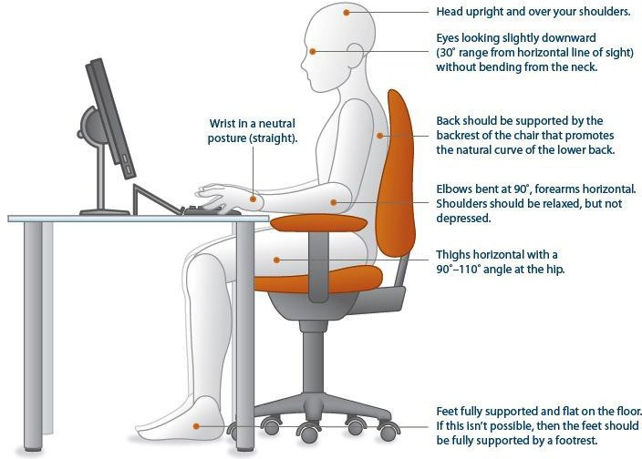
2 | Are your feet fully supported by the floor when you are seated? | ☐ | ☐ | ☐ | Lower the chair Use a footrest
3 | Does your chair provide support for your lower back? | ☐ | ☐ | ☐ | Obtain a fully adjustable chair  Adjust chair back Obtain lumbar role
2 | Are your feet fully supported by the floor when you are seated? | ☐ | ☐ | ☐ | Lower the chair Use a footrest
4 | When your back is supported, are you able to sit without feeling pressure from the chair seat on the back of your knees? | ☐ | ☐ | ☐ | Adjust seat pan Add back support
5 | Do your arm rests allow you to get close to your keyboard? | ☐ | ☐ | ☐ | Lower arm rests Remove arm rest  Obtain chair without arm rests

 | Your Work Surface | Yes | No | NA | Suggested Actions
1 | Is your monitor positioned directly in front of you? | ☐ | ☐ | ☐ | Reposition monitor
2 | Is your monitor at least an arm’s length away? | ☐ | ☐ | ☐ | Reposition monitor  Obtain alternative monitor, eg flat screen
3 | Is your monitor slightly below eye level? | ☐ | ☐ | ☐ | Add or remove monitor stand Adjust monitor height
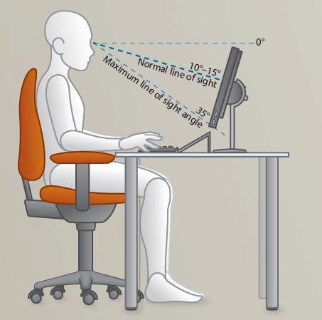
4 | Is your monitor and work surface free from glare? | ☐ | ☐ | ☐ | Position monitor to have windows at side  Cover windows  Adjust overhead lighting Obtain anti-glare screen
4 | Do you have appropriate light for reading or handwriting documents and notes? | ☐ | ☐ | ☐ | Obtain desk lamp  Place on appropriate side for handedness (left / right)
5 | Are frequently used items located within usual work area and occasionally used items in another area? | ☐ | ☐ | ☐ | Rearrange workstation
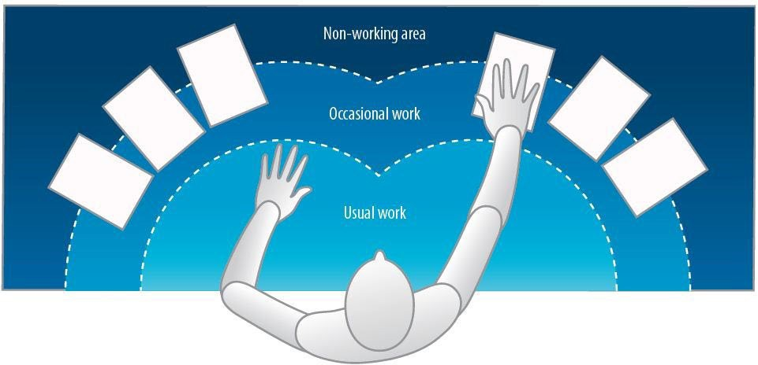

 | Your Keyboard and Mouse | Yes | No | NA | Suggested Actions
1 | Are your keyboard, mouse and work surface at your elbow height? | ☐ | ☐ | ☐ | Raise or lower workstation and  /or keyboard and / or chair
2 | Are frequently used items within easy reach? | ☐ | ☐ | ☐ | Rearrange workstation
3 | When using your keyboard and mouse, are your wrists straight and your upper arms relaxed?  Your keyboard should be flat and not propped up on keyboard legs as an angled keyboard may place the write in an awkward posture. | ☐ | ☐ | ☐ | Recheck chair, raise or lower Check posture  Check keyboard and mouse height
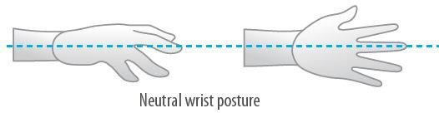
4 | Is your mouse at the same level and as close as possible to your keyboard? | ☐ | ☐ | ☐ | Move mouse closer to keyboard Obtain larger keyboard tray
5 | Is the mouse comfortable to use?  Rest your dominant hand by using mouse with non-dominant hand periodically (change mouse buttons in control panel) | ☐ | ☐ | ☐ | Investigate alternative

 | Breaks | Yes | No | NA | Suggested Actions
1 | Do you take postural breaks every 30 minutes –  e.g. standing, walking to the printer, etc.? | ☐ | ☐ | ☐ | Set reminders to take breaks
2 | Do you take regular eye breaks from looking at your monitor? | ☐ | ☐ | ☐ | Focus to the long or medium distances every 30 minutes
 | Accessories | Yes | No | NA | Suggested Actions
1 | Is there a sloped desk surface or angle board for reading and writing if required? | ☐ | ☐ | ☐ | Obtain angle board
2 | Is there a document holder either beside screen or between screen and keyboard if required? | ☐ | ☐ | ☐ | Obtain document holder
3 | Are you using a headset or speaker phone if you are writing or keying while talking on the phone? | ☐ | ☐ | ☐ | Obtain headset or use speaker phone
 | Laptop | Yes | No | NA | Suggested Actions
1 | If using a laptop for long periods, are you using:  - A full-sized external mouse and keyboard  - A docking station with full-sized monitor or laptop stand | ☐ | ☐ | ☐ | Obtain necessary equipment
 | Hot Desking | Yes | No | NA | Suggested Actions
1 | Are you provided with the time, support and supervision to make the above adjustments? | ☐ | ☐ | ☐ | Speak to supervisor

Supervisor Name
Position
Date
Signature
Comments:

Working From Home Weekly Check-In

Employee Name | Click here to enter text.
Supervisor Name | Click here to enter text.
Date of Check-In | Click here to enter text.

Weekly Check-In
Support & Supervision
How are you experiencing the level support and supervision you need to work optimally?
Poor | 1 | 2 | 3 | 4 | 5 | 6 | 7 | 8 | 9 | 10 | Excellent
Notes:
How well connected to do you feel to the team this week?
Not at all | 1 | 2 | 3 | 4 | 5 | 6 | 7 | 8 | 9 | 10 | Very
Notes:
Personal Well-Being
Which of the following are you regularly practicing during working hours?
- 5-minute stretch break each hour ☐ 30-minute lunch break
- 10-minute morning tea ☐ 10-minute afternoon tea
On a scale of 1 (lowest) to 10 (highest), how is your emotional well-being at the moment?
Low | 1 | 2 | 3 | 4 | 5 | 6 | 7 | 8 | 9 | 10 | High
Explore supports required for low scores (e.g. EAP):
Home Office Facilities
Has anything changed from your initial Home Office Facilities Assessment Checklist or since our last Check-In?
- Yes ☐ No

If yes, detail what these changes are (e.g., reduced space to work, children at home, connectivity, etc.):

What equipment and facilities do you need:

