Joint Proposal for Economic Stimulus

Healthy & affordable homes: national low-income energy productivity program

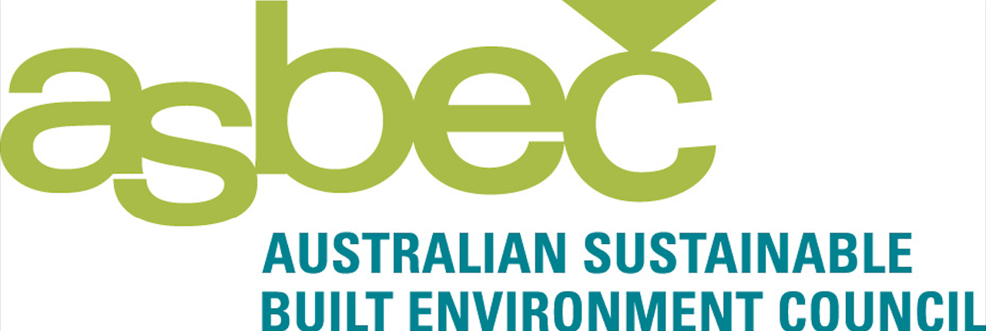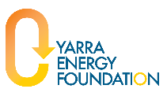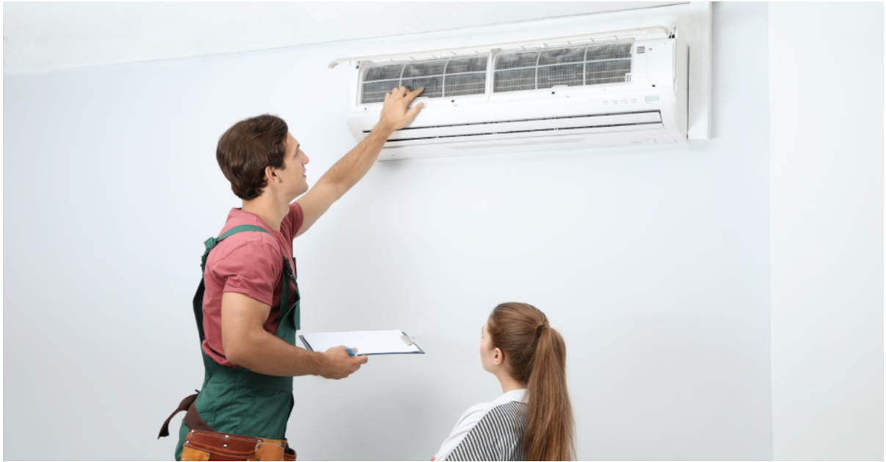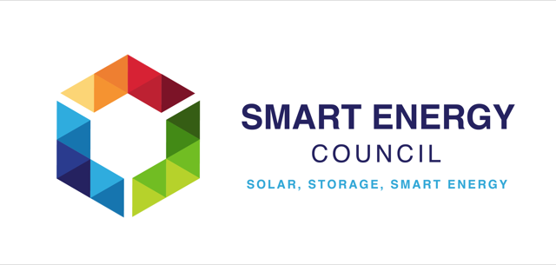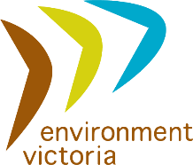](https://www.anglicare-nt.org.au/)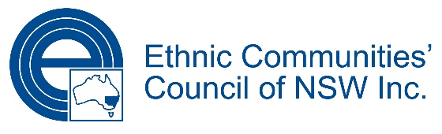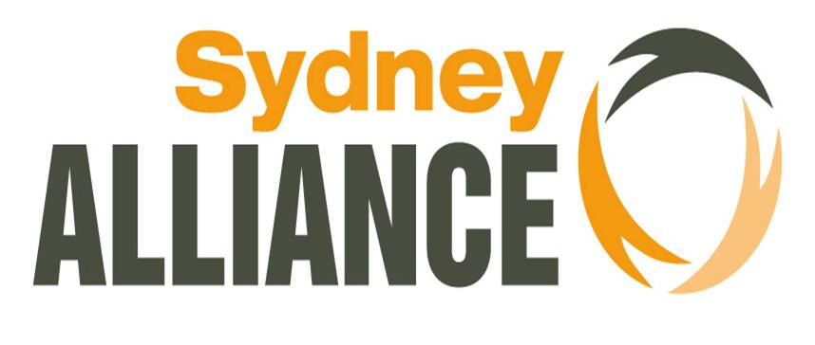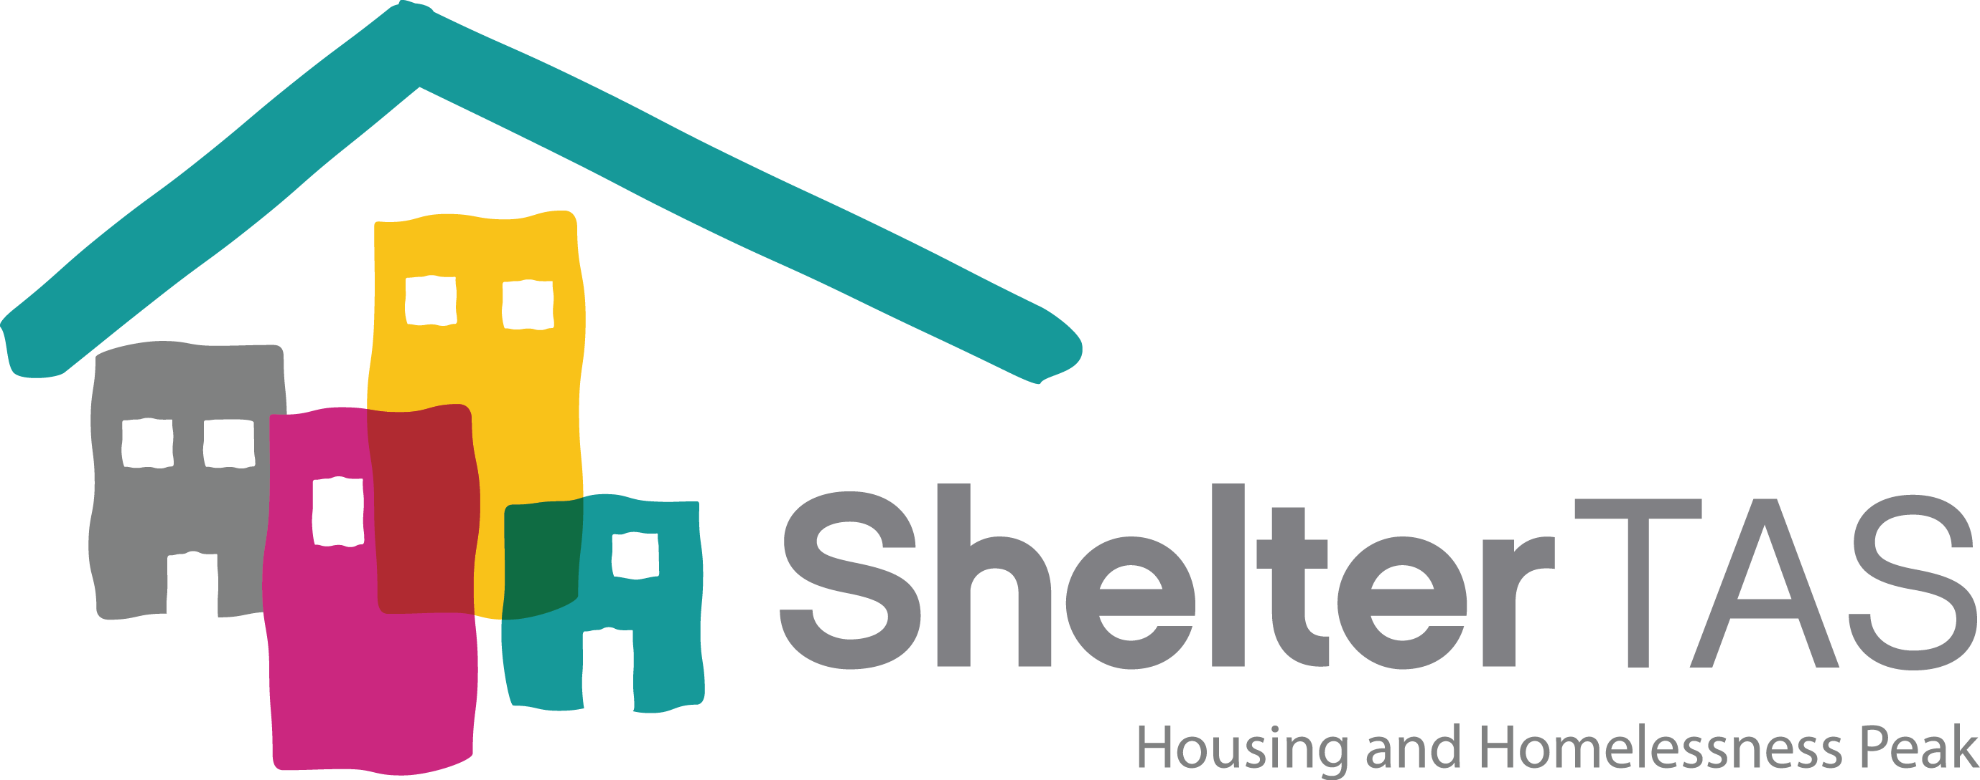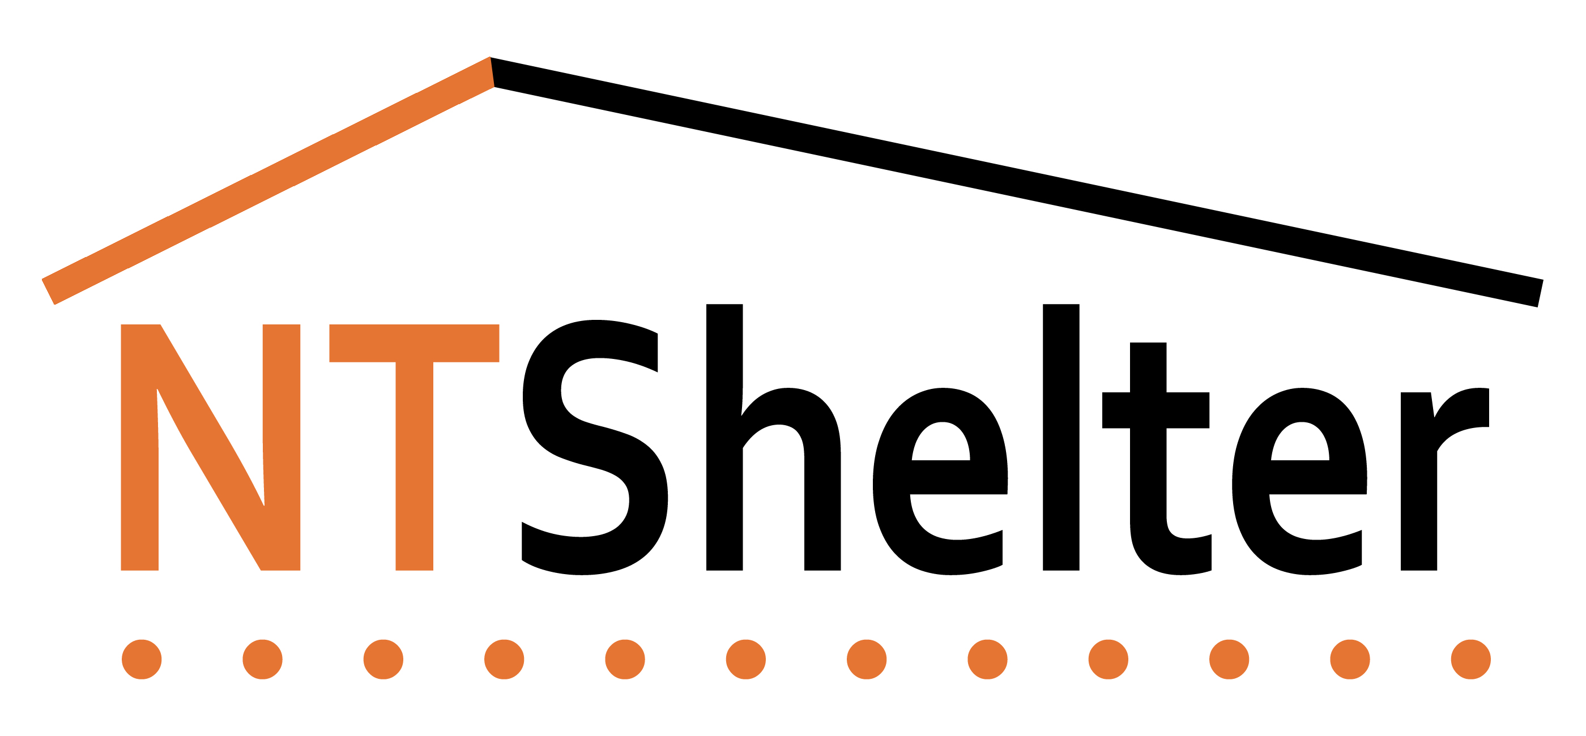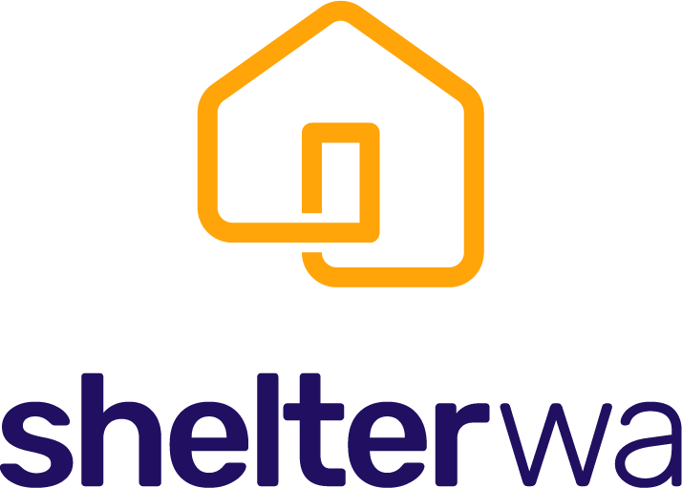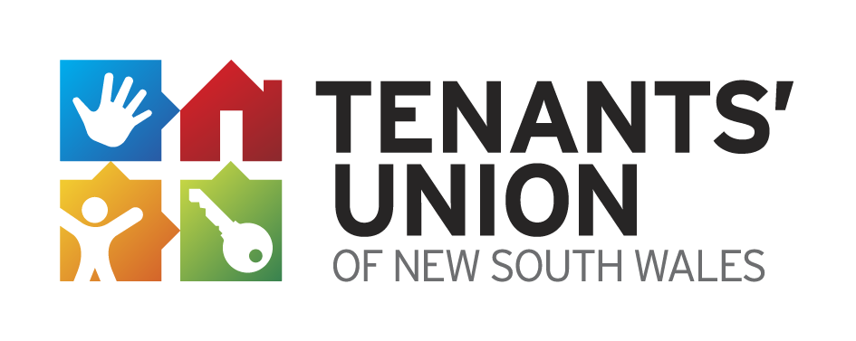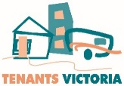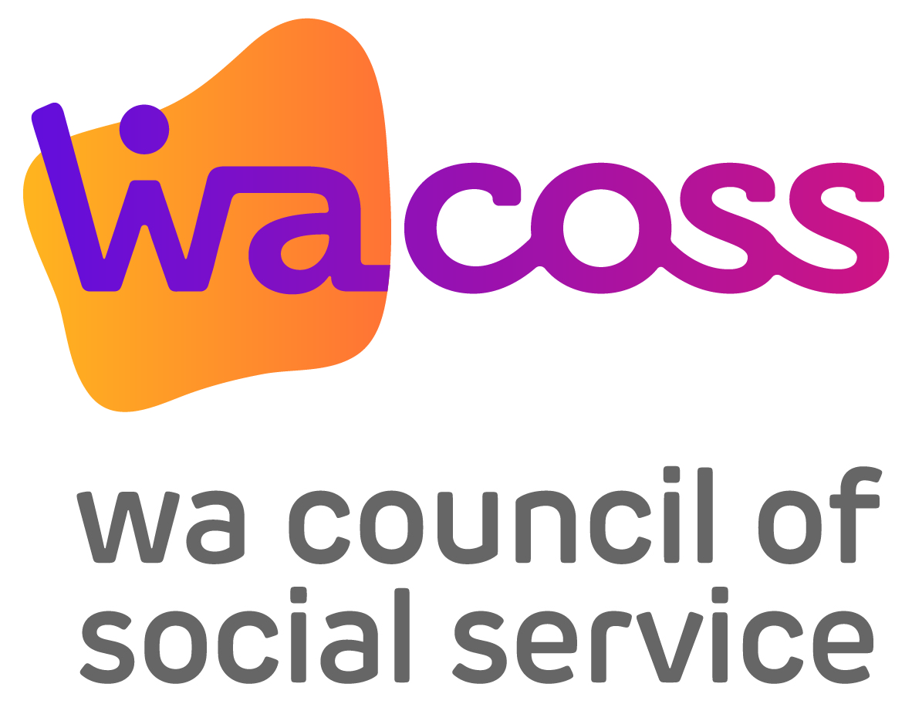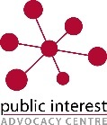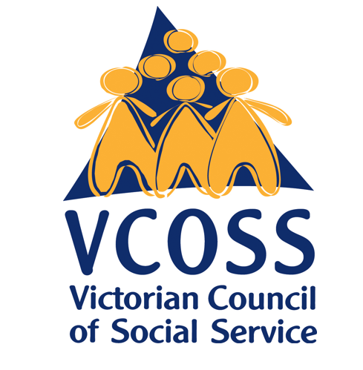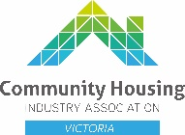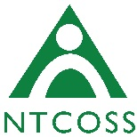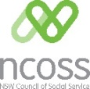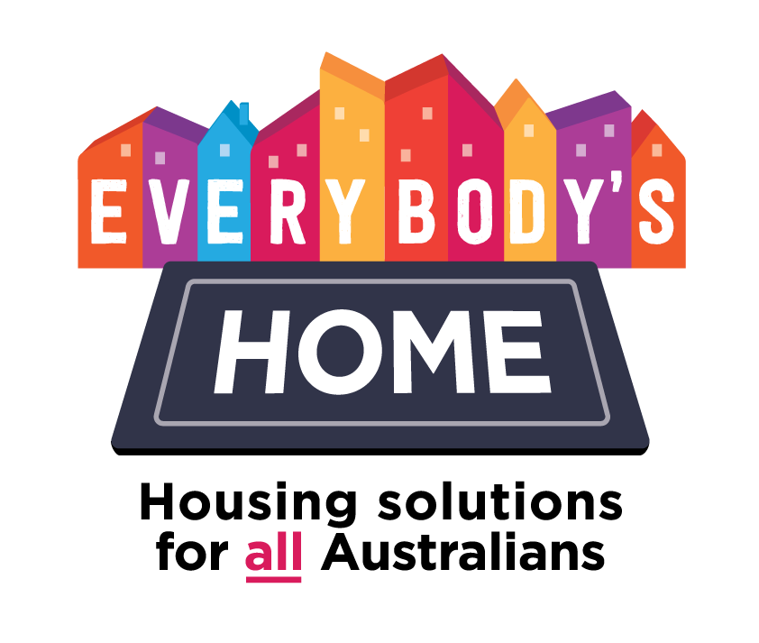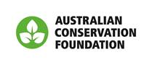[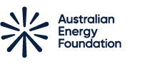](https://aef.com.au/)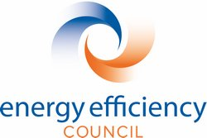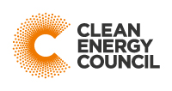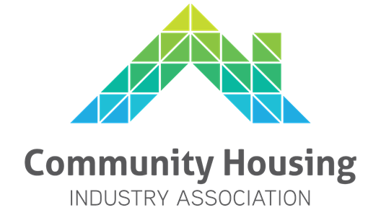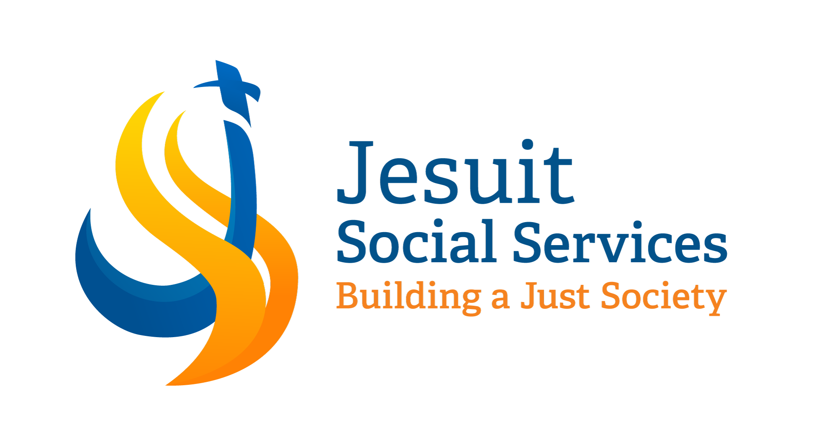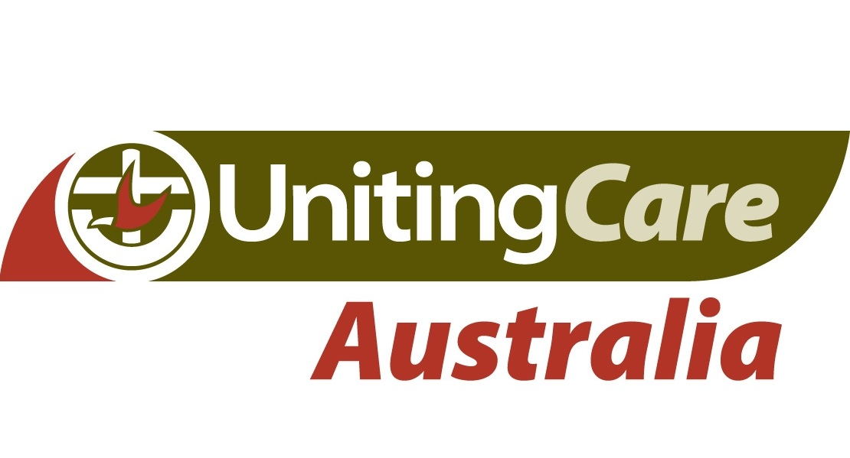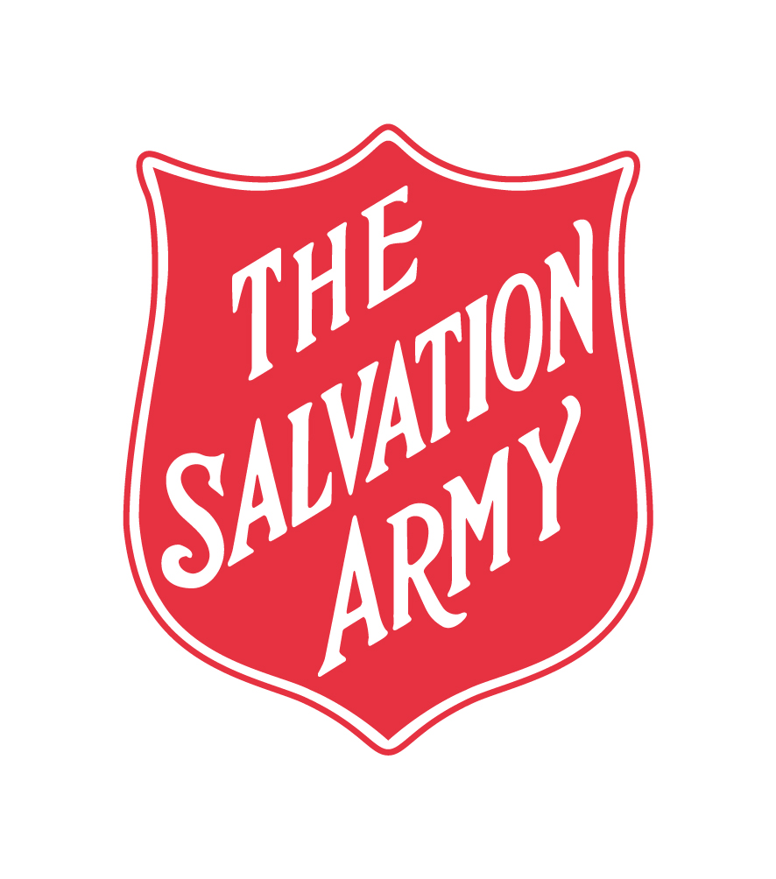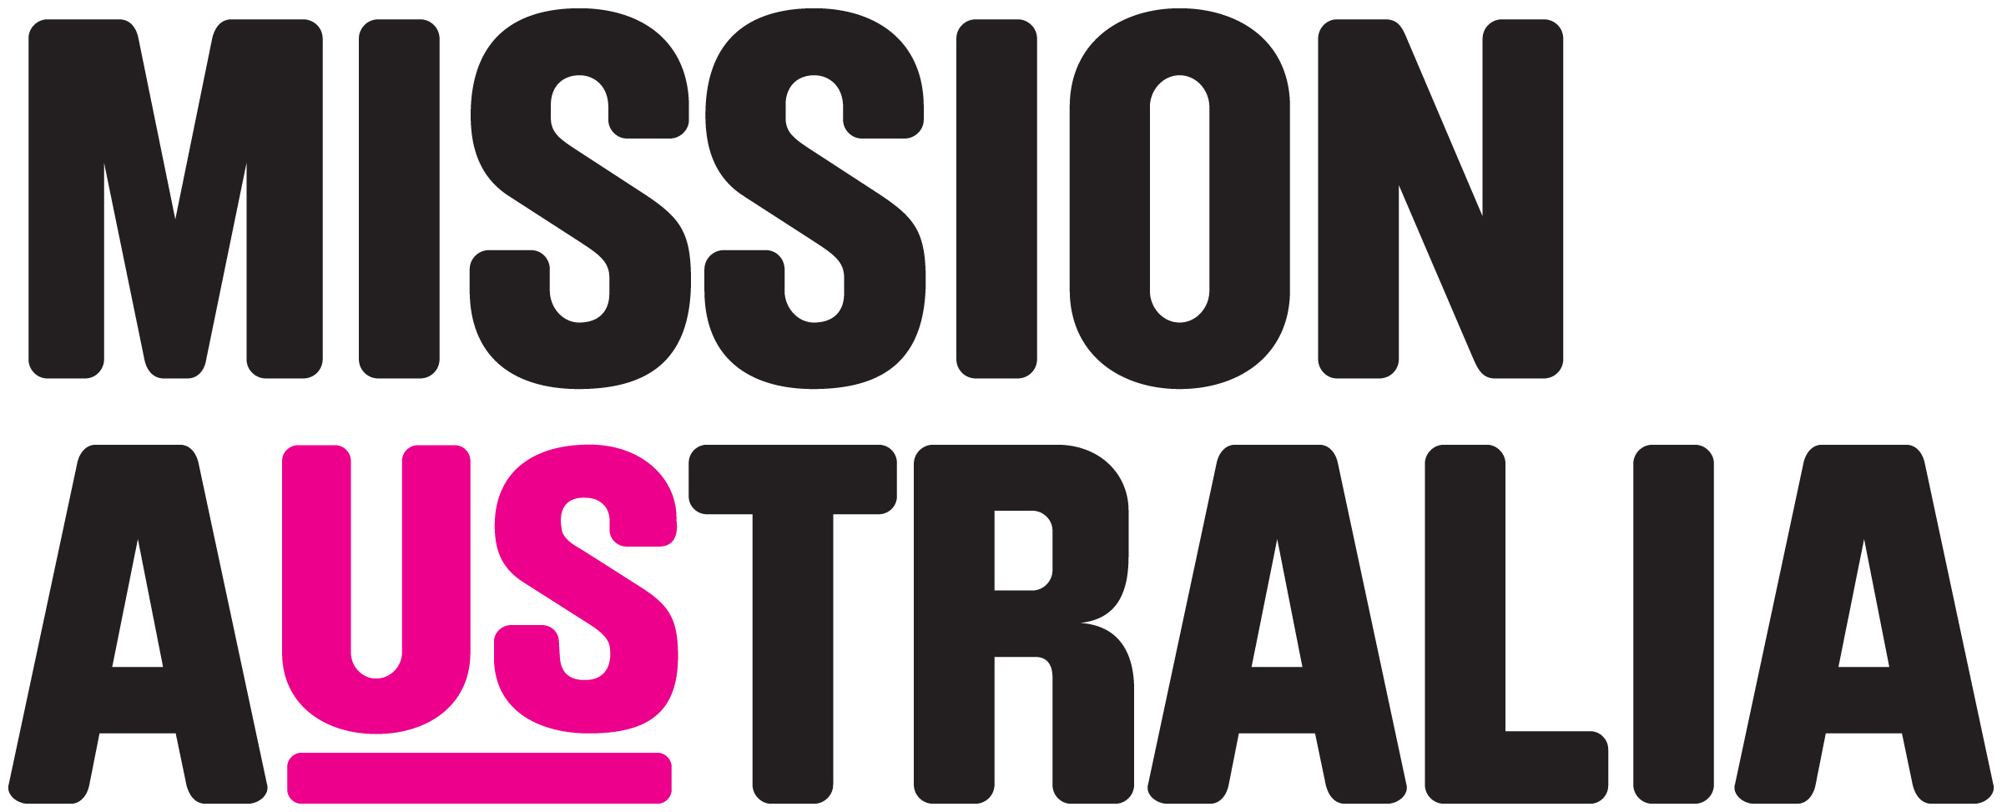

**Supporting organisations**^

Summary

As we move to respond to the COVID Crisis, we should aim to**build back stronger and more resilient.**

We should start from**first principles, agree criteria**for the way forward,**adopt measures that meet these criteria and set specific goals to be achieved.**

To succeed, we must **work together: government, community, business and unions.**

Our **First Principles** includes jobs-rich growth, a focus on people most at risk, a collaborative approach with a regional focus, improving liveability and resilience and reducing carbon emissions.

Our **Criteria** includes targeting projects towards people on lower incomes who are most likely to spend in the economy, projects that generate jobs quickly but deliver long-term security, assist the most disadvantaged regions and deliver long-term social, economic and environmental benefits.

One job-rich **Proposal** that will help people and communities to recover and build back stronger, is to create healthy and affordable homes by improving the energy productivity of low-income existing homes. The proposal has four components:

1. **Social housing** - Federal and state/territory governments provide matching funds to invest in energy efficiency upgrades and solar PV installations for social housing dwellings.
2. **Low-income home owners** - The Federal Government partner with state/territory, local councils and community organisations to provide energy efficiency audits, upgrades and solar PV installations for low-income owner occupiers.
3. **Inefficient rental properties**- Over the next two to three years, COAG Energy Council is working on a proposal to implement mandatory energy efficiency standards for rental properties. In the meantime, the Federal Government could provide grants to landlords to support the upgrade of poor performing rental properties.
4. **Low-income appliance replacement offer**– Governments provide subsidies for low-income households to replace inefficient appliances, or purchase more energy efficient appliances.

Briefing

We are advocating for governments to implement a national low-income energy productivity program (NLEPP), that installs energy efficiency and solar in the homes of people on low incomes.

The average energy efficiency rating of existing homes is only 1.7 stars (new homes average 6.1 stars). Many people are living in homes that are too cold in winter, too hot in summer and too expensive to maintain health and wellbeing. Many people go without heating or cooling or forego food or medication, putting their health and lives at risk. People on low incomes are more likely to live in energy inefficient homes and cannot afford (or are unable in the case of renters) to improve efficiency. These impacts have been felt more acutely during the COVID-19 crisis as people are spending more time at home.

The COAG Energy Council has agreed to a Trajectory for Low Energy Buildings, a national plan that sets a trajectory towards zero energy (and carbon) ready buildings, including existing homes.[1]  There are actions that can be taken now.

Investment in energy efficiency and solar now would quickly create thousands of jobs (in training, auditing, installation, manufacturing and local retail),[2] increase household disposable incomes to spend in the economy (through reduced household energy costs), and lead to improved health and wellbeing. The investment would also deliver on other government priorities including reduced energy bills, cuts in carbon emissions and reduced load on the electricity grid.

It is envisaged that NLEPP would be delivered in partnership with state, territory and local governments and organisations* that have a track record of delivering high quality, low-risk, energy productivity programs in homes. These organisations have established relationships with trusted, qualified installers and a track record of working with federal, state, territory and local governments to roll out energy efficiency and solar programs in accordance with relevant safety and quality standards.

Energy productivity measures would include (but not be limited to), reverse cycle air conditioners for heating and cooling, more efficient hot water (heat pumps), draught sealing, ceiling fans, efficient thermal building envelope, lighting, shade structures, and solar photovoltaic (PV).[3]

It is envisaged the NLEPP would be designed to work with local suppliers and create new apprenticeships and where possible local jobs. The program can be rolled out in phases:

1. Immediate: Training in audits and installations, conduct of energy audits, sale of energy efficiency appliances, program planning and promotion;
2. Economic restart: Begin in areas where state, territory and local governments, community housing and delivery organisations have some experience and have means to implement the program quickly or where need is urgently identified such as bushfire affected areas; and
3. Economic rebuild: through broader national rollout.

The energy audits will contribute to the aims of COAG’s Trajectory for Low Energy Buildingsto test rating tools and build a database of the energy performance of Australian housing stock.

**NLEPP has four components:**

1. Social housing

There are approximately 440,000 social housing dwellings in Australia,[4] which provide low-cost housing for people who cannot afford accommodation in the private rental market.[5]

The Social Housing NLEPP project proposes that federal, state and territory governments co-invest to implement energy efficiency upgrades and solar PV installations for public, Aboriginal and community housing dwellings.[6]

It is proposed that an energy audit be undertaken for all social housing properties to determine the appropriateness of the dwelling for an energy productivity upgrade or, alternatively, advise whether a new re-build is required. The energy audits will also contribute to the aims of COAG’s Trajectory for Low Energy Buildingsto test rating tools and build a database of the energy performance of Australian housing stock.

Based on the outcomes of the energy audits, social housing properties could install energy productivity measures that would include (but not be limited to) reverse cycle air conditioners for heating and cooling, more efficient hot water (heat pumps), draught sealing, ceiling fans, efficient thermal building envelope, lighting and solar PV.

***Public and Aboriginal Housing*** - jurisdictions would be responsible for managing the roll out of retrofits for public and Aboriginal housing. A number of jurisdictions have already begun retrofit programs and have the mechanisms in place for expanding delivery.

***Community Housing*** – federal and state/territory government funding would be provided to community housing providers to implement energy efficiency upgrades and solar PV installations.

State and territory governments and community housing providers would work with organisations that have a track record of delivering high quality, low-risk, and energy productivity programs.*

All dwelling energy savings must be passed on to the tenant.

**Budget:** $336 million in 2020-21, $502 million in 2021-22#

**Costing Assumptions:**There are approximately 440,000 social housing dwellings (based on ABS data) in Australia. Cost of $3,800 per house to invest in a combination of more efficient hot water, heating/cooling, lights, gap sealing and insulation (noting some houses will require slightly greater investment and some will require slightly less). Assumed the program will ramp up over four years, with 20% of required 440,000 homes in 2020-21, 30% in 2021-2022, 30% in 2022-2023 and 20% in the final year.

**New Social Housing** - We are also advocating for federal and state/territory governments to co-invest in building 30,000 new social housing dwellings, which would stimulate new jobs and reduce homelessness. For every dollar spent it is estimated to boost GDP by $1.30. See [the Social Housing Acceleration and Renovation Program](https://www.communityhousing.com.au/wp-content/uploads/2020/05/SHARP-Program.pdf?x59559).

1. Low-income home owners

There are 1.1 million low-income households,[7] including many older people with health risks that own their own home but do not have the disposable income to improve their home’s energy performance.

The NLEPP for low-income home owners proposes that the Federal Government fund states, local councils or community organisations to coordinate access to energy efficiency audits, energy efficiency upgrades and solar PV installations for low-income owner occupiers.[8]

The program would build on the experience of local councils and community service organisations in delivering energy efficiency and solar programs, including through the Australian Government's Solar Cities and Low Income Energy Efficiency Program (LIEEP) project.

The program would be delivered in partnership with organisations experienced in delivering home energy services that have a track record of delivering high quality, low-risk, energy services programs.*

Funding of up to $5,000, based on the outcome of energy audits, would be provided to install energy productivity measures that would include (but not be limited to), reverse cycle air conditioners for heating and cooling, more efficient hot water (heat pumps), draught sealing, ceiling fans, efficient thermal building envelope, lighting and solar PV.

**Budget:** $836 million in 2020-21 and $1,254 million in 2021-22#

**Costing Assumptions:** There are 1.1 million low-income households (quintile 1), ABS data. Cost of $3,800 per house to invest in a combination of more efficient hot water, heating/cooling, lights, gap sealing and insulation (noting some houses will require slightly greater investment and some will require slightly less). ACOSS has assumed the program will ramp up over four years and has allocated 20% of required budget for 1.1 million homes in 2020-21, 30% in 2021-2022, 30% in 2022‑2023 and 20% in the final year.

A portion of the costs could be recouped through council rates.[9]

1. Inefficient rental properties

Over the next two to three years, the COAG Energy Council is working on a proposal to implement mandatory energy efficiency standards for rental properties. Minimum standards for rental properties are considered essential to ensure that rental homes are safe for tenants, and are strongly supported by community, social sector housing organisations and research institutions.

In the meantime, to stimulate jobs and upgrade the poorest performing rental properties, the Federal Government could provide time limited grants to landlords to support energy productivity improvements.[10]

It is proposed that all landlords would be entitled to free energy audits (this would support COAG Energy Council’s goal to build a database of dwellings and test rating tools). Homes that perform under a predetermined energy rating would then be eligible to access a grant of up to $5,000 to upgrade the energy performance of the home based on recommendations of the energy audit.

The program would be delivered in partnership with organisations experienced in delivering home energy services that have a track record of delivering high quality, low-risk, energy services programs.*

As this is a voluntary scheme, there is a risk that rents could be increased making renting more unaffordable to people on low income. To mitigate against this, a requirement to ensure tenants benefit from the upgrade should be implemented and tied to receiving and retaining the grant. This could be done by restricting the level of rent on the property for two years at either a) rent at the time of accepting the grant + CPI or b) an assessed market rent for the property, whichever is **lower**. Grant terms must be disclosed in the Tenancy Agreement.

**Budget:** $232.2 millionin 2020-21 and $232.2 million in 2021-22#

**Costing Assumptions:** According to 2017-18 ABS housing data, it is estimated there are 1.8 million relevant private landlord rental properties (excluding community housing, defence housing, caravan parks, and family members). Estimate 20% (360,000) might take up energy audit ($250) at cost of $90 million. It is estimated 10% (180,000) would be eligible to access energy efficiency subsidy. Cost of $3,800 per house to invest in a combination of more efficient hot water, heating/cooling, lights, gap sealing and insulation (noting some houses will require slightly greater investment and some will require slightly less), for a cost of $684 million. Assumed the program will delivered over 3 years prior to mandatory standards being implemented. Allocate 30% of required budget in 2020-21, 30% in 2021-2022 and 40% in 2022-2023.

1. Low-income inefficient appliance replacement offer

Federal and state governments should provide subsidies for low-income households to replace inefficient appliances or purchase new energy efficient appliances.

There are already some appliance replacement schemes that exist in some jurisdictions like ACT’s ActSmart Replacing old appliances scheme[11] and the NSW appliance replacement offer[12] that could be expanded as outlined below and implemented in other jurisdictions.

The subsidy should be delivered efficiently to reduce potential profiteering by companies and maximize benefits for households, through for example the No Interest Loans Scheme (NILS) in partnership with community sector organisations (see for example the ACT appliance replacement scheme) and/or via vouchers for pre-approved retailers[13] or suppliers[14].

Approved appliances would include: heating and cooling appliances, fridges, hot-water systems, washing machines, dryers and TVs (size limited).

Eligibility would include households who are accessing the following:

* JobSeeker Payment
* Youth Allowance
* Pensioner Concession Card
* Health Care Card or Low Income Health Care Card from Centrelink
* Veterans' Affairs Gold Card
* Parenting Payment
* Special Benefit
* Or alternatively, households that can demonstrate they are on a low income (less than $1,500 single income per fortnight, $2,125 per fortnight if single with a dependent child, or $3,000 partnered income per fortnight) or recently had a substantial decrease in household income (e.g. loss or reduction of employment, family separation).

The appliance replacement scheme can be implemented during COVID-19 restrictions, as currently trades and services are able to enter homes when done so safely.

The appliance replacement offer would stimulate jobs in community services, retail, local manufacturing and supply chain (transport and handling).

This initiative would quickly contribute to addressing immediate energy efficiency needs during COVID 19 social restrictions, reducing energy bills and increasing disposable incomes to be spent elsewhere in the economy. It would also improve the health and wellbeing of millions of people who are spending more time at home as result of COVID-19 measures.

For further information please contact:

Kellie Caught, Senior Adviser, ACOSS, [kellie@acoss.org.au](mailto:kellie@acoss.org.au)

June 2020

* There are multiple organisations that have a track record of delivering high quality, low-risk, energy productivity programs in low-income homes. Some examples include, but not limited to, the Australian Energy Foundation (AEF), Brotherhood of St Laurence, Energy for the People (BOOMPower), Uniting and Good Shepherd. These organisations have established relationships with trusted, qualified installers and a track record of working with federal, state, territory and local governments to roll out energy efficiency and solar programs in accordance with relevant safety and quality standards. Jurisdictions will also have additional relationships with other experienced organisations.

# Existing government programs such as the Climate Solutions Fund, could contribute to fund some of the measures above. However, we believe the response to COVID requires additional government expenditure to support this package, along with other clean energy measures, in order to urgently stimulate jobs and re-build a sustainable and strong economy.

^ Policy is sufficiently aligned with organisations interests and the organisation supports the intent of the policy.

1. <http://coagenergycouncil.gov.au/publications/trajectory-low-energy-buildings>
2. For example, a report for the [Energy Efficiency Council](https://www.eec.org.au/uploads/Projects/Energy%20Efficiency%20Employment%20in%20Australia%20-%20full%20report.pdf) has estimated a major drive to improve the energy efficiency of residential could deliver over 34,000 job. And, if only one-third of the households identified in this package received solar installations it could deliver 27,000 jobs (estimation based on there being roughly [160,000 rooftop solar installations](https://www.energycouncil.com.au/media/11188/australian-energy-council-solar-report_-january-2018.pdf) in 2017 and according to [ABS data there were 8,240 jobs](https://www.abs.gov.au/ausstats/abs@.nsf/mf/4631.0) in rooftop solar in the same year. If 516,000 low-income homes installed solar an estimated 27,000 jobs could be created).
3. Some jurisdictions may want to expand the program with additional funds to include battery storage, which will provide further support for low-income households and support grid reliability and stability.
4. AIHW (2018) Housing Assistance in Australia 2018. <https://www.aihw.gov.au/reports/housing-assistance/housing-assistance-in-australia-2018/contents/social-housing-dwellings>
5. Including public, community housing and Aboriginal housing
6. This proposal acknowledges the some jurisdictions have invested in improving the energy efficiency and installing solar on **some** public housing and community housing. The SA government is investing in the installation of solar PV and battery systems on public housing as part of South Australia's Virtual Power Plant. Through the NLEPP we are encouraging jurisdictions to expand and accelerate existing programs or introduce new programs.
7. ACOSS and BSL (2018) Energy Stressed in Australia. Appendix 2 <https://www.acoss.org.au/wp-content/uploads/2018/10/Energy-Stressed-in-Australia.pdf>
8. Examples of how the program could be funded include, Darebin City Council Solar Savers program where they pay upfront costs and help access suppliers <http://www.darebin.vic.gov.au/en/Darebin-Living/Caring-for-the-environment/EnergyClimate>. Or the Green Smart Program where consortiums of organisations, including community sector organisations could bid to manage and implement programs for low-income households <http://library.bsl.org.au/jspui/bitstream/1/1906/1/green-start-guidelines.pdf>
9. For example, a number of Victorian Councils provide upfront costs of solar installations for low-income home owners, who then pay back zero interest through council rates <https://solarsavers.org.au/>
10. Scotland has provided a grants program to landlords ahead of introducing mandatory rental standards.
11. <https://www.actsmart.act.gov.au/energy-saving/replacing-old-appliances>
12. https://www.service.nsw.gov.au/transaction/apply-appliance-replacement- offer?gclid=CjwKCAjwv4_1BRAhEiwAtMDLstMinDCA7WxTHpFGtP7FqpVwXF5MbrLemtH73HBFBI67zvTmd6YvGxoCxb4QAvD_BwE&gclsrc=aw.ds
13. General household appliances.
14. Hot water systems.