February 2020

New Energy Compact

*People centred vision for the Australian energy system*

Consultation Draft 4.0

horizontal line

horizontal line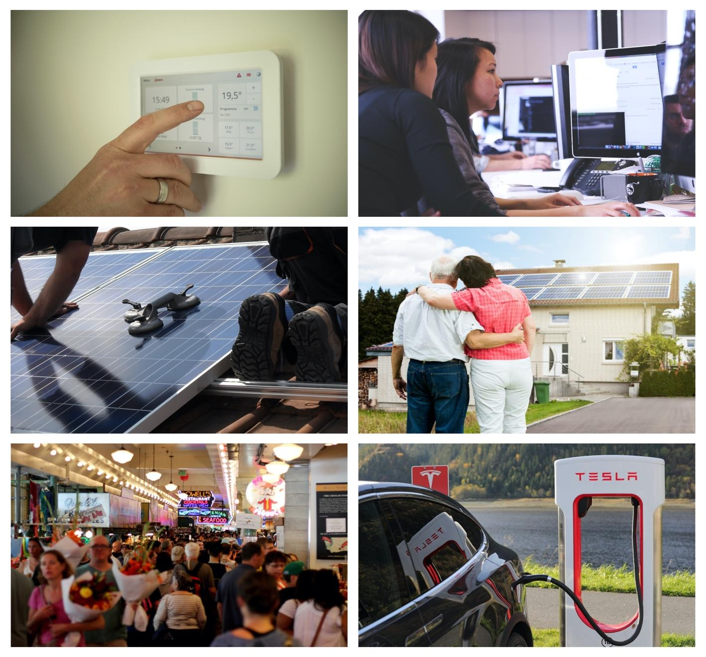

Contents

**Overview** ii

Structure ii

Contact details ii

The New Energy Compact on a page iii

**Developing the New Energy Compact** 1

Scope 2

How you can be involved 2

Your feedback 2

**New Energy Compact** 3

Why we need a New Energy Compact 3

The Principles 4

1. Put the people at the centre 5

2. Think long term and by flexible 6

3. Be just and fair 7

4. Ensure it works 8

5. Deliver clean and healthy energy 9

**Applying the New Energy Compact** 10

# 

# 

# 

# Overview

The New Energy Compact, is an initiative of The Australian Council of Social Services (ACOSS) and the Total Environment Centre (TEC) with the support of Energy Consumers Australia (ECA).[1]

The New Energy Compact is a people centred vision for the Australian energy system. The purpose of the Compact is to instill a new vision and principles that reflects the values of people, is future focused and is used by decision makers to guide policy and reform for an inclusive, affordable, dependable and clean energy system.

The objective of this Consultation Draft is to provide stakeholders with an opportunity to review the Draft Compact and to seek their views on the key features of the document.

## Structure

This Consultation Draft is composed of three parts designed to advance the conversation about the New Energy Compact:

1. **Developing the New Energy Compact:** explains the process for creating the Compact, its scope and how you can engage with its development.
2. **The New Energy Compact:** explains why we need a New Energy Compact and sets out five principles to advance the vision, supported with guidance on how the principle might be applied.
3. **How to use the New Energy Compact:** explains how the*New Energy Compact* could be applied to secure the most favourable outcomes for people, business, the community and the environment.

## Contact details

**For more information, please contact:**

**Kellie Caught Mark Byrne**  
Senior Adviser, Climate and Energy Energy Market Advocate  
ACOSS Total Environment Centre  
E: kellie@acoss.org.au E: [markb@tec.org.au](mailto:markb@tec.org.au)

## The New Energy Compact on a page

## 

**Principles**

**Guiding values**

**Vision**

**Purpose**

# Developing the New Energy Compact

The New Energy Compact (the Compact) is an initiative of the Australian Council of Social Services (ACOSS) and the Total Environment Centre (TEC) with the support of Energy Consumers Australia (ECA) to guide reform in a changing energy system.

The development of the Compact is a collaborative process, informed by expert advice and insights from a range of stakeholders, as well as international and domestic research on what people expect from their energy system.[2]

An initial workshop was held in Sydney in September 2019, bringing together 49 energy user groups, energy companies, energy market bodies and other stakeholders to develop a vision and high-level principles to guide policy and regulatory reform in a rapidly changing energy system.

A drafting team with representatives from ACOSS, TEC and ECA drafted version 1.0 based on the outcomes of the workshop. The drafting team then consulted with a smaller group of workshop participants to develop version 2.0.

In October 2019, ACOSS, TEC and ECA held forums in Melbourne, Sydney, and Brisbane and hosted a webinar, to consult with workshop participants and interested stakeholders.

The forums focused on building consensus around the vision statement, refining the guiding principles, and exploring what actions are needed to demonstrate the values. The consultation also revealed that guidance could be useful on how to apply the Compact. Based on this feedback, Consultation Draft Version 3.0 released in November 2019, included a *Methodology to apply the New Energy Compact.*

A communications expert was engaged to further refine the draft Compact.

Feedback is now sought on this Consultation Draft 4.0 with a view to releasing the first edition of the New Energy Compact in May 2020.

**Initiation workshop**   
September 2019

**Forums & webinar**  
October 2019

**Consultation draft**February 2020

**Consultation**February -  March 2020

**Target release**May 2020

**Domestic and international research**

## Scope

The Compact is designed to guide decision makers and advocates engaged in energy reform and processes. The principles are drafted to apply to all decision makers in the energy system regardless of their role or where they sit in the supply chain.

The focus of the Compact is on decision makers and advocates. However, all who engage with the energy system have responsibilities, therefore the principles of the Compact have been designed in a way that can be applied both to decision makers and to individuals.

How the Compact is applied will vary depending on the role an organisation or individual plays in the system. This flexibility allows for broad application, while also being clear about expectations.

The Compact is intended to complement existing customer focused initiatives and is expected to evolve over time with experience and further consultation. It should be used in addition to the [National Energy Objectives](https://www.aemc.gov.au/regulation/regulation), w[hich govern and guide the operation of the National electricity market](https://www.aemc.gov.au/regulation/regulation). It is complementary to the [Energy Charter](https://www.theenergycharter.com.au/), which is an industry led initiative that outlines what energy companies will do to rebuild trust and deliver better outcomes for customers.

Interested stakeholders will be invited to endorse the Compact and to engage with its refinement over time.

## How you can be involved

The Compact has been developed in collaboration with a range of organisations, representing governments, institutions, companies, industry, environment and consumer representatives.

To achieve the Vision articulated in the Compact we will be seeking the endorsement of the Compact by governments, institutions, companies, organisations and individuals.

You can find out more about how you can endorse the Compact by contacting Kellie Caught, ACOSS, [kellie@acoss.org.au](mailto:kellie@acoss.org.au)

## Your feedback

This consultation draft of the Compact has benefited from the expertise and insights of many individuals, organisations and representative groups. We value the perspectives of all stakeholders and now seek your views on this Consultation Draft.

Please send your feedback to Kellie Caught, ACOSS, e: [kellie@acoss.org.au](mailto:kellie@acoss.org.au) or m: 0406 383 277 or contact Kellie to organise a direct briefing.

# New Energy Compact

## Why we need a New Energy Compact

The energy system has improved the lives of many Australians. It is an essential service that plays a critical role in the health and wellbeing of people and in powering the economy. It is also going through a fundamental transformation - driven by technological innovation, business model changes, greater customer choice and the urgent need to reach zero emission clean energy.

When the Australian energy system was built it was primarily a centralised, one-way system, owned and managed by State governments. The social contract to supply energy was between governments and the Australian people. Governments were accountable to their citizens for service, affordability and reliability.

Now ownership is mixed between government, private businesses and millions of individually owned infrastructure in people’s homes and businesses, in the form of more renewable, de-centralised, and variable energy with two-way flows. People are no longer just buying energy, but are also generating, storing and trading, as well as consuming their own energy. The move to clean energy is a priority for people and Australia has made commitments to international emissions reduction agreements and to sustainable development goals[3].

The changes in the energy system mean that the old social contract to provide this essential service has become fractured. In this process, trust has been lost, energy is unaffordable for some, others are unable to benefit from the transformation taking place and we urgently need to decarbonise our energy system. While reform processes have focussed more on the technical and market challenges, which are necessary to the transition, there has been an absence of a discussion of the values that are needed to build confidence and trust in the energy system of the future.

Access for all to affordable, dependable, and clean energy services are critical. We need to ensure that energy continues to be a valued as an essential service and to create a more inclusive and sustainable system that delivers better outcomes for all. A new contract between governments, people, industry, institutions and communities must be created. It needs to be focused on the future and be consistent with the values of people and the community, to meet their energy needs.

We all have a role to play in the energy system, a system that delivers for people, business and the community and takes account of environmental needs. The benefits of energy transformation also bring responsibilities to behave fairly, mindful of the future and considering the energy system as a whole.

Delivering the Compact’s vision requires an agreement between all who engage with the energy system - one that instills confidence that people will benefit, that the energy transformation will have a positive impact on the community and environment and that change will be undertaken together.

## 

## Values and principles

The Compact sets out core values and five principles to meet the vision for the energy system developed by stakeholders. They are focused on fostering a mindset about how we deliver energy to people, grounded in values, a win-win mentality, and reciprocity between participants based on trust.

The guiding values help the decision maker identify what’s most important when making choices

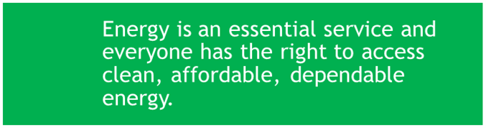

**Guiding values**

The principles are intended to guide the development and evaluation of regulation and policy.

Where the application of one principle appears to be in conflict with another, solutions that reflect the spirit of the principles should be sought, with final decisions being transparent and justifiable in terms of the overarching vision.

The principles are numbered for ease of reference but are not in priority order.

Each principle contains guidance on how it might be applied and the mindset and behaviours that reflect the principle. This is provided to demonstrate how decision makers, advocates and people might meet the spirit and intent of each principle - it is not intended to be prescriptive; it is not comprehensive and will evolve over time.

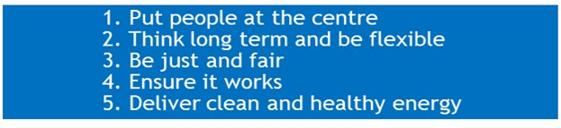

**Principles**

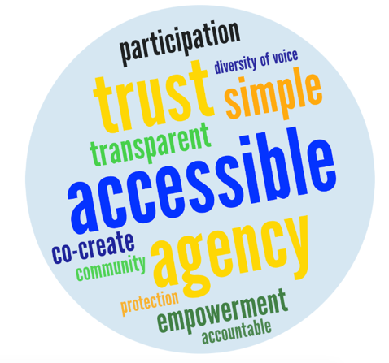

***We will...***

### Put people at the centre

We will meet people where they are and deliver their energy needs. This will be done by understanding them and through engagement on the design, operation and delivery of the energy system. We will be honest and transparent about our actions.

|  |
| --- |
| To apply this principle  1. Ensure that everyone can access energy. 2. People should not be disadvantaged if they cannot or do not want to engage in new energy products and services. 3. Understand and engage with people and businesses to meet their needs, provide choice and improve outcomes. 4. Enable people, businesses and communities to contribute to society, economic development and a sustainable environment. 5. Enable choice and decision-making by ensuring options and tools are clear, transparent, learnable, in plain language and accessible. 6. Ensure energy service platforms are open and portable to provide choice and support innovation and effective competition. 7. Collect better energy user information to improve decision making. 8. Be honest and transparent to build trust. 9. Enable co-design by bringing a diversity of views to the table when policy, regulation, new services and products are being developed. 10. Ensure that people understand their responsibilities and the impacts on others of their energy choices. 11. Adequate protections are in place to enable full participation in the energy system. |

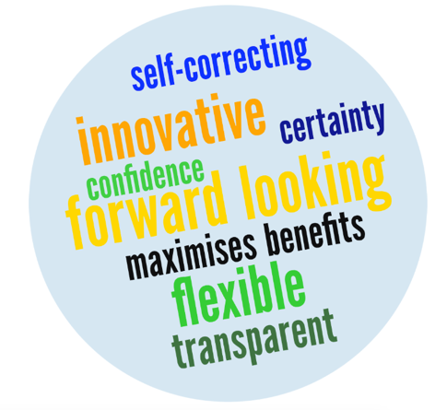

***We will...***

### Think long term and be flexible

We will focus on delivering the energy system we are likely to need in the future. It will be flexible, innovative, responsive and based on people's expectations. This includes cleaner energy and transport, and the digitisation and decentralisation of energy services.

|  |
| --- |
| To apply this principle  1. Articulate clear long-term objectives to assess progress in innovation, policy and regulation. 2. Be flexible and innovative in response to changes in people’s needs and preferences, the environment and technology. 3. Focus investment in innovation, research and development to develop products and services that meet the diverse needs of people, businesses and communities. 4. Identify and implement ‘least regrets’ actions where possible to preserve flexibility. 5. Focus government investments on actions with long-term economic, social and environmental benefits, including reducing inequity between different types of energy users. 6. Test reforms against a range of future outcomes, including their ability to withstand large and sudden changes, impacts on system reliability and security, costs and effects on people. 7. Draw experts and stakeholders in early to reform processes to co-design and test solutions prior to full implementation, including through pilots and trials. |

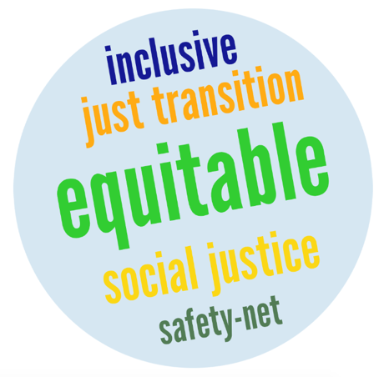

***We will...***

### Be just and fair

We will manage the energy system and the energy transition in a way that is just, fair and inclusive and ensure no-one is left behind. This includes people, workers and communities impacted by the evolution of the energy system. Costs and benefits must be equitably shared, recognising that governments will play a role in supporting a just and fair system.

|  |
| --- |
| To apply this principle:  1. Distribute costs, benefits and risks transparently and fairly to allow for equitable outcomes regardless of people’s ability to engage with the energy system. 2. Ensure the costs and benefits of initiatives are transparent, so that people, decision makers and advocates can respond appropriately. Cross-subsidies should be transparent and justifiable. 3. Public spending should be targeted to achieve economic and environmental benefits and reduce inequality. Public policy related costs should be met through the progressive tax system, not energy bills. 4. Implement policies that ensure fair pricing and conduct by energy service providers. 5. Other complementary measures or non-market measures may be required to ensure a just and fair energy system. 6. To maintain access to energy, identify and manage hardship and vulnerability early, without penalty, and provide assistance through trusted and appropriate experienced community services. 7. Where energy remains unaffordable for people on low-income or experiencing disadvantage, governments should provide adequate and equitable financial support to meet their essential needs. 8. Facilitate a just transition for impacted workers and communities though economic and employment diversification policies, social protection measures and education and training. This should be managed through formal consultation with stakeholders including trade unions, employers and communities. |

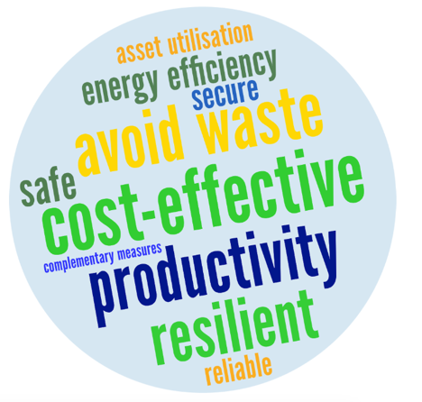

***We will...***

### Ensure it works

We will make sure the community can depend on the energy system. We will be efficient and make sure the system is dependable and productive across the supply chain, promoting efficient energy use and new technologies and services that benefit people and the environment. The energy system should also be resilient to extreme weather and security events.

|  |
| --- |
| To apply this principle  1. Ensure that investment in, and the operation of, the energy system are economically efficient and avoid wasting money and resources. 2. Engage with people and the community on investment and services so that energy is delivered in line with expectations, particularly on reliability and price. 3. Provide incentives and prioritise energy solutions to manage demand and improve the utilisation and reliability of existing generation and network infrastructure. 4. Enable energy management technology and behaviour that enhances consumer outcomes and reduces the costs of the energy system. 5. Ensure that the energy system can operate safely and securely regardless of how energy is produced. 6. Improve the resilience of people, communities, businesses and institutions as well as the energy system to manage the increasing frequency and intensity of bushfires and other severe weather events. 7. Collect reliability, security and resilience data to inform decision-making and efficient investment. |

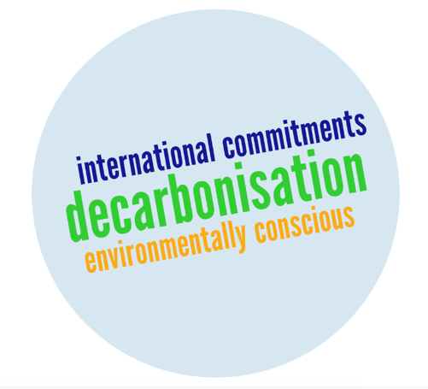

***We will...***

### Deliver clean and healthy energy

We will transform the energy system to achieve net-zero emissions by enabling the environmentally sustainable production and use of energy. The transition to a clean energy system is a shared responsibility, so it should be planned in line with science and community expectations and enable everyone to live healthy lives.

|  |
| --- |
| To apply this principle  1. Implement policies and strategies in line with a planned transition to net-zero emissions and limiting global heating to 1.5 degrees, including putting a price on carbon, prioritising investment in zero emissions technology and deploying clean energy production. 2. Be transparent in reporting on environmental performance. 3. Avoid energy sources that negatively impact the health and wellbeing of people and the environment. 4. Build and dispose of energy infrastructure and components in a socially responsible and sustainable way. 5. Ensure people, businesses and the community can play a role in the transition to a clean and sustainable environment. |

# Applying the New Energy Compact

The *Compact* serves as a guide for decision makers to consider processes and decisions and identify solutions that secure the most favourable outcomes for people, business and the community.

Inherent in the New Energy Compact is the need to be inclusive, not just in the final outcome but in the process to develop reforms, regulations, policies, products and services.

A good process is one that brings together a range of stakeholders to jointly agree on a vision, problem, principles, objectives, options and optimal solutions. See for example the methodology in the figure below.

How stakeholders work together is also important. The Compact encourages a change in mindset towards collaboration, innovation and striving to achieve win-win outcomes.

The complex nature of the energy market and people’s interactions with it mean that some principles may sometimes appear to be in tension with others. Where the practical application of one principle appears to be in conflict with another, stakeholders should endeavour to find solutions which honour the spirit or intent of both, with final decisions being transparent and justifiable in terms of the overarching vision.

Figure 1. Example of a methodology for applying the New Energy Compact[4]

**Co-design:** bring together key stakeholders to work together on developing and implementing solutions

1. **Vision**: what is the vision that the “problem is stopping from achieving.
2. **Problem definition:** define the problem trying to be solved.
3. **Principles:** consider principles that should guide the outcome and inform the objectives, requirements, options and testing. They can be drawn from the Compact’s guidance and/or be expanded on to provide more detail.
4. **Objectives:** use the principles to develop the objectives - ie what you are trying to achieve.
5. **Requirements:**  define what other factors need to be taken into account.
6. **Options:** identify a range of solutions to the problem and test against principles, objectives and requirements.
7. **Solution**

1. The process to develop the New Energy Compact has been supported by Australian renewable Energy Agency (ARENA), Australian Energy Markets Commission (AEMC) and the Australian Energy regulator (AER)
2. Energy Consumers Australia, [Consumer Sentiment Survey](https://energyconsumersaustralia.com.au/projects/consumer-sentiment-survey), UK Energy Research Centre [Transforming the UK Energy System – Public Values, Attitudes and Acceptability](http://www.ukerc.ac.uk/publications/transforming-the-uk-energy-system-public-values-attitudes-and-acceptability.html), Centre for Urban Research, RMIT University, [Engaging households towards the Future Grid: Interim Report Experiences, expectations and emerging trends](https://storage.googleapis.com/wzukusers/user-33684651/documents/5c93fa1a09283O0D8Ygr/RMIT2019%20Future%20Grid%20Homes-research%20report.pdf)
3. UNFCCC [Paris Agreement](https://unfccc.int/process-and-meetings/the-paris-agreement/the-paris-agreement), United Nations [The 2030 Agenda for Sustainable Development](https://sustainabledevelopment.un.org/post2015/transformingourworld)
4. The following approach has been developed with stakeholders to provide guidance on how to apply the New Energy Compact